Pennsylvania Department of Environmental Protection

………………………………………

**Draft**

Model Chesapeake Bay Pollutant Reduction Plan

Prepared for

“Stormyville Township,” Pennsylvania

PAG131234

February 2015

**The Pennsylvania Department of Environmental Protection (DEP) is soliciting comments on this draft document. Please submit your ideas on how it can be improved via email to** [**RA-PAMS4@pa.gov**](mailto:RA-PAMS4@pa.gov) **by July 1, 2015.**

1. This plan is formatted to address the requirements of the 2013 PA Municipal Separate Storm Sewer System (MS4) permit.

2. It is designed as a tool for use by MS4 permittees with CB requirements, but it will need to be adapted by each permittee to reflect individual TMDL requirements, varying local conditions and the preferences of local officials.

3. The preparation of this document was funded by DEP and the US Environmental Protection Agency (EPA). Although it was reviewed by DEP, it does not necessarily reflect the view of DEP or EPA and no official endorsement can be inferred.

**Table of Contents**

Introduction 4

Requirement #1: Drainage Area Description 5

Requirement #2: Municipal Infrastructure Upgrades 7

Requirement #3: Current Loads (Optional) 9

Simple Current Load Estimating 9

Chesapeake Assessment and Scenario Tool (CAST) 10

Requirement #4 13

Control Measures 14

Calculating Estimate Load Reduction from BMPs 17

Regional CB Pollution Reduction Plan 20

Optional Elements 24

Codes and Ordinances 24

Stormwater Financing 24

References 27

Appendix A. Municipal Upgrade Considerations 28

Common Structural BMPs Evaluated in the Review of Municipal Upgrades. 28

Common Non-Structural BMPs to Evaluated in the Review of Municipal Upgrades 28

Common Feasibility Considerations Evaluated in the Review of Municipal Upgrades 28

Appendix B. Table of PA County Developed Land Loading Rates (from CAST) 29

Appendix C. BMP Inspection, Operation, and Maintenance 33

Rain Garden/Bioretention 33

Vegetated swale 35

Step Pool Storm Conveyance 36

Wet Pond/Retention Basin (Stormwater Pond Retrofit) 37

Constructed Wetlands 38

Riparian Buffer Restoration 39

Floodplain Restoration 40

*This Chesapeake Bay Plan has been developed as a model plan for Pennsylvania MS4 communities. The information presented here has been developed to demonstrate appropriate concepts. The details in Individual plans will vary from the model.*

**Chesapeake Bay Pollutant Reduction Plan for**

**Muddy River Watershed in Stormyville Township**

# Introduction

The outline used in this document is found in Section B of the Pennsylvania Department of Environmental Protection (DEP) document 3800-FM-BPNPSM0493 “MS4 TMDL Plan / Chesapeake Bay Pollution Reduction Plan.” The document describes what Stormyville Township plans to do to meet the requirements of the Chesapeake Bay Pollutant Reduction Plan (CBPRP). Future updates to this plan are expected to be prepared occur for each permit renewal.

A separate Stormyville plan focuses on the TMDL Plan. Not all MS4s have to do both a TMDL and a Chesapeake Bay Plan. Where both plans are required, the MS4 is encouraged to combine the two plans into one, especially when the pollutants of concern are the same.

Below is the permittee information required by the DEP form “TMDL Design Details/Chesapeake Bay Pollution Reduction Plan” template (3800-FM-BPNPSM0493).  The remaining required content of the form follows.

**Check all that apply:**

TMDL Design Details (Section A) Completed

**X** Chesapeake Bay Pollutant Reduction Plan (Section B) Completed

|  |  |  |  |
| --- | --- | --- | --- |
| **GENERAL INFORMATION** | | | |
| Permittee Name: | **Stormyville Township** | NPDES Permit No.: | **PA1234567** |
| Mailing Address: | **122 Muddy River Lane** | Effective Date: | **March 15, 2013** |
| City, State, Zip: | **Stormyville, PA 11111** | Expiration Date: | **March 14, 2018** |
| MS4 Contact Person: | **Dusty Rhodes** | Renewal Due Date: | **September 15, 2017** |
| Title: | **Township Manager** | Municipality: | **Stormyville, PA** |
| Phone: | **000-000-0000** | County: | **Stormy** |
| Email: | [**drhodes@stormyville.org**](mailto:drhodes@stormyville.org) | Consultant Name: | **ABC/123 Engineering  Consultants** |
| Co-Permittees (if applicable): **N/A** | | | |
|  | | | |

# Requirement #1: Drainage Area Description

*Provide a description of the drainage area of the MS4 within the Urban Area that discharges to the Chesapeake Bay Watershed. The description should discuss pervious and impervious cover*.

Characteristics for the municipality can be described using existing local knowledge. It is good practice to also make use of Geographic Information System (GIS) data. These characteristics may include MS4 status, urbanized area, pervious and impervious coverage, land use, stream miles, and other data specific to your region. Table 1 identifies potential GIS data used to calculate these characteristics and where to obtain the data. The data sources include statewide and national data available for free download from the internet. It is important to contact a local GIS agency such as the planning commission to obtain more accurate, local GIS data if available.

Stormyville Township discharges stormwater to tributaries of the Chesapeake Bay, and is therefore required to develop a CBPRP. The Muddy River Watershed does not have a local TMDL. However, Stormyville Township anticipates a 28% sediment reduction requirement beginning in the next permit cycle and is voluntarily addressing this load with this plan. A 28% sediment load reduction would require a reduction of approximatly 312 tons/year in Stormyville Township to satisfy this goal.

A description of the MS4 characteristics in Stormyville Township was developed using the GIS data from Table 1. Local GIS data (the mapped MS4 area for Stormyville Township) was used as a boundary layer to calculate the amount of pervious and impervious area in the township. The stream length and sensitive lands were identified to support Best Management Practice (BMP) targeting. Land use was identified to support nutrient and sediment load calculations and to support BMP targeting.

| **Table 1. GIS Data Types and Sources** |
| --- |

|  |  |
| --- | --- |
| **Data Type** | **Data Source** |
| Urbanized Area[1] | Obtained from the U.S. Census Bureau |
| Impervious Cover | Chesapeake Bay Program (2000 Impervious Cover Layer; available as raster data) <ftp://ftp.chesapeakebay.net/pub/Geographic/> |
| Pervious Cover | Created by subtracting the impervious cover acres from the total acres of urbanized area |
| Land Use | USGS National Land Cover Dataset (obtain data through USDA Geospatial Data Gateway <http://datagateway.nrcs.usda.gov/>) |
| Streams | PASDA <http://www.pasda.psu.edu/> |
| Watershed Boundaries | PASDA <http://www.pasda.psu.edu/> |
| Municipal Boundaries | PASDA <http://www.pasda.psu.edu/> |
| Sensitive Lands (wetlands, contiguous forest, rare, threatened and endangered species, public drinking water supplies, etc.) | Various:   * Fish and Wildlife Service (FWS) * Local Data * National Resource Conservation Service (NRCS) |

All of the watersheds in the Township drain to the Chesapeake Bay. This plan applies to the entire MS4 area. This section of the report includes the available data, stormwater management practices implemented and planned, and modeled information to support the load reductions to meet the Chesapeake Bay TMDL.

The Township boundary, Urbanized Area, and local MS4 boundaries were used to develop the drainage area of the MS4s that discharge to the Chesapeake Bay Watershed. The proportion of pervious and impervious cover shown in Table 2 was used to develop current loading estimates.

The majority of soils in the Stormyville are characterized as hydrologic group B and C. In addition, part of the jurisdiction (12%) contains karst geology. The jurisdiction has 10.2 miles of stream with a gentle rolling hill terrain. The selection and design of BMPs in the watershed will take into consideration the karst terrain and amount of publicly owned land (9%). The Chesapeake Stormwater Network (2009) provides guidance on the design and implementation of BMPs in karst topography.

| **Table 2. Pervious and Impervious Cover of MS4 in the Chesapeake Bay Watershed** | | | | | |
| --- | --- | --- | --- | --- | --- |
| **Municipality** | **Impervious Cover (acres)** | **% Impervious** | **Pervious Cover (acres)** | **% Pervious** | **Total acres** |
| **Stormyville Township** | **1480.40** | **32%** | **3110.73** | **68%** | **4591.13** |
| *Note: Impervious cover estimates were developed using a GIS data developed by Woods Hole Research Center and is based on % impervious per 30-meter grid cell. This 30-meter grid cell layer does not offer the accuracy of a digitized impervious layer, but represents the best available data at the time of this report.* | | | | | |

The above information supports a conclusion that the significant percentage of impervious surfaces is a root cause of both overland flow and stream erosion sedimentation.

# Requirement #2: Municipal Infrastructure Upgrades

*Identify areas where municipal infrastructure upgrades are planned and include an evaluation of the suitability of green infrastructure, low impact development (LID) or Environmental Site Design (ESD) BMPs.*

In an effort to identify cost effective opportunities to implement control measures, all public infrastructure projects are required to be evaluated for the potential to integrate BMPs (Appendix A).

Typical public infrastructure upgrade projects include:

* Transportation (roads, sidewalks, parking lots)
* Utilities (stormwater/sewer pipes)
* Vertical Construction (municipal buildings, schools, garages)
* Open Space (park development and expansion)

Stormyville Township evaluated seven (7) planned municipal infrastructure upgrades for their potential to incorporate green infrastructure (GI), environmental sight design (ESD), and/or low impact development (LID) BMPs. This process involved evaluating existing planned projects for opportunities to incorporate stormwater BMPs to allow for enhanced stormwater treatment at the site, a reduction in the amount of impervious cover created at a site, and/or the maintenance of natural resources.

For example, Stormyville Township has plans to replace sidewalks and curbs along Main Street. The design for this project was re-evaluated to consider integrating street side bioretention to capture part of the runoff from the street.

Table 3 provides a summary of the 7 planned public infrastructure upgrade projects in Stormyville Township. The table also includes a summary of the site evaluation process and any actions being taken. For some projects, integrating GI/ESD/LID was not feasible at this time due to the stage of project completion (e.g., permits and construction contracts in place) and level of activity (e.g., repaving, maintenance activities). Stormyville Townshipwill continue to evaluate public infrastructure upgrades as they occur for the potential to incorporate GI/ESD/LID practices. These evaluations will be documented and reported upon as addendums to the CBPRP Annual Report.

|  |  |  |  |  |  |
| --- | --- | --- | --- | --- | --- |
| **Table 3. Planned Public Infrastructure Upgrade Projects in Stormyville Township** | | | | | |
| **Infrastructure Upgrade Project** | **Estimated Date of Upgrade** | **LID Considerations** | | | **Actions** |
| **Non-Structural BMPs** | **Structural BMP** | **Considerations** |
| Sewer line realignment / replacement (south side of Dark Hollow Rd. along unnamed trib. to Susquehanna River.) | Spring 2016 | Protect sensitive/special features, protect/enhance riparian area, minimize disturbance, protect/utilize natural flow paths | Stream restoration | Cost ($250,000), estimated nutrient load reduction benefits | Project pending GP-11 permit |
| Enhance existing swale along roadway and replace road drainage (between Schoolhouse Rd & Spring Road) | January 2015-July 2015 | None | Enhance the existing swale | Cost, permitting, project timeline, adjacent landowners | Modify swale cross section and install 2 weirs. |
| Replace 1,000 ft. of stormwater pipe | Summer 2015 | None | Vegetated swale, impervious removal, landscape restoration, infiltration trench | Cost ($400,000), adjacent landowners, project timeline | Replace pipe and direct stormwater to detention basin |
| Curb and sidewalk replacement (7th Ave., 8th Ave., Queen St.) | Summer 2016 | Reduce street imperviousness | Impervious removal, vegetated curb extension | Cost, feasibility | None- Parking, limited space and impacts to numerous mature trees make LID impractical. |
| Susquehanna St. and West St. improvements | Summer 2016 or 2017 | None | WQ filter/hydrodynamic device | Cost, feasibility | Township is exploring using water quality inlets however cost will play a significant factor. |
| Example Township Sports Park Expansion | Summer 2017 | Protect/enhance riparian area, minimize disturbance, protect/utilize natural flow paths | Porous Pavement | Cost | Porous pavers in the parking stalls are being installed as part project. |
| Highway Restoration | Summer 2015 | None | None | Cost, feasibility, timeline | None-Project involves repaving and sealing only, limited opportunities to integrate LID. |

# Requirement #3: Current Loads (Optional)

*Provide estimates of current loads (lbs/yr.) of Nitrogen, Phosphorus, and Sediment being discharged annually to receiving waters in the Chesapeake Bay Watershed. Explain how estimates were made.*

Stormyville chose to pursue Chesapeake Bay pollution load reductions (for sediment and nutrients) because they believe future MS4 permits will require it, and because they felt it made sense to get an early start. Stormyville chose to estimate current loads in order to establish a baseline for the calculation of a load reduction percentage.

MS4s who wish to know their current pollution loads must do their own estimate (unless there is a completed TMDL or other report which has already completed an estimate). Assume for this scenario that a TMDL had not been done for Stormyville. Stormyville could have employed a sophisticated modeling tool (like Mapshed) to estimate the current load, but chose to use the much simpler (and less accurate) approach in CAST. DEP accepts the use of CAST for this purpose.

Current loads as listed in Table 4 for Stormyville Township were developed using the Chesapeake Assessment and Scenario Tool (CAST). CAST allows users to rapidly develop scenarios with varying best management practices. Output includes nitrogen, phosphorus, and sediment loads from all sectors and sources; acres of each BMP; and costs for the scenario for any area in the Chesapeake Bay Watershed. These loads are consistent with the Chesapeake Bay Program’s Watershed Model.

|  |  |  |  |  |  |
| --- | --- | --- | --- | --- | --- |
| **Table 4. Example Current Load Calculation for Stormyville** | | | | | |
| **Municipality** | **Impervious Cover (acres)** | **% Impervious** | **Pervious Cover (acres)** | **% Pervious** | **Total acres** |
| **Stormyville Township** | **1480.4** | **32%** | **3110.73** | **68%** | **4591.13** |
| TSS lbs. /ac. (from CAST) | 1,614.15 | Impervious | 220.4 | Pervious |  |
| TOAL MS4 Load(lbs. TSS) | 2,389,588 | 685,605 | 3,075,193 |

## Simple Current Load Estimating

Table 4 shows a simplified approach to determining a current load estimate. In this case, Stormyville used its MS4 boundary and the percent impervious cover for that area. This estimation may be significantly refined with additional information, such other land use categories, amount of forest cover and/or locations and characteristics of existing voluntary BMPs (Figure 1).

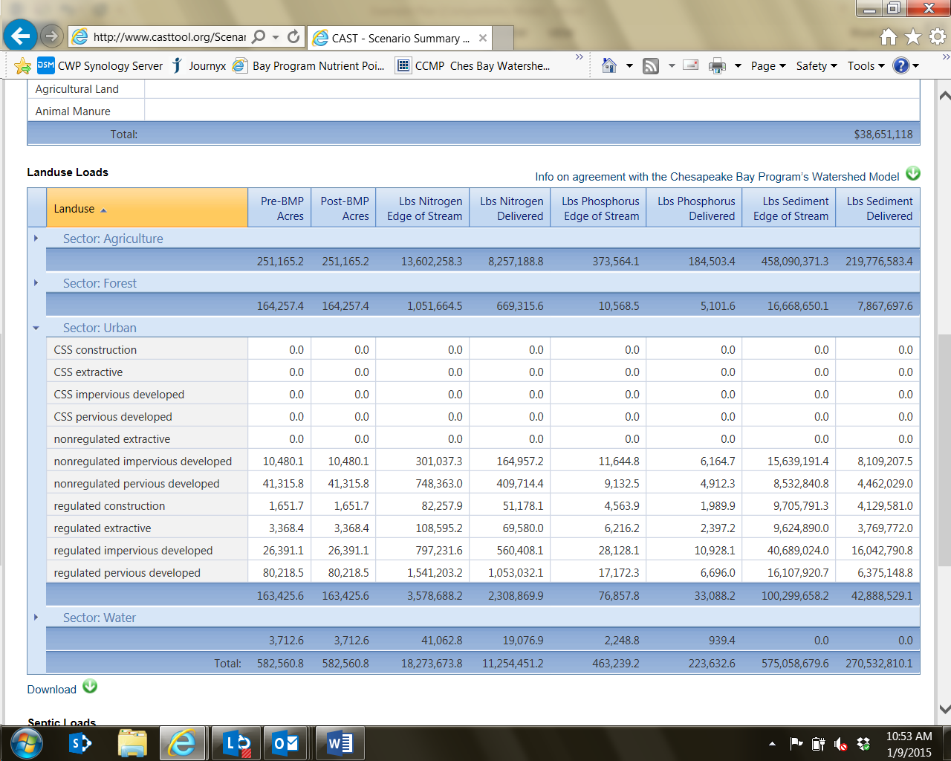

Figure 1. Screenshot of CAST

## Chesapeake Assessment and Scenario Tool (CAST)

The current CAST tool will only work down to the county scale. It does not currently work down to the individual municipal scale. As a result, some scenarios in the CAST program are more difficult to apply and use at the municipal scale.

One notable feature is the land use loading outputs for land use categories associated with the Chesapeake Bay Model. These tables provide land use loading rates at edge of stream and as delivered to the Chesapeake Bay. The tables provide acreage estimates for each land use and load estimates for total nitrogen, total phosphorus and total suspended solids.

When working with small acreages or trying to determine the current and predicted loads from a smaller piece of the overall county, these tables provide the user with some of the basic data inputs for the Chesapeake Bay Model. This data can then be imported to other tools or even simple spreadsheets for basic planning level estimates. Keep in mind that using a spreadsheet reduces or eliminates some of the functionality of the CAST tool, especially in estimating loading to the Chesapeake Bay.

Appendix B provides developed land loading rates from CAST for each county in Pennsylvania as of January 2015. Similar tables can be generated for any land use and used in basic planning level calculations. These numbers may change as the Chesapeake Bay Model is updated and the CAST tool is improved. Refer to the CAST tool for current figures ([www.casttool.org](http://www.casttool.org)).

CAST also provides inputs to the Chesapeake Bay Program computer models that include land use loading rates for land uses as categorized in the Chesapeake Bay model. Users can compare scenarios to select the practices that reduce the most pollution and are most cost-effective. Users can then target these practices to the highest impact areas. Scenarios can be used for TMDL Watershed Implementation Plans (WIPs), milestones, or for local planning purposes. The CAST tool includes a variety of pre-populated scenarios, including Current Progress for each state, and will provide load calculations down to the county scale.

**MapShed**

Penn State University developed MapShed is an advancement to the *AVGWLF model*, which has been used for federally-mandated "total maximum daily load" (TMDL) studies in Pennsylvania since 1999. MapShed is a GIS-based watershed modeling tool that uses hydrology, land cover, soils, topography, weather, pollutant discharges, and other critical environmental data to model sediment and nutrient transport within a watershed.

Current loads for Stormyville may be calculated using MapShed instead of CAST. Using Mapshed to update loadings may be particularly useful if there is a local TMDL that used MapShed, and the TMDL documents provide land use loading rates or current load estimate. Table 5 is an example of current load estimates for a variety of land uses in Muddy River.

| **Table 5. Muddy River Current Loads from Mapshed** | | | | | | | |
| --- | --- | --- | --- | --- | --- | --- | --- |
| **Source** | **Area**  **(acres)** | **Sediment (tons)** | **Sediment (lbs.)** | **Dissolved N** | **Total N** | **Dissolved P** | **Total P** |
| Hay/Past | 2521 | 371 | 741240 | 1367 | 2849 | 274 | 556 |
| Cropland | 1139 | 1941 | 3882200 | 4220 | 11984 | 219 | 1694 |
| Forest | 16378 | 183 | 366620 | 1914 | 2647 | 101 | 240 |
| Wetland | 67 | 0 | 140 | 14 | 14 | 1 | 1 |
| Disturbed | 218 | 9 | 18020 | 10 | 46 | 5 | 12 |
| Turfgrass | 0 | 0 | 0 | 0 | 0 | 0 | 0 |
| Open_Land | 0 | 0 | 0 | 0 | 0 | 0 | 0 |
| Bare_Rock | 0 | 0 | 0 | 0 | 0 | 0 | 0 |
| Sandy_Areas | 0 | 0 | 0 | 0 | 0 | 0 | 0 |
| Unpaved_Road | 0 | 0 | 0 | 0 | 0 | 0 | 0 |
| Ld_Mixed | 10 | 0 | 180 | 1 | 4 | 0 | 0 |
| Md_Mixed | 299 | 12 | 23700 | 166 | 542 | 23 | 61 |
| Hd_Mixed | 1312 | 52 | 104060 | 727 | 2377 | 103 | 268 |
| Ld_Residential | 996 | 9 | 18320 | 120 | 429 | 17 | 46 |
| Md_Residential | 2454 | 97 | 194580 | 1359 | 4445 | 193 | 501 |
| Hd_Residential | 524 | 21 | 41540 | 290 | 949 | 41 | 107 |
| Farm Animals |  |  |  |  | 0 |  | 0 |
| Tile Drainage |  | 0 | 0 |  | 0 |  | 0 |
| Stream Bank |  | 6389 | 12777215 |  | 6389 |  | 1215 |
| Groundwater |  |  |  | 79788 | 79788 | 2110 | 2110 |
| Point Source |  |  |  | 0 | 0 | 0 | 0 |
| Septic Systems |  |  |  | 5649 | 5649 | 113 | 113 |
| **Total** | **25,918** | **9,084** | **18,167,815** | **95,625** | **118,112** | **3,200** | **6,924** |

# Requirement #4

*Identify the control measures from the Notice of Intent (NOI) or others which will be implemented in the MS4 to reduce the pollutant load to the Chesapeake Bay Watershed.*

Control measure implementation schedules can be determined based on the following guidelines:

*Permit Cycle 1: BMPs that are ready to be implemented. These projects contain several of the following factors: have a completed preliminary design, permits, property owner permission (or might be public land), site access and an O&M plan. Projects implemented in this permit cycle provide 8% of the voluntary sediment reduction goal.*

*Permit Cycle 2: BMPs that need to finish one or two factors before being ready for implementation. Projects implemented in this permit cycle provide 26% of the voluntary sediment reduction goal.*

*Permit Cycle 3: BMPs that are in the concept phase and were field evaluated. Projects implemented in this permit cycle provide 24% of the voluntary sediment reduction goal.*

*Permit Cycle 4: BMPs that are identified as part of a long term Capital Improvement Program (CIP), and are an idea without project details identified (i.e. permits, property ownership, access, etc.). Projects implemented in this permit cycle provide 3% of the voluntary sediment reduction goal.*

*Permit Cycle 5-6: Other private BMPs that correspond to a capital project being implemented at a later time with legal ordinance restrictions. Voluntary BMPs on individual homes that require a maximum amount of time to engage homeowners and ensure proper long term operation and maintenance. Projects implemented in this permit cycle provide 40% of the voluntary sediment reduction goal.*

For example, BMPs to be installed in the first permit cycle are ready for implementation and have addressed the following factors:

* Preliminary design,
* Permits,
* Public land or right-a-way,
* High demonstration value.

In the later permit cycle, BMPs to be installed may be:

* Part of a long term Capital Improvement Program (CIP),
* At planning or concepts stage,
* Part of long term plans,
* On private land,
* Taken on by the private sector (redevelopment, homeowners, etc.).

**Recommended and approved BMP pollutant reduction values and efficiencies can be identified in a variety of sources**:

* Pennsylvania BMP Manual .
* Chesapeake Bay Model Documentation – BMP efficiencies used in the Chesapeake Bay Model
* Chesapeake Bay expert panel reports – BMP efficiencies agreed upon by experts that may be used in the Bay Model in the future.
* Peer reviewed BMP studies – Peer reviewed research with supporting data.
* Local Monitoring Data- Direct and/or related local project monitoring information with supporting and defensible data.

# Control Measures

Stormyville Township has a goal to reduce total sediment loads by 28% over the next 6 permit cycles or 30 years. The TMDL control measures or BMPs identified to be implemented to achieve the required pollutant load reductions include stream restoration, impervious surface removal, bioretention, stormwater pond retrofits, and tree buffer planting. These TMDL strategies focused on the BMPs that effectively remove pollutants, are cost effective, and either are included or could be included in the other planned projects in the jurisdiction. These BMPs are effective at nitrogen, phosphorus, and sediment removal based on the justification provided in Table 6. The table also includes specific information regarding each BMP. Table 7 includes the projects identified in Stormyville Township. Table 7 provides an example of how to distribute project implementation over 6 permit cycles by taking into account which projects are ready for implementation and those that need additional time to acquire permits, landowner permission, design, etc.

The control measures identified and presented here support Stormyville Township’s efforts to meet the Chesapeake Bay Pollutant Reduction goals.

| **Table 6. Stormyville Township BMP Justification** | | | | |
| --- | --- | --- | --- | --- |
| **BMP** | **TN Reduction Effectiveness Justification** | **TP Reduction Effectiveness Justification** | **Sediment Reduction Effectiveness Justification** | **References** |
| Stream Restoration | 0.075 lbs. per linear foot per year | 0.068 lbs. per linear foot per year | 248 lbs. per linear foot per year | Chesapeake Assessment Scenario Tool (CAST)1 |
| Impervious Surface Removal | 9.5 % reduction | 72.2% reduction | 84.5% reduction | Change in Impervious to Pervious in the Chesapeake Assessment Scenario Tool (CAST)1 and Scenario Builder documentation2 |
| Bioretention | 58.3% reduction3 | 68.3% reduction3 | 75% reduction3 | Chesapeake Assessment Scenario Tool (CAST)1 and Scenario Builder documentation2 |
| Tree Buffer Planting | 78% reduction4  + Land use change5 | 81% reduction4  + Land use change5 | 62% reduction4  + Land use change5 | Chesapeake Assessment Scenario Tool (CAST)1 and Scenario Builder documentation2 |
| Stormwater Pond Retrofit | 15% reduction6 | 35% reduction6 | 50% reduction6 | Chesapeake Assessment Scenario Tool (CAST)1 and Scenario Builder documentation2 |
| 1Available from the US Environmental Protection Agency Chesapeake Bay Program Office at <http://www.casttool.org/default.aspx?AcceptsCookies=no>  2 Available from the US Environmental Protection Agency Chesapeake Bay Program Office at <http://www.chesapeakebay.net/about/programs/modeling>  3 Average sediment removal based on soil types, underdrain, and no underdrain conditions  4The tree buffer planting project TN, TP, and TSS effectiveness are based on the land use change from regulated pervious to forest plus treat of adjacent acreage on a 1 to 1 basis. Baseline efficiencies are available from the US Environmental Protection Agency Chesapeake Bay Program Office in the CAST documentation that is online at <http://www.casttool.org/default.aspx?AcceptsCookies=no>.  5Tree planting includes a land use change in the Chesapeake Bay Watershed Model (see Scenario Builder Documentation Section 8 Best Management Practice Implementation: <http://www.chesapeakebay.net/documents/SB_Documentation_V24_01_04_2013.pdf>)  6 Average load reductions based on conversion of a dry pond to a wet pond or wetland. | | | | |



### Calculating Estimate Load Reduction from BMPs

Calculating estimated pollutant load reductions for each BMP in the CBPRP can be done using a variety of techniques and basic calculations or existing modeling tools. Some methods require more data than others but at a minimum the user will need to know the following:

* Type of BMP
* Drainage area
* Drainage area land use
* Amount of runoff from drainage area being treated by the BMP (recommended)

#### BMP Calculation Approach:

The BMP Calculation Approach will allow a quick planning level estimate of load reduction potential from individual BMPs. As each BMP opportunity is evaluated in greater detail and concept level plans are developed, advanced estimates should be updated using the additional information. If sufficient data is available, the use of the methods detailed in Chapter 8 of the Pennsylvania Stormwater Best Management Practices Manual (<http://www.elibrary.dep.state.pa.us/dsweb/Get/Document-48479/09_Chapter_8.pdf>) are recommended. Long term planning level load reduction estimates where only basic information exists (BMP type, drainage area, practice location, available space) may require a more basic approach. One option is to use land-use loading rates out of a modeling tool (MapShed, CAST), an approved BMP efficiency, a drainage area estimate, and some basic project assumptions to calculate the potential pollutant load reduction.

#### Existing Modeling Tools:

* MapShed - This tool and approach may be particularly useful if the municipality also has to complete a TMDL plan for a TMDL developed using MapShed.
* CAST - This tool is provided by the Chesapeake Bay Program office of EPA to act as a resource for jurisdictions preparing Chesapeake Bay Watershed Implementation Plans. This tool is consistent with the Chesapeake Bay Model calculations and assumptions.
* Watershed Treatment Model (WTM) - This is a spreadsheet-based tool designed for municipal or watershed managers that estimates the benefits of a wide range of management practices in urban watersheds. The WTM is able to track sediment, nutrients, bacteria and runoff volume on an annual basis.

##### BMP Calculation Example:

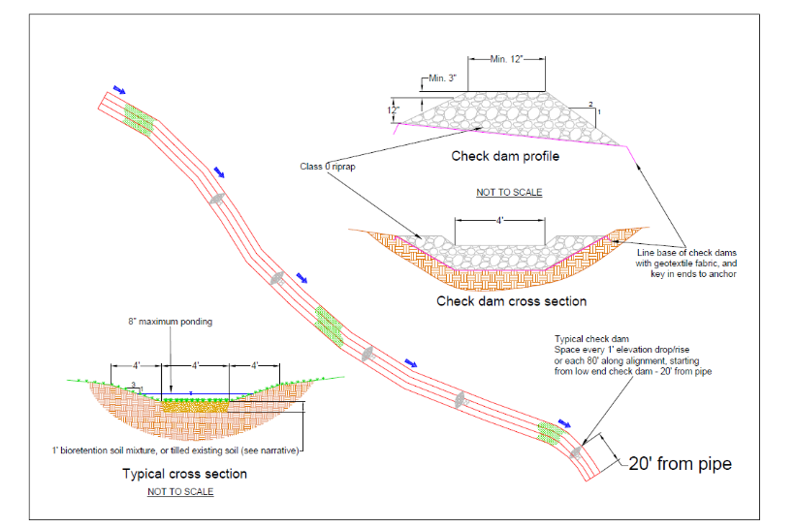Vegetated Swale in a Park

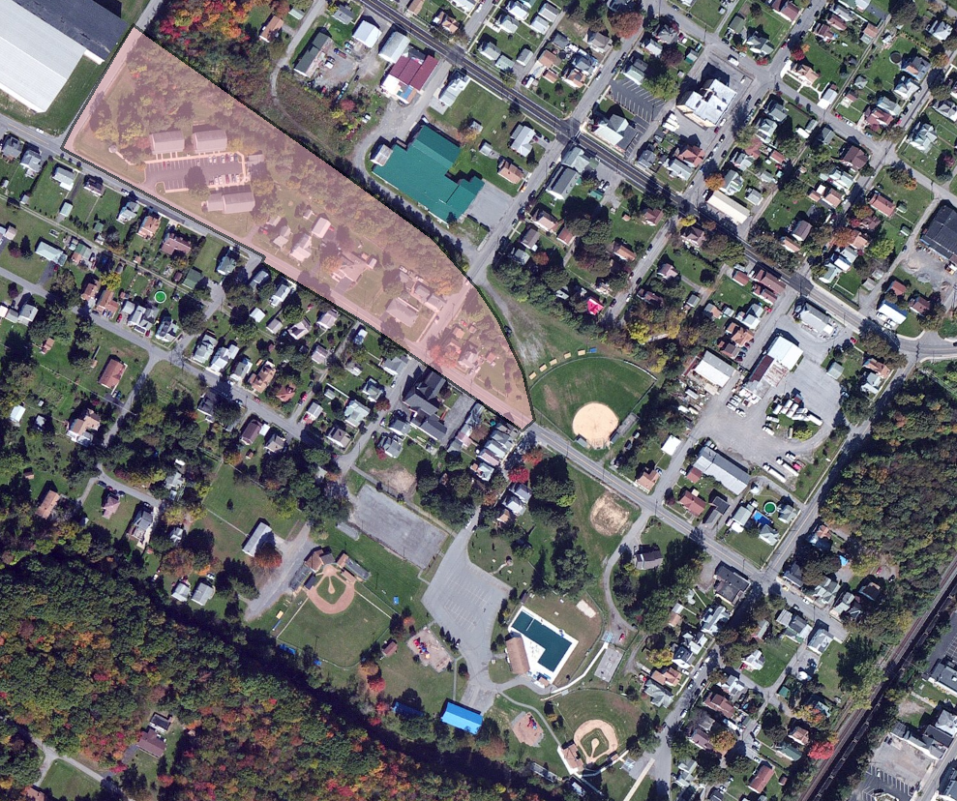

|  |  |  |  |
| --- | --- | --- | --- |
| **Parameter** | **Value** | **Units** | **Source** |
| Drainage Area | 297511 | sf | GIS |
| Drainage Area (A) | 6.8 | acres | Conversion (1 acre / 43,560 sf) |
| Impervious Proportion (Imp) | 0.33 | decimal percent | Estimate from aerial imagery |
| Impervious Area | 2.3 | acres | A*Imp |
| Intensity10-year,24-hour (i) | 1.42 | in/hr | NOAA, Peak intensity Type II storm |
| Runoff Coefficient (C) | 0.46 |  | (0.95*impervious)+(0.22*pervious)  (0.95*Imp) + (0.22*(1-Imp)) |
| Peak flow (Q) | 4.5 | cfs | Q=CiA |
| Target Rainfall Event (PE) | 0.7 | inches | 90th percentile rainfall event for Blair County |
| Water Quality Volume (WQv) | 8000 | cubic feet | PE*C*A*(43,560 sf/12 in) |

|  |  |  |  |
| --- | --- | --- | --- |
| **Location** | **TP reduction: lbs/yr** | **TN reduction: lbs/yr** | **TSS reduction: lbs/yr** |
| Bioswale | 1.16 | 19.38 | 975.28 |

### Regional CB Pollution Reduction Plan

It may be advantageous to take a regional approach to developing a Chesapeake Bay Pollution Reduction Plan, especially for neighboring jurisdictions in the same county. Taking a regional approach may save money and allow for a watershed approach to BMP implementation. Using a watershed approach may produce a greater suite of potential BMPs, which will allow for greater optimization by enabling the selection of the most cost-effective projects.

1. Create a new layer of the urbanized area for each participating municipality
   1. In the U.S. Census urbanized area layer, select the Urban Areas. This will ensure Urban Clusters are not included in your analysis.
   2. Intersect the U.S. Census urbanized area layer (with selected Urban Areas from Step a) and the municipality boundary layer (or with cooperating municipalities selected) (Figure 1).
   3. Upon completion of steps a and b, a new layer is created that contains the urbanized area for the municipality. This layer will be used as a ‘boundary’ layer to obtain characteristics for the municipality in Step 2.
   4. Check with DEP to obtain a list of entities that are regulated under a separate stormwater permit (Figure 2) (e.g., industrial facilities, federal facilities, educational institutions, state highways, etc.). If these facilities exist within your municipality, contact the facility to obtain a GIS shapefile that defines their regulated boundary. In the ArcToolbox, use the Erase function to remove the regulated boundary of the facility from the municipality’s urbanized area.

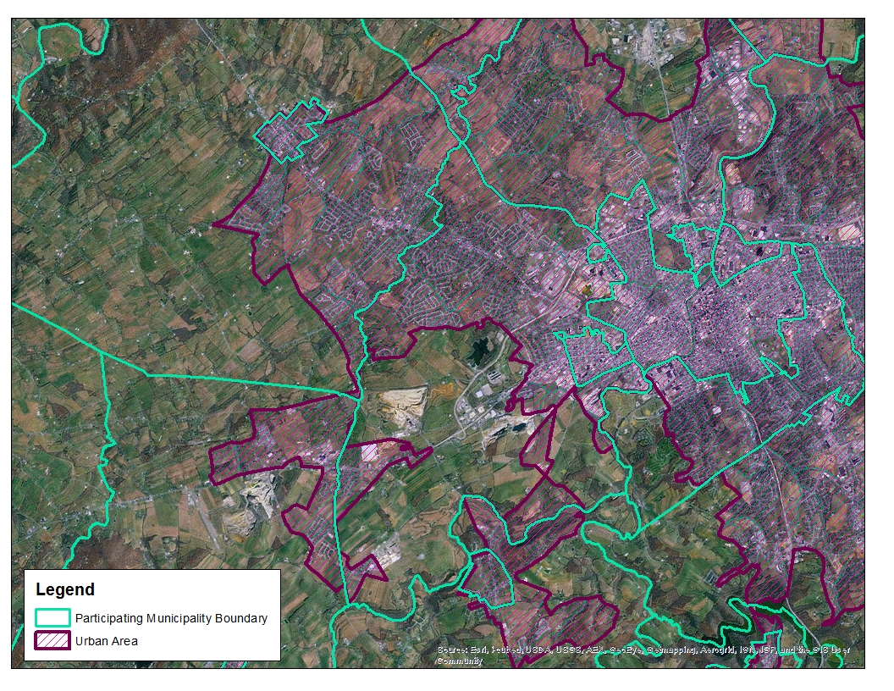

**Figure 1. Urbanized Areas for Participating Municipalities.**

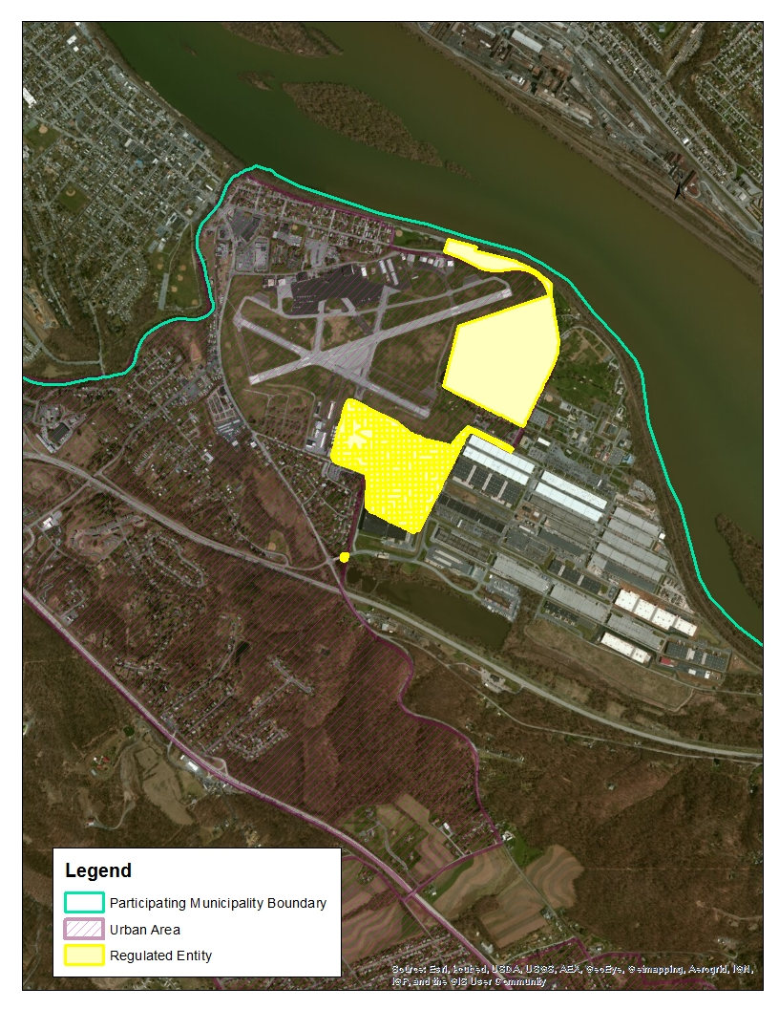

**Figure 2. Example of Regulated Entity within a Municipal Urban Area.**

1. Use the new ‘urbanized area- municipality’ layer created in step 1 to calculate characteristics for each municipality. Intersect the appropriate data layers with the ‘urbanized area- municipality’ shapefile created in step 1. This will result in a new shapefile that contains all of the characteristics of the municipality’s urbanized area. These characteristics are then summarized for the municipality in a table format as shown in the Table 7.

| **Table 7. Example Summary of Participating Municipality Characteristics** | | | | | |
| --- | --- | --- | --- | --- | --- |
| **Participating Municipalities** | **MS4 Permit** | **2000 Urbanized Area (Acres)** | **Impervious Cover (Acres)** | **Pervious Cover (Acres)** | **Stream Length (Miles)** |
| Old Township | Yes | 3,071.88 | 170.86 | 2,901.02 | 11.97 |
| North Township | Yes | 1,382.34 | 168.95 | 1,213.39 | 9.99 |
| Green Borough | Yes | 503.70 | 227.49 | 276.21 | 0.40 |

Operations and Maintenance

A brief specific description of the O&M to be applied to each BMP proposed in permit term #1 is included in Appendix E.

An example of a specific O&M plan is still in development

# Optional Elements

In addition to the required elements of the CBPRP, MS4s have the option to include additional information.

## Codes and Ordinances

One way to stimulate the implementation of BMPs is through refinements to local ordinances.

This can be done by undertaking an in-depth review of the standards, ordinances, and codes (i.e., the development rules) that shape how development occurs in the community by comparing local development rules against model development principles. Institutional frameworks, regulatory structures and incentive programs could be included in this review. This review process may result in agreement where local codes and ordinances are changed or adopted and result in the implementation of additional TMDL control measures over time.

If local ordinances require greater stormwater treatment than the state Chapter 102 requirements then the difference in these requirements is applied as a credit towards the pollutant load reduction.

Stormyville Township conducted a review of their local development ordinances to identify and remove impediments to LID in their ordinances. Examples of documents reviewed in this process include subdivision regulations, road standards, parking standards, and natural resource regulations such as forest conservation and stream buffer ordinances.

The development standards in Stormyville Township were compared to a set of national standards. The evaluation identified several recommended changes to ordinances that will better encourage the use of LID during development. The changes are:

* Require the use of curb and gutter along residential streets only where necessary and allow for open section roadways when applicable;
* Reduce the number of parking spaces required for commercial properties;
* Require landscaping in parking islands that can also be used for stormwater treatment; and
* Require a stream buffer and tree conservation at development sites.

Stormyville also decided to require greater stormwater treatment than is required by state Chapter 102 standards, with the intent of applying the difference as a credit against TMDL obligations.

## Stormwater Financing

Stormyville is aware of the financing requirements needed for these projects to occur. Our methodology is to identify and implement the most cost effective solutions first. For example, LID improvements to municipal upgrades do not add significant additional costs. Some even create efficiencies.

The listed BMPs are being done in conjunction with other related projects, so less funding is required than if they were standalone projects. For long term projects, we will look at CIP budgets, infrastructure bonds, low interest revolving loans and potentially imposing a fee.

*Permittees are encouraged to seek funding from the Pennsylvania Infrastructure Investment Authority (PENNVEST). PENNVEST provides funding in the form of low interest loans to pay for the construction of nonpoint pollution, mitigation and municipal stormwater projects. Information is available at* [*www.pennvest.pa.gov*](http://www.pennvest.pa.gov)*.*

Appendix C provides a list of manuals and reports that communities can use to evaluate sources of revenue for financing stormwater management. These resources include a stormwater financing manual for local governments and two reports on creating financial markets and financing stormwater infrastructure in the City of Philadelphia.

1. Environmental Finance Center. 2014. Local Government Stormwater Financing Manual: A Process for Program Reform. University of Maryland.

<http://www.efc.umd.edu/assets/publications/2efc_stormwater_financing_manual_final_(1).pdf>

*The goal of this manual is to provide local leaders with the foundation for establishing and growing effective stormwater management programs that maximize the value and impact of every dollar invested in their communities.*

1. Natural Resources Defense Council. 2012. Financing Stormwater Retrofits in Philadelphia and Beyond.

<http://www.nrdc.org/water/files/stormwaterfinancing-report.pdf>

*This report uses Philadelphia as a test case to explore how cities can attract billions of dollars in private investment in stormwater retrofits, saving on public infrastructure costs while cleaning waterways and greening communities. Drawing lessons from the energy efficiency finance sphere, it explains how Philadelphia’s stormwater billing structure lays the groundwork for innovative financing mechanisms that can underwrite the capital costs of green infrastructure retrofits. The report provides recommendations for local and state officials, as well as private firms, to stimulate investment.*

1. Natural Resources Defense Council, EKO Asset Management Partners, The Nature Conservancy. 2013. Creating Clean Water Cash Flows Developing Private Markets for Green Stormwater Infrastructure in Philadelphia

<http://www.nrdc.org/water/stormwater/files/green-infrastructure-pa-report.pdf>

*This report provides more detailed analysis and recommendations to stimulate investment in green infrastructure on the part of municipalities and private investors. Although the analysis and recommendations are directed toward the case of Philadelphia, the report provides strategies that other cities can use to identify economical green infrastructure retrofit opportunities and, where possible, leverage private capital in efforts to “green” their urban space.*

Combining stormwater BMP construction with other planned infrastructure improvement projects can save significant costs and may have additional benefit to the community. One such example is in the City of Lancaster. The city was dealing with an intersection that was prone to flooding and traffic accidents. The city decided to fix the intersection, but took the opportunity to build four bioretention basins on each side of the intersection as part of the intersection realignment project to capture stormwater and reduce runoff. A local business located at the intersection built a cistern to store rainwater from its roof, decreasing the flow into the street. They use the cistern to water the plants they grow for their operation. They also installed permeable pavers in the patio space and new parking stalls.

List references used in the development of your plan

# References

Chesapeake Stormwater Network (CSN) 2013. Technical Bulletin No. 10. Biotetention Illustrated: A Visual Guide for Constructing, Inspecting, Maintaining and Verifying the Bioretention Practice 2013.

Chesapeake Stormwater Network (CSN) 2009. Technical Bulletin No.1. Stormwater Design Guidelines for Karst Terrain in the Chesapeake Bay Watershed. Version 2.0. http://chesapeakestormwater.net/wp-content/uploads/downloads/2012/01/Karst20Working20Draft20Revised2006-05-20091.pdf

Devereu, O. 2011. Chesapeake Bay Assessment Scenario Model Documentation.

Fraley, L., A. Miller and C. Welty. 2009. Contribution of in-channel processes to sediment yield in an urbanizing watershed. *Journal of American Water Resources Association*. 45(3):748-766.

Hirschman, D., Kosco, J. 2008. Managing Stormwater in Your Community: A Guide for Building an Effective Post-Construction Program. EPA Publication No: 833-R-08-001. Center for Watershed Protection, Ellicott City, MD. http://www.cwp.org/online-watershed-library/doc_download/70-post-construction-manual-managing-stormwater-in-your-community

King, D. and P. Hagan, 2011. Costs of Stormwater Management Practices in Maryland Counties. Prepared for the Maryland Department of the Environment. Technical Report Series No. TS-626-11 of the University of Maryland Center for Environmental Science. Solomons, Maryland.

Land Studies. 2005. Stream bank erosion as a source of pollution: research report.

Pennsylvania Department of Environmental Protection (PA DEP), 2013. Municipal Separate Storm Sewer System (MS4) TMDL Plan/Chesapeake Bay Pollution Reduction Plan Instructions. <http://www.elibrary.dep.state.pa.us/dsweb/Get/Version-103707/3800-FM-BPNPSM0493%20Instructions%20and%20Instructions%20-%20Attachment%20A.pdf>

Schenk, E., Hupp, C., Gellis, A., and G. Noe. 2012. Developing a new stream metric for comparing stream function using a bank-floodplain sediment budget: a case study of three piedmont streams. Earth Surf. Process. Landforms doi: 10.1002/esp.3314.

Schueler, T., and B. Stack. 2014. Recommendations of the Expert Panel to Define Removal Rates for Individual Stream Restoration Projects. US EPA Chesapeake Bay Program. Annapolis, MD.

# Appendix A. Municipal Upgrade Considerations

### Common Structural BMPs Evaluated in the Review of Municipal Upgrades.

|  |  |  |  |
| --- | --- | --- | --- |
| Pervious Pavement | Infiltration Basin | Subsurface Infiltration Bed | Infiltration Trench |
| Vegetated Swale | Vegetated Filter Strip | Infiltration Berm | Vegetated Roof |
| WQ Filter/Hydrodynamic Device | Riparian Buffer | Landscape Restoration | Soil Amendment |
| Dry Extended Detention Basin | Impervious Removal | Construction Filter | Wet Pond |
| Bioretention | Dry Well | Cistern | Constructed Wetland |
| Floodplain Restoration | Level Spreader | Stream Restoration | Other Proprietary Practice |

### Common Non-Structural BMPs to Evaluated in the Review of Municipal Upgrades

|  |  |  |  |
| --- | --- | --- | --- |
| Protect Sensitive/Special Features | Protect/Enhance Riparian Area | Protect/Utilize Natural Flow Paths | Cluster Building |
| Concentrate Uses/Smart Growth | Minimize Disturbance | Minimize Soil Compaction | Re-veg/Re-forest Disturbance |
| Reduce Street Imperviousness | Reduce Parking Imperviousness | Rooftop Disconnection | Disconnect from Storm Sewer |

### Common Feasibility Considerations Evaluated in the Review of Municipal Upgrades

|  |  |  |  |
| --- | --- | --- | --- |
| Cost | Feasibility | Est. Nutrient Load Reduction Benefits | Permitting |
| Project Timeline | Ownership | Safety | Adjacent Landowners |

# Appendix B. Table of PA County Developed Land Loading Rates (from CAST)

| **PA County Developed Land Loading Rates (from CAST)** | | | | |
| --- | --- | --- | --- | --- |
| **County** | **Category** | **TN/lbs/ac** | **TP/lbs/ac** | **TSS/lbs/ac** |
| Adams | impervious developed | 33.43 | 2.10 | 1,398.77 |
| pervious developed | 22.99 | 0.80 | 207.67 |
| Bedford | impervious developed | 19.42 | 1.90 | 2,034.34 |
| pervious developed | 17.97 | 0.68 | 301.22 |
| Berks | impervious developed | 36.81 | 2.26 | 1,925.79 |
| pervious developed | 34.02 | 0.98 | 264.29 |
| Blair | impervious developed | 20.88 | 1.73 | 1,813.55 |
| pervious developed | 18.90 | 0.62 | 267.34 |
| Bradford | impervious developed | 14.82 | 2.37 | 1,880.87 |
| pervious developed | 13.05 | 0.85 | 272.25 |
| Cambria | impervious developed | 20.91 | 2.90 | 2,155.29 |
| pervious developed | 19.86 | 1.12 | 325.30 |
| Cameron | impervious developed | 18.46 | 2.98 | 2,574.49 |
| pervious developed | 19.41 | 1.21 | 379.36 |
| Carbon | impervious developed | 28.61 | 3.97 | 2,177.04 |
| pervious developed | 30.37 | 2.04 | 323.36 |
| Centre | impervious developed | 19.21 | 2.32 | 1,771.63 |
| pervious developed | 18.52 | 0.61 | 215.84 |
| Chester | impervious developed | 21.15 | 1.46 | 1,504.78 |
| pervious developed | 14.09 | 0.36 | 185.12 |
| Clearfield | impervious developed | 17.54 | 2.78 | 1,902.90 |
| pervious developed | 18.89 | 1.05 | 266.62 |
| Clinton | impervious developed | 18.02 | 2.80 | 1,856.91 |
| pervious developed | 16.88 | 0.92 | 275.81 |
| Columbia | impervious developed | 21.21 | 3.08 | 1,929.18 |
| pervious developed | 22.15 | 1.22 | 280.39 |
| Cumberland | impervious developed | 28.93 | 1.11 | 2,065.10 |
| pervious developed | 23.29 | 0.34 | 306.95 |
| Dauphin | impervious developed | 28.59 | 1.07 | 1,999.14 |
| pervious developed | 21.24 | 0.34 | 299.62 |
| Elks | impervious developed | 18.91 | 2.91 | 1,556.93 |
| pervious developed | 19.32 | 1.19 | 239.85 |
| Franklin | impervious developed | 31.60 | 2.72 | 1,944.85 |
| pervious developed | 24.37 | 0.76 | 308.31 |
| Fulton | impervious developed | 22.28 | 2.41 | 1,586.75 |
| pervious developed | 18.75 | 0.91 | 236.54 |
| Huntington | impervious developed | 18.58 | 1.63 | 1,647.53 |
| pervious developed | 17.80 | 0.61 | 260.15 |
| Indiana | impervious developed | 19.29 | 2.79 | 1,621.25 |
| pervious developed | 20.10 | 1.16 | 220.68 |
| Jefferson | impervious developed | 18.07 | 2.76 | 1,369.63 |
| pervious developed | 19.96 | 1.24 | 198.60 |
| Juniata | impervious developed | 22.58 | 1.69 | 1,903.96 |
| pervious developed | 17.84 | 0.55 | 260.68 |
| Lackawanna | impervious developed | 19.89 | 2.84 | 1,305.05 |
| pervious developed | 17.51 | 0.76 | 132.98 |
| Lancaster | impervious developed | 38.53 | 1.55 | 1,480.43 |
| pervious developed | 22.24 | 0.36 | 190.93 |
| Lebanon | impervious developed | 40.58 | 1.85 | 1,948.53 |
| pervious developed | 27.11 | 0.40 | 269.81 |
| Luzerne | impervious developed | 20.43 | 3.00 | 1,648.22 |
| pervious developed | 19.46 | 0.98 | 221.19 |
| Lycoming | impervious developed | 16.48 | 2.57 | 1,989.64 |
| pervious developed | 16.00 | 0.84 | 277.38 |
| McKean | impervious developed | 20.93 | 3.21 | 1,843.27 |
| pervious developed | 22.58 | 1.45 | 249.26 |
| Mifflin | impervious developed | 21.83 | 1.79 | 1,979.13 |
| pervious developed | 21.13 | 0.71 | 296.07 |
| Montour | impervious developed | 21.83 | 1.79 | 1,979.13 |
| pervious developed | 21.13 | 0.71 | 296.07 |
| Northumberland | impervious developed | 25.73 | 1.54 | 2,197.08 |
| pervious developed | 24.63 | 0.54 | 367.84 |
| Perry | impervious developed | 26.77 | 1.32 | 2,314.70 |
| pervious developed | 23.94 | 0.51 | 343.16 |
| Potter | impervious developed | 16.95 | 2.75 | 1,728.34 |
| pervious developed | 17.11 | 1.09 | 265.20 |
| Schuylkill | impervious developed | 30.49 | 1.56 | 1,921.08 |
| pervious developed | 29.41 | 0.57 | 264.04 |
| Snyder | impervious developed | 28.60 | 1.11 | 2,068.16 |
| pervious developed | 24.35 | 0.40 | 301.50 |
| Somerset | impervious developed | 25.13 | 2.79 | 1,845.70 |
| pervious developed | 25.71 | 1.14 | 293.42 |
| Sullivan | impervious developed | 19.08 | 2.85 | 2,013.90 |
| pervious developed | 21.55 | 1.31 | 301.58 |
| Susquehanna | impervious developed | 19.29 | 2.86 | 1,405.73 |
| pervious developed | 20.77 | 1.21 | 203.85 |
| Tioga | impervious developed | 12.37 | 2.09 | 1,767.75 |
| pervious developed | 12.22 | 0.76 | 261.94 |
| Union | impervious developed | 22.98 | 2.04 | 2,393.55 |
| pervious developed | 20.88 | 0.69 | 343.81 |
| Wayne | impervious developed | 18.69 | 2.89 | 1,002.58 |
| pervious developed | 21.14 | 1.31 | 158.48 |
| Wyoming | impervious developed | 16.03 | 2.53 | 2,022.32 |
| pervious developed | 13.75 | 0.70 | 238.26 |
| York | impervious developed | 29.69 | 1.18 | 1,614.15 |
| pervious developed | 18.73 | 0.29 | 220.40 |

# Appendix C. BMP Inspection, Operation, and Maintenance

This provides general material on BMP O&M that plan developers may wish to use to develop specific O&M plans for individual proposed BMPs. This general material (or comparable material) may be included in actual plans at the discretion of the plan developer.

## 

## Rain Garden/Bioretention

A bioretention area (also referred to as a rain garden) is a shallow planted depression designed to retain stormwater before it is infiltrated or discharged downstream. Considerations for effective inspection, operation, and maintenance of bioretention practices are provided below.

* A site specific O&M plan that includes the following considerations should be prepared by the designer prior to putting the bioretention practice into operation:
  + Operating instructions for outlet component
  + Vegetation maintenance schedule
  + Inspection checklists
  + Routine maintenance checklists
* Adequate access to all facilities is required for inspection, maintenance and landscaping upkeep.
* The surface of the bioretention area may become clogged with fine sediment over time. Core aeration or cultivating of non-vegetated areas may be required to ensure adequate filtration.
* Bioretention areas should not be used as dedicated snow storage areas.
  + Areas designed for infiltration should be protected from excessive snow storage where sand and salt is applied.
* In areas of high salt use in the winter, the bioretention area should be planted with salt tolerant and non woody plant species.
* Bioretention areas should be periodically inspected for sediment build-up on the surface.

#### Recommended maintenance activities

* During establishment
  + Water plants as needed unless rainfall is adequate
  + Replace dead plant material
* As needed
  + Prune and weed to maintain appearance and plant survival
  + Replace mulch as needed
  + Remove trash and debris
  + Replace vegetation whenever percent cover of acceptable vegetation falls below acceptable levels
* Semi-annually
  + Inspect inflow and overflow points for clogging; remove any sediment and debris
  + Inspect for erosion or gullying as necessary
  + Evaluate the health of plant material and replant as appropriate to meet project goals
  + Remove any dead or severely diseased vegetation
  + Cut back and remove previous year’s plant material and remove accumulated leaves if needed (or controlled burn where appropriate)

## Vegetated swale

A bioswale or vegetated swale is a form of bioretention used to treat water quality, attenuate flooding potential, and convey stormwater away from critical infrastructure. These systems are linear, with length and width dimensions much greater than typical bioretention cells. Considerations for effective inspection, operation, and maintenance of bioswale practices are provided below.

* A site specific O&M plan that includes the following considerations should be prepared by the designer prior to putting the bioretention practice into operation:
  + Operating instructions for outlet and inlet components if applicable
  + Vegetation maintenance schedule
  + Inspection checklists
  + Routine maintenance checklists
* Adequate access to all facilities for inspection, maintenance and landscaping upkeep.
* The surface of the ponding area may become clogged with fine sediment over time. Core aeration or cultivating of non-vegetated areas may be required to ensure adequate filtration.
* Bioswale areas should be periodically inspected for sediment build-up on the surface.

#### Recommended maintenance activities

* During establishment
  + Water plants as needed unless rainfall is adequate
  + Replace dead plant material
* As needed
  + Prune and weed to maintain appearance and plant survival
  + Replace mulch as needed
  + Remove trash and debris
  + Replace vegetation whenever percent cover of acceptable vegetation falls below acceptable levels
* Semi-annually
  + Inspect inflow and overflow points for clogging; remove any sediment and debris
  + Inspect for erosion or gullying as necessary
  + Inspect check dams for erosion, bypass, and stability
  + Evaluate the health of plant material and replanted as appropriate to meet project goals
  + Remove any dead or severely diseased vegetation
  + Cut back and remove previous year’s plant material and remove accumulated leaves if needed

## Step Pool Storm Conveyance

*This information comes from the West Virginia Stormwater Manual, which was recently updated.*

Step Pool Storm Conveyance (also referred to as regenerative stormwater conveyance or RSC) are open-channel conveyance structures that convert surface storm flow to shallow groundwater flow through attenuation ponds and a sand seepage filter. These systems safely convey, attenuate, and treat the quality of storm flow. These structures utilize a series of constructed shallow aquatic pools, riffle grade control, native vegetation, and an underlying sand/woodchip mix filter bed media. Considerations for effective inspection, operation, and maintenance of step pool storm conveyance practices are provided below.

* A site specific O&M plan that includes the following considerations should be prepared by the designer prior to putting the RSC practice into operation:
  + Vegetation maintenance schedule
  + Inspection checklists
  + Routine maintenance checklists
* Adequate access to all facilities for inspection, maintenance and landscaping upkeep

#### Recommended maintenance activities

* During establishment
  + Inlet and outlet cleaning
  + Replace dead plant material
  + Remove litter and debris
* As needed
  + Prune and weed to maintain appearance and plant survival
  + Repair of damaged check dams
  + Realignment of rip-rap or cobble
  + Sediment removal
  + Repair erosion areas
* Semi Annual
  + Regular inspections should be undertaken after significant storm events

## Wet Pond/Retention Basin (Stormwater Pond Retrofit)

Retrofitting existing stormwater basins to provide additional storage and/or water quality treatment is an effective way to provide additional water quality and downstream benefits. There are a variety of approaches to retrofitting existing basins. Each project may be unique and require its own specific operation and maintenance requirements. However, common considerations for effective inspection, operation, and maintenance of basin retrofit practices are provided below.

* A site specific O&M plan that includes the following considerations should be prepared by the designer prior to putting the bioretention practice into operation:
  + Operating instructions for outlet and inlet components, if applicable
  + Inspection checklists
  + Routine maintenance checklists
* Adequate access to all facilities for inspection, maintenance and landscaping upkeep

#### Recommended maintenance activities

* Semi-annually
  + Inspect inflow and overflow points for clogging
  + Inspect for erosion or gullying
* As needed
  + Remove sediment and debris from forebay
  + Mow pond buffer to maintain access
  + Remove woody vegetation from embankments
* Periodically
  + Remove sediment from permanent pool every 2-7 years, or after 50 percent of permanent pool capacity has been lost (to prevent rapid release and minimize the discharge of sediments or anoxic water)

## Constructed Wetlands

Stormwater wetlands are similar to stormwater wet ponds and can be a form of a retrofit. Stormwater wetlands incorporate vegetation and wetland plants into the design. Similar to bioretention, pollutant removal is achieved through settling and biological uptake within the practice. Stormwater wetlands can also provide aesthetic and habitat benefits. There are many design variations of stormwater wetlands. However, common considerations for effective inspection, operation, and maintenance considerations for basin retrofit practices are provided below.

* A site specific O&M plan that includes the following considerations should be prepared by the designer prior to putting the bioretention practice into operation:
  + Operating instructions for outlet and inlet components, if applicable
  + Vegetation maintenance schedule
  + Inspection checklists
  + Routine maintenance checklists
* Adequate access to all facilities for inspection, maintenance and landscaping upkeep

#### Recommended maintenance activities

* Semi-annually
  + Inspect inflow and overflow points for clogging
  + Inspect for erosion or gullying
* As needed
  + Remove sediment and debris from forebay before it occupies 50% of the forebay, typically every 3 to 7 years
  + Mow pond buffer to maintain access
  + Remove woody vegetation from embankments
  + Repair slumping, animal burrows, and seepage associated with dam
* Periodically
  + Manage invasive plants
* Others
  + During first growing season, vegetation should be inspected every 2 to 3 weeks
  + During the first two years, inspect at least 3 times per year and after major storms (greater than 2 inches in 24 hours)

## Riparian Buffer Restoration

Riparian buffer restoration is planting trees and shrubs next to streams, lakes, ponds and wetlands. Stream buffers add to the quality of the stream and the community by reducing watershed imperviousness, protecting streambanks from erosion, increasing pollutant removal, providing food and habitat for wildlife, and helping with flood control. Considerations for effective inspection, operation, and maintenance of riparian buffer practices are provided below.

* A site specific O&M plan that includes the following considerations should be prepared by the designer prior to putting the riparian buffer practice into operation:
  + Vegetation maintenance schedule
  + Inspection checklists
  + Routine maintenance checklists
* Adequate access to all facilities for inspection, maintenance and landscaping upkeep

## Floodplain Restoration

Floodplain restoration, or stream restoration, in the broadest sense is a set of activities that aim to restore the natural state and functioning of the stream system to support, biodiversity, recreation, flood management and landscape development. Stream restoration typically involves the application of fluvial geomorphology to create stable channels that maintain a state of dynamic equilibrium among water, sediment, and vegetation such that the channel does not aggrade or degrade over time. Stream restoration projects may or may not include substantial floodplain connection. While there are a variety of approaches to stream restoration some common considerations for effective inspection, operation, and maintenance considerations for stream restoration are provided below.

* A site specific O&M plan that includes the following considerations should be prepared by the designer prior to putting the floodplain restoration practice into operation:
  + Vegetation maintenance schedule
  + Inspection checklists
  + Routine maintenance checklists
* Adequate access to all facilities for inspection, maintenance and landscaping upkeep.

#### Recommended maintenance activities

* During establishment
  + Replace dead plant material.
  + Remove litter and debris
* As needed
  + Prune and weed to maintain appearance and plant survival
* Semi Annual
  + Regular inspections should be undertaken after significant storm
    - Inspect structural elements (weirs, rock veins, etc.)

1. The U.S. Census urbanized area data layer includes both Urban Areas and Urban Clusters. For this process, only use the Urban Areas.