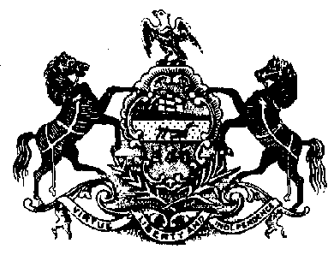

NOTICE

WORKER PROTECTION AND INVESTMENT

On October 21, 2021, Governor Tom Wolf signed Executive Order 2021-06, Worker Protection and Investment. The Executive Order affirms that the Commonwealth is responsible for ensuring that every worker in Pennsylvania has a safe and healthy work environment and the protections afforded them through labor laws. To that end and in accordance with the Executive Order, prior to being awarded a contract or grant, contractors and grantees of the Commonwealth must certify that they are in compliance with all applicable Pennsylvania state labor and workforce safety laws including:

- Construction Workplace Misclassification Act
- Employment of Minors Child Labor Act
- Minimum Wage Act
- Prevailing Wage Act
- Equal Pay Law
- Employer to Pay Employment Medical Examination Fee Act
- Seasonal Farm Labor Act
- Wage Payment and Collection Law
- Industrial Homework Law
- Construction Industry Employee Verification Act
- Act 102: Prohibition on Excessive Overtime in healthcare
- Apprenticeship and Training Act
- Inspection of Employment Records Law

Contractors and grantees must also certify compliance with Unemployment Compensation tax requirements and Workers’ Compensation insurance requirements.

To ensure compliance with these statutes, Contractors and Grantees will be required to submit the Worker Protection and Investment Certification Form BOP-2201 in response to all procurement solicitations (invitations for bids, requests for proposals, requests for quotes, emergency procurements and sole source procurements) and grant applications and or requests for applications for grants. Contracts and grants will not be executed with prospective contractors or grantees until such certification form is received.

In addition, the Pennsylvania Department of Labor and Industry has created a public list of businesses that have been found to be non-compliant with Pennsylvania state labor and workforce safety law which will be published on its public-facing website. Agencies are required to ensure that prospective contractors or grantees are not on the list prior to awarding any contract or grant. Contractors and grantees who appear on the list can be removed by remedying their statutory noncompliance. Contact information for addressing compliance status is available on the list website.

These requirements of the Executive Order are currently in effect. Questions should be directed to the contracting or granting agency.

