I am writing in support of the Sunoco Logistics Mariner East 2 project.

I have 20 years of experience in operational efficiency and risk management in the energy, oil & gas and water resources sectors, including eight years with a Fortune 200 energy company where I was responsible for the sustainable operation of assets. As a member of the company’s Risk Committee, I was part of a team responsible for assessing the risk and viability of proposed acquisitions and development. I have worked on behalf of the Riverkeeper organization to protect the water supply watershed for a major metropolitan city, and with international oil & gas exploration and production companies to develop and implement programs to protect the environment. My BS is in Physics and my MS is in hydrogeology.

I was born in Chester County, and proudly call this county my home.

I support the Sunoco Logistics Mariner East 2 project for the following reasons:

- Sunoco Logistics works to protect sensitive areas through the use of best management practices such as:

  - Minimizing construction areas within wetlands and waterways;
  - Using Horizontal Directional Drilling (HDD) in environmentally sensitive areas such as forested wetlands and/or habitats containing threatened and endangered species; and
  - Not clearing forested wetlands above drills to reduce habitat fragmentation effects.

- Sunoco Logistics has committed to preserving natural waterways and wetlands, along with water recreation areas, and will not withdrawal or discharge any water during construction of Mariner East 2, specifically:

  - River Basin water will not be used for testing. Water for testing will be purchased from local water authorities and where applicable, will be recycled to minimize water usage and wastewater discharge; and
  - When ready for discharge, Sunoco Logistics will work with local wastewater treatment plant to dispose of the water.

- With regards to safety, I understand the concerns about transporting a volatile liquid through our backyards. While there are safety risks, a 2015 Fraser Institute report found that transporting natural gas by pipeline and rail is “in general quite safe”, and that pipeline transportation is safer than transportation by rail.

What does “quite safe” mean?

The US Department of Transportation Pipeline and Hazardous Materials Safety Administration (PHMSA) provides data on injuries and fatalities related to natural gas and hazardous liquid transmission lines. For natural gas transmission lines, the nationwide average for fatalities is two per year. The average for injuries is nine per year. For hazardous liquid transmission lines (the type of line Mariner East 2 is), the nationwide twenty year average for fatalities is one fatality per year. The twenty year average for injuries is two per year.

There has not been a fatality in Pennsylvania due to natural gas or hazardous liquid transmission lines since PHMSA started their database in 1996.

Any injury, any fatality is too many, and so I applaud PHMSA and others in their efforts to increase safety measures, especially around inspection of older pipelines. The answer lies in better safety measures, not in preventing the construction of this pipeline.

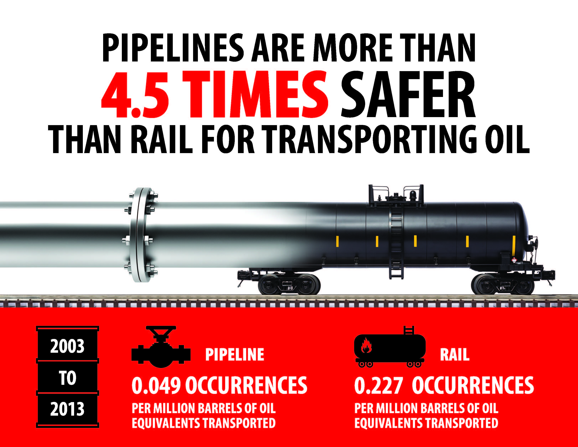

- This pipeline will be transporting natural gas liquids, specifically propane, ethane and butane. Each plays an important role in everyday lives. We use propane for home heating, cooking and as a feedstock for manufacturing. Ethane is a major building block for the chemical industry and manufacturing. By building block, I mean that these carbon based compounds are used to make things we all use such as water bottles, aspirin, football helmets, medical equipment, laptops. And lastly, butane is blended into gasoline in the northeast during the fall and winter.

- This project leverages the abundant, local resources of the Marcellus Shale formation to create technical, well-paying jobs, and grow our regional economy. The Mariner East projects combined will support more than 30,000 jobs during construction, with a total economic benefit to the state of $4.2 billion. Once operational, these projects directly support 300 – 400 permanent jobs. Annually, the economic benefit to the Commonwealth as a whole is estimated at $100 million to $150 million.
I strongly encourage the Department of Environmental Protection to approve these permits and I thank you for the opportunity to comment.

