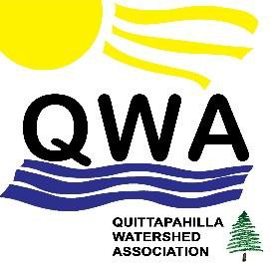

Quittap ahill a Waters hed As soci ati on

8 E a s t H i g h S t r e e t , A n n v i l l e P A 1 7 0 0 3

May 31, 2016

Mr. Scott Williamson

Waterways & Wetlands Program DEP South-Central Region

909 Elmerton Ave.

Harrisburg, PA 17110 Email: [scwilliams@pa.gov](mailto:scwilliams@pa.gov)

*Sent in PDF file via email*

Dear Mr. Williamson:

We write on behalf of the Quittapahilla Watershed Association (QWA), a nonprofit community

organization dedicated to cleaner water flowing from the Quittapahilla watershed to the Chesapeake Bay, to request that the PA-DEP schedule a public hearing on Williams / Transcontinental Gas Pipeline Company’s (Williams/Transco) application for water obstruction and encroachment permits for its proposed Atlantic Sunrise Pipeline (FERC Docket No. CP15- 138-00).

As you know, Williams/Transco’s proposed Atlantic Sunrise pipeline would create a new

“greenfield” right-of-way extending some 184 miles north-south across Pennsylvania, including approximately 15 miles across the Quittapahilla watershed. This new pipeline corridor is projected to cross through hundreds streams and wetlands in Pennsylvania. We in the QWA are very concerned about the potential negative environmental impacts to the Quittapahilla watershed of this proposed high-pressure, 42-inch diameter underground natural gas pipeline.

More specifically, our concerns for this project and reason we are requesting a public hearing

include the following:

•

Review of stream crossing plans shows that Williams/Transco does not intend to use

horizontal directional drilling techniques beneath any of the streams and wetlands it intends to traverse. Instead it proposes to use open-trench methods, which as you know are substantially more environmentally damaging to streams and wetlands. Stream crossings in South-Central PA include not only the Quittapahilla Creek but the Swatara and Conewago creeks. All these waterways have been the subject of substantial and sustained restoration efforts by local watershed associations – including our own – over the past 15 to 20 years. Over the past two years, the QWA, in partnership with the Lebanon Valley Conservancy, has received nearly $1 million in Growing Greener grants from the PA-DEP for stream restoration work. Our concern is that the positive water- quality benefits from these restoration efforts will be undermined and degraded by

Williams/Transco’s stream and wetland crossing plans.

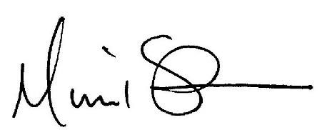

•

Current plans for the building of the Atlantic Sunrise pipeline using open-trench methods

have a high likelihood of contributing substantially to increased erosion and sediment runoff in the Quittapahilla and other watersheds. Williams/Transco’s plans to create a permanent, tree-free corridor to house the proposed pipeline include the riparian buffers

along our waterways, including Quittapahilla Creek, that currently minimize erosion and sediment runoff into the Chesapeake Bay.

•

The scale and scope of this proposed pipeline project require PA-DEP to consider not

only this project’s local impacts in discrete stream and wetland crossings, but its overall, cumulative impact along its entire 184-mile route. Larger, multi-state efforts to improve the quality of the water flowing into the Chesapeake Bay by minimizing erosion and runoff and preserving existing riparian buffers are directly threatened by this proposed pipeline project.

The foregoing represent only some of our deep and abiding concerns about this project. We are

confident that many other organizations and individuals in South-Central PA harbor similar concerns. For these reasons we urge your office to schedule a public hearing on these questions, so that the public can voice its concerns and have its questions addressed by PA-DEP and Williams/Transco.

Thank you for receiving this urgent request.

Respectfully,

Michael Schroeder

Co-President

Quittapahilla Watershed Association 8 East High Street

Annville PA 17003

[www.QuittapahillaWatershedAssociation.org](http://www.quittapahillawatershedassociation.org/)

David Lasky

Co-President

Quittapahilla Watershed Association 610 East Walnut St.

Annville PA 17003