Office of Oil and Gas Management

EFA Granting User Access in ePermitting

Version 1.0
December 16, 2021

Table of Contents
Contacting the Office of Oil and Gas Management 3
Purpose 3
Log in to Greenport 3
My Applications - Select DEP Application 4
ePermitting Home Page 4
Granting User Access 5
Screen Control Processing Buttons 5
Step 1: Review Program Area and Submitter Type Selected 6
Step 2: Review Submitter Type 6
Step 3: View Signed Security Agreement 6
Step 4: Grant or Reject Access 7
Step 5: Setup Access Permissions 7
Change History 10

Contacting the Office of Oil and Gas Management
If you have any questions or issues regarding granting User Access in the ePermitting Application, please contact the Office of Oil and Gas Management.
Number: (717) 772-2199
Hours: Monday to Friday 8:00am to 4:00pm
Email: RA-ep-BOGMOGRE@pa.gov

Purpose
This guide provides information on how to successfully grant User access and roles in the ePermitting application. This guide is intended for Electronic Filing Administrators (EFAs) on the DEP GreenPort website and use the functions available through the ePermitting Application.

Log in to Greenport
To access the ePermitting application you must have a registered Keystone GreenPort account. To register for a new GreenPort Account go to https://greenport.uat.pa.gov/gpl and click on the Register button and enter the required information as prompted.

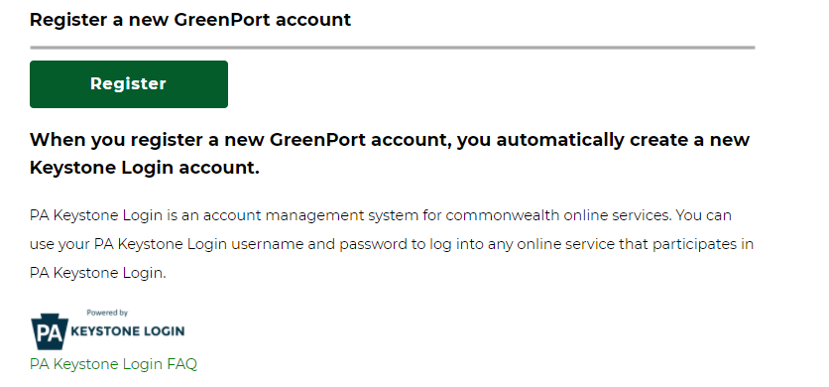

When you have registered your GreenPort account or already have a GreenPort account, enter your Username and Password and click Login.
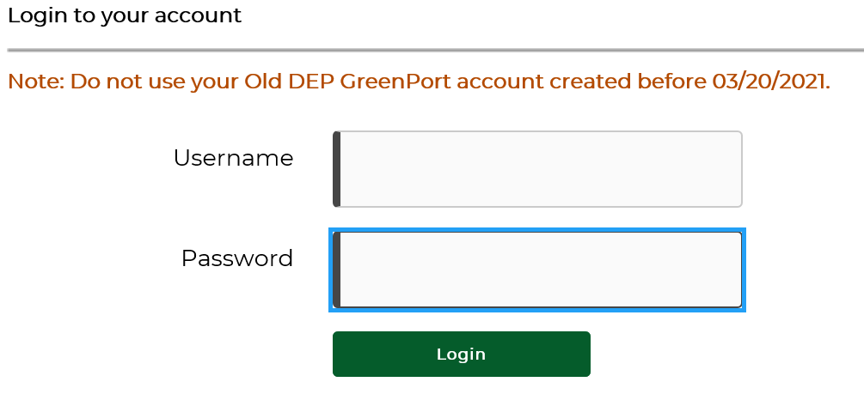

My Applications - Select DEP Application
Click on ePermitting in the Permitting section of the My Applications Home Page
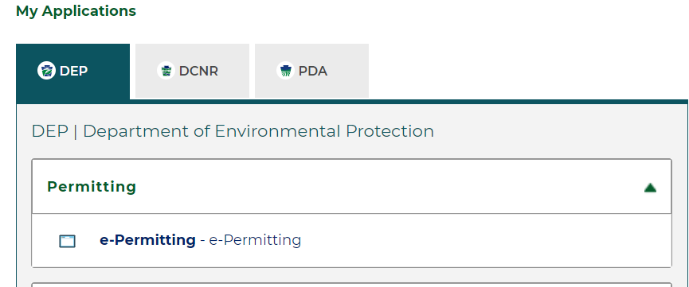

ePermitting Home Page
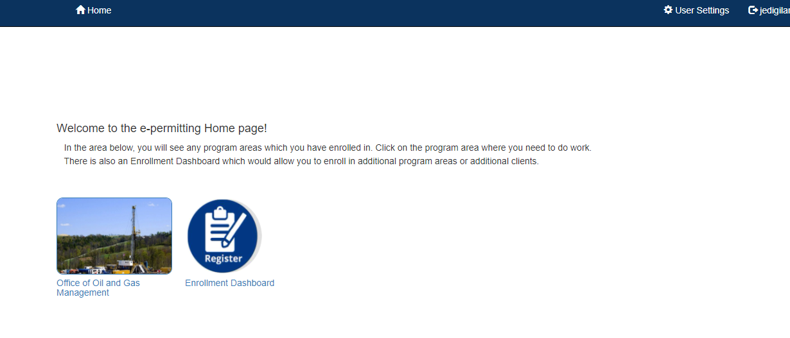
To view pending enrollment requests submitted by Users, click on Enrollment Dashboard icon on the ePermitting Home Page.

Granting User Access
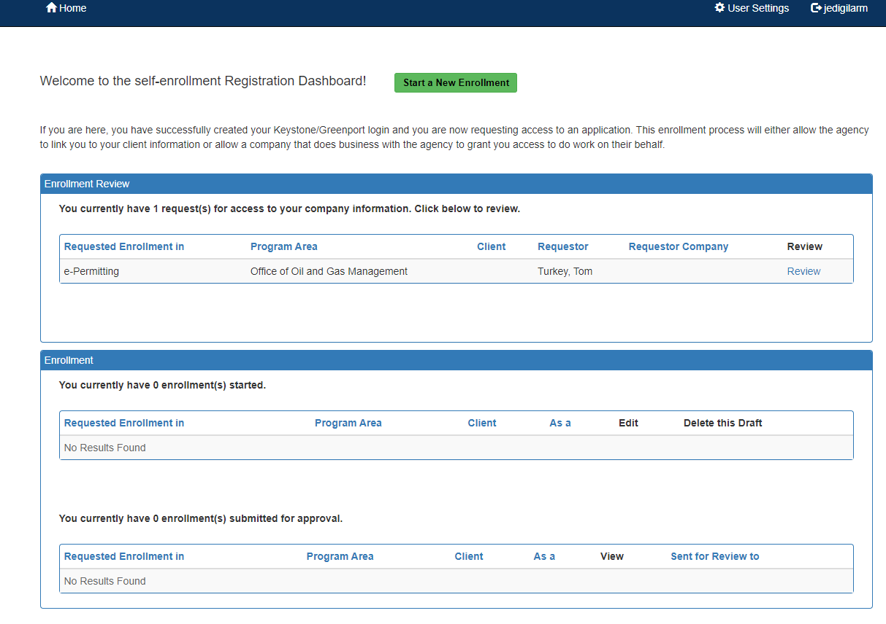
The EFA can view all Users requesting access in the Enrollment Review block. To grant user’s requesting access, click on Review.

Screen Control Processing Buttons
The granting or rejection of a User Request is completed through a 5-Step Wizard process that has Screen Control buttons that will allow the user to navigate through the multiple screens. Data entered in each step will automatically be saved and can be returned to at any time.
will continue enrollment, all previously entered data will be saved.
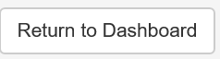 Will return user to Start new enrollment screen.
will return user to previous screen, all previously entered data will be saved.

The following outlines the 5 Step Wizard process necessary to process a user’s enrollment request. EFA’s should review all information submitted by the User before granting access.

Step 1: Review Program Area and Submitter Type Selected
Review the Program Area the Requestor has selected to ensure it is correct. For ePermit applications for oil and gas activities, the program area should be Office of Oil and Gas Management.
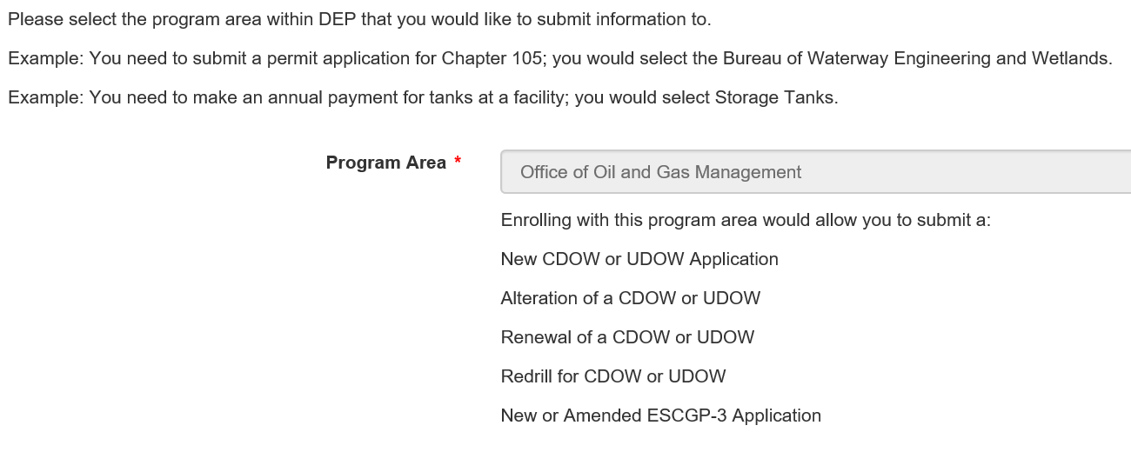

Step 2: Review Submitter Type
Review the submitter type information to ensure you are giving access to the appropriate individual.
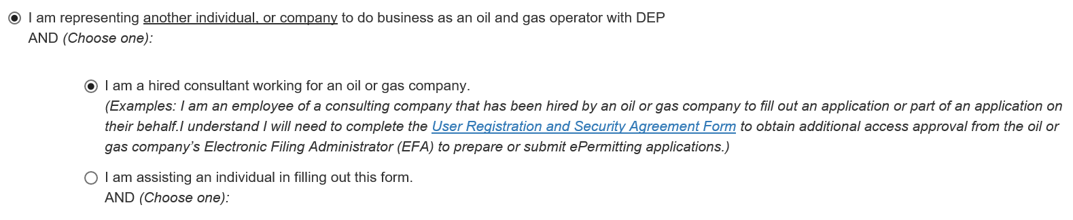

Step 3: View Signed Security Agreement
The Security Agreement can be viewed by clicking the hyperlink in this section. A new window will open displaying the information the User entered during their User Request Enrollment. The EFA should review to ensure the correct Program Area, Submitter Type, Company Access ID, User Information, and Security Agreement has been acknowledged signed and dated.

After reviewing the signed Security Agreement, simply close the window to go back to the approval screen and click the Continue button.
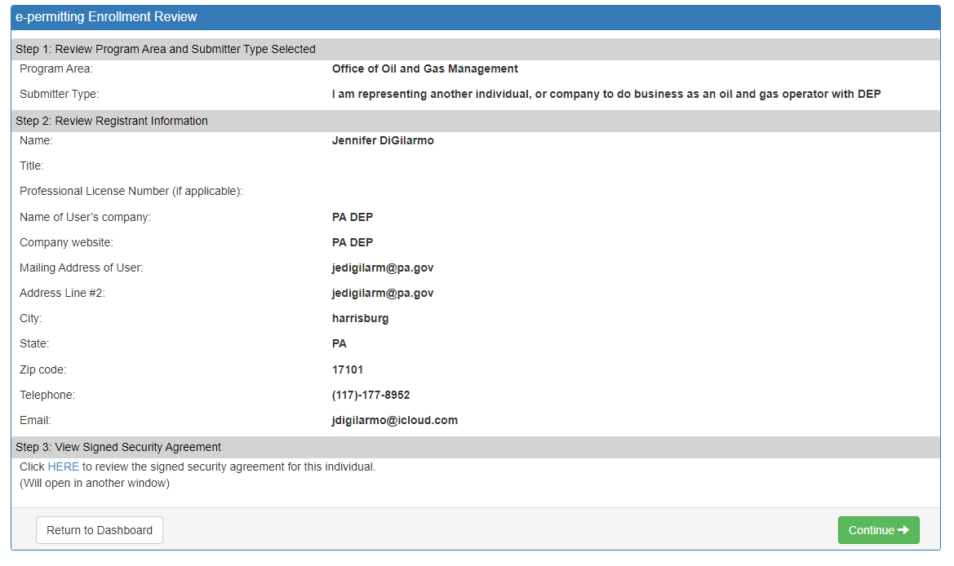
Security Agreement can be viewed by clicking this hyperlink.

Step 4: Grant or Reject Access
The EFA has the option to grant or reject the User’s the Security Access. Once the appropriate selection is made click the Continue button.
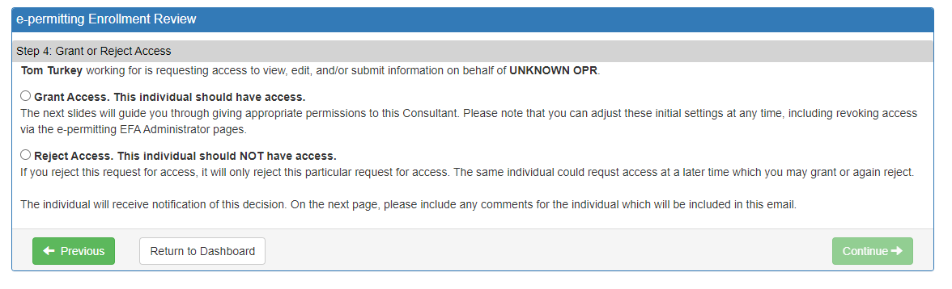

Step 5: Setup Access Permissions
If Granting Access, the EFA will need to select the Permission Type needed and click Grant Access Request button. The Permission Types are explained below.
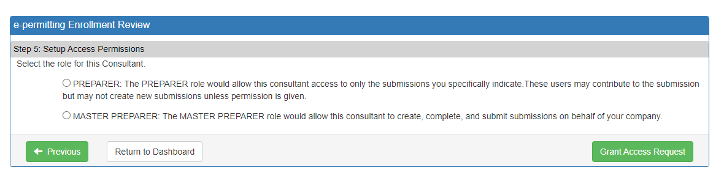
Preparer Role
The Preparer selection will allow the User access to work on and review new or draft applications. The Preparer Role does not allow the user to submit applications as final or make payment to DEP. The EFA will need to select what application types the User can have access to. Also, the EFA can check the Create New block to Allow the User to create new applications.
The EFA can also give access to other draft applications by checking the Grant Access box in the list of current draft applications in the lower section of the screen as show in the picture below.
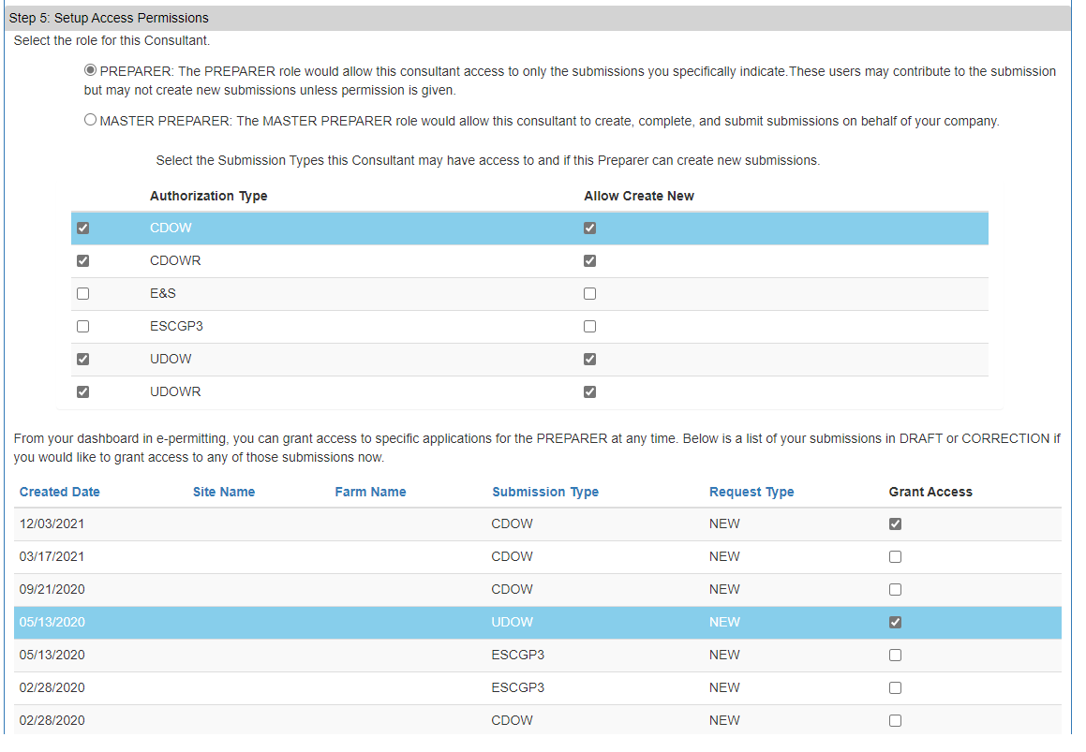

Master Preparer Role
The Master Preparer Role will allow the User to create, complete, submit and make payment to DEP on behalf of your company.
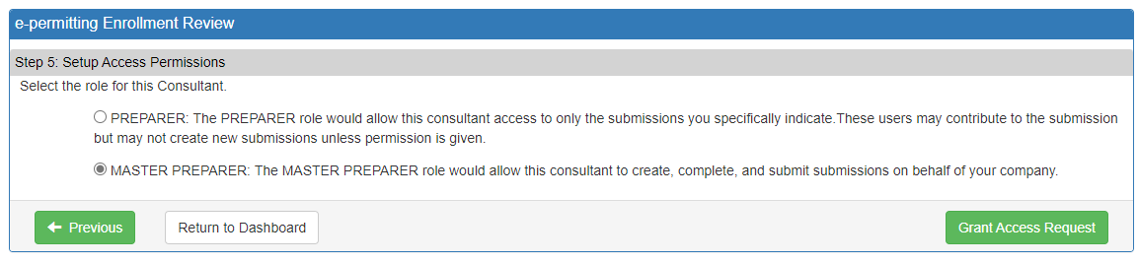

Once you have chosen the Access Permissions necessary for the User, select the Grant Access Request button. The page will re-direct back to the Enrollment Dashboard where the EFA can grant additional Users who requested access if applicable. The User that was just granted access should no longer appear in the Enrollment Review window.
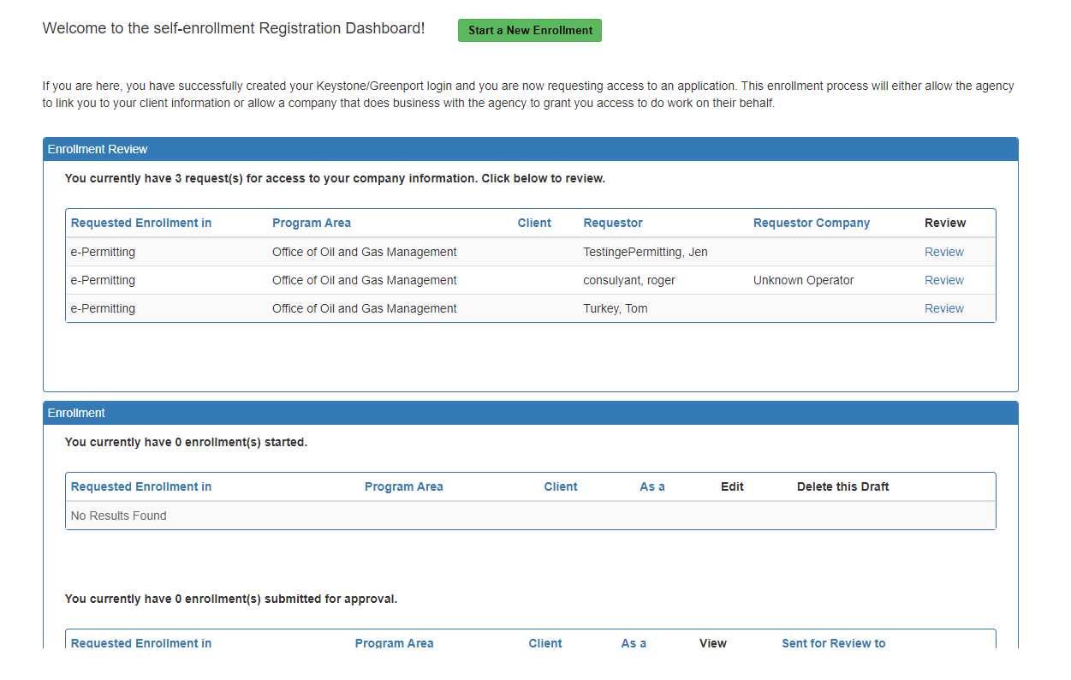

To return to the ePermitting dashboard select the button at the top of the screen.

Change History

Version | Date | Revision Description
1.0 | December 3, 2021 | Creation of EFA Granting User Enrollment Guide

