SURFACE MINING CONSERVATION AND RECLAMATION ACT
2016
RECLAMATION AND REMINING INCENTIVES REPORT
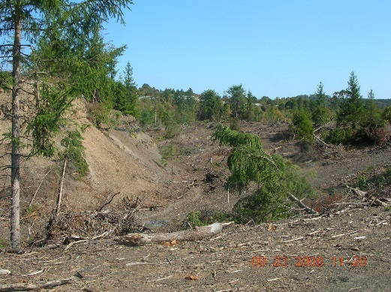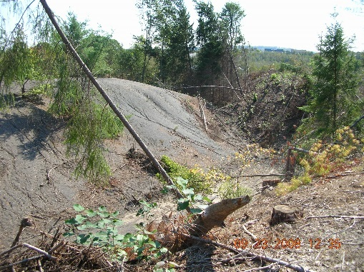

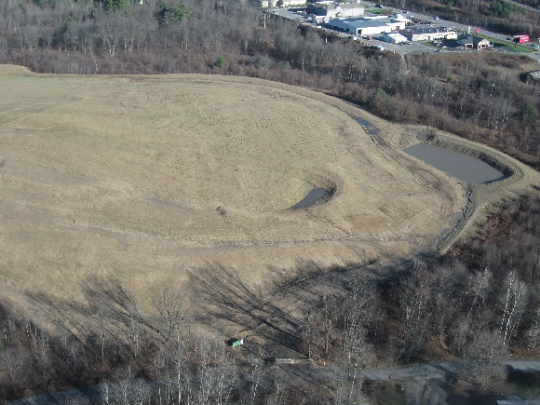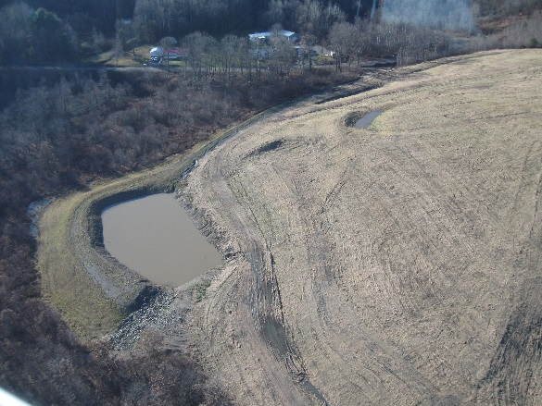

Prepared for:
Senate Environmental Resources and Energy Committee
and
House Environmental Resources and Energy Committee

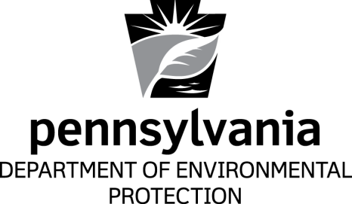

Prepared by:
Pennsylvania Department of Environmental Protection
Office of Active and Abandoned Mine Operations

5600-RE-DEP4249 7/2017

TABLE OF CONTENTS

I. Executive Summary 1

II. Conclusions and Recommendations 4

III. Background 4

IV. Individual Program Descriptions 5

A. SMCRA Section 4.8 – Government-Financed Reclamation and Construction
Contracts 5

B. SMCRA Section 4.9 – Designating Areas Suitable for Reclamation by Remining 5

C. SMCRA Section 4.10 – Remining Operator’s Assistance Program (ROAP) 5

D. SMCRA Section 4.12 – Remining Financial Guarantees to Ensure Reclamation 6

E. SMCRA Section 4.13 – Reclamation Bond Credits Program 7

V. Remining Environmental Enhancement Fund (REEF) 8

VI. Remining Financial Assurance Fund (RFAF) 8

Appendices

A) Mining and Reclamation Advisory Board Comments
B) Government-Financed Reclamation and Construction Contracts Project List
C) Remining Operator’s Assistance Program Project List
D) Remining Financial Guarantees to Ensure Reclamation Project List
E) Reclamation Bond Credit Project List

Cover Photo: Before and after images of RES Coal LLC.’s Mine #34 GFCC, Contract # 17-10-02 that was completed in 2015-16. It is located in Lawrence Township, Clearfield County.
I. Executive Summary
In accordance with the requirements of Section 4.11(b) of the commonwealth’s Surface Mining Conservation and Reclamation Act (SMCRA) regarding the Department of Environmental Protection’s (DEP) reclamation and remining programs, this report is submitted to the Senate Environmental Resources and Energy Committee and to the House Environmental Resources and Energy Committee. This report provides the status of the DEP’s reclamation and remining programs authorized under the SMCRA Sections 4.8, 4.9, 4.10, 4.12, 4.13, and 18. Information is current to Dec. 31, 2016.

Since its inception, Pennsylvania’s reclamation and remining incentives programs have been very successful. Coal mine operators using these programs have reclaimed almost 7,000 abandoned mine land (AML) acres equivalent to an estimated $47.4 million in reclamation value. Current reclamation costs for grading and revegetation of abandoned mine sites average about $9,500 per acre.

The Government-Financed Reclamation Construction Contracts (GFCC) program benefits the public and the mining operators by establishing contracts for mining companies to conduct operations that will reclaim AML sites at little or no cost to the public. Between Jan. 1991 and Dec. 31, 2016, there were 279 contracts issued, with an estimated total reclamation value of approximately $21 million.

The Remining Operator Assistance Program (ROAP) created an incentive to remine and reclaim AML areas by providing financial assistance for most of the cost of permitting the remining area. Between Aug. 1996 and Dec. 31, 2016, there were 30 mine operators participating in this program on 60 remining sites. The total cost to the commonwealth of these 60 remining ROAP projects was $913,284. Through Dec. 31, 2016, there were 45 projects with approved remining permits at a cost to the commonwealth of $800,971. Of these 45 ROAP permits, two became bond forfeitures and two projects had their ROAP funds reimbursed to DEP by the mine operator because of reimbursement liability regulations. The remaining 41 permits will eventually reclaim 1,923.4 acres of AML with an approximate reclamation value of $18.3 million (the $18.3 million figure includes estimated costs, which are $9,500.00/acre). The ROAP figures provided here reflect revised ROAP status for several cases.

Under the Financial Guarantees program, DEP provides low cost bonding of remining areas. As of Dec. 31, 2016, 149 coal mine operators used financial guarantees to bond 740 mining permit increments. When completed, those operations will have reclaimed 3,978.1 acres of AML, saving the commonwealth an estimated $37.8 million.

The Bond Credits program also provides an incentive for operators to reclaim an AML area by earning a “bond credit” under a Consent Order and Agreement with DEP. Five licensed mine operators have completed six bond credit projects. The six projects that have been completed under this program reclaimed 50.1 acres and represent a reclamation value of $553,239. A Consent Order and Agreement for a seventh project was signed on Aug. 21, 2013. The project plans to reclaim 50.6 acres and reconstruct over 3,600 feet of stream channel. Reclamation started in calendar year 2014 with a completion date of August 2015. DEP is currently considering an extension until 2018 to complete the reclamation as requested by the operator.

Because of implementation feasibility, DEP has not promulgated regulations nor established final criteria for the Designating Areas Suitable for Remining program, as explained on page 5 Individual Program Descriptions.
Summary of Reclamation and Remining Incentives Program
1996-2015
Program | Year | Number of Companies | Number of Projects | AML Acres Reclaimed as of 12/31/2016 | Reclamation Value of Projects Completed by 12/31/2016
Government-Financed Rec. Contracts | 91-15 | 111 | 273 | 2,984.7 | $28,354,650
ROAP | 97-15* | 30 | 41 | 335.4 | $3,186,300
Financial Guarantees | 96-15 | 146 | 737 | 3,865.9 | $36,726,050
Bond Credits | 96-15 | 6 | 7 | 50.1 | $475,950
Totals |  | 293 | 1,058 | 7,236.1 | $68,742,950
*This program was ceased after 2014, reclamation does continue on the remaining sites.

Summary of Reclamation and Remining Incentives Programs
2016
Program | Year | Number of Companies | Number of New Projects | AML Acres Reclaimed During 2016 | Reclamation Value of Projects Completed in 2016
Government-Financed Rec. Contracts | 2016 | 5 | 6 | 154.6 | $1,468,700
ROAP | 2016 | Program Ceased | Program Ceased | 5.7 | $54,150
Financial Guarantees | 2016 | 3 | 3 | 112.2 | $1,065,900
Bond Credits | 2016 | 0 | 0 | 0 | 0
Totals |  | 8 | 9 | 272.5 | $2,588,750

II. Conclusions and Recommendations
DEP has developed four of the five reclamation and remining incentive programs authorized by the 1992 amendment to SMCRA. They are: Government Financed Reclamation and Construction Contracts, Remining Operator’s Assistance Program, Remining Financial Guarantees to Ensure Reclamation, and Reclamation Bond Credits. The fifth program - Designating Areas Suitable for Remining has not been implemented. Mine operators utilizing these four programs have reclaimed almost 7200 acres of AML. This equates to an approximate reclamation value of $47.4 million (completed reclamation areas only). There are projects in progress with remining or reclamation yet to be completed.

III. Background
This report has been prepared in accordance with the requirements of Section 4.11(b) and (c) of SMCRA. Section 4.11(b) requires DEP to prepare a report regarding DEP’s reclamation and remining programs to the Senate and House Environmental Resources and Energy Committees. Section 4.11(b) was added to the SMCRA by passage of Act 173 on Dec. 18, 1992. This report summarizes the status of DEP’s reclamation and remining programs authorized under the SMCRA Sections 4.8, 4.9, 4.10, 4.12, 4.13, and 18.

There are five primary reclamation and remining programs authorized by these sections of the SMCRA:

- Section 4.8 – Government Financed Reclamation and Construction Contracts

- Section 4.9 – Designating Areas Suitable for Reclamation by Remining

- Section 4.10 – Remining Operator’s Assistance Program (ROAP)

- Section 4.12 – Remining Financial Guarantees to Ensure Reclamation

- Section 4.13 – Reclamation Bond Credits

Section 18 of the SMCRA includes the creation of the Remining Environmental Enhancement Fund and the Remining Financial Assurance Fund. The status of both of these funds is included in Sections V and VI, of this report, respectively.

In addition to the program descriptions contained in this report, appropriate tables for each program showing site/operator lists, project cost, reclamation dollar value and pertinent dates are included in the appendices to this report. Many of the remining incentive program descriptions refer to a “remined area.” A “remined area,” as defined in these descriptions, includes the AML area to be reclaimed and up to 300 feet of adjacent previously unmined area that is needed to complete the reclamation.

This report was submitted to the Mining and Reclamation Advisory Board (MRAB) as required by Section 4.11(c)(5) of SMCRA. The MRAB’s comments are included as Appendix A.

IV. Individual Program Descriptions
A. SMCRA Section 4.8 - Government-Financed Reclamation and Construction Contracts

The GFCC program involves contracted operations that will reclaim AML sites at little or no cost to the public. This program was previously known as the No-Cost Government-Financed Reclamation Contracts Program. Regulations were deemed unnecessary for implementation of this program.

This program allows removal of incidental coal or coal refuse during the reclamation of an AML site. Occasionally, coal removal is necessary in order to effectively and efficiently reclaim an AML site. The value of the coal or coal refuse that must be removed to reclaim the site offsets the cost of the reclamation project.

Under the GFCC program, the mining industry has made progress in reclaiming coal refuse and other AML sites at no additional direct cost to the commonwealth. Between Jan. 1991 and Dec. 31, 2016, there were 279 contracts issued reclaiming 2,993.7 acres for a total reclamation value of approximately $19.6 million. The projects contracted during 2016 are listed in Appendix B.

Government-Financed Reclamation & Construction Contracts Overview:
 | As of 12/31/15 | As of 12/31/16
Number of surface acres completed | 2,956.2 | 2,993.7
Number of underground acres completed | 237.5 | 255.5
Number of companies | 111 | 116
Number of projects | 273 | 279

B. SMCRA Section 4.9 - Designating Areas Suitable for Reclamation by Remining

DEP has not promulgated regulations nor established a program for designating areas suitable for remining. DEP concluded it was not practical or feasible to implement this program.

C. SMCRA Section 4.10 - Remining Operator’s Assistance Program (ROAP)

The regulations for the ROAP program were promulgated as 25 Pa. Code Sections 86.261-86.270 and became effective on Aug. 24, 1996. The ROAP program provided an incentive to an operator to remine and reclaim an AML area that the operator would not otherwise reclaim. This incentive was in the form of DEP financial assistance towards the cost of obtaining a permit for the remining area. The ROAP program paid qualified consultants to collect and analyze permit-specific hydrogeological data and prepare reports used in the mine permit application.

Between Aug. 1997 and April 2003, 30 operators applied to this program for 60 remining ROAP projects. As of Dec. 31, 2016, 41 ROAP projects became mining permits. When completed, these 41 operations will have provided 1,923.4 acres of surface AML reclamation and almost 1,000 acres of AML underground reclamation. The cost to DEP in ROAP assistance for these 41 permits was $800,971. DEP or the applicant cancelled 19 of
the 60 projects. DEP’s cost for these 19 projects totaled $145,763. Of the 41 ROAP applications that became mining permits, seven of these permits are actively mining, while seven are in various stages of reclamation and 27 have fully completed reclamation activities. No additional applications have been taken into the program since 2003 because funding for the program has ceased.

The complete ROAP program projects are listed in Appendix C.

Remining Operator’s Assistance Program (ROAP) Overview:

ROAP AML acres reclaimed between Jan. 1, 2016 and Dec. 31, 2016 are 5.7 AML surface acres. Total ROAP AML acres reclaimed as of Dec. 31, 2016 are 341.1 AML surface acres.

Total ROAP AML acres reclaimed upon completion of all ROAP Projects are estimated at 1,923.4 at a cost of $800,971, with an estimated total reclamation value over $18.3 million.

D. SMCRA Section 4.12 – Remining Financial Guarantees to Ensure Reclamation

The Remining Financial Guarantees to Ensure Reclamation Program regulations were promulgated as 25 Pa. Code Sections 86.281-86.284 and became effective on Aug. 24, 1996. Under this program, DEP provides low-cost bonds to guarantee reclamation of the remining area of a surface mine permit.

Each operator and each permit must meet the regulatory criteria to participate in this program. An operator is limited to a maximum financial guarantee value of 30 percent of the amount allocated in the Financial Guarantee Special Account within the Remining Financial Assurance Fund (RFAF). Each permit is limited to a maximum financial guarantee value of 10 percent of the amount allocated in the Financial Guarantee Special Account within the RFAF. During 2006, with the support of the MRAB, DEP increased the amount allocated from $800,000 to $1,000,000. This allowed DEP to raise the maximum amount of remining financial guarantees that an operator may use at any one time from $240,000 to $300,000 and the maximum permit limit from $80,000 to $100,000. During 2010 (again with the approval of the MRAB) DEP used part of the fees paid by operators to increase the amount of funding allocated to the Remining Financial Guarantee Program to $1,200,000. This allowed DEP to again raise the maximum amount of remining financial guarantees that an operator may use at any one time to a maximum permit limit of $120,000 and a maximum operator limit of $360,000. This amount may be adjusted periodically by DEP based on premium payments made by the operators as well as bond forfeitures.

Act 157 of Oct. 24, 2012 authorized the transfer of up to $500,000 to the RFAF for use in supporting remining financial guarantees issued by DEP. The additional $500,000 was transferred to the RFAF in March 2013. By allocating an additional $500,000 the maximum limits for the Remining Financial Guarantee Program increased to $510,000 per operator and $170,000 per permit.

An operator is not required to pay the per acre reclamation fee on any area bonded with financial guarantees. Bond release is the same as for any other bond; however, financial guarantees are the first bond released on a surface mining permit.

The operator pays an annual fee for financial guarantees of one percent per year. The fee is paid in advance and is not refundable. The one percent fee goes into the RFAF. This is the only source of income to the fund.

As of Dec. 31, 2016, a total of 149 coal mine operators had used financial guarantees 740 times. Those operators have reclaimed 3865.9 acres of AML. This has saved the commonwealth an estimated $36.7 million in reclamation costs. There are eleven permits that are at the $170,000 per permit limit and two operators are near or at their $510,000 per operator limit.

Appendix D lists the individual projects that were issued in 2016.

Remining Financial Guarantees to Ensure Reclamation Program Overview:

 | As of 12/31/15 | As of 12/31/16
Reclamation value of abandoned mine projects | $36,726,050 | $37,791,950
Number of acres of surface AML completed | 3,865.9 | 3,978.1
Number of operators participating | 146 | 149
Number of financial guarantees issued | 737 | 740

E. SMCRA Section 4.13 - Reclamation Bond Credits Program

The Bond Credits program regulations were promulgated as 25 Pa. Code, Sections 86.291-86.295, and took effect on Aug. 24, 1996.

The Bond Credits program provides an incentive to an operator to voluntarily reclaim an abandoned mine area that the industry would not ordinarily reclaim. An operator may earn a “bond credit” under a Consent Order and Agreement with DEP by reclaiming an AML area. The area does not have to be associated with a mining permit. The value of the bond credit is equal to the lesser of either DEP’s cost or the operator’s cost to reclaim the stipulated area. Once earned, the operator may use the bond credit instead of normal bonding on future mining permits. The reclamation values for the bond credit reclamation projects are based on DEP’s calculated costs for reclamation of the sites.

Each bond credit may be used twice by the operator in lieu of a normal bond on a mining permit. The bond credit may be transferred to another operator.

Five licensed mine operators have completed six bond credit projects. The earned “bond credits” are being used. Approximately $57,000 has been released from its second use and is available for use on new projects. The special account established to financially assure bonding obligations under this program was increased from $500,000 to $1,100,000 in
July 2014. This increase was supported by funds held in the Remining Financial Assurance Fund.

A Consent Order and Agreement for a seventh project for the amount of $562,305, was signed on Aug. 21, 2013. The project will reclaim 50.6 acres of AML and reconstruct 3,648 feet of stream channel. Reclamation started in calendar year 2014 with a completion date of August 2015. The operator requested an extension until 2018 to complete the reclamation. The extension is currently under review.

Reclamation Bond Credits Overview:
 | As of 12/31/15 | As of 12/31/16
Reclamation value for completed projects | $553,239 | $553,239
Number of acres reclaimed | 50.1 | 50.1
Number of projects completed | 6 | 6
Number of projects in process | 1 | 1

V. Remining Environmental Enhancement Fund (REEF)
This fund is now depleted. The money remaining in the Surface Mining Conservation Fund, the Coal Refuse Disposal Control Fund, and the Bituminous Mine Subsidence and Land Conservation Fund is obligated to complete reclamation of forfeited sites.

VI. Remining Financial Assurance Fund (RFAF)
The Pennsylvania Legislature also authorized the establishment of the RFAF in the 1992 amendments to SMCRA. This fund is used to provide the reserve for the Remining Financial Guarantees to Ensure Reclamation and Reclamation Bond Credit Programs. These amendments authorized DEP to transfer up to $5 million from the Land and Water Development Fund to the RFAF. In 1996 $1 million was transferred into the RFAF. A second $1 million was transferred into the RFAF in 1997. Act 157 of Oct. 24, 2012 authorized the transfer of up to $500,000 to the RFAF for use in supporting remining financial guarantees issued by the department.

The money in this fund is used as a reserve to guarantee the bonds written in the Reclamation Bond Credit and Financial Guarantee programs. The bond credit program is required to have funds in the RFAF at least equal to funds issued as bond credits. The Financial Guarantee program is authorized to use an actuarial formula (mine permit forfeiture rate + a safety factor) to leverage the amount of money in the reserve to write more financial guarantees than are actually allocated in the fund, based on the historical rate of bond forfeitures. Currently, $1.7 million is allocated for financial guarantees, allowing DEP to write $22.6 million in financial guarantees. As of Dec. 31, 2016, $9,522,813 was designated to financially assure reclamation obligations on mining permits with approved remining areas.

There have been 20 permits forfeited with a total of 26 financial guarantees since the program was established. Reclamation has been completed on 12 of the permits using other options without spending any money from the RFAF and one permit has a project pending. Seven permits still require the reclamation to be completed with a total of $589,621 obligated in financial guarantees to assure the reclamation of these permits.

The only other source of funding for the Financial Guarantee and Bond Credit Programs stems from the one percent annual fee that the permittees pay for the use of the financial guarantees. Since the Financial Guarantee program became available in Jan. 1997, participating coal mine operators have paid $2,261,515 in annual fees. The annual fees must be held in reserve until the fund for Financial Guarantees is considered actuarially sound. The fund is actuarially sound when there is a sufficient amount of money in reserve to cover any expected losses.

DEP has allocated $1.7 million to the Financial Guarantee Special Account to act as the reserve for the Financial Guarantee Program. DEP had allocated $500,000 to the Bond Credit Account to act as the reserve for the Bond Credit Program. In July 2014, DEP allocated an additional $600,000 within the RFAF to the Bond Credit Account bringing the total amount in the account to $1,100,000.
Appendix A
Mining and Reclamation Advisory Board Comments

A copy of the draft report was presented for review and comment to the MRAB during their April 6, 2017 meeting.

Appendix B
New Government-Financed Reclamation and Construction Contracts Project List for 2016

2016 GFCCs Issued

Year | County | Company | Contract | Contract Date | No. Acres Proposed | Bond
2016 | Westmoreland | DAVID L PATTERSON JR | 65-15-01 | 03/14/16 | 35.4 | $122,100
2016 | Westmoreland | COAL LOADERS INC | 65-11-04 | 06/01/16 | 20.4 | $253,750
2016 | Cambria | ROBINDALE ENERGY SVC INC | 11-14-01 | 08/08/16 | 12.8 | $91,680
2016 | Jefferson | P & N COAL CO INC | 33-13-17 | 09/20/16 | 20.3 | $348,800
2016 | Westmoreland | DAVID L PATTERSON JR | 65-15-04 | 11/15/16 | 60.2 | $195,850
2016 | Somerset | RIDGE ENERGY CO | 56-15-02 | 12/06/16 | 5.5 | $57,175

Appendix C
Remining Operator’s Assistance Program Project List for 2016
Total ROAP Inventory

ROAP # | SMP # | SMP ISSD | Operator | District | Status
1 | 17990101 | 2/7/2001 | Sky Haven Coal Co. | Moshannon | Reclamation Continues
2 | 17980101 | 2/9/2000 | Ed Hanslovan Coal Co. | Moshannon | Bond Forfeiture
3 | 32980109 | 7/28/1999 | Amerikohl Mining Co. | Cambria | Reclamation Completed
4 | 32980105 | 5/11/1999 | Amerikohl Mining Co. | Cambria | Reclamation Completed
5 |  |  | Hepburnia Coal Co. | Moshannon | Cancelled
6 | 32980108 | 1/27/1999 | Amerikohl Mining Co. | Cambria | Reclamation Completed
7 |  |  | Amerikohl Mining Co. | Cambria | Cancelled
8 | 17990107 | 7/5/2001 | River Hill Coal Company | Moshannon | Reclamation Continues
9 | 54980103 | 2/4/1999 | Gale Coal Co. | Pottsville | Active
10 | 54980201 | 12/4/1999 | A C Fuels Co. | Pottsville | Reclamation Completed
11 | 26980102 | 9/11/1998 | Patterson Coal Co. | New Stanton | Reclamation Completed
12 | 11980202 | 10/2/1998 | Smith Energy | Cambria | Reclamation Completed
13 | 56980110 | 5/3/1999 | Fritz Coal Co. | Cambria | Reclamation Completed
14 |  |  | Reichard Contracting | New Stanton | Cancelled
15 | 56990101 | 12/22/1999 | Hoffman Mining Inc. | Cambria | Reclamation Completed
16 | 03990103 | 12/3/1999 | Amerikohl Mining Co. | New Stanton | Reclamation Completed
17 | 32990103 | 3/8/2001 | T L H Coal Co. | Cambria | Reclamation Completed
18 | 63990102 | PBNM | Robinson Coal Co. | New Stanton | Cancelled
19 | 17980124 | 10/18/1999 | River Hill Coal Company | Moshannon | Reclamation Completed
20 | 03990102 | 11/13/2000 | Thomas J. Smith Inc. | New Stanton | Reclamation Completed

Total ROAP Inventory

ROAP # | SMP # | SMP ISSD | Operator | District | Status
21 | 32000108 | 12/23/2004 | River Hill Coal Company | Cambria | Reclamation Continues
22 | 26990101 | PBNM | PBS Coal Inc. | New Stanton | Cancelled
23 | 17000101 | 9/13/2001 | River Hill Coal Company | Moshannon | Reclamation Completed
24 | 33990101 | 7/19/1999 | Amerikohl Mining Co. | Knox | Reclamation Completed
25 | 17990102 | 9/13/2001 | River Hill Coal Company | Moshannon | Active
26 |  |  | Marquise Mining Corp. | New Stanton | Cancelled
27 | 17990103 | 8/4/2002 | River Hill Coal Company | Moshannon | Active
28 |  |  | Energy Resource Inc. | Moshannon | Cancelled
29 |  |  | Hepburnia Coal Co. | Cambria | Cancelled
30 | 11990102 | 7/16/2003 | AMFIRE Mining Co. | Cambria | Reclamation Completed
31 | 40990101 | 9/15/2000 | Hazleton Shaft Corp. | Pottsville | Active
32 | 03000101 | 10/10/2000 | Amerikohl Mining Co. | New Stanton | Reclamation Completed
33 |  |  | Larson Enterprises Inc. | Moshannon | Cancelled
34 | 65990106 | 5/11/2000 | Ralph Smith & Son | New Stanton | Bond Forfeiture
35 |  |  | Cooney Bros. Coal Co. | Cambria | Cancelled
36 | 17000105 | 2/15/2001 | Hilltop Coal Co. | Moshannon | Reclamation Completed
37 | 32010105 | 9/4/2003 | Amerikohl Mining Co. | Cambria | Reclamation Completed
38 | 56000103 | 11/6/2000 | Hoffman Mining Inc. | Cambria | Reclamation Completed
39 | 56000105 | 3/8/2001 | Hoffman Mining Inc. | Cambria | Reclamation Completed
40 | 33010101 | 8/21/2001 | Sky Haven Coal Co. | Knox | Reclamation Completed
41 | 17010110 | 8/15/2002 | River Hill Coal Company | Moshannon | Active
42 |  |  | Energy Resource Inc. | Knox | Cancelled
43 | 24010101 | 10/4/2001 | Energy Resource Inc. | Knox | Reclamation Continues
44 | 11000104 | 6/8/2001 | Hoffman Mining Inc. | Cambria | Reclamation Continues*

Total ROAP Inventory

ROAP # | SMP # | SMP ISSD | Operator | District | Status
45 | 33010103 | 7/10/2002 | Sky Haven Coal Co. | Knox | Reclamation Completed
46 | 17030102 | 12/13/2006 | River Hill Coal Company | Moshannon | Reimbursed
47 | 03010108 | PBNM | T D K Coal Sales | New Stanton | Cancelled
48 |  |  | T D K Coal Sales | Knox | Reimbursed
49 | 14040103 | 11/13/2007 | River Hill Coal Company | Moshannon | Reclamation Continues
50 | 02020102 | 2/20/2004 | Amerikohl Mining Co. | New Stanton | Reclamation Completed
51 | 14040101 | 8/30/2007 | River Hill Coal Company | Moshannon | Reimbursed
52 | 32000101 | 12/1/2000 | Amerikohl Mining Co. | Cambria | Reclamation Completed
53 |  |  | RSK Mines | Pottsville | Cancelled
54 | 56030103 | 8/4/2003 | Hoffman Mining Inc. | Cambria | Reclamation Completed
55 | 56030102 | 4/8/2004 | Mountaineer Mining Corp. | Cambria | Reclamation Completed
56 | 54030201 | 8/10/2003 | Devil's Hole, Inc. | Pottsville | Active
57 | 26040102 | 2/3/2006 | Amerikohl Mining Co. | New Stanton | Reclamation Completed
58 |  |  | Cooney Bros. Coal Co. | Cambria | Cancelled
59 | 54030103 | 4/21/2004 | Jett Contracting Inc. | Pottsville | Active
60 | 56040105 | 10/19/2005 | Berwind Coal Sales Co. | Cambria | Reclamation Completed

*: The status of the Hoffman Mining site remains “reclamation continues,” although the bond was forfeited.

Appendix D
New Remining Financial Guarantees to Ensure Reclamation Project List for 2016

Year | County | Company | Permit No. | FG Number | Issuance Date | Original Amount
2016 | Clearfield | RES COAL LLC | 17090102 | 4820225FG | 01/28/2016 | $70,000.00
2016 | Clearfield | RIVER HILL COAL CO INC | 17990103 | 4820224FG | 01/27/2016 | $77,246.00
2016 | Somerset | ELK RESOURCES INC | 56130102 | 5340201FG | 06/30/2016 | $170,000.00

Appendix E
Reclamation Bond Credit Project List
Years 1997 – 2016
County | Fiscal Year | Company Name | Original Issuance Date | Remine Acres Agreed to Reclaim | Value of Bond Credit | AML Acres Reclaimed | Value of Reclamation
Armstrong | 1998 | Amerikohl Mining, Inc. | 7/16/1998 | 7.3 | $41,747 | 7.3 | $43,800
Clarion | 1998 | MSM Coal Company Inc. | 10/22/1999 | 3.9 | $20,645 | 3.9 | $23,400
Clearfield | 1999 | Larson Enterprises, Inc. | 10/20/1999 | 19.4 | $43,150 | 19.4 | $82,500
Northumberland | 1999 | Blaschak Coal | 10/13/2000 | 2.6 | $28,832 | 3 | $28,832
Columbia | 2001 | Blaschak Coal | 10/4/2001 | 1.8 | $34,466 | 1.8 | $38,739
Clearfield | 2006 | Res Coal | 07/2006 | 14.7 | $335,968 | 14.7 | $335,968
Schuylkill | 2013 | BET Associates IV, LLC | 8/21/2013 | 50.6 | $562,305 | On going
 |  | Totals |  | 100.3 | $1,067,113 | 50.1 | $553,239

