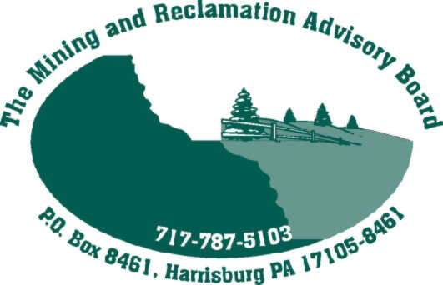 June 13, 2007

Members and Alternates of the Mining and Reclamation Advisory Board (MRAB)

The next quarterly meeting of the Mining and Reclamation Advisory Board (MRAB) is scheduled for Thursday, July 12, in the Delaware Room, 16th Floor, Rachel Carson State Office Building (RCSOB), Harrisburg, PA. The meeting will start promptly at 10:00 a.m.

The agenda and materials for this meeting are attached. Please bring them with you to the meeting on July 12. Refreshments will be provided.

Sincerely,

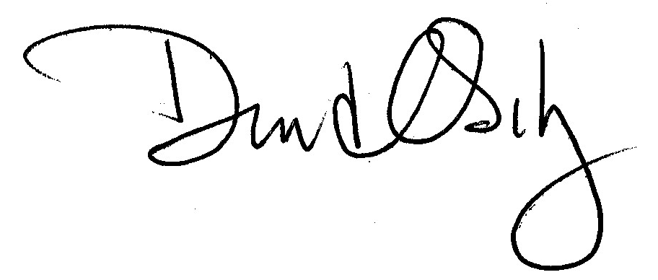
David Osikowicz

Chairman

Enclosures

