Alternative Fuels Incentive Grant (AFIG) Online Application Instructions

The AFIG Grant Application must be submitted through the Electronic Single Application (ESA) website. Paper and faxed copies will not be accepted. This change allows the Department of Environmental Protection (DEP) to expedite the review process. The link to the online application is: https://www.esa.dced.state.pa.us/Login.aspx

User Tips

- ESA works best when accessed through Microsoft Edge or Google Chrome.
- If you allow your screen to sit idle for 30 minutes or more, you will lose the data entered since last save. For best results, save frequently.
- When completing the application, fields with a “” are required fields. If a required field as skipped, you will be notified later in the application to return to that section to complete the field.
- Do not use special characters in the fields such as \, /, *, &, %, #, etc.
- You do not need to send the signature page and/or any further documentation to the Grants Center. All required information is contained in your online submission.
- If you have questions completing the application, please contact Enterprise eGrants Customer Service Center at 1-833-448-0647 or email at egrantshelp@pa.gov. Operating hours are Monday through Friday from 8:30 am to 6:00 pm EST.

- Registration and Login
- If you are a first-time user, click “Register” as shown below.

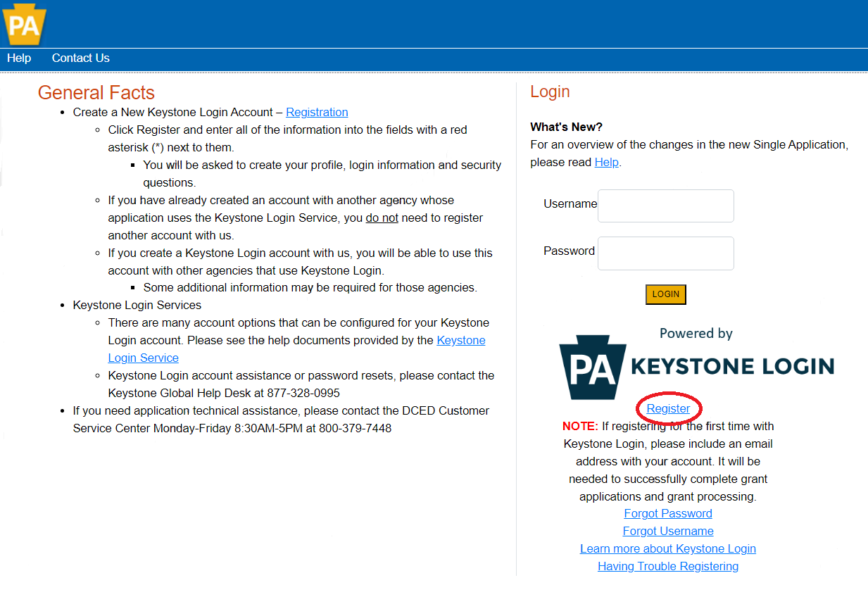
- Write down and save the username and password created during registration. This information will be used when applying for the grant.

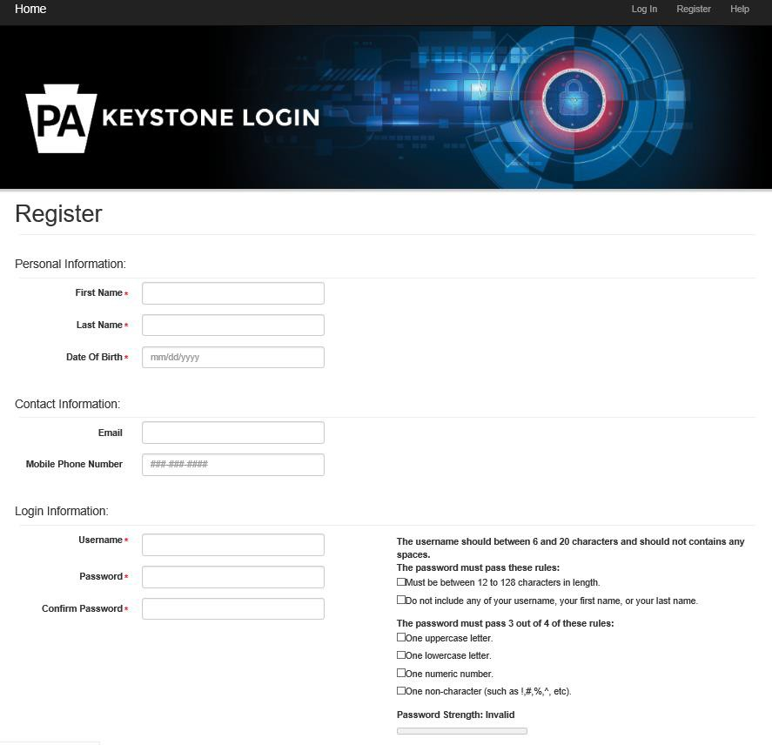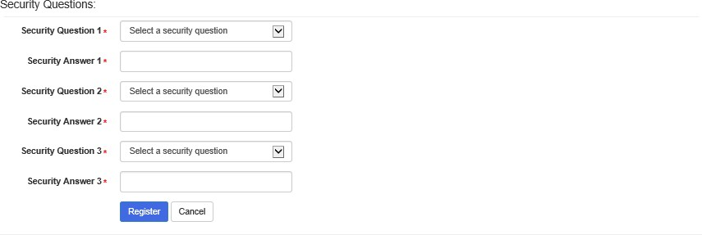

- Complete all required fields (denoted with a red diamond)
- Email address – Used to forward forgotten password when requested. An email address cannot be used twice.
- Username – Must be unique to all other user accounts within Keystone Login system.
- Password – Case sensitive and requires a minimum of 8 characters. Passwords must include each of the following: uppercase letter, lowercase letter, number, and symbol.
- Security Question/Answer – protects identity of account. Security answer is case sensitive. Information used to reset password. Used by Customer Service Center to verify user and reset password.

- Single Application Information “Are you Applying As?” – Allows the Applicant to set up Single Application Information and is used to display applicable programs. Choose appropriate entity type.

- Click the orange SUBMIT button – when you have completed all fields. You should be at the Login screen. Proceed to enter the username and password. Click Login button.

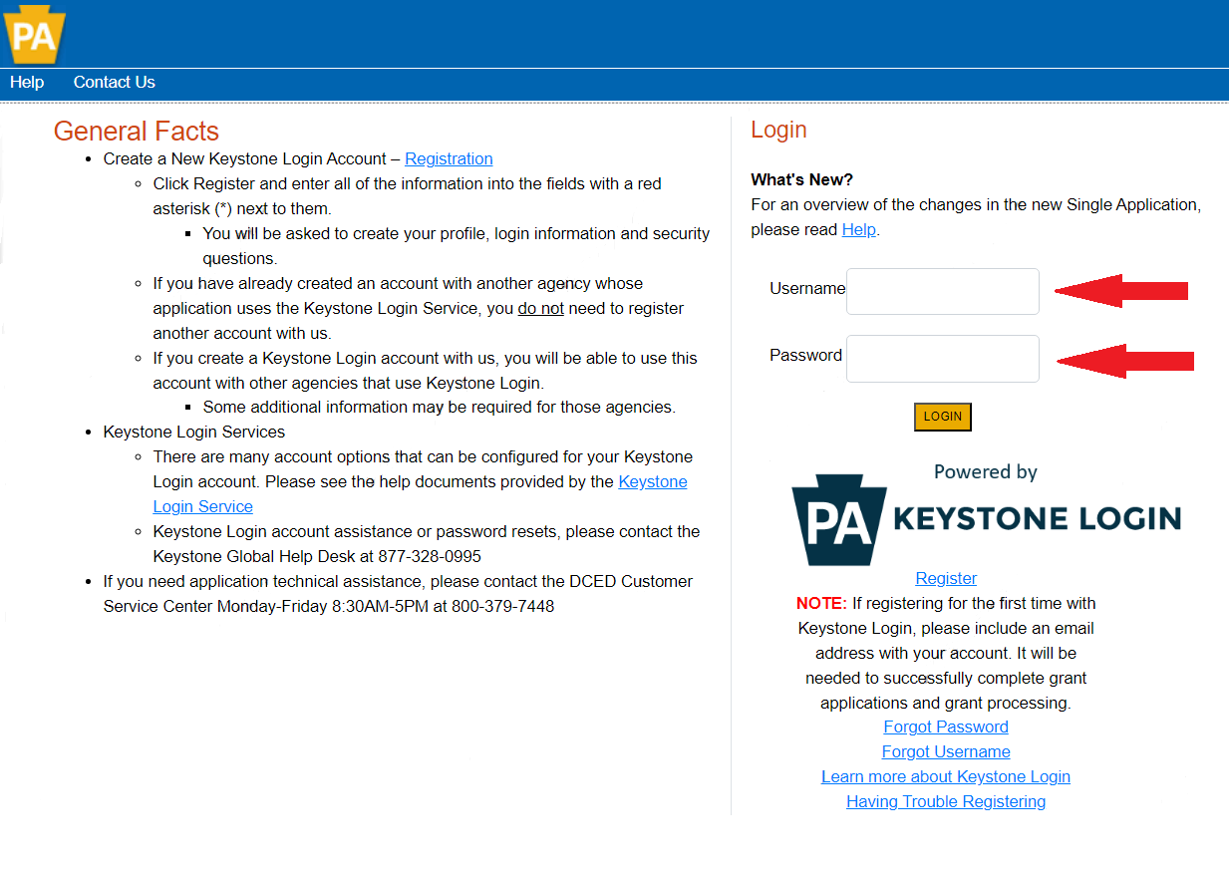

- Begin a New Application
- Project Name – Choose and enter a name for your project.
- Do you need help selecting your program? Select “Yes.”
- Click on “Create a New Application.”

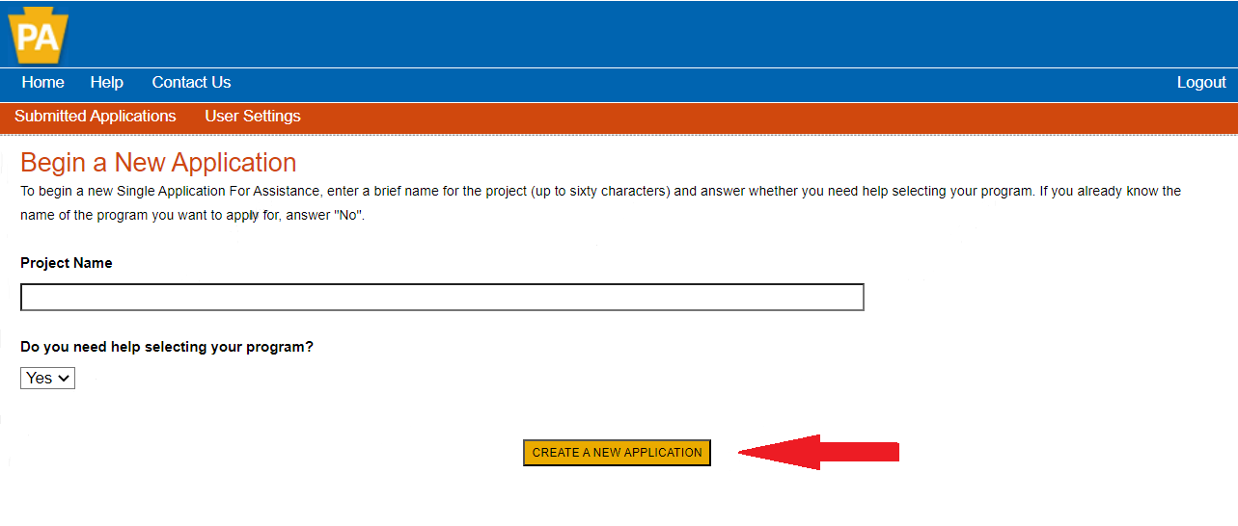

- Select Program
- Under “Agencies,” click on DEP.
- Scroll down and click “Search.”

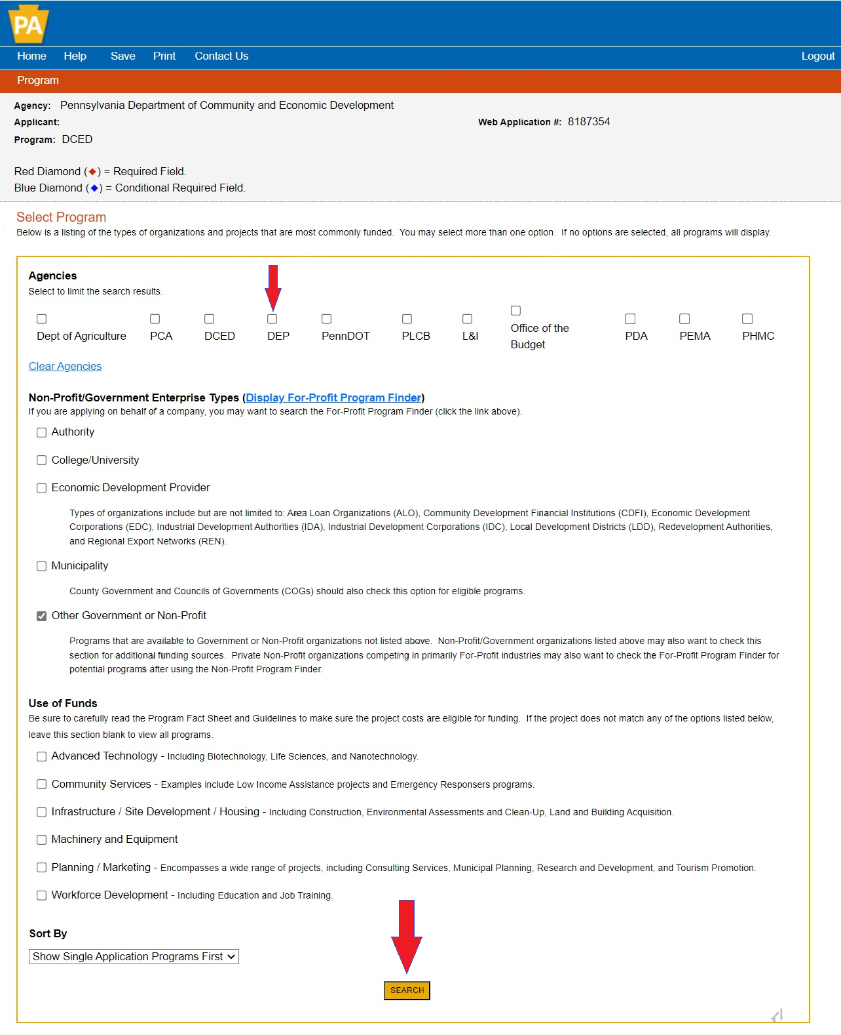
- Apply
- Scroll down through the various grant offerings, locate “AFIG” and click on the “apply” link for the specific project type that you would like to apply for.

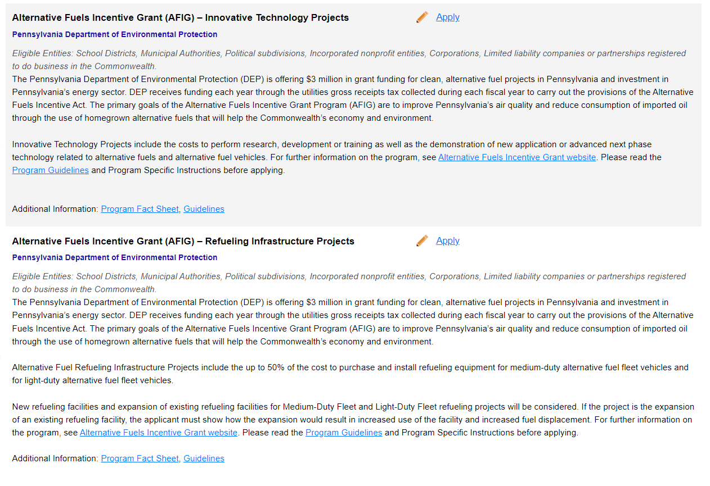
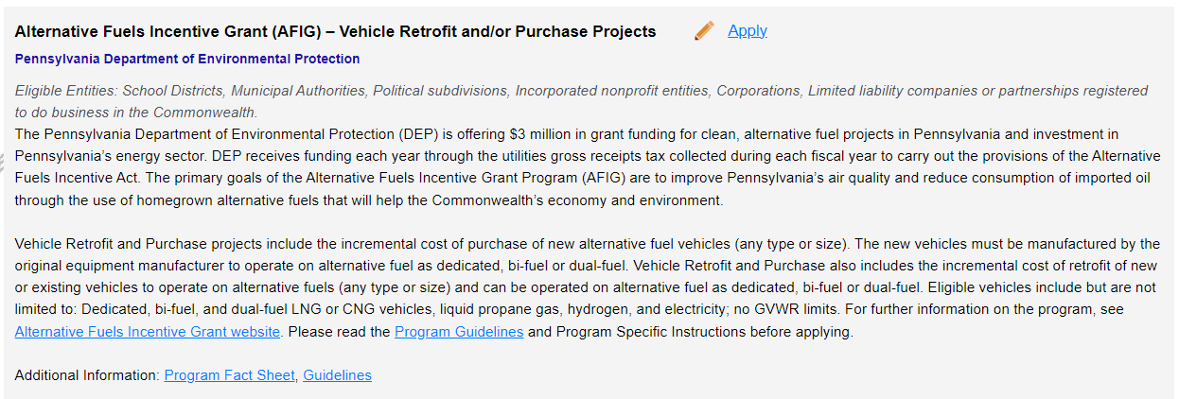

- Applicant Information
- The Applicant Information section requires data related to the County for which the application is being submitted.
- Applicant Entity Type – Select Appropriate Entity Type of your Organization.
- Applicant Name – Enter the legal entity name, the name under which the county legally conducts business
- NAICS Code – From the dropdown box, select Business, Professional Labor, Political, and Similar Organizations. The NAICS code will auto-populate for you.
- FEIN/SSN Number – Enter the Federal Tax ID number for the legal County name (no dashes).
- UEI Number – Unique Entity Identifier. Enter the apply organizations unique, 12-character alphanumeric identifier assigned to all entities that conduct business with the Federal Government.
- Top Official/Signing Authority – Enter the name of the individual at the organization who has authority to enter into a grant agreement with DEP (e.g. name of the President, Chairperson, CEO, etc.)
- Title – Enter the title of the Top Official/Signing Authority.
- SAP Vendor # - Fill in if known.
- Contact Name – Enter the primary contact name for this project.
- Contact Title – Enter the primary contact title for this project.
- Phone and Fax – Enter the phone and fax number for the primary contact for this project.
- Email – Enter the email for the primary contact title for this project.
- Mailing address, City, State and Zip Code – Enter this information for the primary contact for the project.
- Enterprise Type – Select appropriate type for the organization.
- Click on Continue at the bottom right

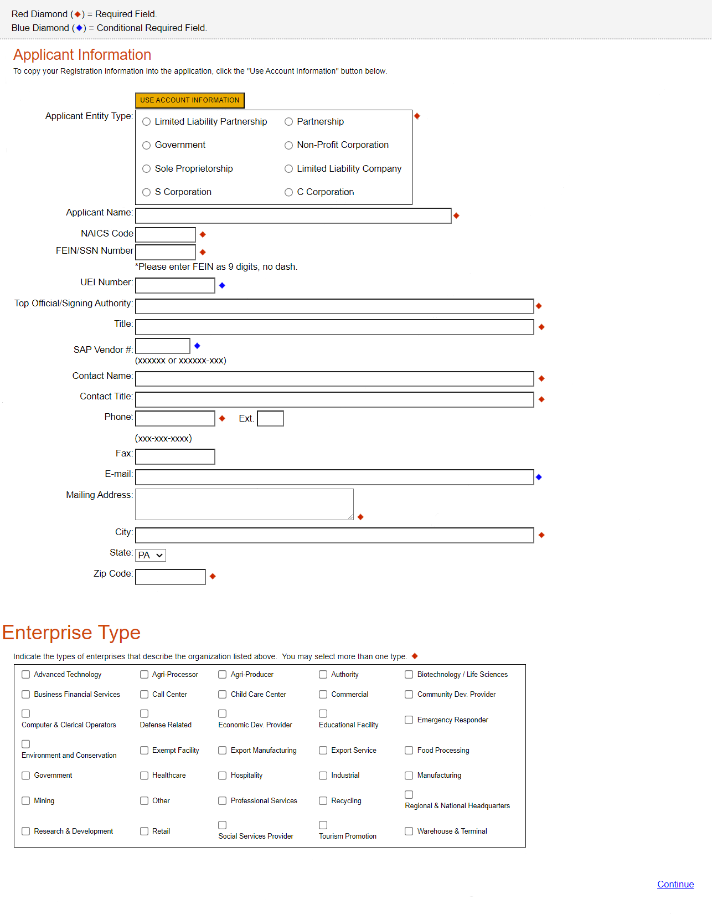
- Project Overview
- Project Name – The project name will auto-populate with information fill in at the beginning of the process. You may change the project name at this time.
- Is this project related to another previously submitted project? Select “Yes” if appropriate.
- Have you contacted anyone at DEP about your project? If so, please indicate “Yes” and the name of the person you spoke with.
- Site Locations – Enter as many sites that are applicable for your project.
- The rest of the information in the Project Overview section is not required and does not need to be filled out.
- Click “Continue”

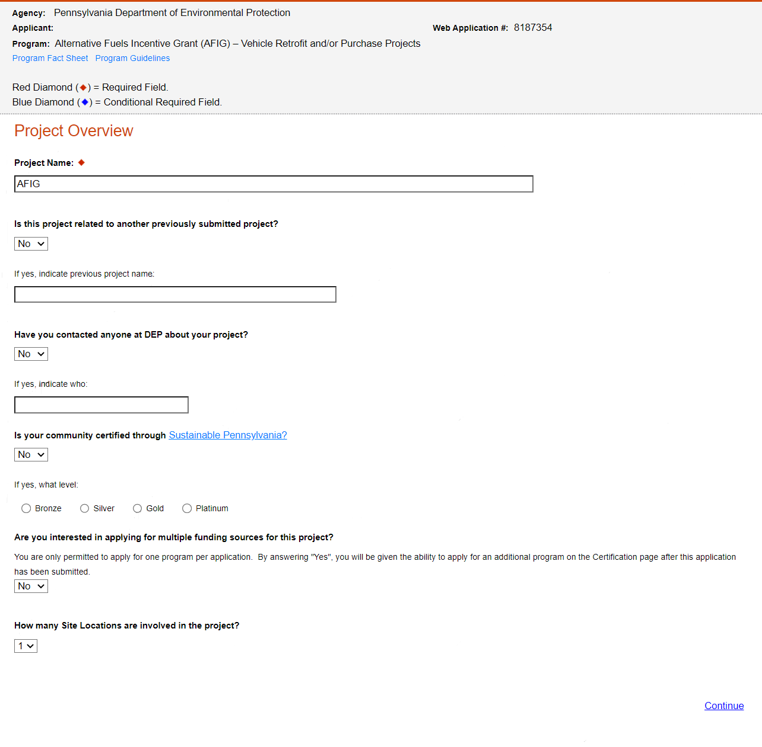
- Project Site
- Address – Enter the project location site. P.O. Boxes are not acceptable.
- City, State and Zip Code – Enter this information. If you indicated more than one site on the prior tab, you will be required to complete this information for all sites.
- County – Select county from the dropdown box.
- Municipality – Select municipality from the dropdown box.
- PA House & PA Senate – These fields will auto-populate based on county and municipality. If a Legislator does not auto-populate, please visit http://www.legis.state.pa.us/cfdocs/legis/home/findyourlegislator/
- Designated Areas – Leave blank.
- Click “Continue.”

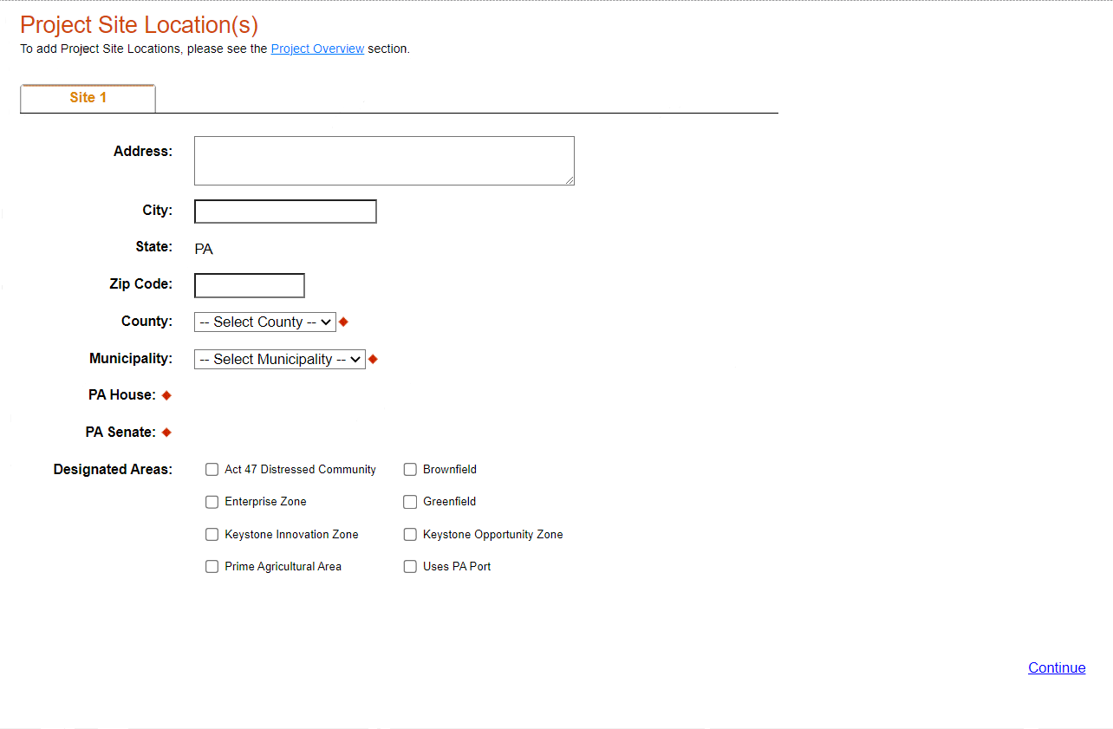

- Project Narrative
- Complete the project narrative section.
- Click Continue

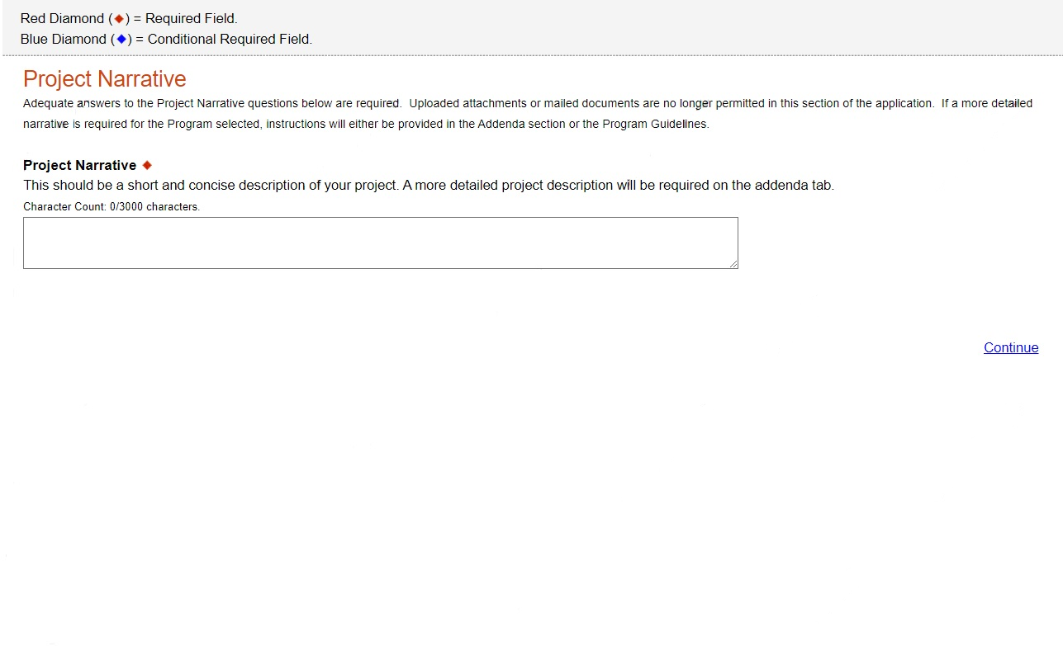

- Program Budget
- Spreadsheet Tab
- Click on the Spreadsheet tab.
- In the first column, enter the amount of funding you are requesting from DEP in the appropriate categories.
- Click on “Continue.”

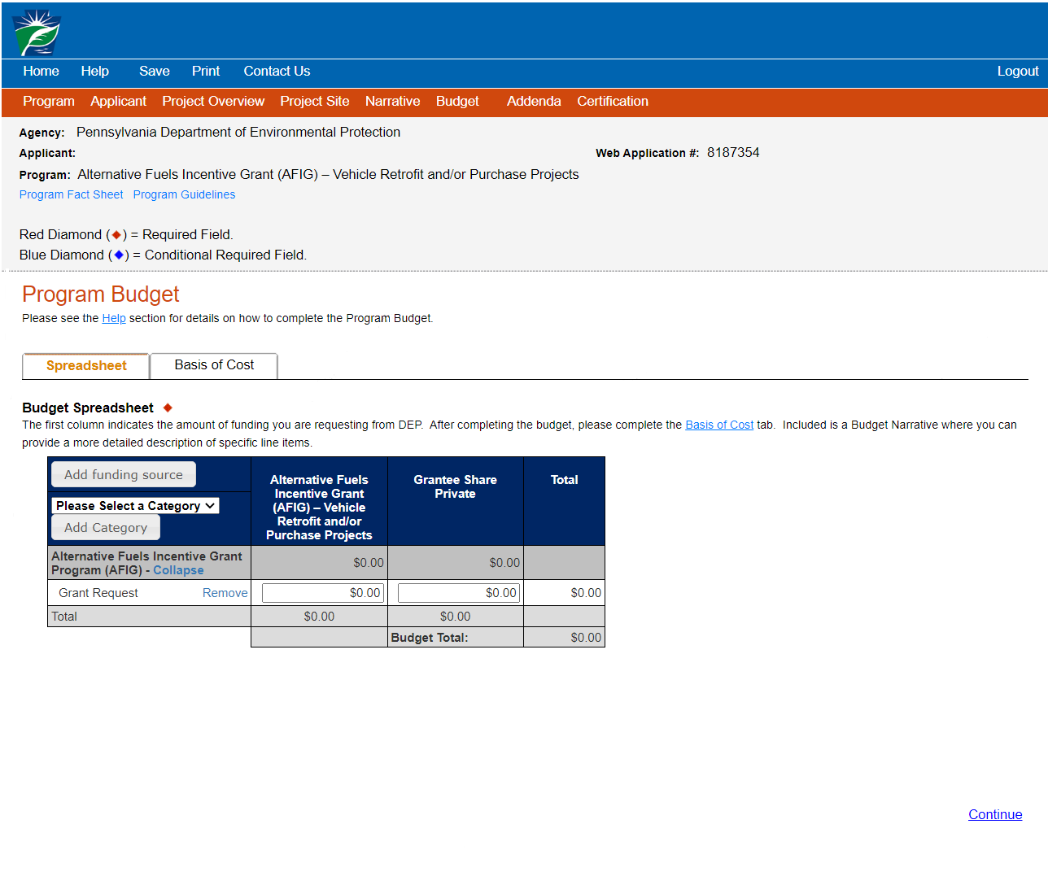

- Basis of Cost Tab
- The Basis of Cost tab will pre-populate. Nothing in this section needs to be filled out.
- Click on “Continue.”

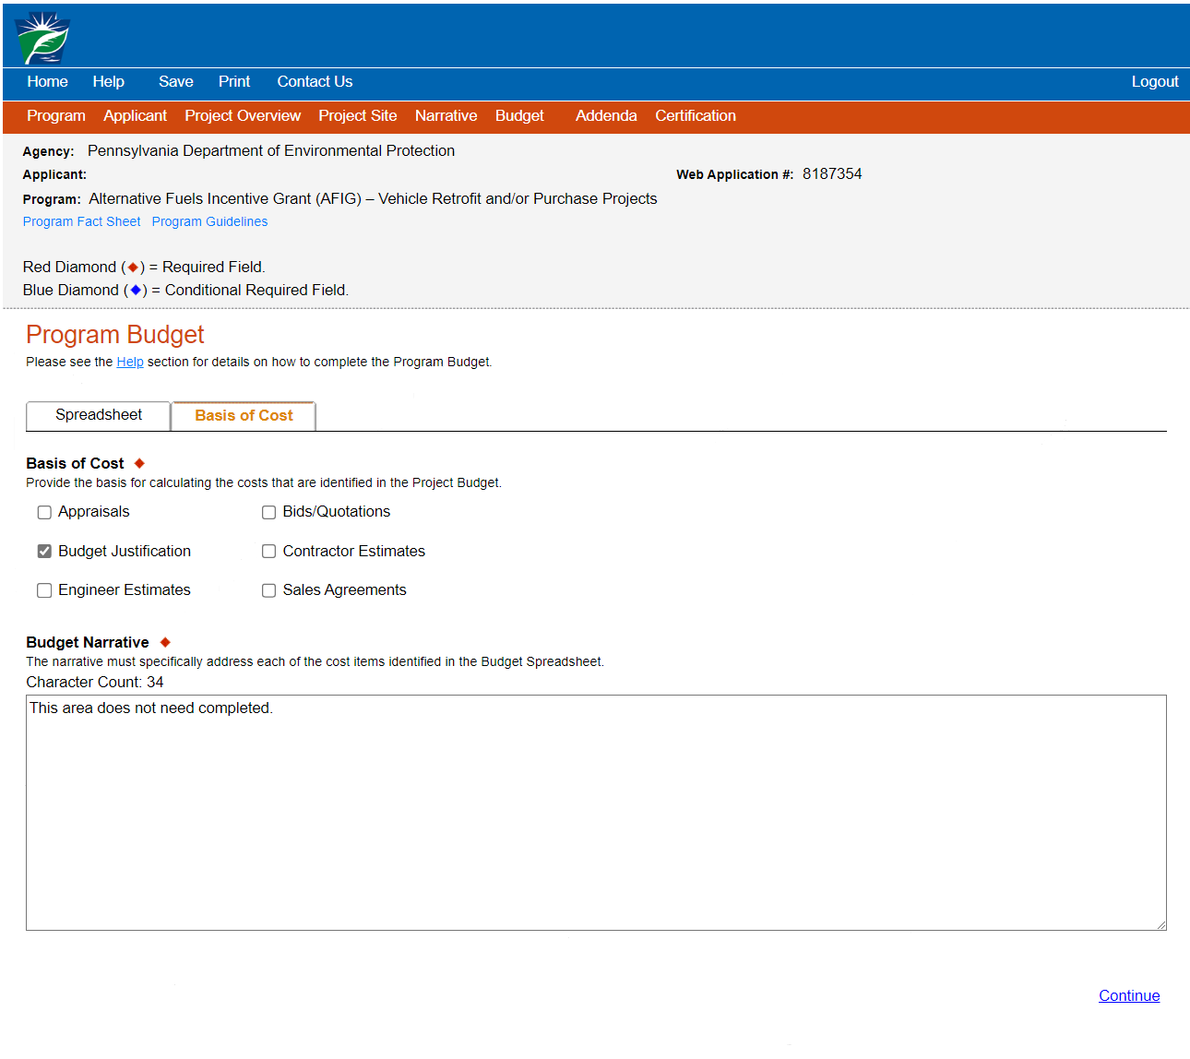

- Program Agenda – Vehicle Retrofit and/or Purchase Projects
- Program Addenda will vary based on the grant type you selected. Please refer to the AFIG Program Specific instructions for step-by-step instructions to complete and upload the required forms for your project type.

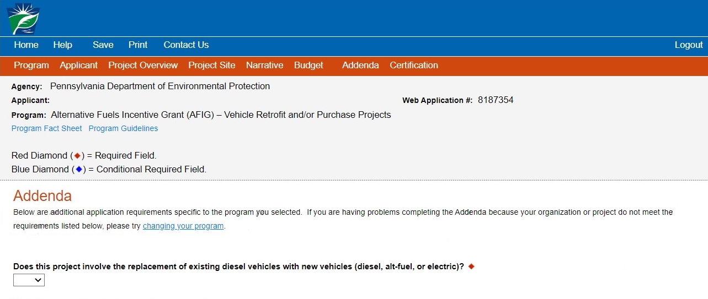
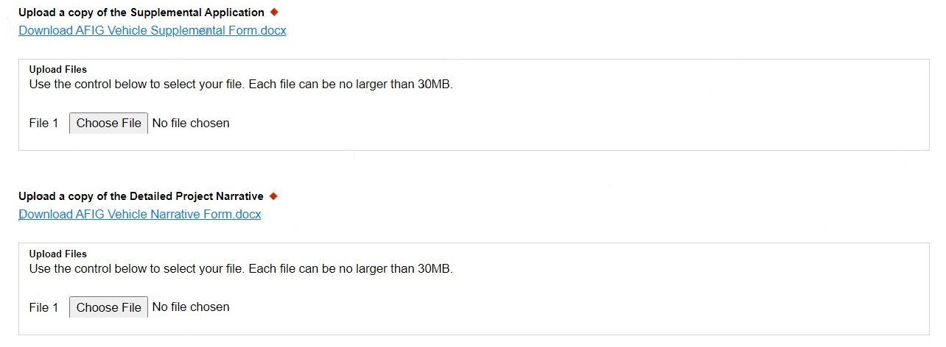
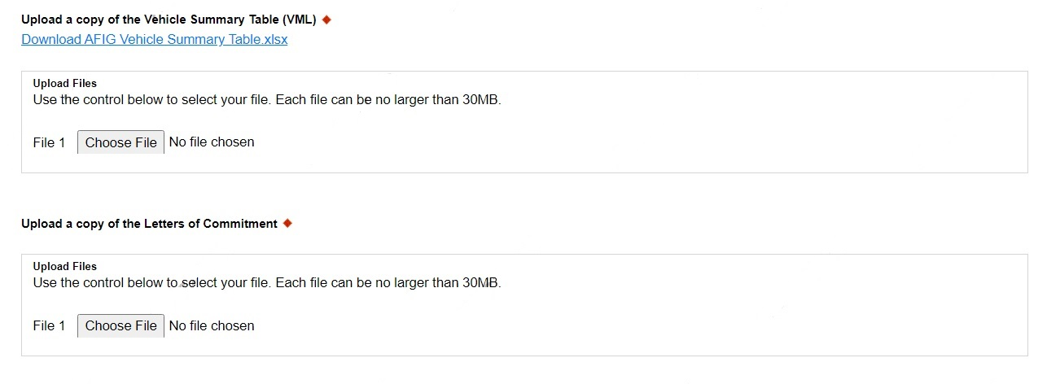
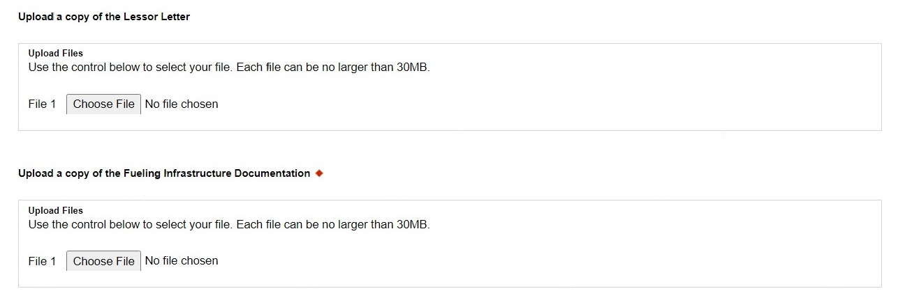
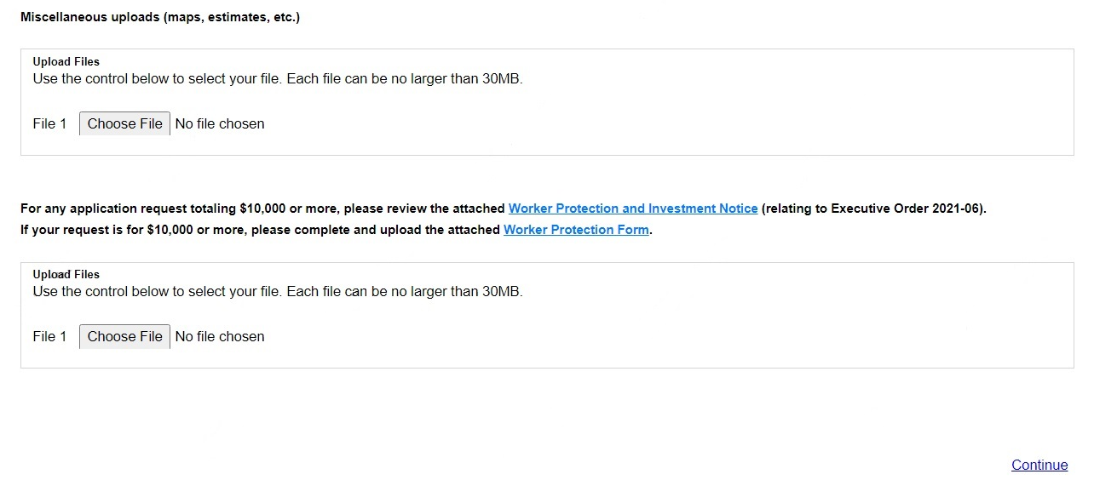

- Program Agenda – Innovative Technology Projects
- Program Addenda will vary based on the grant type you selected. Please refer to the AFIG Program Specific instructions for step-by-step instructions to complete and upload the required forms for your project type.
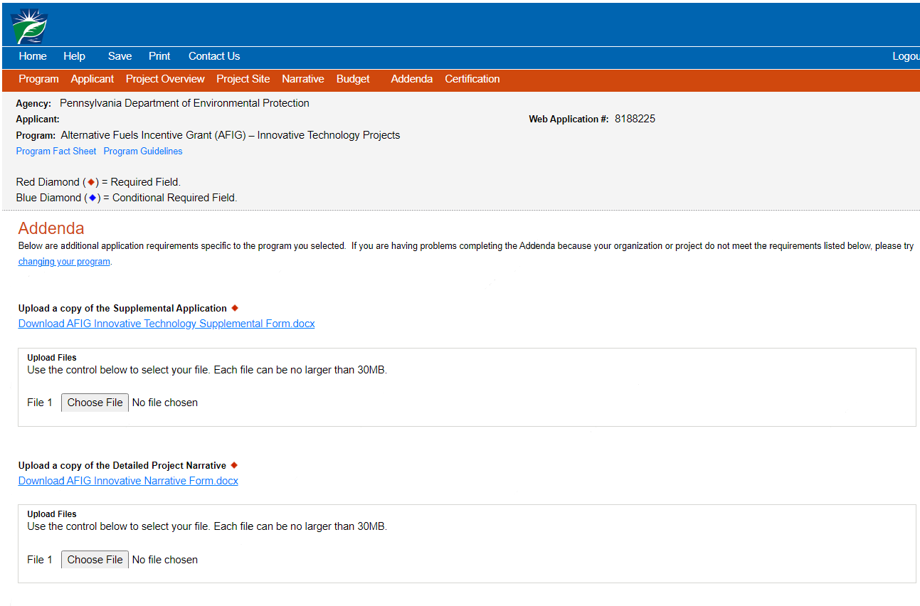
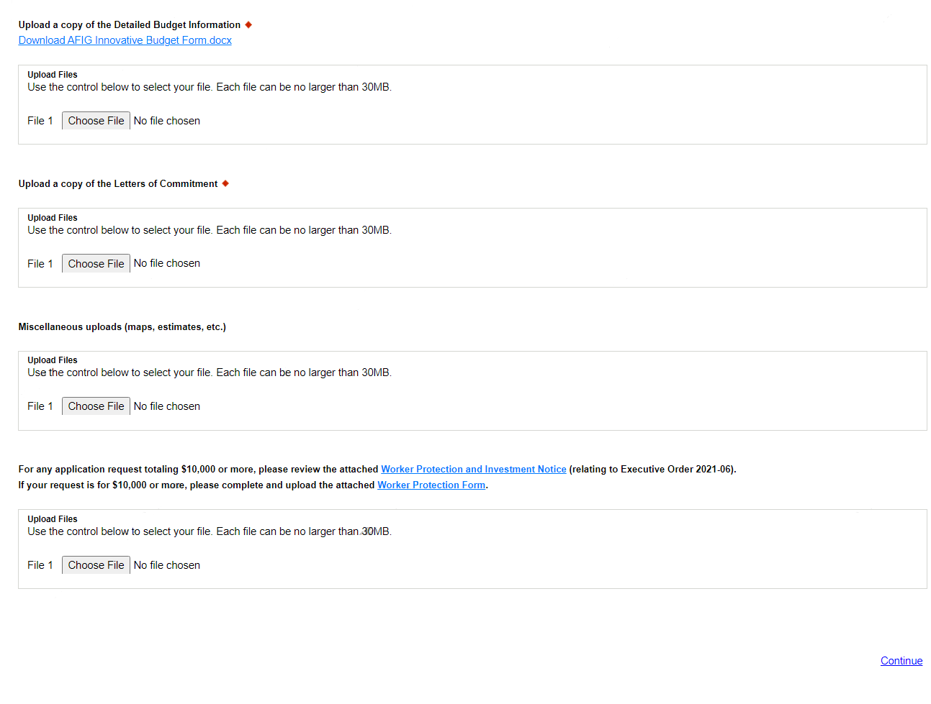
- Program Agenda – Refueling Infrastructure Projects
- Program Addenda will vary based on the grant type you selected. Please refer to the AFIG Program Specific instructions for step-by-step instructions to complete and upload the required forms for your project type.

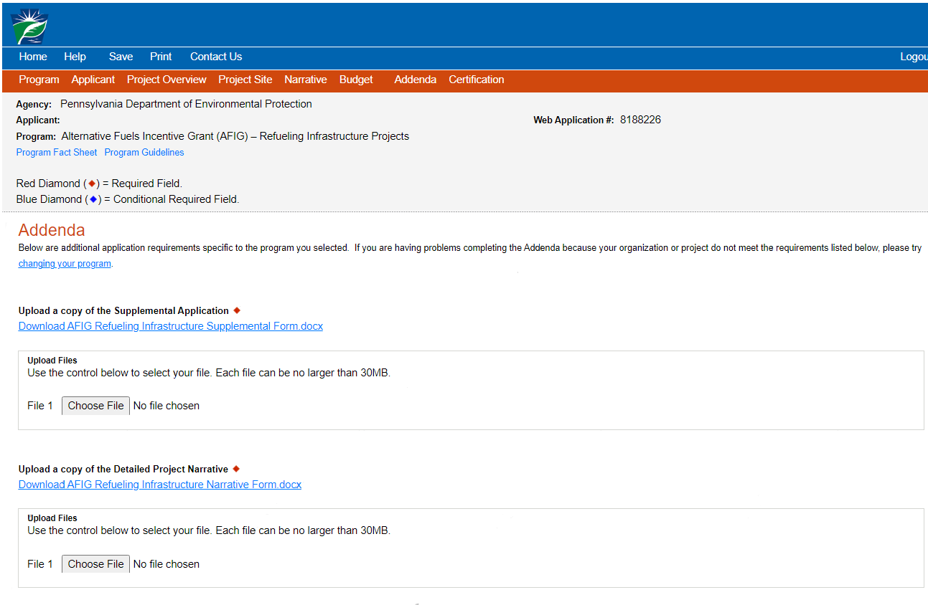
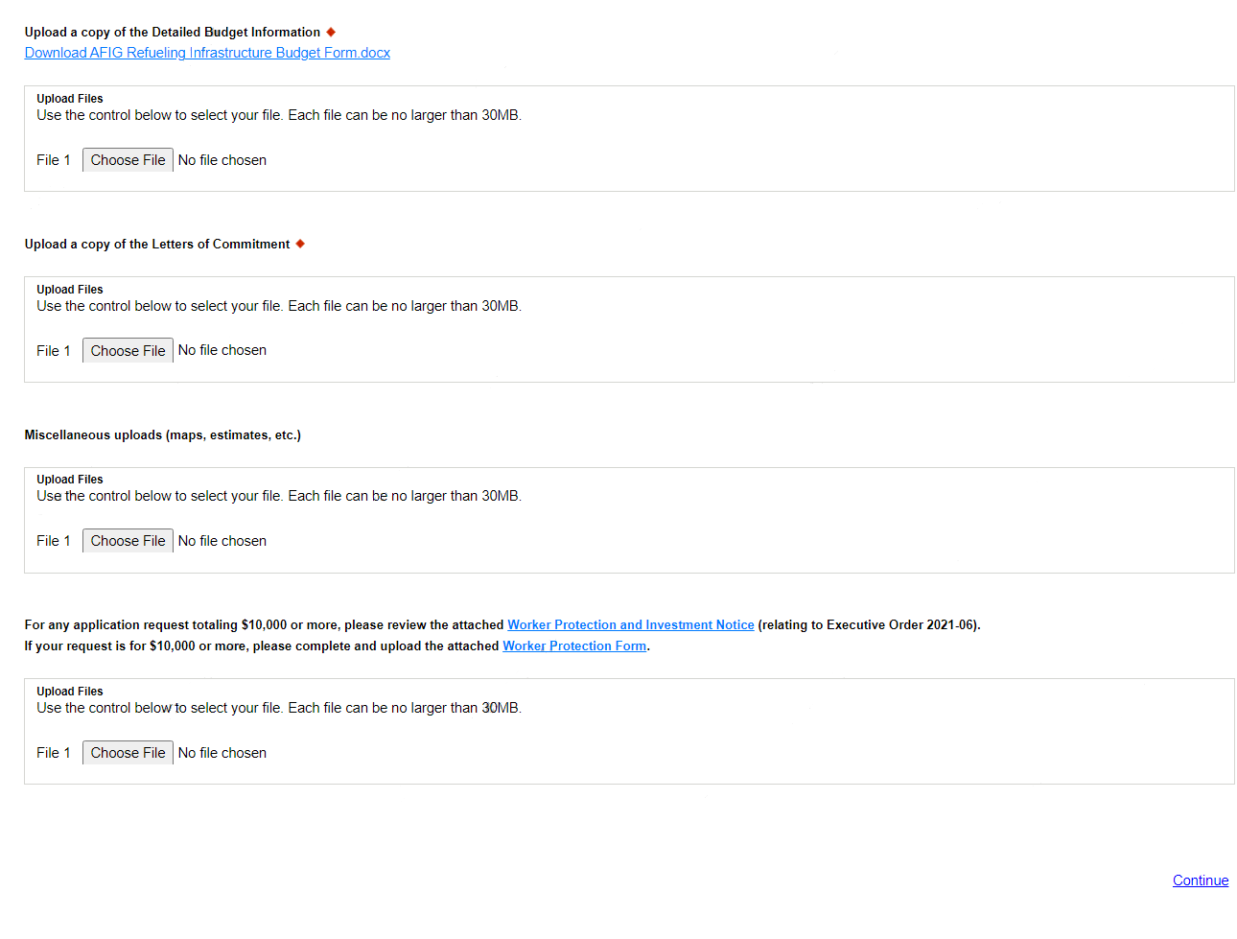

- Certification and Submission
- If there is any missing information in your application, your screen will look similar to the following example.
- Under the orange “Application Certification” heading, it will state, “The following sections are incomplete. All required fields marked with a red diamond must be completed before you are able to submit this application.
- To add/correct the information on your application, click on the section heading to return to the page.
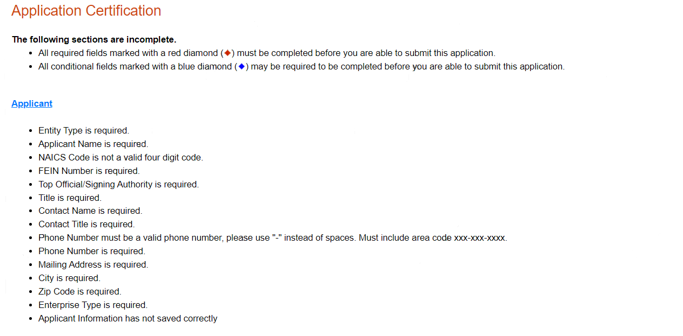
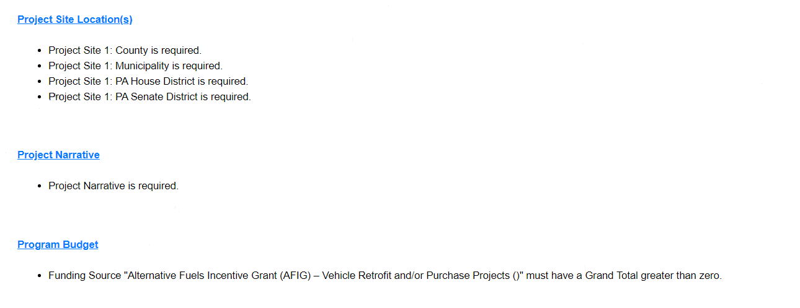

- Complete the following fields:
- Indicate certification of application information by checking the related checkbox under the Electronic Signature Agreement.
- Indicate identity as one of the following:
- I am the applicant.
- I am an authorized representative of the company, organization or local government.
- I am a “Certified” Partner representative.
- Type your name in the “Type Name Here” block. This will serve as your official eSignature and authorizes your application.
- Check the “Electronic Attachment Agreement’ box.
- Click on “Submit Application.”

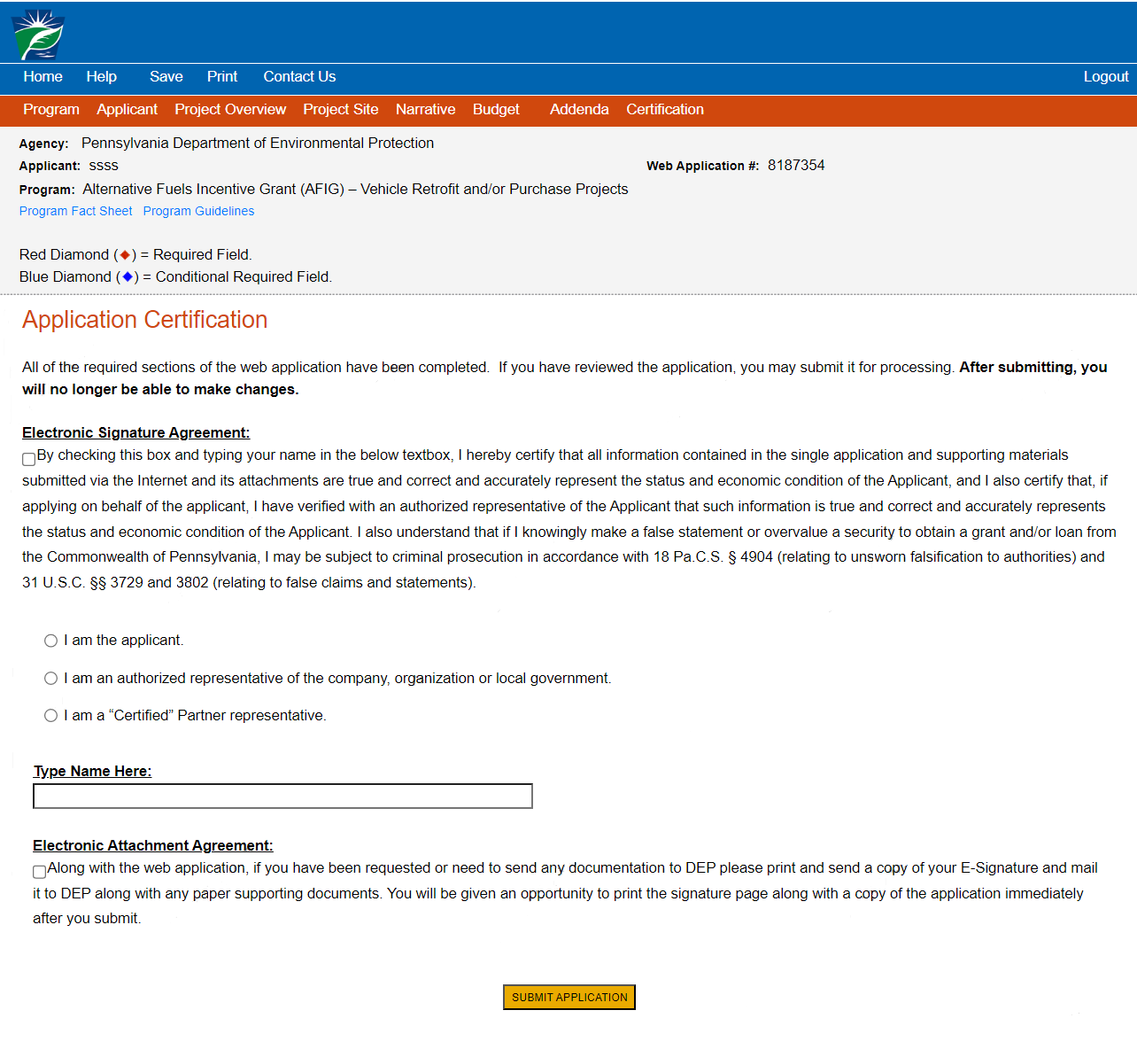
- Application Receipt Verification
- If you want a copy of your application, click the “Print Entire Application with Signature Page” link. You will always be able to access your application with the username and password you created at the beginning of the application.
- Make sure to note the Single Application ID#. All future correspondence from the Department will reference this number.
- You do not need to send the signature page and/or any further documentation to the Grants Center. All information needed is contained within your online submission.

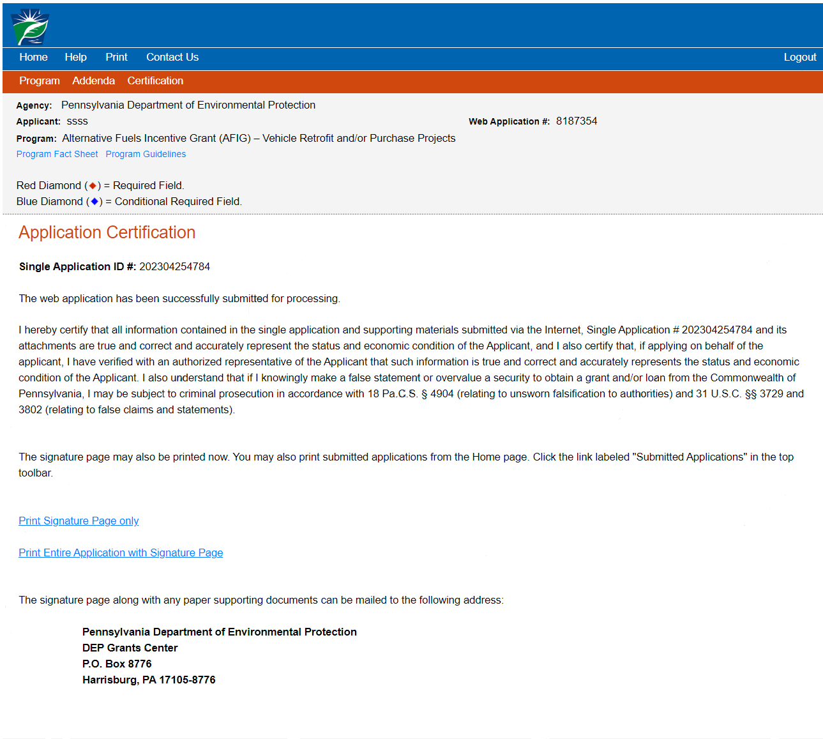

Congratulations! You have completed the online application. You will be notified of your application status in the next few weeks.

