[Jurisdiction]

Climate Action Plan



[Subtitle] (e.g. “Taking Action to Reduce Greenhouse Gas Emissions and Adapt to Climate Change”)

Approved by [Local Authority]

Local

Government Seal

[Date Approved]

[Reference to Public Record]

[Reference to Further Information]

Produced by [Name of Lead Department or Task Force]

**How to Use this Template**

**Please Read & Remove the Following Pages from Your Report**

This **template Climate Action Plan** is intended for use by local governments taking action to reduce greenhouse gas emissions within their jurisdictions. To achieve significant overall reductions, a local government needs a bold vision, equitable process, smart implementation, and excellent communication with the public. This template is designed to speed the development of a custom Climate Action Plan document by reducing the time needed to create and publish content. This document may be useful for inspiration or reference in creating your own Plan.

Wording or portions as they are within this template may not reflect local circumstances or be appropriate for all jurisdictions. As such, please modify this template as needed to accommodate local goals, knowledge, commitments, laws, and the results of your local government’s emissions studies and planning process.

**Modify the Template**

Local governments are encouraged to use whatever information within this template they find useful. Sections may be added or removed or the layout changed altogether. The narrative language included here should be replaced or filled in as needed. **All text should be reviewed to ensure accuracy and relevance.**

* Instructions in the document body are bold and highlighted. **Remove the instructions prior to release.**
* **Replace the words in brackets “[xxxxxx]”** found throughout the document.

The bracketed words function as placeholders for the name of your jurisdiction, a specific date of a local event, or other local information. To quickly find and replace these with local terms, use the functionality of your document editing software; for example, **use** **the Find and Replace function in Microsoft Word to search for common replaceable words like “[Jurisdiction]”** or for locating the brackets themselves “[”. **Searching for either an opening or closing bracket by itself “[” will allow you to find all of the replaceable words**, replace them, and verify that none remain.

**Start by finding and replacing (CTRL+F) the word “[Jurisdiction]” with the name of your local government.** This will allow you to quickly customize the sample text included here.

**Add your own greenhouse gas emissions inventory findings, forecast, and reduction target and change the document to describe your Climate Action Plan.** Use visual aids where possible – good figures and tables can go a long way toward concisely and elegantly expressing the Plan. Sample figures and tables have been included in this report as reference; please replace these with custom figures and tables.

How to Use this Template

**Remove This Page from Your Report**

* **If you need to delete a section or page break, click on the icon below to unhide them and enable editing.**



* **Template citations should be added.**

Your Climate Action Plan should reference the use of this template as follows: *This template was originally created by ICLEI USA and PA Department of Environmental Protection in October 2019 and updated in September 2021 to reflect new information.*

**Icons can be used freely.**

The icons are free to use under [Creative Commons Attribution 3.0 Unported](http://creativecommons.org/licenses/by/3.0/) license from Smashing Magazine.

* **This template contains sections for both mitigation and adaptation**

The adaptation section can be modified as appropriate, but it is recommended that climate impacts are addressed to the fullest extent possible. At the very least, it should be recognized when a mitigation action also reduces climate risk, using the “Reduces Climate Risk” column in the action tables.

**A final note about some of the content within this template:**

This template includes an additional means by which to illustrate your local government’s baseline emissions, forecast and reduction targets in the form of a “Sector Impacts” chart. Even if you have already completed your emissions inventory and forecast, you may not have created such an illustration. If you find it useful to include this chart in your plan, you may utilize the Excel file that accompanies this template. Instructions for utilizing the file to create the chart are included within the file itself.

Local governments structure their Climate Action Plans in a variety of ways. This document divides plan actions into sectors such as “Energy Production” or “Transportation” – through which government and community initiatives can be explained. **The specific sectors used in this template are examples.** You can add/remove/modify the sectors as appropriate for your community. Each sector may also contain example objectives and actions.

Credits and Acknowledgments

Local Government Officials and Staff

* [Acknowledgement – Name and Title]
* [Acknowledgement – Name and Title]
* [Acknowledgement – Name and Title]
* [Acknowledgement – Name and Title]
* [Acknowledgement – Name and Title]

External Agencies and Partners

* [Acknowledgement – Name and Title]
* [Acknowledgement – Name and Title]

Community Stakeholders

* [Acknowledgement – Name and Title]
* [Acknowledgement – Name and Title]
* [Acknowledgement – Name and Title]

Plan Contributors

* [Acknowledgement – Name and Title]
* [Acknowledgement – Name and Title]
* [Acknowledgement – Name and Title]
* [Acknowledgement – Name and Title]

This Climate Action Plan template was made possible through a grant agreement between ICLEI – Local Governments for Sustainability and the PA Department of Environmental Protection, which was funded by the US Department of Energy State Energy Program. This template was originally created by ICLEI USA and PA Department of Environmental Protection in October 2019 and updated in September 2021 to reflect new information.

The icons are licensed under [Creative Commons Attribution 3.0 Unported](http://creativecommons.org/licenses/by/3.0/) from Smashing Magazine.

Table of Contents

**To save time, wait until the rest of the document is finalized to update the table of contents. When you are ready to update, right-click anywhere on the table of contents, choose “update field”, and then “update entire table”. If you wish to use a different format, go to the References tab and click “Table of Contents” to see your options.**

1. Introduction 7

2. Co-Benefits of Climate Action 16

3. [Jurisdiction]’s GHG Emissions 18

4. Taking Action 24

5. Commercial Buildings 31

6. Residential Buildings 33

7. Energy Production 35

8. Waste, Composting, & Recycling 37

9. Water & Wastewater Management 39

10. Transportation 41

11. Agriculture & Forestry 43

12. Climate Adaptation 45

13. Implementation & Monitoring 49

References 52

Appendix I: GHG Quantification Methodology 54

Appendix II: Climate Change Science 57

Appendix III: Task Force and Community Engagement Activities 65

Executive Summary

With seasonal variations and catastrophic natural disasters becoming more intense and frequent, climate change threatens the health, safety, and overall well-being of communities across the globe. The Commonwealth of Pennsylvania and [Jurisdiction] are no exception. The [Jurisdiction] recognizes a growing need to address its own contribution to climate change, as well as adapt to the impacts that will occur and be exacerbated, absent local greenhouse gas reduction. This Climate Action Plan includes an inventory of the [jurisdiction’s] greenhouse gas emissions (GHGs) from community-wide activities, establishes an emissions reduction target, and outlines feasible actions to achieve that target. In addition, the Plan identifies ways in which GHG reduction actions can further the [jurisdiction’s] ability to adapt to climate change impacts. While this plan is not focused on adaptation, it ensures that GHG measures are not counteractive to the [jurisdiction’s] future resilience and will hopefully be a catalyst for developing a robust strategy towards that end.

**Other suggested, community-specific information to include in the executive summary:**

* **Vision statements**
* **Major findings from the jurisdiction’s greenhouse gas inventory**
* **Projections of future emissions**
* **A summary of the actions within the plan**
* **If and how the CAP’s reduction target and actions are aligned with the** [**Commonwealth of Pennsylvania’s 2021 Climate Action Plan**](http://www.depgreenport.state.pa.us/elibrary/GetDocument?docId=3925177&DocName=2021%20PENNSYLVANIA%20CLIMATE%20ACTION%20PLAN.PDF%20%20%3cspan%20style%3D%22color:green%3b%22%3e%3c/span%3e%20%3cspan%20style%3D%22color:blue%3b%22%3e%28NEW%29%3c/span%3e%209/21/2023)**.**

This Climate Action Plan [exceeds or meets] the reduction target outlined in the Commonwealth of Pennsylvania’s 2021 Climate Action Plan.

# Introduction

Climate change is the greatest environmental challenge of the 21st century, with overwhelming evidence in the past decade. It poses a serious threat not just to [Jurisdiction’s] natural resources, but also to our jobs and our health. Climate action also presents huge opportunities for creating a healthier, safer, and more equitable zero-carbon world. [Jurisdiction] has an unparalleled opportunity to make changes in ways that create jobs and benefit all residents. Scientists expect that with the current trends in fossil fuel use, Americans may see more intense heat waves, droughts, rainstorms, floods, wildfires and landslides in the future. These impacts could drag down our economy, stress our natural resources and worsen inequities facing many Americans. Action is required at all levels, and local governments have a unique role to play in building low-carbon communities. In Pennsylvania, temperatures are expected to increase approximately 5.9°F by 2050 from the baseline period (1971-2000). Similarly, average annual precipitation in Pennsylvania has increased by 8 percent, particularly in winter and spring (PA DEP, 2021).

These impacts are caused by the accumulation of greenhouse gas (GHG) such as carbon dioxide (CO2) and methane (CH4) in the atmosphere, primarily resulting from burning fossil fuels and land use changes. Although the natural greenhouse effect is needed to keep the earth warm, a human enhanced greenhouse effect with the rapid accumulation of GHG in the atmosphere leads to too much heat and radiation being trapped. Carbon emissions from human activities have continued to rise in recent decades, reaching the highest rates in human history between 2000 and 2010 (Intergovernmental Panel on Climate Change (IPCC), 2014). About half of all carbon dioxide emitted between 1750 and 2010 occurred in the last 40 years. The energy, industry and transportation sectors have dominated the rise in emissions. In Pennsylvania, the sectors responsible for the most GHG emissions are industrial at 32%, electricity production at 27%, and transportation at 24% (PA DEP, 2021). With the current trajectory of population growth, urbanization, and reliance on personal vehicles, emissions will only continue to rise. Given the critical impacts of climate change on humanity, the time to act to reduce GHG and our carbon footprint is now.

In addition to national and state efforts to make systemic changes that will reduce global emissions, local governments can play a powerful role in addressing climate change. The design of American communities—how we use our land, how we design our buildings, how we get around—greatly impacts the amount of energy we use and the volume of GHG emissions we produce. It is critical that communities like [Jurisdiction] demonstrate that it is possible to dramatically reduce GHG emissions while creating more vibrant and prosperous places to live and do business.

## Statewide Climate Action

In 2008, the Pennsylvania Climate Change Act was passed, and requires the Department of Environmental Protection (DEP) to (1) develop an inventory of GHG emissions and update it annually; (2) administer a Climate Change Advisory Committee; (3) set up a voluntary registry of GHG emissions; and (4) prepare a Climate Change Action Plan and Climate Impacts Assessment, both to be updated once every three years. The most recent Climate Impacts Assessment, Greenhouse Gas Inventory, and Climate Action Plan were released in 2021. These documents offer information and guidance for local climate action planning in the Commonwealth. The Climate Impacts Assessment provides a scientific basis for potential statewide impacts of global climate change, which can be used alongside available local data to inform community adaptation efforts. The Climate Action Plan summarizes statewide greenhouse gas emissions, sets an emissions reduction target, and describes potential mitigation and adaptation actions for residents and businesses, as well as local and state government. The reduction targets are 26% by 2025 and 80% by 2050 from 2005 levels, consistent with Executive Order 2019-01 signed by Governor Wolf in 2019 (PA DEP, 2021).

To ensure consistency with the PA Climate Action Plan, [Jurisdiction’s] reduction targets [meet or exceed] the statewide targets. In addition, many of the statewide actions were incorporated into this plan, which is described further in Chapter 4: *Taking Action*.

## Local and Regional Climate Policy

**Add any other information about relevant local or regional policies, or delete this section if there are none.**

## Purpose and Scope of the Climate Action Plan

[Jurisdiction] is joining an increasing number of local governments committed to addressing climate change at the local level, in particular through its support to [insert any local campaigns here, if applicable].

The [jurisdiction] recognizes the risk that climate change poses to its residents and businesses and is acting now to reduce the GHG emissions of both its government operations and the community at-large through the innovative programs laid out in this Climate Action Plan. Furthermore, it is recognized that [Jurisdiction] needs to address existing climate risks such as [enter current climate hazards] and adapt its systems and infrastructure to new conditions. This Climate Action Plan takes advantage of common sense approaches and cutting-edge policies that our local government is uniquely positioned to implement – actions that can reduce energy use and waste, create local jobs, improve air quality, preserve our local landscape and history, reduce risk to people and property, and in many other ways benefit [Jurisdiction] for years to come.

### Purpose

By creating a clear course of action so that everyone has a role in creating and achieving climate and sustainability goals, our Climate Action Plan drives and coordinates local efforts toward a reduction in GHG emissions of [Base Year] levels by [XX Year] and [XX] percent below [Base Year] emission levels by [XX Year].

The Climate Action Plan is a framework for the development and implementation of actions that reduce [Jurisdiction]’s GHG emissions. The Plan provides guiding objectives and actions to realize [Jurisdiction]’s GHG reduction goal.

In addition to addressing mitigation concerns, the Climate Action Plan considers the vulnerability of [jurisdiction] to hazards that are and will continue to be exacerbated by climate change. The plan prioritizes GHG reduction measures that support climate adaptation and does not propose any actions that are maladaptive to foreseen climate change impacts.

### Scope

This Plan covers objectives and actions for reducing GHG emissions resulting from local government and community-wide activities within the [jurisdiction]. It addresses the major sources of emissions in [Jurisdiction] and sets forth objectives and actions in the following [XX] sectors that both the [jurisdiction] and community members can implement together to reduce greenhouse gas emissions:

**Modify accordingly.**

* Commercial Buildings
* Residential Buildings
* Energy Production
* Waste Management
* Water & Wastewater Management
* Transportation
* Agriculture & Forestry
* Other

The Plan creates a framework to document, coordinate, measure, and adapt efforts moving forward. In addition to listing actions, the Plan discusses how each action will be implemented via timelines, financing, and assignment of responsibilities to departments, staff, or community partners where known.

## Planning Process

### Framework

**Modify text and figures below as necessary.**

While [Jurisdiction] has already begun to reduce greenhouse gas emissions and climate risk through a variety of actions, this plan is a critical component of a comprehensive approach to reduce [Jurisdiction] emissions and increase resilience. The two frameworks below, developed by ICLEI – Local Governments for Sustainability, USA (ICLEI), are known as the Five Milestones for Climate Mitigation and Adaptation.

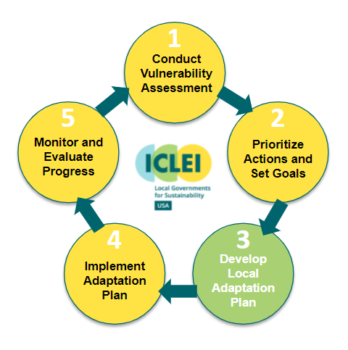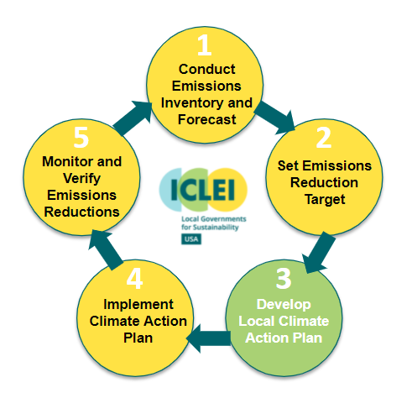

As indicated by the figures above, climate action planning is a continuing cycle and does not stop with the development of this document. However, this Climate Action Plan represents [jurisdiction’s] first planning cycle, including the completion of the first three milestones for mitigation and partial completion of the first milestone for adaptation:

**Milestone 1:** Chapter 3 summarizes the emissions inventory and forecast; Chapter 12 describes potential risks from climate change.

**Milestone 2:** Chapter 4 sets reduction targets

**Milestone 3:** Chapters 5-12 outline objectives and actions for GHG reduction and adaptation

Chapter 13 describes the initial steps of milestones 4 and 5, monitoring and implementation.

**Update the chapters above if your plan is organized differently, if you are excluding adaptation, and/or you include other chapters.**

### Timeline

To develop this Plan, [Jurisdiction] began with forming the [name of task force] in [month, year]….**[Describe the timeline of your planning process in a narrative and/or table format, including dates of task force meetings and community engagement activities]**

See [Appendix III or link to webpage where documentation can be accessed] to view documentation of task force and community engagement activities.

### Planning Team and Stakeholders

* **Describe the composition of the planning team, including names, titles, and department.**
* **List primary stakeholders and the organizations they represent.**

### Social Equity

Climate equity was a core component of the planning process and will continue to be through implementation. Climate Equity ensures the just distribution of the benefits of climate protection efforts and alleviates unequal burdens created by climate change. Implementation of this concept requires intentional policies and projects that simultaneously address the effects of and the systems that perpetuate both climate change and inequity. Under the status quo, however, not everyone is given the opportunity to participate and benefit.

Communities of color and low-income populations have historically been under-served by programs and investments and under-represented in decision-making, including for the development and implementation of climate policy. These exclusionary processes maintain or exacerbate disparities in public health; food, energy, and housing security; air and water quality; economic prosperity, and overall quality of life. These inequities primarily stem from ongoing institutional racial bias and historical discriminatory practices that have resulted in the inequitable distribution of resources and limited access to opportunities.

Climate change is likely to amplify the impacts of these existing inequities. Residents of frontline communities which often include lower income neighborhoods, communities of color, immigrants, unhoused, outdoor workers, the very young, and the elderly will disproportionately bear the burdens of climate change impacts. In addition, the many economic and health benefits of carbon reduction investments are not shared equitably across the jurisdiction especially among people of color and low-income communities.

To ensure an equitable climate action plan, the [Jurisdiction] had a community-driven process, which is described in the following section.

### Community-Driven Planning Process

**The best practice for equitable planning is to have a community-driven process. For more information, see the** [**Community-Driven Climate Resilience Planning: A Framework from the National Association of Climate Resilience Planners.**](https://kresge.org/sites/default/files/library/community_drive_resilience_planning_from_movement_strategy_center.pdf) **Other resources for understanding equity principles and how to incorporate them into your planning process:**

* [**U.S. Climate Resiliency Toolkit**](https://toolkit.climate.gov/topics/built-environment/social-equity)
* [**Equitable and Just National Climate Platform**](https://ajustclimate.org/)
* [**New York City Climate Action Plan**](https://gcc01.safelinks.protection.outlook.com/?url=https%3A%2F%2Fonenyc.cityofnewyork.us%2Fstrategies%2Fonenyc-2050%2F&data=02%7C01%7Calacevedo%40pa.gov%7C6072e7a2f42248f7754108d77213019d%7C418e284101284dd59b6c47fc5a9a1bde%7C0%7C0%7C637103298275761409&sdata=rKWh5u0OV2qfUx2sLHKa2gR50wG0xvNQ%2BZByf32auK0%3D&reserved=0)

**Some examples of how to ensure equity is a core component of your planning process include:**

* **Forming a Community Working Group made up of a diverse group of stakeholders from grassroots groups, business representatives, faith and spiritual communities, and neighborhoods.**
* **Include climate equity in the overall Climate Action Plan vision and objectives.**
* **Evaluate proposed actions on whether they help to uplift climate equity and reduce disparities.**
* **Determine climate equity metrics to help track the progress made on those actions.**

**Modify the following according to your specific planning process.**

In identifying which specific populations should be included in a community driven process, [Jurisdiction] consulted:

* The [Pennsylvania Department of Environmental Protection’s Environmental Justice Viewer](http://www.dep.pa.gov/EJViewer):
* The county planning commission
* The MPO/RPO
* Local community groups or processes

[Jurisdiction’s] community-driven process included the following steps:

* List the steps followed to ensure a community-driven process

## Vision Statements and Objectives

**Your Climate Action Plan should have some guiding visions for the public. Research has shown that communities can relate better to vision statements than quantitative GHG reduction targets, so in an outward facing document like the Climate Action Plan, you should lead with vision statements describing the type of community you want to create. Examples include (keep, delete, or modify as necessary):**

1. Make [Jurisdiction] a leader in clean and local energy that comes from the sun, wind, or other innovative renewable technologies.
2. Transform our buildings into high-performing places to live, work, learn, and play.
3. Ensure the benefits of climate action are equitably distributed and empower historically underserved populations to participate in the process of transitioning to a carbon-free community
4. Transform [Jurisdiction] into a community where people walk, bike, take mass transit, or carpool for most trips in a safe, accessi­ble, and affordable transportation network.
5. Aggressively transition toward a clean, carbon-free transportation system that improves health and livability for the [Jurisdiction] community.
6. Become a leader in sustainable, smart transportation through innovative partnerships, policies, programs, and technology.
7. Understand potential climate-related risks and mitigate these risks while preparing our community for chronic and extreme weather events.

The Climate Action Plan offers a robust set of objectives and actions that will address the climate hazard vulnerabilities and aim for an [X%] reduction in GHG emissions by [Year]. Each action and objective was created and reviewed by a group of stakeholders who considered technology limitations, funding constraints, public support, feasibility of implementation, environmental justice considerations, and other barriers. **Revise based on your stakeholder engagement process**.

The [Jurisdiction] established the following targets to maintain a vibrant, healthy, and safe community for future generations, while improving the quality of life for those who live here today:

**SAMPLE GHG REDUCTION OBJECTIVES**

**Please note that these are examples of objectives, which you can add to, keep, delete, or modify as necessary:**

### By 2025

* [Jurisdiction] will reduce energy use in its buildings by 10%

### By 2030

* [Jurisdiction] will reduce energy use in its buildings by 20%
* 100% of [Jurisdiction]’s electricity will come from renewable energy
* 9% of [Jurisdiction]’s commuters will carpool
* 8% of [Jurisdiction]’s commuters will bike to work
* 9% of [Jurisdiction]’s commuters will walk to work
* 16% of [Jurisdiction]’s commuters will use public transit
* 7% of [Jurisdiction]’s commuters will telecommute
* Electric Vehicles will be powered by 100% renewable energy
* [Jurisdiction] will incentivize Leadership in Energy & Environmental Design (LEED) certification and/or enforce net-zero building codes for new buildings
* At least 30% of new housing units within ¼ mile of high-frequency transit are designated affordable.
* A food outlet selling fresh produce is located within a 15 minute walk of every resident
* An emergency cooling center is located within a 10 minute walk for the most vulnerable residents (based on age, income and other factors)
* 20% of jobs in transit construction and renewable energy installation are provided to residents of low-income neighborhoods, or groups that face employment challenges.
* Miles of bike lane per resident in low-income neighborhoods is equal to that in higher-income neighborhoods
* Increase annual number of households reached by low-income weatherization programs 30%
* Decrease the energy costs of low-income residents 20%
* Install roof-top solar on homes of 1000 low and moderate income residents

### By 2050

* 70% of [Jurisdiction]’s households and businesses will participate in smart grid meter programs
* 90% of [Jurisdiction]’s existing buildings will complete energy-efficiency improvements
* 50% of [Jurisdiction]’s tenants will participate in a green lease program
* 50% of heating fuel derived from fossil-fuels (oil, natural gas and propane) will be switched to a low- carbon fuel source and/or electric heat
* 18% of [Jurisdiction]’s commuters will bike to work
* 15% of [Jurisdiction]’s commuters will walk to work
* 18% of [Jurisdiction]’s commuters will use public transit
* 100% of public transportation will be carbon free
* 80% of light-duty vehicles will be electric
* 100% of [Jurisdiction]’s light- and heavy- duty vehicles will be electric or fueled by carbon-free fuel
* 100% of transportation network companies’ cars (Taxis, Uber, Lyft, etc.) will be electric

# Co-Benefits of Climate Action

Greenhouse gas reduction and climate resilience are not the only beneficial outcomes of climate action plans. The following outcomes are referred to as “co-benefits,” and they illustrate how taking action on climate change results in a more prosperous community.

## Improving Public Health

Climate change mitigation activities, particularly those related to transportation, help to clean the air by reducing vehicle emissions and therefore improve public health. Mitigation activities help to engender a greater degree of choice for [Jurisdiction]’s residents. More transit options combined with transit-oriented development practices make for a more vibrant, livable community with shorter commute times and more opportunities for active transport. This creates more connected and resilient neighborhoods.

## Saving Money and Reducing Risk

In addition to addressing climate change, measures taken to reduce greenhouse gas emissions have other important benefits. The most obvious of these is the potential for significant cost savings. In [Year], [Jurisdiction] spent over [$$$$] on energy to power buildings and fuel its vehicle fleet. Many of the measures in this plan pay for themselves quickly by reducing direct costs, such as fuel or energy used, and also indirect costs such as maintenance. For instance, a “right-sized” vehicle fleet is less expensive to purchase and fuel, while also being less costly to maintain. **Add information here about the expected monetary cost/benefit of Climate Action Plan projects.** Encouraging energy efficiency, public transit use, building improvements, and other measures will also result in lower energy and water bills for residents and employers as well.

Acting now will also save on runaway costs on climate change, especially in the longer term. These costs range from infrastructure damage in extreme storms and pest control to industry losses, particularly for industries that depend on environmental conditions, such as winter sports.

## Enhancing Resource Security

A key strategic side benefit of climate change mitigation activities is enhanced energy security through reduction in total demand. This will put less strain on the energy system as a whole as we transition to clean renewable energy. Similarly, demand shifts can help with improving water and food security as well.

Many of the actions identified here to mitigate GHG emissions will also help [Jurisdiction]’s government, businesses, and residents to adapt to a changing climate. For example, extreme and prolonged heat waves can put considerable strain on the reliability of energy delivery in peak periods, possibly leading to service disruption during times when cooling is most needed. By increasing efficiency across the [Jurisdiction], such service disruptions are less likely and the [Jurisdiction] will be able to better cope with those situations. Similarly, climate actions can secure food and water sources and prevent damage and service disruptions to these systems from [drought, flooding, and fire].

## Creating Jobs

Renewable energy is a growing sector. The U.S. Department of Energy reports that sustainable tourism, green construction, and urban agriculture can provide job opportunities that didn’t exist in the past. These climate protection measures can spur business and job growth during the design, manufacture, and installation of energy efficient technologies, which presents a particular opportunity to reinvest in the local economy and generate green jobs within [Jurisdiction].

## Fostering Social Equity

Social equity and justice are major concerns for addressing climate change, and thus were established as core values behind this plan. Equity is when all individuals have access to the opportunities necessary to satisfy their essential needs, advance their well-being and achieve their full potential. Environmental justice ensures fair treatment and meaningful involvement in the development of laws, policies and regulations and the identification of issues impacting vulnerable communities. As discussed in Chapter 1, [Jurisdiction’s] community-driven planning process generated solutions that will both address climate change and ensure a better quality of life for communities of color and low-income communities.

# [Jurisdiction]’s GHG Emissions

**Once the GHG inventory is done, this section will include community-wide and/or government operations GHG emissions information. ICLEI’s ClearPath software will be used to generate emission forecasts**.

Since the early 1990s, U.S. cities have developed community-wide and local government operations greenhouse gas (GHG) inventories based on accounting protocols created by ICLEI. Known as the [U.S. Community Protocol for Accounting and Reporting of Greenhouse Gas Emissions](http://icleiusa.org/us-community-protocol/) and the [Local Government Operations Protocol](https://s3.amazonaws.com/icleiusaresources/lgo_protocol_v1_1_2010-05-03.pdf), these standards created a credible and defensible methodology which accelerated the number of inventories created and provides consistency within and across U.S. communities. In 2014, ICLEI partnered with the World Resources Institute and C40 Climate Leadership Group to create the Global Protocol for Community Scale GHG Emissions, which allows communities around the world to compare their emissions footprint.

[Jurisdiction] used the [XXX Protocol] for the inventory…

Through the completion of a local emissions study, or “greenhouse gas inventory,” our [Jurisdiction] has determined emissions levels for the community as a whole. Community-wide emissions represent the sum total of emissions produced within [Jurisdiction] limits as well as emissions resulting from electricity use within the jurisdiction, even if said electricity is generated elsewhere. In this way, the community-wide figures represent all emissions for which the community is responsible.

## [Jurisdiction] Community-Wide GHG Emissions

**Figure 2 is a sample GHG inventory output produced using data from ClearPath.**

The following figure breaks down community-wide emissions in [Jurisdiction]. Note that emissions from the [Jurisdiction]’s operations are embedded within the community-wide totals. For example, emissions from government buildings are included in the “Commercial” sector and emissions from [Jurisdiction] fleet vehicles are included in the “Transportation” figure above. Government operations are therefore a subset of total community emissions.

Figure 2: [Jurisdiction] Community-Wide GHG Emissions

Government emissions include all sources for which the local government exercises direct operational control including **Refer to government operations GHG inventory, list emissions-generating services offered by local government, possibly including water/wastewater services, solid waste, electric utility, etc.**

## Forecasting [Jurisdiction’s] GHG Emissions

**Figure 3 is a sample GHG inventory output produced using data from ClearPath.**

The [Jurisdiction] has also completed an emissions forecast based on projections of current data and expected future trends. This emissions forecast is the “Original” forecast (also known as a “Business As Usual” forecast), a scenario estimating future emissions levels if no further local action (i.e. projects within this Climate Action Plan) were to take place. The forecast indicates that, if we do not take action, GHG emissions will continue to increase. **Align statements with your local forecast; ICLEI’s ClearPath software can be used to generate these forecasts.**

##### Projected Growth in GHG Emissions

**Figure 3 is a sample GHG forecasting output produced using data from ClearPath. If you use ClearPath for your emissions accounting, these graphs live update and can easily be extracted to use in your reports.**

Figure 3 shows the projected growth in GHG emissions in [Jurisdiction] from ___ to ____. For complete information regarding the emissions inventory and forecast, including methodology and supporting data, please reference Appendix I.

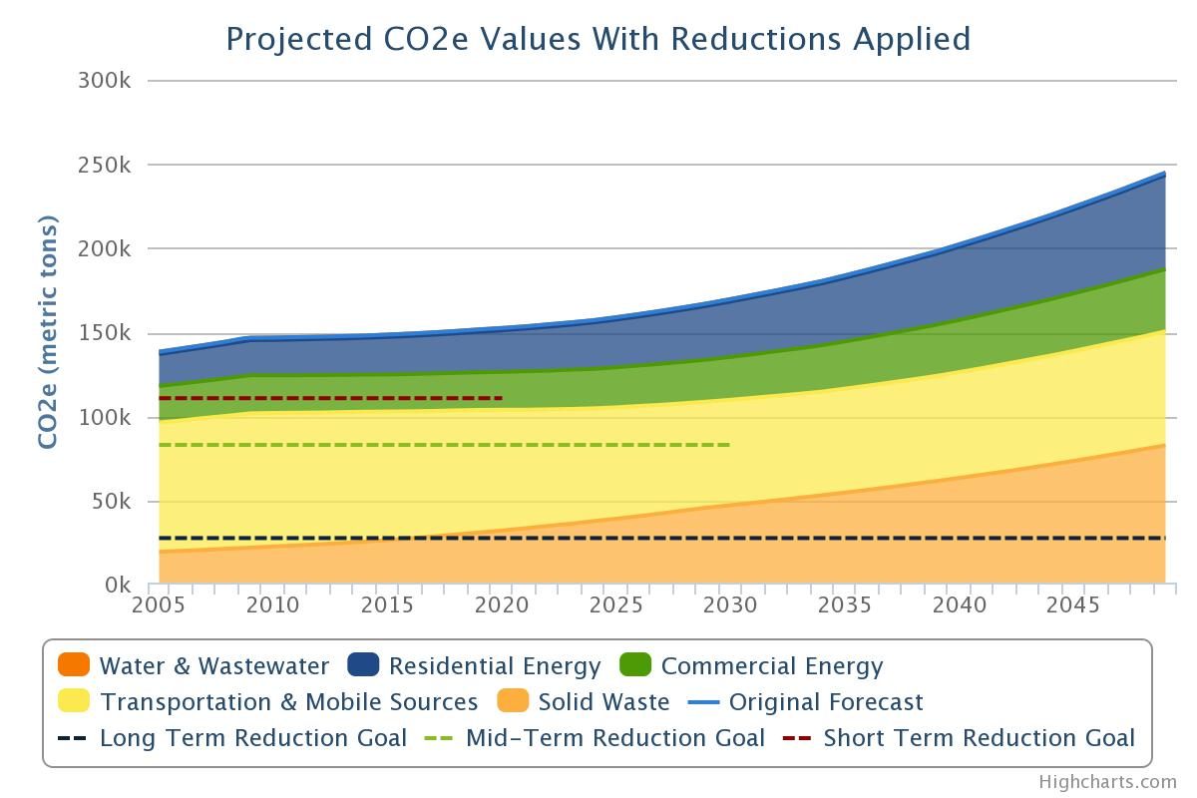

Figure 3: Projected Growth in GHG Emissions from ___ to ___

## [Jurisdiction]’s GHG Reduction Target

**Change the following and figure 4 as necessary to reflect targets.** [Jurisdiction] has set targets to reduce its emissions to [Base Year] levels by [Target Year], or [XX] percent below [Base Year] levels by [Target Year]. Figure 4 compares the reduction target with the business-as-usual forecast. The combination of measures that [Jurisdiction] has already implemented, are currently planned, and are presented through this Climate Action Plan are designed to achieve the [Target Year] targets. Reductions in [Target Year] rely on the best information currently available pertaining to population forecasts, future changes to building codes, and vehicle fuel efficiency standards among other information. **Align previous statement with the specific forecast methodology used.**

Figure 4: GHG Reduction Target

[Jurisdiction]’s reduction target is consistent with the statewide target of 26% reduction by 2025 and 80% by 2050 from 2005 levels, as it exceeds its local percentage of the total emissions reduction needed in order to achieve that target (see Appendix I for these calculations).

## The [Jurisdiction] Climate Action Plan

**Consider collapsing specific actions into project categories or inventory sectors such as “Energy” or “Buildings,” “Transportation,” and so on if your plan has not been organized in this way already. These categories might be inspired through the GHG inventory process or other organizing principles and make the plan easier to communicate. Summarize the Plan via table format, laying out all of the sectors in one location.**

**If you feel that some actions do not fit into one particular focus area but instead affect, build on, or are a component of all areas, consider making a “Cross-Cutting Actions” focus area. This optional focus area can help to call out the importance of a cross-cutting objective or group of actions. Although embedded in components of other focus areas, calling out cross-cutting actions or objectives in their own section allows one to set quality thresholds or success metrics for these activities, ensuring that these objectives are observed and done well. Good examples include Public Education and Outreach, Land Use, Climate Adaptation, or Developing a Green Economy.**

The summary table below identifies the sectors within the [Jurisdiction] Climate Action Plan, the number of actions within each sector, and the contribution of each sector toward the GHG reduction goal. Each sector has a dedicated section within this document where objectives and specific actions (both new and those already employed) are described.

While the local government cannot address climate change by itself, government policies and practices can dramatically reduce greenhouse gas emissions from a range of sources and help prepare [Jurisdiction] for the anticipated impacts of climate change. In addition, the [Jurisdiction] will assist residents and businesses in their endeavors to reduce emissions through programs explained in this Plan. By working together, [Jurisdiction] can not only do its part toward achieving a stable climate - we can reap the benefits of healthier air, lower costs for utilities and services, improved transportation and accessibility, a more vibrant local economy, and many other positive side effects of reducing our carbon footprint.

##### [Jurisdiction] Climate Action Plan Summary Table – Sectors

|  |  |  |  |  |
| --- | --- | --- | --- | --- |
| Sector | Description | Number of Distinct Actions | Anticipated MTCO2e Reduction by XXXX | Percentage of Total Reduction at XXXX |
| **Commercial & Industrial Buildings** | Policies and programs to reduce commercial, municipal, and industrial sector energy use. | 9 | ~14,900 | 22% |
| **Residential Buildings** | Policies and programs to reduce residential sector energy use. | 6 | ~12,900 | 19% |
| **Energy Production** | Policies and programs to promote local small-scale renewables. | 7 | ~6,800 | 10% |
| **Waste, Composting and Recycling** | Policies and programs to reduce solid waste generation. | [X] | ~10,200 | 15% |
| **Water and Wastewater Management** | Policies and programs to reduce water demands and corresponding wastewater treatment needs. | [X] | ~8,100 | 12% |
| **Transportation** | Policies and programs to reduce on-road vehicle miles traveled and promote electric or low emission vehicles. | [X] | ~7,450 | 11% |
| **[Other Sector]** | Table provided here as example – to be modified according to local plan/conditions. | [X] | ~7,450 | 11% |

*MTCO2e (Metric tons of CO2 equivalent)

The Impact on Emissions

The figure below depicts historic GHG emissions, forecasted growth in emissions, and target emissions from [Year] to [Year]. The color wedges represent the projected reductions in emissions based on state and local programs.

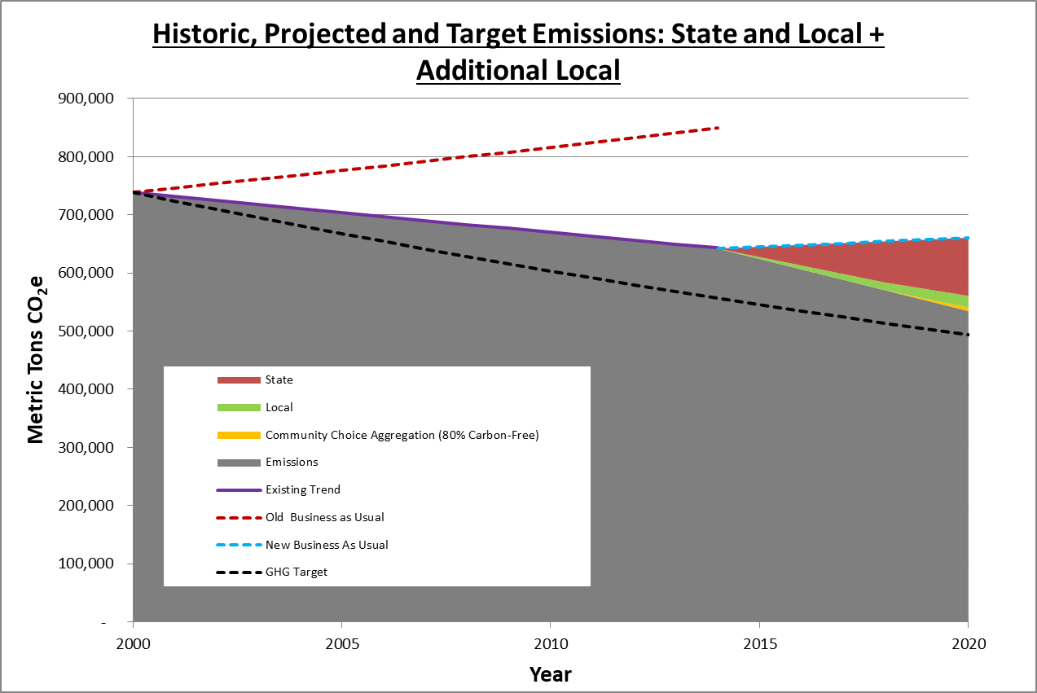

Figure 5: Visualizing GHG Reductions

# Taking Action

In the following chapters, a series of objectives with supporting actions are explored for each emissions sector. An “Objective” is a goal, end result, or target, and an “Action” is a means of realizing the objective. Each sector draws on the actions of the local government, residents, and businesses, although some areas may be largely one or the other.

## Emissions Reduction Potential

Calculating expected emissions reductions for each objective and action requires making assumptions about degree of implementation, technology, and individual behavioral changes several years into the future. The uncertainty associated with these assumptions makes it difficult to assign exact reduction totals to each objective or action. To address this uncertainty and provide a simple but useful reference for reduction potential, a series of symbols and percentage ranges has been devised to represent the emission reductions associated with each objective and its actions:

|  |  |
| --- | --- |
| Symbol | GHG Reduction |
|  | [Small Impact Range] |
|  | [Moderate Impact Range] |
|  | [Significant Impact Range] |

Specific implementation assumptions and GHG reduction estimates are listed in the Appendix.

**Symbols are a good alternative to listing specific reduction figures since results will vary to some degree. Choose the ranges for each symbol depending on the expected emissions reductions from proposed actions. Or, if your local government prefers to display actual values to represent GHG reduction potential, delete this symbol guide. If you choose this approach, it is recommended that you use round figures, so as not to convey a false sense of precision.**

## Evaluating Co-Benefits

In addition to measuring the GHG reduction potential, each objective and action is also evaluated for other benefits such as public health, equity and justice, jobs and prosperity, and environmental conservation. The symbols below will indicate which co-benefits a measure will generate.

**Feel free to use these symbols or create your own.**

|  |  |
| --- | --- |
| Symbol | Co-Benefit |
|  | Supports jobs and economic prosperity |
|  | Advances social equity |
|  | Fosters resource security |
|  | Improves public health and local environmental quality |

## Supporting Actions

Certain actions might be supportive of more than one objective within the same or another sector. These cross-cutting actions will be indicated in the “Supporting Actions” column for each objective.

## New and Existing Actions

This Climate Action Plan includes a combination of existing policies and programs as well as new ideas based on best practices from around the country. Whether an action is new or existing is noted in the action heading.

**It is necessary to detail out the implementation activities, indicators/metrics, and timelines for the strategies. This may be included in this document in the tables below or in an internal implementation plan.**

## Consistency with Statewide Climate Action Plan

The Commonwealth of Pennsylvania’s 2021 Climate Action Plan includes many actions that are meant to be implemented by local governments as well as on the state-level. This Climate Action Plan incorporates as many of those actions as possible and appropriate. The tables in the following chapters will allow you to indicate whether an action is adapted from the statewide plan.

## Climate Adaptation

**[Modify text as necessary]**

Some of the proposed actions reduce risk to climate hazards as well as greenhouse gas emissions, which is explicitly identified in the “Reduces Climate Risks” column. This Plan does not propose any actions that would foreseeably increase the community’s risk to climate hazards, but some actions are more directly supportive of climate adaptation than others. The “Climate Adaptation” chapter describes climate hazards and related actions in more detail.

**\*\* NOTES ON STATEWIDE CAP CONSISTENCY\*\***

**Read & Delete**

**Pennsylvania’s most recent** [**Climate Action Plan (CAP)**](https://www.dep.pa.gov/citizens/climate/Pages/PA-Climate-Action-Plan.aspx) **was issued in September 2021. All of the strategies applicable to local governments are listed here for your reference, but reviewing the detailed descriptions of these strategies in the statewide CAP is encouraged. Local governments should consider proposing actions that align with the existing or proposed state programs, policies, and objectives mentioned below, as feasible and relevant.**

**Residential & Commercial Buildings:**

* Support energy efficiency through building codes
  + This strategy involves the compliance of state and local building codes with the most recent International Energy Efficiency Code (IECC)
* Improve residential and commercial energy efficiency (electricity)
  + This strategy includes the expansion of Act 129 and the establishment and growth of a Commercial Building Energy Performance Program.
  + Specific ways to improve efficiency of electricity usage include but are not limited to:
    - Building envelope improvements (e.g., better windows, insulation, and air sealing)
    - New and more efficient appliances and equipment
    - Lighting retrofits (e.g., LED and other advanced technologies)
    - Changes to heating and cooling systems (e.g., ground-source or air-source heat pumps, variable refrigerant flow, and ductless systems).
* Improve residential and commercial energy efficiency (gas)
  + This strategy includes creating a new energy efficiency program focused on reducing gas consumption that is similar to the voluntary gas demand-side management (DSM) programs already in place with some Pennsylvania gas utilities.
  + Specific ways to improve efficiency of natural gas usage include but are not limited to:
    - Building-envelope improvements (e.g., better windows, insulation, and air sealing)
    - New and more efficient appliances and equipment
    - Changes to heating and cooling systems (e.g., enhanced building controls, high-efficiency boilers, and high-efficiency hot water heaters).
* Incentivize building electrification
  + This strategy includes incentivizing building electrification (e.g.,heating and hot water) for the residential and commercial sectors. It also includes a new program focused on beneficial electrification, possibly modeled on the New York Clean Heat program. This includes incentives for converting fuel oil and natural gas use to electricity use in existing buildings and electrification of new buildings when there are large natural gas infrastructure costs or when fuel oil is the alternative
* Introduce state appliance efficiency standards
* Increase distributed on-site solar
  + This strategy includes the installation of on-site distributed solar in both the residential and commercial sectors.
* Take actions to promote and advance CPACE financing and other tools for net-zero buildings and high-performance buildings

**Transportation:**

* Increase fuel efficiency of all light duty vehicles and reduce vehicle miles traveled for single occupancy vehicles
  + This strategy models a reduction of vehicle miles traveled (VMT) for single-occupancy vehicles by implementing travel-demand solutions such as shifting travel mode choice, making travel more efficient, and increasing telecommuting. VMT reduction efforts are paired with land-use and development policies that promote and incentivize sustainable transportation modes (e.g., walking, biking, transit) in densely populated urban areas and assume the expansion of options for sustainable mobility to and from urban centers (bus rapid transit, carpool) in the medium and long terms
* Increase adoption of light-duty electric vehicles
  + This strategy includes increasing the adoption of light-duty electric passenger vehicles, including private and municipal fleet vehicles. Assuming a moderate EV adoption scenario from the Pennsylvania Electric Vehicle Roadmap, the modeling assumes that electric vehicles will represent 20% of the light-duty market share by 2030, rising to 70% by 2050.

**Industry:**

* Increase industrial energy efficiency and fuel switching
  + This strategy includes leveraging DEP programs (e.g., the Energy Efficiency, Environment, and Economics [E4] Initiative) and implementing the types of actions outlined in the Clean Energy Program Plan, which was developed by DEP’s Energy Programs Office. This strategy would rely on tools such as virtual training and expanded partnerships to reach smaller and hard-to-reach industries. In addition to energy efficiency measures, industrial opportunities that switch from fuel oil to natural gas and measures to switch from natural gas to electricity are included in this strategy.

**Fuel Supply:**

* Increase production and use of biogas/renewable gas
  + This strategy involves increasing the production and use of biogas/renewable gas from sources including animal manure, food waste, landfill gas, water resources recovery facilities, agricultural residue, energy crops, forestry residue, and municipal solid waste. This strategy considers the potential for renewable gas and specific applications in Pennsylvania and regionally for a number of feedstocks identified in the 2019 American Gas Foundation RNG report, Penn State University’s RNG analysis, and ICF’s Pennsylvania RNG database. Some feedstocks for RNG will be used in direct combined heat and power (CHP) applications, although most of the RNG supply will be injected into the pipeline to decarbonize the gas supply in Pennsylvania.
* Incentivize and increase use of distributed Combined Heat and Power
  + This strategy includes incentivizing and increasing the use of distributed CHP with microgrids, particularly for high-value applications such as critical facilities (e.g., hospitals) and industrial facilities. High-value applications are those with critical power requirements that can operate CHP systems continuously and are able to utilize all the available electricity and thermal energy. This maximizes the operational efficiency, emission reductions, and resiliency benefits associated with the CHP installations. Critical infrastructure and industrial facilities meet these criteria, making them suitable locations for CHP operations.
* Reduce methane emissions across oil and natural gas systems
  + This strategy includes the implementation of practices to reduce methane emissions from upstream and midstream oil and gas operations. This strategy reflects reductions in methane emissions as a co-benefit of the ongoing rulemaking to curb VOC emissions from oil and gas operations. It also includes voluntary mitigation technologies that would be implemented across operations to further reduce methane emissions beyond regulatory requirements. Methane mitigation actions vary in cost, complexity, and reduction effectiveness. Common technologies include the installation of vapor recovery units, routing blowdown gas to flare, replacement of reciprocating rod-packing systems, and implementing leak detection and repair programs.

**Electricity Generation:**

* Create a carbon emissions free grid
  + Although this is a statewide policy that will benefit local governments whether they take action or not, local governments can support the effectiveness of this strategy by reducing and eventually eliminating energy sourced by stationary fuel combustion (natural gas, propane, etc), through encouraging electrification.

**Agriculture:**

* Use programs, tools, and incentives to increase energy efficiency for agriculture
  + This strategy includes programs, tools, and incentives to increase energy efficiency for agricultural end uses such as refrigeration, ventilation, and lighting.
* Provide trainings and tools to implement agricultural best practices
  + This strategy includes trainings and tools to implement agricultural best practices, such as those focused on no-till farming practices and integrated farm management to reduce the amount of GHGs emitted by farmlands. Practices could include rotational grazing, silvopasture, and organic and regenerative agricultural methods.

**Land Use and Forestry:**

* Increase land and forest management for natural sequestration
  + Pennsylvania’s 6.9 million hectares (17 million acres) of forest land are estimated to sequester about 34 million MTCO2e annually. Of several natural strategies evaluated for their potential to increase the carbon sequestration of forestland in Pennsylvania, extending harvest cycles and reforestation showed the highest potential. Afforestation of abandoned/legacy mine lands and marginalized croplands (cropland uncultivated due to challenging soil conditions) offer additional opportunities through expansion on land with no competing uses.
  + Land management strategies that increase carbon sequestration include:
    - Reforestation of forest and urban open spaces, suitable shrub and grass areas, pasture, and marginal crop land
    - Afforestation (establishment of new forest) on abandoned mine lands
    - Extend harvest cycles, where feasible (on state, private, and other lands) coupled with a 5% increase in long-lived wood products.

**Waste:**

* Reduce food waste
* Reduce waste generated by citizens and businesses and expand beneficial use of waste

# Commercial Buildings

**Provide a summary of the overall vision, types of actions included in the focus area, and its importance to the overall Plan.**

Energy consumed in commercial buildings and industrial processes account for [XX]% of [Jurisdiction]’s total GHG emissions. Improving the efficiency of our commercial building stock and reducing the energy intensity of the local industrial sector will contribute significantly to achieving [Jurisdiction]’s greenhouse gas reduction target. This chapter focuses on opportunities to retrofit existing commercial and industrial buildings and to ensure that future activities in these sectors are compatible with our community’s climate protection goals.

**The following tables contain sample objectives and actions. Please update the text and symbols accordingly.**

|  |  |  |  |
| --- | --- | --- | --- |
| **Objective** | **Supporting Actions** | **Co-Benefits** | **Reduction Potential** |
| CB 1 – Retrofit existing commercial and industrial buildings to achieve a [XX]% reduction in energy use by [Year] | RB 1, EP 1 |  |  |
| CB 2 – Ensure new commercial and industrial construction is built to maximize energy efficiency | CB 1,  RB 2 |  |  |
| [Other Objective] | [X] |  |  |
| [Other Objective] | [X] |  |  |
| [Other Objective] | [X] |  |  |

|  |  |  |
| --- | --- | --- |
| Objective CB 1 – Existing Commercial and Industrial Buildings | | |
| Retrofit existing commercial and industrial buildings to achieve a [XX]% reduction in energy use by [Year] |  |  |

|  |  |  |  |  |  |  |  |
| --- | --- | --- | --- | --- | --- | --- | --- |
| Action Number | Action | New (N) or Existing (E) | Statewide CAP Action | Reduces Climate Risk | Co-Benefits | Lead Actor | Metric |
| CB-1A EXAMPLE | Partner with local utility companies to ensure commercial properties maximize use of energy efficiency rebate programs | N | Y |  |  | Community and Buildings Dept | Number of partnerships |
| CB- 1B EXAMPLE | Require benchmarking and disclosure of energy use in commercial and industrial buildings over [XX] square feet | N | Y |  |  | Utility, Bldgs & Finance Dept | Number of buildings using benchmarking |
| CB-1C  EXAMPLE | Establish PACE program and/or partner with utilities to offer on-bill financing for commercial energy efficiency retrofit projects | N | N |  |  | Utility, Bldgs & Finance Dept | Number of PACE projects |
|  |  |  |  |  |  |  |  |
|  |  |  |  |  |  |  |  |

# Residential Buildings

**Provide a summary of the overall vision, types of actions included in the focus area, and its importance to the overall Plan.**

Energy consumed in residential buildings accounts for [XX]% of [Jurisdiction]’s total GHG emissions. Improving the efficiency of our residential building stock will contribute significantly to achieving [Jurisdiction]’s greenhouse gas reduction target, while saving residents money on utility bills and reducing the need for new infrastructure. This chapter focuses on opportunities to retrofit existing residential buildings, increase the quality of new construction, and to ensure that future activities in these sectors are compatible with our community’s climate protection goals.

**The following tables contain sample objectives and actions. Please update the text and symbols accordingly.**

|  |  |  |  |
| --- | --- | --- | --- |
| **Objective** | **Supporting Actions** | **Benefits** | **Reduction Potential** |
| **RB 1 – Retrofit existing residential buildings and homes to achieve a [XX]% reduction in energy use by [Year]** | [X] |  |  |
| **RB 2 – Ensure new residential buildings and homes are built to maximize energy efficiency** | [X] |  |  |
| **[Other Objective]** | [X] |  |  |
| **[Other Objective]** | [X] |  |  |
| **[Other Objective]** | [X] |  |  |

|  |  |  |
| --- | --- | --- |
| Objective RB 1 – Existing Residential Buildings | | |
| Retrofit existing residential buildings and homes to achieve a [XX]% reduction in energy use by [Year] |  |  |

|  |  |  |  |  |  |  |  |
| --- | --- | --- | --- | --- | --- | --- | --- |
| Action Number | Action | New (N) or Existing (E) | Statewide CAP Action | Reduces Climate Risk | Co-Benefits | Lead Actor | Metric |
| RB-1A | Double the number of homes weatherized through existing programs per year | E | N | Y |  | Community and Buildings Dept | Number of homes weatherized |
| RB- 1B | Offer financing vehicle to residential sector for energy retrofits | N | N | Y |  | Utility, Bldgs & Finance Dept | Financing program finalized |
| RB-1C | Increase residential uptake of utility incentives for energy efficiency | N | N | Y |  | Utility, Bldgs & Finance Dept | Number of residents participating |
|  |  |  |  |  |  |  |  |
|  |  |  |  |  |  |  |  |

|  |  |  |
| --- | --- | --- |
| Objective RB 2 – New Residential Buildings | | |
| Ensure new residential buildings and homes are built to maximize energy efficiency |  |  |

|  |  |  |  |  |  |  |  |
| --- | --- | --- | --- | --- | --- | --- | --- |
| Action Number | Action | New (N) or Existing (E) | Statewide CAP Action | Reduces Climate Risk | Co-Benefits | Lead Actor | Metric |
| RB-2A | Improve building codes to exceed minimum efficiency requirements by XX% | N | Y | Y |  | Community and Buildings Dept | Number of homes weatherized |
| RB- 2B | [strategy description] | - | - | - |  | Utility, Bldgs & Finance Dept | Financing program finalized |
| RB-2C | [strategy description] | - | - | - |  | Utility, Bldgs & Finance Dept | Number of residents participating |

# Energy Production

**Provide a summary of the overall vision, types of actions included in the sector, and its importance to the overall Plan.**

Broadly speaking, the use of fossil fuels for energy (including electricity, heating, transportation, and other uses) is the single largest contributor to greenhouse gas emissions and climate change. Fossil fuels still supply a considerable share of energy for electricity, heating, transportation, and other energy-producing uses. Emissions from fossil fuel combustion for energy, including transportation, represent [XX]% of the community’s total GHG emissions. Energy Production is a cross-cutting sector in that nearly all activities that take place in the community require energy of some sort. While [Local Utility] is working hard to increase the percentage of electricity generated through renewable sources, opportunities also exist for citizens and [Jurisdiction’s] local government to produce small-scale renewable energy or fuels, offsetting the need for fossil fuels. This sector is limited to energy production exclusively – objectives and actions that focus on end use energy efficiency are included in other sectors. The programs and projects within this sector are designed to spur local government and community investment in renewable energy sources including those that produce electricity, heat, and mobile fuels.

**The following tables contain sample objectives and actions. Please update the text and symbols accordingly.**

|  |  |  |  |
| --- | --- | --- | --- |
| **Objective** | **Supporting Actions** | **Benefits** | **Reduction Potential** |
| EP 1 – Enhance support to residents for installing small-scale renewable energy systems | CB 1, RB 1 |  |  |
| EP 2 – Supply [XX]% of [Jurisdiction] local government electricity demand via local renewable generation | CB 1 |  |  |
| EP 3 – Promote local production of biofuels and harness waste energy | WR 1, WW 1 |  |  |
| [Other Objective] | [X] |  |  |
| **[Other Objective]** | [X] |  |  |

|  |  |  |
| --- | --- | --- |
| Objective EP 1 – Small-Scale Renewable Energy Systems | | |
| Enhance support to residents for installing small-scale renewable energy systems |  |  |

|  |  |  |  |  |  |  |  |
| --- | --- | --- | --- | --- | --- | --- | --- |
| Action Number | Action | New (N) or Existing (E) | Statewide CAP Action | Reduces Climate Risk | Co-Benefits | Lead Actor | Metric |
| EP-1A EXAMPLE | Encourage community partners to finance and install renewable systems on large-scale private facilities | N | Y | N/A |  | Community, Economic Dev Committee | Number of partnerships |
| EP- 1B EXAMPLE | Establish a program to offer renewable energy system financing to small commercial properties | N | Y | N/A |  | Community, Local Bank, Bldgs, Finance, Legal Depts, Utility Experts | Program establishment |
| EP-1C  EXAMPLE | [strategy description] | - | - | - |  | - | - |

|  |  |  |
| --- | --- | --- |
| Objective EP 2 – Local Renewable Generation for [Jurisdiction] | | |
| Supply [XX]% of [Jurisdiction] local government electricity demand via local renewable generation |  |  |

|  |  |  |  |  |  |  |  |
| --- | --- | --- | --- | --- | --- | --- | --- |
| Action Number | Action | New (N) or Existing (E) | Statewide CAP Action | Reduces Climate Risk | Co-Benefits | Lead Actor | Metric |
| EP-2A EXAMPLE | Install renewable energy systems on [jurisdiction]-owned facilities such that [20]% of total energy demand of local government buildings is met. | N | Y | N/A |  | PW Dept | Number of RE systems installed; percentage of energy demand met |
| EP- 2B EXAMPLE | Execute renewable power purchase agreement with [Utility] for 30% of total electricity demand of local government buildings | N | Y | N/A |  | PW Dept, Utility | Establishment of RE power purchase |

# Waste, Composting, & Recycling

**Provide a summary of the overall vision, types of actions included in the sector, and its importance to the overall Plan.**

[Jurisdiction]’s solid waste is disposed of, primarily, at [Name of Landfill], **provide description of landfill location**. Emissions from decaying putrescible material directly contribute [XX]% of [Jurisdiction]’s total GHG emissions and contribute to emissions in the Transportation sector via hauling of waste to and from facilities. Additionally, embodied energy within the items that we throw away might be harnessed through reuse and recycling of materials. It is in [Jurisdiction]’s long-term interest to reduce waste at its source, expand recycling facilities, reduce food waste, and enable re-use of materials. This chapter focuses on opportunities to reduce waste, reuse materials, and recycle what cannot be reused.

**The following tables contain sample objectives and actions. Please update the text and symbols accordingly.**

|  |  |  |  |
| --- | --- | --- | --- |
| **Objective** | **Supporting Actions** | **Benefits** | **Reduction Potential** |
| WR 1 – Reduce solid waste generation by [XX]% by [Year] | CB 1, RB 1 |  |  |
| **WR 2 - [objective description]** | CB 1 |  |  |
|  | WR 1, WW 1 |  |  |
|  | [X] |  |  |
|  | [X] |  |  |

|  |  |  |
| --- | --- | --- |
| Objective WR 1 – Reduce Solid Waste | | |
| Reduce solid waste generation by [XX]% by [Year] |  |  |

|  |  |  |  |  |  |  |  |
| --- | --- | --- | --- | --- | --- | --- | --- |
| Action Number | Action | New (N) or Existing (E) | Statewide CAP Action | Reduces Climate Risk | Co-Benefits | Lead Actor | Metric |
| WR-1A EXAMPLE | Establish “Building Materials Reuse Warehouse” for community construction and demolition use. | N | N | N/A |  | Solid Waste, PW, Bldg Depts | Establishment of warehouse |
| WR - 1B EXAMPLE | [Strategy description] | - | - | - |  | - | - |
| WR -1C  EXAMPLE | [Strategy description] | - | - | - |  | - | - |
|  |  |  |  |  |  |  |  |
|  |  |  |  |  |  |  |  |

# Water & Wastewater Management

**Provide a summary of the overall vision, types of actions included in the sector, and its importance to the overall Plan.**

**This section largely pertains to those local governments who own their own water delivery or wastewater services, or are partners in a multi-jurisdictional water delivery and treatment arrangement. It is also possible for local governments to partner with water utilities to accomplish these goals, if privately or otherwise owned or operated.**

This sector does not include the methane collection system; please refer to Energy Production sector for this project.

**The following tables contain sample objectives and actions. Please update the text and symbols accordingly.**

|  |  |  |  |
| --- | --- | --- | --- |
| **Objective** | **Supporting Actions** | **Benefits** | **Reduction Potential** |
| WW 1 – Upgrade the energy efficiency of water delivery and treatment systems by 15% | CB 1, RB 1 |  |  |
| **WW 2 - [objective description]** | CB 1 |  |  |
|  | WR 1, WW 1 |  |  |
|  | [X] |  |  |
|  | [X] |  |  |

|  |  |  |
| --- | --- | --- |
| Objective WW 1 – Energy Efficiency | | |
| Upgrade the energy efficiency of water delivery and treatment systems by 15% by ___ |  |  |

|  |  |  |  |  |  |  |  |
| --- | --- | --- | --- | --- | --- | --- | --- |
| Action Number | Action | New (N) or Existing (E) | Statewide CAP Action | Reduces Climate Risk | Co-Benefits | Lead Actor | Metric |
| WW -1A EXAMPLE | Upgrade the mechanical and electrical systems at [Water or Wastewater Facility] | N | Y | Y |  | Co-owners, PW Dept | Number of systems upgraded |
| WW- 1B EXAMPLE | Participate in [Utility] energy efficiency incentive programs to upgrade pump efficiency | N | N | Y |  | PW Dept | Program participation |
| WW -1C  EXAMPLE | [Strategy description] | - | - | - |  | - | - |
|  |  |  |  |  |  |  |  |
|  |  |  |  |  |  |  |  |

# Transportation

**Provide a summary of the overall vision, types of actions included in the sector, and its importance to the overall Plan.**

Emissions from transportation is a common sight to nearly everyone in [Jurisdiction]. Besides emitting greenhouse gases, transportation fossil fuels also produce a host of criteria air pollutants when combusted, reducing local air quality and affecting our health. Transportation accounts for [X]% of [Jurisdiction]’s total GHG emissions. This chapter focuses on programs and policies to reduce emissions from transportation and includes design-oriented approaches as well as expansion of alternate modes such as walking, biking, or public transportation to and from the most common destinations in [Jurisdiction].

**The following tables contain sample objectives and actions. Please update the text and symbols accordingly.**

|  |  |  |  |
| --- | --- | --- | --- |
| **Objective** | **Supporting Actions** | **Benefits** | **Reduction Potential** |
| TR 1 – **Reduce vehicle miles traveled by single-occupancy vehicles by XX% by XXXX** | CB 1, RB 1 |  |  |
| TR 2 – Electrify all municipal fleet and buses by 2050 | CB 1 |  |  |
| **TR 3 – Build electric vehicle accommodations into development requirements** | WR 1, WW 1 |  |  |
| **TR 4 –** | [X] |  |  |
|  | [X] |  |  |

|  |  |  |
| --- | --- | --- |
| Objective TR 1 – Reduce single-occupancy vehicles | | |
| Reduce vehicle miles traveled by single-occupancy vehicles by XX% by XXXX |  |  |

|  |  |  |  |  |  |  |  |
| --- | --- | --- | --- | --- | --- | --- | --- |
| Action Number | Action | New (N) or Existing (E) | Statewide CAP Action | Reduces Climate Risk | Co-Benefits | Lead Actor | Metric |
| TR-1A EXAMPLE | Expand existing XX bus route to XX street and add XX more stops | - | - | - |  | - | - |
| TR- 1B EXAMPLE | Incorporate designated carpool parking requirements into the development code | - | - | - |  | - | - |
| TR-1C  EXAMPLE | Convert major corridors, including XX street, into complete streets | - | - | - |  | - | - |
|  |  |  |  |  |  |  |  |
|  |  |  |  |  |  |  |  |

# Agriculture & Forestry

**Summary of the overall vision, types of actions included in the sector, and its importance to the overall Plan.**

|  |  |  |  |
| --- | --- | --- | --- |
| **Objective** | **Supporting Actions** | **Benefits** | **Reduction Potential** |
| AG 1 – **[objective description]** | CB 1, RB 1 |  |  |
| **AG 2 - [objective description]** | CB 1 |  |  |
|  | WR 1, WW 1 |  |  |
|  | [X] |  |  |
|  | [X] |  |  |

**Please update the text and symbols accordingly.**

|  |  |  |
| --- | --- | --- |
| Objective AG 1 – | | |
|  |  |  |

|  |  |  |  |  |  |  |  |
| --- | --- | --- | --- | --- | --- | --- | --- |
| Action Number | Action | New (N) or Existing (E) | Statewide CAP Action | Reduces Climate Risk | Co-Benefits | Lead Actor | Metric |
| AG-1A EXAMPLE | [description] | - | - | - |  | - | - |
| AG - 1B EXAMPLE | [description] | - | - | - |  | - | - |
| AG -1C  EXAMPLE | [description] | - | - | - |  | - | - |
|  |  |  |  |  |  |  |  |
|  |  |  |  |  |  |  |  |

# Climate Adaptation

[Example introduction text provided below and should be modified as appropriate]

This section provides a high-level assessment of potential climate impacts and highlights those greenhouse gas reduction actions that support adaptation for each type of hazard. While the [Jurisdiction] does not currently have the capacity to complete a more robust climate vulnerability assessment and adaptation plan, the following analysis was completed to educate the public on local impacts and inform future efforts. **If applicable, add a narrative of how the community intends to more thoroughly address climate impacts in the future.**

**As appropriate, include a narrative about actions that the community is already taking to address climate impacts, such as through an existing Climate Adaptation Plan, Hazard Mitigation Plan and/or Emergency Preparedness Plan. Make sure to explicitly discuss existing or planned efforts to help protect and prepare the most vulnerable populations in your community.**

**If your community would like to have a more in-depth adaptation component to the Plan, this section can be modified to include a more robust vulnerability assessment, and you can either (1) add adaptation-specific objectives/measures to this section, or (2) for more depth, add adaptation-specific chapters for each applicable community sector or hazard by copy-and-pasting the mitigation sector chapters, changing the chapter titles, and updating the placeholder text to reflect your adaptation objectives and actions, or (3) incorporate both mitigation and adaptation objectives/measures into the same chapters, which may require changing or redefining the example sectors provided. For this option, you might still find it appropriate to include some chapters that are mitigation- or adaptation-specific.**

## Anticipated Climate Impacts

Over the last 110 years, the Commonwealth of Pennsylvania has experienced a long-term warming of more than 1.8°F, as well as an increasing number of wet months. The warming and wetting trend is expected to continue at an accelerated rate, especially if the world continues on its current path of greenhouse gas emissions. As compared to a 1977-2000 baseline, the average annual statewide temperature will likely increase 5.9°F by mid-century and 9.4°F by end-of-century. Compared to the same baseline, average precipitation will likely increase about 8% by mid-century and 12% by end-of-century. Furthermore, the Commonwealth is likely to see an increase in the frequency and intensity of extreme heat events and extreme rainfall events. The extent of drought conditions is less predictable at this time, but higher overall temperatures will increase evaporative demand and reduce water availability. These changes will have a variety of ecological, economic, and social impacts on the Commonwealth, particularly related to agriculture, energy, forests, human health, outdoor recreation, water, wetlands and aquatic ecosystems, and coastal resources (PA DEP, 2021). See more details about statewide climate projections and risks in the [Pennsylvania Climate Impacts Assessment](http://www.depgreenport.state.pa.us/elibrary/GetDocument?docId=3667348&DocName=PENNSYLVANIA%20CLIMATE%20IMPACTS%20ASSESSMENT%202021.PDF%20%20%3cspan%20style%3D%22color:green%3b%22%3e%3c/span%3e%20%3cspan%20style%3D%22color:blue%3b%22%3e%28NEW%29%3c/span%3e%204/30/2023), updated in 2021.

In order to understand the extent to which these statewide impacts will be felt in [Jurisdiction], the following resources were reviewed to identify likely changes from today through [Year].

* [List resources…]

**The next sections should summarize hazards and vulnerabilities identified in any regional or local climate vulnerability assessments. If your community does not have a regional or local vulnerability assessment, the following resources are available for details and illustrations on regional and local climate impacts:**

* [Pennsylvania Climate Impacts Assessment Update](https://www.dep.pa.gov/citizens/climate/Pages/impacts.aspx) includes projections for the whole Commonwealth, and breaks down some information by region. Feel free to pull figures directly from this report.
* [U.S. Climate Explorer](https://toolkit.climate.gov/tools/climate-explorer) provides locationally specific projections for temperature and precipitation in the form of exportable charts.
* [Temperate](http://www.temperate.io) is a license-based software that identifies top hazards for your community based on the National Climate Assessment, and allows you to view, customize, and download projection charts. A Temperate license also includes features to help your community do a comprehensive vulnerability assessment and build an adaptation strategy.

**This is also a chance to report concerns you heard when conducting your community meetings.**

**EXAMPLE:**

### Rising Temperatures & Heat

The following graph indicates that average daily temperatures have been increasing and will continue to rise through 2090, which could impact agriculture, public health, and other sectors of the community

**This graph is from U.S. Climate Explorer.**

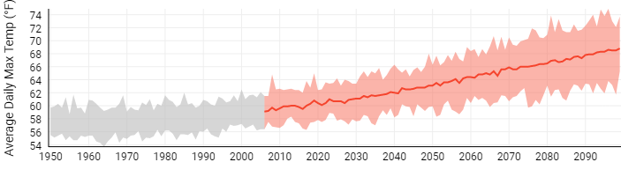

Figure 5: Average Daily Temperature Between 1950-2090

## Adaptive Greenhouse Gas Reduction Measures

Some greenhouse gas reduction measures also reduce risk to climate hazards. The following are a few of many examples of how these outcomes can be related to one another:

**This is not an exhaustive list of potential synergies between mitigation and adaptation, but it presents some of the most common examples. Modify this list according to the types of measures included in your climate action plan, or indicate if an example action is currently not feasible but might be in the future.**

* Actions that improve energy efficiency and distribute renewable energy can (1) reduce pressure on the grid when there is higher energy demand for heating and air conditioning during extreme heat events, and (2) increase energy independence for households and businesses, as opposed to complete reliance on centralized power infrastructure that could fail during a catastrophic event. These types of actions include, but are not limited to:
  + Energy-efficient building design for new construction, and retrofits for existing buildings (e.g. weatherization)
  + Onsite combined heat and power (CHP)
  + Smart grid technologies
  + Microgrids
* Actions that reduce impervious surfaces can reduce the potential for flooding by retaining stormwater in place. These types of actions include, but are not limited to:
  + Expanding or restoring green space
  + Installing green roofs, rain gardens, bioswales, pervious pavers, and other green infrastructure (as well as requiring them for future development)
* Installing green roofs and planting trees adjacent to buildings can regulate indoor temperatures during extreme heat events
* Expanding and protecting alternative transportation routes (bicycle, pedestrian, bus, and rail) provides network redundancies and alternative routes for emergency evacuation
* Water efficiency and conservation actions can (1) reduce pressure on the grid from energy used for pumping, treating, and distributing water, and (2) make the community less vulnerable to drought

The following table identifies specific greenhouse gas reduction actions from the previous chapters that have the potential to reduce risk from climate hazards, and which hazards they address.

**Populate this table with those actions you marked “Y” in the “Reduces Climate Risk” column.**

|  |  |  |  |  |  |
| --- | --- | --- | --- | --- | --- |
| **Action** | **Extreme Temperatures** | **Flooding** | **Drought** | **Seasonal Variations** | **[Other Hazard]** |
| XX-1A **EXAMPLE** | X |  | X |  |  |
|  |  |  |  |  |  |

# Implementation & Monitoring

This chapter describes the process [Jurisdiction] will follow to implement the Climate Action Plan and monitor progress.

## Implementing the Climate Action Plan

The following matrix summarizes the actions contained within this plan, a timeline that reflects priority and feasibility, status (if an existing action), the entities responsible for implementation, potential funding mechanism/source, and metrics to monitor progress.

|  |  |  |
| --- | --- | --- |
| Acronyms:  **[add any acronyms you will be using in the table]** | | |
| **Status:**  NS= Not Started  IP = In Progress  C = Complete  O = Ongoing | **Departments:**  CDD = Community Development Dept  Building Dept = BD  **[add others]** | **Funding:**  ST = Staff Time  GF = General Fund  **[add others]** |

**Modify table as appropriate. Example provided.**

Climate Action Plan Implementation Matrix

|  |  |  |  |  |  |  |
| --- | --- | --- | --- | --- | --- | --- |
| Action Number | Action | Timeline | Status* | Responsible Entities | Funding Mechanism / Source** | Metric |
| CB-1C | Establish PACE program and/or partner with utilities to offer on-bill financing for commercial energy efficiency retrofit projects | 0-2 yr | NS | CDD | ST; GF | # PACE projects |
|  |  |  |  |  |  |  |
|  |  |  |  |  |  |  |
|  |  |  |  |  |  |  |
|  |  |  |  |  |  |  |
|  |  |  |  |  |  |  |
|  |  |  |  |  |  |  |
|  |  |  |  |  |  |  |
|  |  |  |  |  |  |  |

**Please note that your community can include additional implementation details, such as an outline of the steps to be taken to complete the action, in an appendix or in a separate document following adoption of the CAP.**

**Describe the next steps in the process to implementing the action plan. This may include further outreach efforts to stakeholder groups, additional feasibility studies that may need to be taken, identification of funding sources, and identification of key partners that will be required for successful implementation.**

**EXAMPLE TEXT:**

Starting in Month, Year, the Climate Action Planning Task Force will prepare for any prerequisite or additional actions needed to begin plan implementation according to the timeline in the Implementation Matrix.

These prerequisite actions include:

* Creating citizen advisory groups for programs that require considerable community engagement.
* Gathering bids for contracted services and equipment.
* Making necessary changes to local policies or existing programs, including staffing.
* [Other steps the community intends to take immediately to kick off programs, and provide ways for citizens to become involved with the Climate Action Plan.]

## Monitoring Progress of the Climate Action Plan

Establishing a monitoring process enables [Jurisdiction] to track the impacts of the actions included in the plan and compare estimated impacts to what is actually achieved in terms of energy savings, renewable energy production, and GHG emissions reduction. Assessing the implementation status of the actions will allow determination of whether the action is performing well and to identify corrective measures. This process is also an opportunity to understand barriers to implementation and identify best practices or new opportunities in moving forward.

Starting in [year], progress reports are to occur every [X] years and will include status updates on each action within this plan, including any known metrics of impact (e.g. reduction in residential kWh and the corresponding GHG emissions). Every [X] years, the progress report will also include an updated community GHG inventory to illustrate progress towards the reduction target(s) and allow [jurisdiction] to evaluate the need for any modification to the original targets, objectives, and/or actions of this Climate Action Plan.

**As necessary, check on the Jurisdiction’s climate commitments for specific requirements for monitoring, implementing, and updating the CAP. For example, if signed on to Global Covenant of Mayors (GCoM) there are specific timelines that the Jurisdiction needs to follow for compliance – e.g. the GHG inventory must be updated every two years.**

# References

Intergovernmental Panel on Climate Change (IPCC). (2014). *Synthesis Report. Contribution of Working Groups I, II and III to the Fifth Assessment Report of the Intergovernmental Panel on Climate Change [Core Writing Team, R.K Pachauri, and L.A. Meyer (eds.)].* Geneva, Switzerland: Cambridge University Press.

IPCC. (2014). *Climate Change 2014: Synthesis Report. Contribution of Working Groups I, II, and III tothe Fifth Assessment Report of the IPCC [Core Writing Team, R.K. Pachauri, and L.A. Meyer (eds.)].* Geneva, Switzerland.

IPCC. (2014). *Summary for Policymakers. In: Climate Change 2014: The Physical Science Basis. Contribution of Working Group I to the Fifth Assessment Report of the Intergovernmental Panel on Climate Change [Solomon, S., D. Qin, M. Manning, Z. Chen, M. Marquis, K.B. Av.* Cambridge, U.K. and New York, NY, USA.: Cambridge University Press.

PA DEP. (2021). *Climate Change*. Retrieved from Pennsylvania Department of Environmental Protection: <https://www.dep.pa.gov/Citizens/climate/Pages/default.aspx>

PA DEP. (2021). *Pennsylvania Climate Impacts Assessment 2021*. Retrieved from [http://www.depgreenport.state.pa.us/elibrary/GetDocument?docId=3667348&DocName=PENNSYLVANIA%20CLIMATE%20IMPACTS%20ASSESSMENT%202021.PDF%20%20%3cspan%20style%3D%22color:green%3b%22%3e%3c/span%3e%20%3cspan%20style%3D%22color:blue%3b%22%3e%28NEW%29%3c/span%3](http://www.depgreenport.state.pa.us/elibrary/GetDocument?docId=3667348&DocName=PENNSYLVANIA%20CLIMATE%20IMPACTS%20ASSESSMENT%202021.PDF%20%20%3cspan%20style%3D%22color:green%3b%22%3e%3c/span%3e%20%3cspan%20style%3D%22color:blue%3b%22%3e%28NEW%29%3c/span%253)

PA DEP. (2021). *Pennsylvania Greenhouse Gas Inventory*. Retrieved from <https://files.dep.state.pa.us/Energy/Office%20of%20Energy%20and%20Technology/OETDPortalFiles/Climate%20Change%20Advisory%20Committee/2021/2021_GHG_Inventory_Report_2021-09-02.pdf>

Pennsylvania Department of Environmental Protection (PA DEP). (2021). *Pennsylvania Climate Action Plan*. Retrieved from <http://www.depgreenport.state.pa.us/elibrary/GetDocument?docId=3925177&DocName=2021%20PENNSYLVANIA%20CLIMATE%20ACTION%20PLAN.PDF%20%20%3cspan%20style%3D%22color:green%3b%22%3e%3c/span%3e%20%3cspan%20style%3D%22color:blue%3b%22%3e%28NEW%29%3c/span%3e%209/2>

Shortle et al. 2015. (n.d.). *Climate Impacts Assessment Update.* Retrieved from PA Department of Environmental Protection: <http://www.depgreenport.state.pa.us/elibrary/GetDocument?docId=5002&DocName=2015%20PENNSYLVANIA%20CLIMATE%20IMPACTS%20ASSESSMENT%20UPDATE.PDF%20>

Shortle, J. (2015). *Climate Change.* Retrieved November 14, 2019, from Pennsylvania Department of Environmental Protection (PA DEP): <https://www.pennfuture.org/Files/Admin/Pennsylvania-Climate-Impacts-Assessment-Update---2700-BK-DEP4494.compressed.pdf>

Appendix I: GHG Quantification Methodology

**This appendix details GHG calculation methods and other technical information gathered and used throughout the report.**

## Greenhouse Gas Inventory

**More details on the GHG inventory may be included here or referenced if there is already a separate report. The following is a template for documenting GHG data sources and assumptions if you choose to include them here.**

Edit the following tables according to the data you collected and used in your inventory.

### Energy

The following table shows each activity related to energy consumption, data source, and notes on data gaps.

Table 3: Energy Data Sources

|  |  |  |
| --- | --- | --- |
| **Activity** | **Data Source** | **Data Gaps/Assumptions** |
| **Community-wide** | | |
| Residential, commercial, and industrial electricity consumption |  |  |
| Residential, commercial, and industrial natural gas consumption |  |  |
| Residential [Non-utility Fuel] Consumption |  |  |
| Residential [Non-utility Fuel] Consumption |  |  |
| Residential [Non-utility Fuel] Consumption |  |  |

If you have multiple emissions factors to represent multiple utilities, add another row and change column Title from “Year” to “Emissions Factor.” Then delete this Line.

Table 4: Emissions Factors for Electricity Consumption

|  |  |  |  |
| --- | --- | --- | --- |
| **Year** | **CO2 (lbs./MWh)** | **CH4 (lbs./GWh)** | **N2O (lbs./GWh)** |
| [Baseline Year] |  |  |  |

### Transportation

Table 5: Transportation Data Sources

|  |  |  |
| --- | --- | --- |
| **Activity** | **Data Source** | **Data Gaps/Assumptions** |
| **Community-wide** | | |
| Vehicle miles travelled |  |  |
| Transit ridership |  |  |

For vehicle transportation, it is necessary to apply average miles per gallon and emissions factors for CH4 and N2O to each vehicle type. The factors used are shown in Table 6.

Table 6: MPG and Emissions Factors by Vehicle Type

|  |  |  |  |  |
| --- | --- | --- | --- | --- |
| **Fuel** | **Vehicle type** | **MPG** | **CH4 g/mile** | **N2O g/mile** |
| Gasoline | Passenger car |  |  |  |
| Gasoline | Light truck |  |  |  |
| Gasoline | Heavy truck |  |  |  |
| Gasoline | Motorcycle |  |  |  |
| Diesel | Passenger car |  |  |  |
| Diesel | Light truck |  |  |  |
| Diesel | Heavy truck |  |  |  |

### Wastewater

|  |  |  |
| --- | --- | --- |
| **Activity** | **Data Source** | **Data Gaps/Assumptions** |
| **Community-wide Operations** | | |
| Nitrogen Discharge |  |  |
| Digester Gas Combustion/Flaring |
| Energy used in wastewater facilities [if reported separately, omit if not] |  |  |

### Potable Water [if reported separately, omit if not]

|  |  |  |
| --- | --- | --- |
| **Activity** | **Data Source** | **Data Gaps/Assumptions** |
| **Community-wide** | | |
|  |  |  |
|  |  |  |

### Solid Waste

|  |  |  |
| --- | --- | --- |
| **Activity** | **Data Source** | **Data Gaps/Assumptions** |
| **Community-wide** | | |
|  |  |  |
|  |  |  |

### Fugitive Emissions

|  |  |  |
| --- | --- | --- |
| **Activity** | **Data Source** | **Data Gaps/Assumptions** |
| **Community-wide** | | |
|  |  |  |
|  |  |  |

### Inventory Calculations

The [Baseline Year] inventory was calculated following the US Community Protocol and ICLEI’s ClearPath software. As discussed in Inventory Methodology, the [IPCC __th Assessment] was used for global warming potential (GWP) values to convert methane and nitrous oxide to CO2 equivalent units. ClearPath’s inventory calculators allow for input of the sector activity (i.e. kWh or VMT) and emission factor to calculate the final CO2e emissions.

## Forecast and Reduction Modeling

**If appropriate, you can also include any assumptions made in the forecast and reduction models that are not already described in the body of the document.**

Appendix II: Climate Change Science

**For some communities, this section might be unnecessary. An alternative is to simply provide links to scientific articles here for those who would like more information, such as** [**PA DEP’s 2021 Climate Impacts Assessment.**](http://www.depgreenport.state.pa.us/elibrary/GetDocument?docId=3667348&DocName=PENNSYLVANIA%20CLIMATE%20IMPACTS%20ASSESSMENT%202021.PDF%20%20%3cspan%20style%3D%22color:green%3b%22%3e%3c/span%3e%20%3cspan%20style%3D%22color:blue%3b%22%3e%28NEW%29%3c/span%3e%204/30/2023)

**If your community would like to add more details about local/regional climate change projections than what is provided in the Climate Adaptation chapter, feel free to add to the text below as necessary.**

**The climate change science section should communicate the importance of climate change to the community. Put the issue in local context by adding to the global and regional data presented here, if not already addressed in the Climate Adaptation chapter.**

The Intergovernmental Panel on Climate Change (IPCC)’s *Global Warming of 1.5°C* Special Report affirms that “temperature rise to date has already resulted in profound alterations to human and natural systems, including increases in droughts, floods, and some other types of extreme weather; sea level rise; and biodiversity loss – these changes are causing unprecedented risks to vulnerable persons and populations.”**[1]** Researchers have made progress in their understanding of how the Earth’s climate is changing in space and time through improvements and extensions of numerous datasets and data analyses, broader geographical coverage, better understanding of uncertainties and a wider variety of measurements.**[2]** These refinements expand upon the findings of previous IPCC Assessments – today, in the IPCC Sixth Assessment Report, observational evidence from all continents and most oceans shows that “with further global warming, every region is projected to increasingly experience concurrent and multiple changes in climatic impact-drivers.”[3]

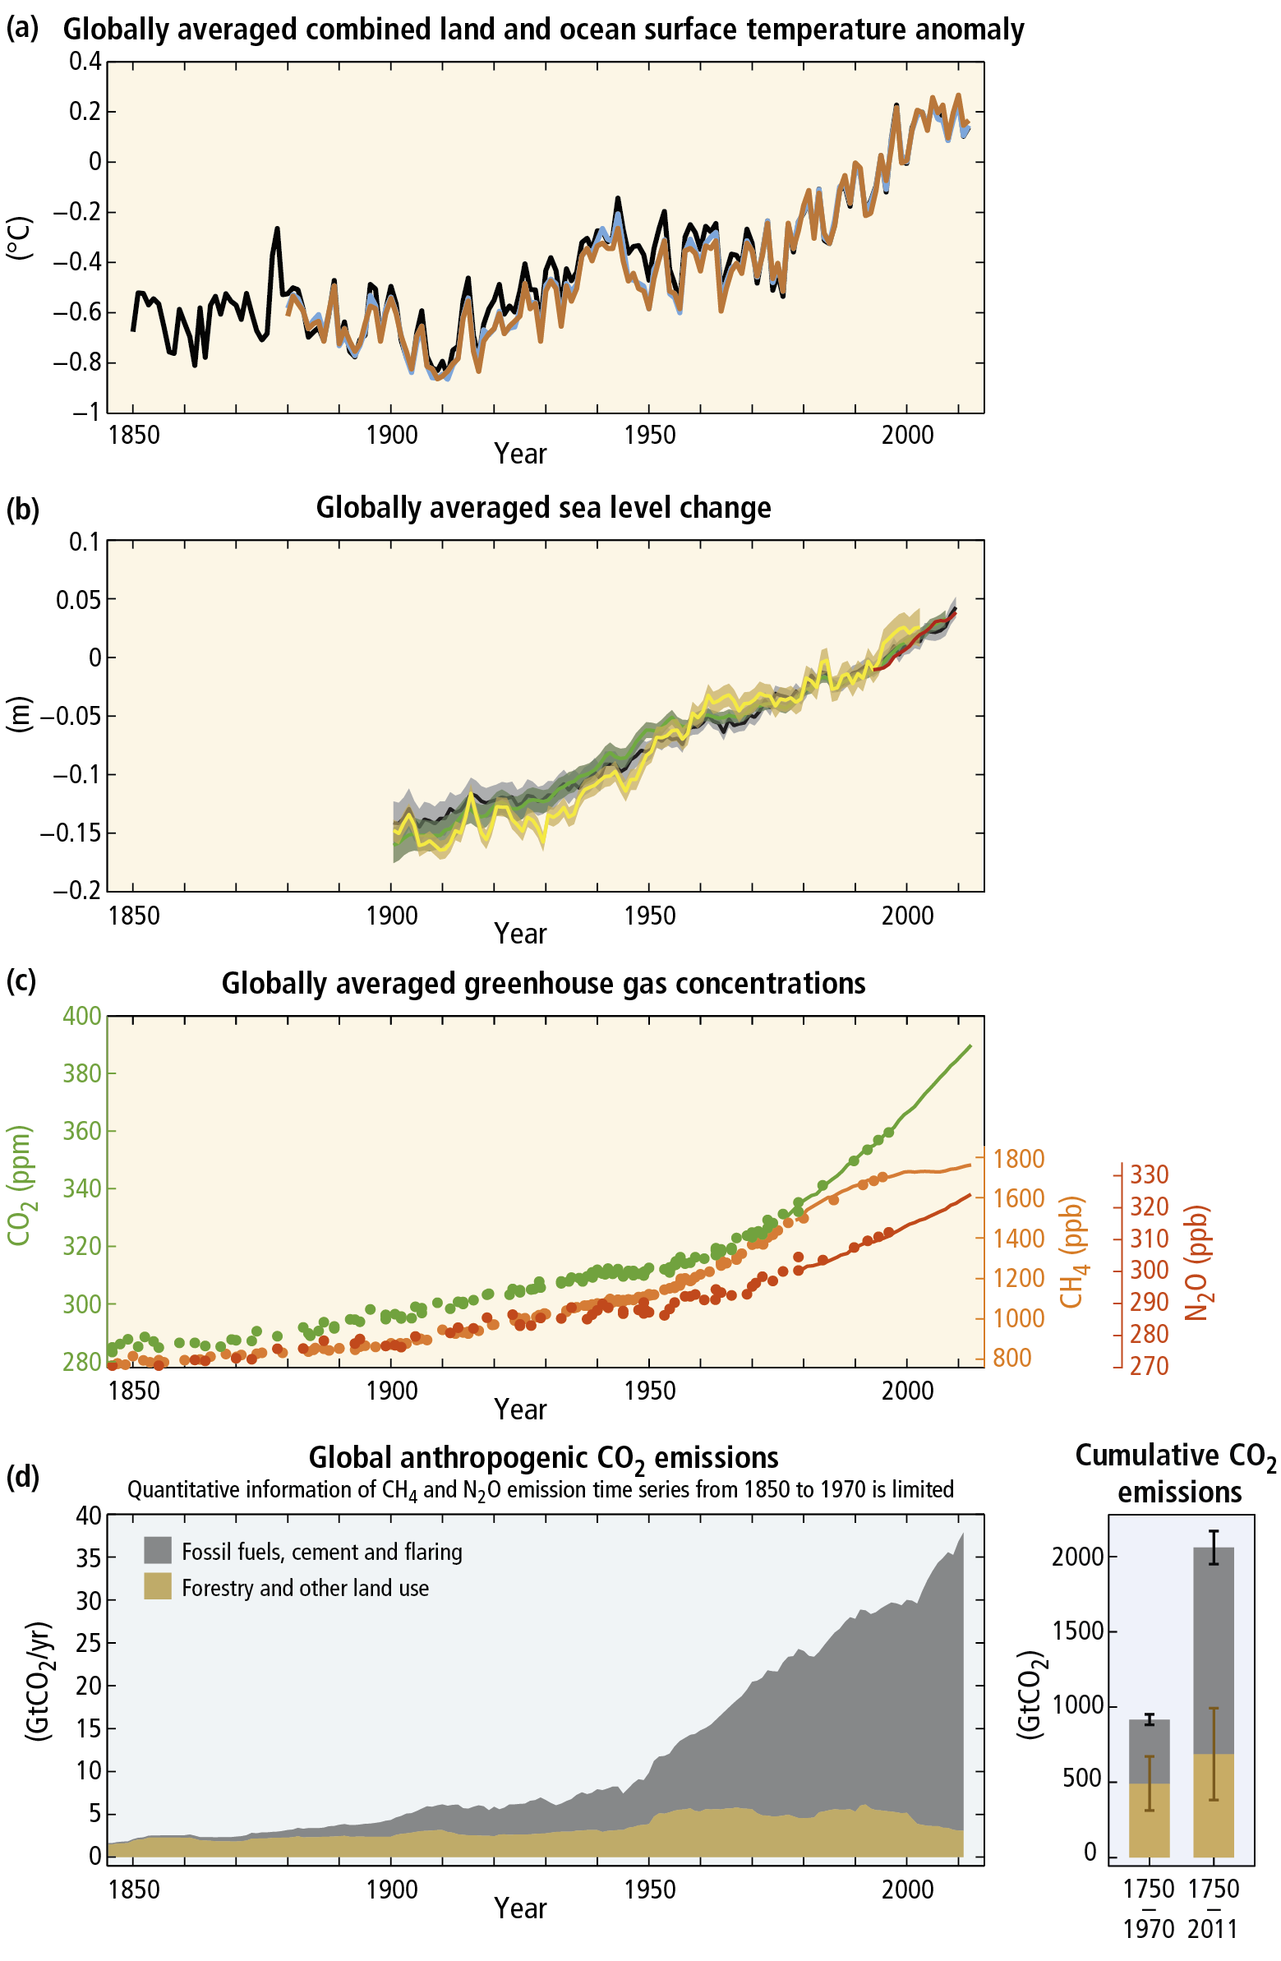

**Figure 1**: Observations and other indicators of a changing global climate system[4]

The IPCC Sixth Assessment asserts that “each of the last four decades have been successively warmer than any decade that preceded it since 1850. The likely range of total human-caused global surface temperature increase from 1850-1900 to 2010-2019 is 0.8°C to 1.3°C. Human influence is very likely the main driver of the global retreat of glaciers since the 1990s and the decrease in Arctic sea ice area between 1979–1988 and 2010–2019.” Lastly, “human-induced climate change is already affecting many weather and climate extremes in every region across the globe. Evidence of observed changes in extremes such as heatwaves, heavy precipitation, droughts, and tropical cyclones, and, in particular, their attribution to human influence, has strengthened since AR5.”[5]

In short, the Earth is already responding to climate change drivers introduced by mankind.

### Temperatures and Extreme Events are Increasing Globally

Surface temperature is projected to continue to rise until at least the mid-century under all assessed emission scenarios. Subsequently, increased global warming also includes the frequency and intensity of hot extremes, marine heatwaves, extreme precipitation, agricultural and ecological droughts, tropical cyclones, and the reduction in Arctic sea ice, snow cover, and permafrost. The ocean will continue to warm and acidify, and global mean sea level to rise. Changes in many extreme weather and climate events have been observed since about 1950. Some of these changes have been linked to human influences, including a decrease in cold temperature extremes, an increase in warm temperature extremes, an increase in extreme high sea levels and an increase in the number of heavy precipitation events in a number of regions.[6]

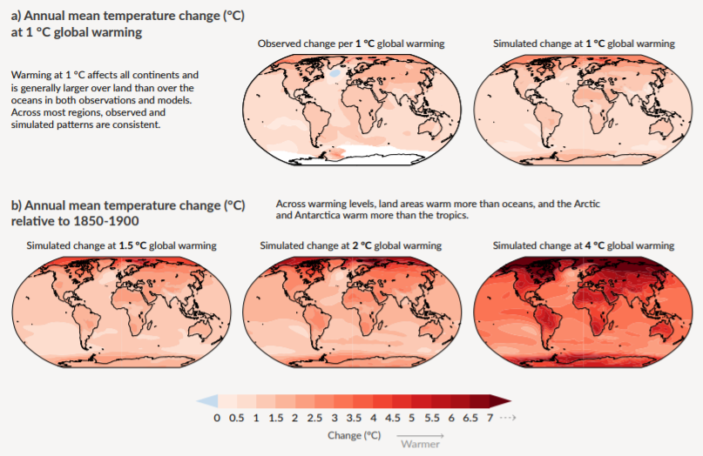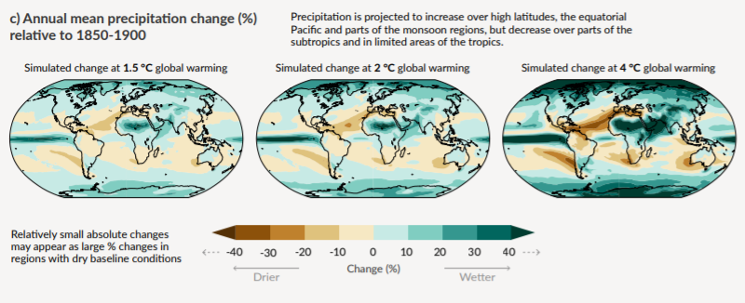

**Figure 2**: Change in average surface temperature, precipitation and soil moisture. Panel a) shows the comparison between observed and simulated surface temperature at 1°C global warming. Relative to 1850-1900, panel b) highlights simulated surface temperature changes at global warming levels of 1.5°C, 2°C and 4°C, whereas, panel c) shows simulated precipitation changes when global warming levels of 1.5°C, 2°C and 4°C are applied.[7]

### Climate Risks

Climate change is projected to undermine food security. Due to projected climate change by the mid-21st century and beyond, global marine species redistribution and marine biodiversity reduction in sensitive regions will challenge the sustained provision of fisheries productivity and other ecosystem services. For wheat, rice and maize in tropical and temperate regions, climate change without adaptation is projected to negatively impact production for local temperature increases of 2°C or more above late 20th century levels, although individual locations may benefit. Global temperature increases of ~4°C or more above late 20th century levels, combined with increasing food demand, would pose large risks to food security globally. Climate change is projected to reduce renewable surface water and groundwater resources in most dry subtropical region, intensifying competition for water among sectors.

Until mid-century, projected climate change will impact human health mainly by exacerbating health problems that already exist. Throughout the 21st century, climate change is expected to lead to increases in ill-health in many regions and especially in developing countries with low income, as compared to a baseline without climate change. Health impacts include greater likelihood of injury and death due to more intense heat waves and fires, increased risks from foodborne and waterborne diseases and loss of work capacity and reduced labor productivity in vulnerable populations. Risks of undernutrition in poor regions will increase. Risks from vector-borne diseases are projected to generally increase with warming, due to the extension of the infection area and season, despite reductions in some areas that become too hot for disease vectors.

In urban areas climate change is projected to increase risks for people, assets, economies and ecosystems, including risks from heat stress, storms and extreme precipitation, inland and coastal flooding, landslides, air pollution, drought, water scarcity, sea level rise and storm surges. These risks are amplified for those lacking essential infrastructure and services or living in exposed areas. Rural areas are expected to experience major impacts on water availability and supply, food security, infrastructure and agricultural incomes, including shifts in the production areas of food and non-food crops around the world.

Climate change is projected to increase displacement of people. Populations that lack the resources for planned migration experience higher exposure to extreme weather events, particularly in developing countries with low income. Climate change can indirectly increase risks of violent conflicts by amplifying well-documented drivers of these conflicts such as poverty and economic shocks.[8]

### Regional and Local Impacts

Because the impacts of climate change vary geographically, it is important to know what effects are specifically expected for your corner of the globe.

**Insert specific local impacts that are not addressed in the body of the document; use regional or local climate vulnerability assessments.**

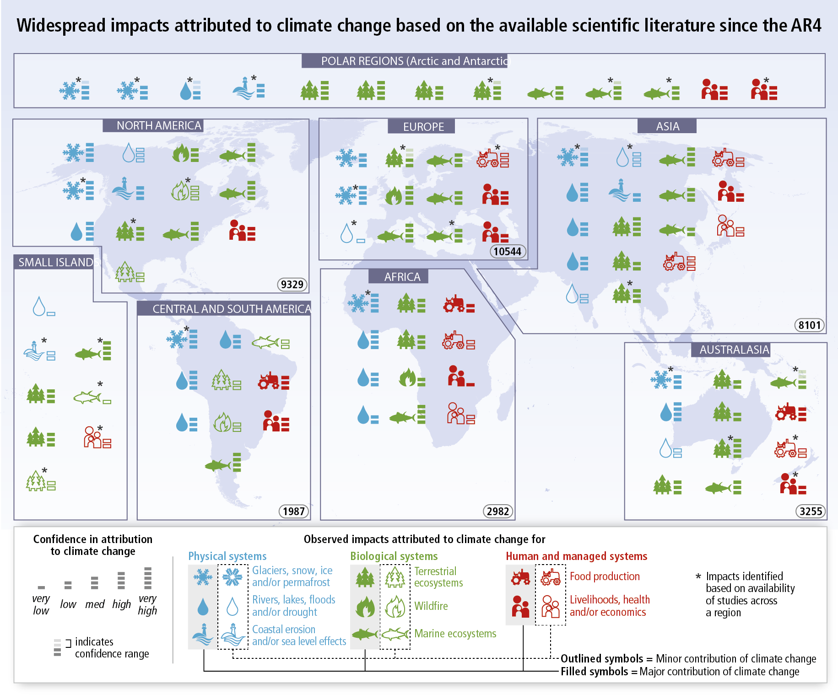

**Figure 3:** Climate impacts around the world. Symbols indicate categories of attributed impacts, the relative contribution of climate change (major or minor) to the observed impact and confidence in attribution. Numbers in ovals indicate regional totals of climate change publications from 2001 to 2010, based on the Scopus bibliographic database for publications in English with individual countries mentioned in title, abstract or key words (as of July 2011). These numbers provide an overall measure of the available scientific literature on climate change across regions; they do not indicate the number of publications supporting attribution of climate change impacts in each region. Studies for polar regions and small islands are grouped with neighboring continental regions.[9]

### Greenhouse Gas Emissions Must be Reduced

The recent and massive buildup of greenhouse gases in our atmosphere is conceivably more extraordinary than changes observed thus far regarding temperature, sea level, and snow cover in the Northern hemisphere in that current levels greatly exceed recorded precedent going back much further than the modern temperature record.

Anthropogenic greenhouse gas emissions have increased since the pre-industrial era driven largely by economic and population growth. In 2019, emissions concentrations were higher than at any time in the last two million years.[10] Historical emissions have increased atmospheric concentrations of carbon dioxide, methane and nitrous oxide to a rate ten times faster than any sustained rise of CO2 in the last 800,000 years, leading to an uptake of energy by the climate system. [11]

In response to the problem of climate change, many communities in the United States are taking responsibility for addressing emissions at the local level. Since many of the major sources of greenhouse gas emissions are directly or indirectly controlled through local policies, local governments have a strong role to play in reducing greenhouse gas emissions within their boundaries. Through proactive measures around land use patterns, transportation demand management, energy efficiency, green building, and waste diversion, local governments can dramatically reduce emissions in their communities. In addition, local governments are primarily responsible for the provision of emergency services and the mitigation of natural disaster impacts. While this Plan is designed to reduce overall emissions levels, as the effects of climate change become more common and severe, local government adaptation policies will be fundamental in preserving the welfare of residents and businesses.

Appendix III: Task Force and Community Engagement Activities

**[Use this appendix to include supporting documentation for the task force and community engagement activities, such as meeting agendas, presentation, notes, survey results, etc. OR delete this appendix and instead provide these documents on your CAP webpage]**

1. Allen, M.R., O.P. Dube, W. Solecki, F. Aragón-Durand, W. Cramer, S. Humphreys, M. Kainuma, J. Kala, N. Mahowald, Y. Mulugetta, R. Perez, M.Wairiu, and K. Zickfeld, 2018: Framing and Context. In: *Global Warming of 1.5°C. An IPCC Special Report on the impacts of global warming of 1.5°C above pre-industrial levels and related global greenhouse gas emission pathways, in the context of strengthening the global response to the threat of climate change, sustainable development, and efforts to eradicate poverty* [Masson-Delmotte, V., P. Zhai, H.-O. Pörtner, D. Roberts, J. Skea, P.R. Shukla, A. Pirani, W. Moufouma-Okia, C. Péan, R. Pidcock, S. Connors, J.B.R. Matthews, Y. Chen, X. Zhou, M.I. Gomis, E. Lonnoy, T. Maycock, M. Tignor, and T. Waterfield (eds.)]. In Press. 53 pp.
2. IPCC, 2018: Summary for Policymakers. In: *Global Warming of 1.5°C. An IPCC Special Report on the impacts of global warming of 1.5°C above pre-industrial levels and related global greenhouse gas emission pathways, in the context of strengthening the global response to the threat of climate change, sustainable development, and efforts to eradicate poverty* [Masson-Delmotte, V., P. Zhai, H.-O. Pörtner, D. Roberts, J. Skea, P.R. Shukla, A. Pirani, W. Moufouma-Okia, C. Péan, R. Pidcock, S. Connors, J.B.R. Matthews, Y. Chen, X. Zhou, M.I. Gomis, E. Lonnoy, T. Maycock, M. Tignor, and T. Waterfield (eds.)]. In Press.
3. IPCC, 2021: Summary for Policymakers. In: Climate Change 2021: The Physical Science Basis. Contribution of Working Group I to the Sixth Assessment Report of the Intergovernmental Panel on Climate Change [MassonDelmotte, V., P. Zhai, A. Pirani, S. L. Connors, C. Péan, S. Berger, N. Caud, Y. Chen, L. Goldfarb, M. I. Gomis, M. Huang, K. Leitzell, E. Lonnoy, J. B. R. Matthews, T. K. Maycock, T. Waterfield, O. Yelekçi, R. Yu and B. Zhou (eds.)]. Cambridge University Press. In Press.
4. IPCC, 2014: Climate Change 2014: Synthesis Report. Contribution of Working Groups I, II and III to the Fifth Assessment Report of the Intergovernmental Panel on Climate Change [Core Writing Team, R.K Pachauri, and L.A. Meyer (eds.)]. Geneva, Switzerland, 151 pp
5. IPCC, 2021: Summary for Policymakers. In: Climate Change 2021: The Physical Science Basis. Contribution of Working Group I to the Sixth Assessment Report of the Intergovernmental Panel on Climate Change [MassonDelmotte, V., P. Zhai, A. Pirani, S. L. Connors, C. Péan, S. Berger, N. Caud, Y. Chen, L. Goldfarb, M. I. Gomis, M. Huang, K. Leitzell, E. Lonnoy, J. B. R. Matthews, T. K. Maycock, T. Waterfield, O. Yelekçi, R. Yu and B. Zhou (eds.)]. Cambridge University Press. In Press.
6. Ibid.
7. IPCC, 2021: Summary for Policymakers. In: Climate Change 2021: The Physical Science Basis. Contribution of Working Group I to the Sixth Assessment Report of the Intergovernmental Panel on Climate Change [MassonDelmotte, V., P. Zhai, A. Pirani, S. L. Connors, C. Péan, S. Berger, N. Caud, Y. Chen, L. Goldfarb, M. I. Gomis, M. Huang, K. Leitzell, E. Lonnoy, J. B. R. Matthews, T. K. Maycock, T. Waterfield, O. Yelekçi, R. Yu and B. Zhou (eds.)]. Cambridge University Press. In Press.
8. Hoegh-Guldberg, O., D. Jacob, M. Taylor, M. Bindi, S. Brown, I. Camilloni, A. Diedhiou, R. Djalante, K.L. Ebi, F. Engelbrecht, J.Guiot, Y. Hijioka, S. Mehrotra, A. Payne, S.I. Seneviratne, A. Thomas, R. Warren, and G. Zhou, 2018: Impacts of 1.5ºC Global Warming on Natural and Human Systems. In: Global Warming of 1.5°C. An IPCC Special Report on the impacts of global warming of 1.5°C above pre-industrial levels and related global greenhouse gas emission pathways, in the context of strengthening the global response to the threat of climate change, sustainable development, and efforts to eradicate poverty [Masson-Delmotte, V., P. Zhai, H.-O. Pörtner, D. Roberts, J. Skea, P.R. Shukla, A. Pirani, W. Moufouma-Okia, C. Péan, R. Pidcock, S. Connors, J.B.R. Matthews, Y. Chen, X. Zhou, M.I.Gomis, E. Lonnoy, T.Maycock, M.Tignor, and T. Waterfield (eds.)]. In Press
9. IPCC, 2014: Climate Change 2014: Synthesis Report. Contribution of Working Groups I, II and III to the Fifth Assessment Report of the Intergovernmental Panel on Climate Change [Core Writing Team, R.K Pachauri, and L.A. Meyer (eds.)]. Geneva, Switzerland, 151 pp
10. Ibid.
11. Allen, M.R., O.P. Dube, W. Solecki, F. Aragón-Durand, W. Cramer, S. Humphreys, M. Kainuma, J. Kala, N. Mahowald, Y. Mulugetta, R. Perez, M.Wairiu, and K. Zickfeld, 2018: Framing and Context. In: Global Warming of 1.5°C. An IPCC Special Report on the impacts of global warming of 1.5°C *above pre-industrial levels and related global greenhouse gas emission pathways, in the context of strengthening the global response to the threat of climate change, sustainable development, and efforts to eradicate poverty* [Masson-Delmotte, V., P. Zhai, H.-O. Pörtner, D. Roberts, J. Skea, P.R. Shukla, A. Pirani, W. Moufouma-Okia, C. Péan, R. Pidcock, S. Connors, J.B.R. Matthews, Y. Chen, X. Zhou, M.I. Gomis, E. Lonnoy, T. Maycock, M. Tignor, and T. Waterfield (eds.)]. In Press.