e-permitting GreenPort
Non-EFA
User's Guide

Prepared by: | Business Support Services
Version: | 2.1
Date: | April 26, 2019

Table of Contents
Disclosure Information 3
Change History 3
Purpose 3
Applications Support Help Desk Team 3
GreenPort Self-Registration and Enrollment 4
Creating a Greenport Account 4
Enrolling into the ePermitting Application as User 7
User Application & Security Agreement Form 8
ePermit Dashboard 10
Accessing the ePermit Dashboard 10
Creating a Draft Permit Application 11
Working Through a Draft Permit Application 12
Types of Data Fields 12
Unlocking Non-Required/Optional Modules 12
Entering Data into Your Draft Application 12
Uploading Attachments 14
Submitting a Permit Application 16
Submitting Permit Applications 16
Paying and Submitting the Application 16
Pay by Credit Card 17
Pay by Telecheck 18
Reviewing and Modifying a Correction Required Permit Application 20
Reviewing and Completing a Correction Required Permit Application 20
Viewing a Previously Submitted Permit Application 22
Viewing Submitted Applications 22

Disclosure Information
The information in this document may not be changed without the express written agreement of the Department of Environmental Protection.

Change History
Version | Date | Revision Description
1.0 | January 12, 2017 | Version for user review.
2.0 | May 4, 2018 | Updates to user review.
2.1 | April 26, 2019 | Version for user review.

Purpose
Welcome to the guide to user administration for the ePermitting website via the DEPGreenPort website.
This guide provides information on how to successfully administer eDMR users on the DEPGreenPort website and use the functions available through the ePermitting Application.

Applications Support Help Desk Team
Help Desk Support Line:
Number: (717) 787-HELP (4357)
Hours: Monday to Friday 8:00 am to 4:30 pm
Applications Support Help Desk Team:
The Applications Support Help Desk Team includes helpdesk specialists, trainers, web masters, on-line help developers, and testing engineers working together to provide complete end-user support for eFACTS and other applications.
Applications Support Help Desk Team's Services:
- Applications Training
- Formalized Classroom Training
- Small Group Training
- One-on-One Training
- Participate in meetings to provide application guidance
- Telephone Support Help Desk
- Application Web Page Development and Maintenance
- Publish articles identifying solutions to common problems
- Application Testing
- Documentation Development
- Application On-Line Help Development and Maintenance

GreenPort Self-Registration and Enrollment
ePermitting users will need to register for a Greenport account on https://www.depgreenport.state.pa.us in order to access the ePermitting application. Users must also submit the User Application & Security Agreement Form to the EFA before they can use the ePermitting application.

Creating a Greenport Account
- Go to https://www.depgreenport.state.pa.us.
The ‘DEP GreenPort Login’ screen will display.
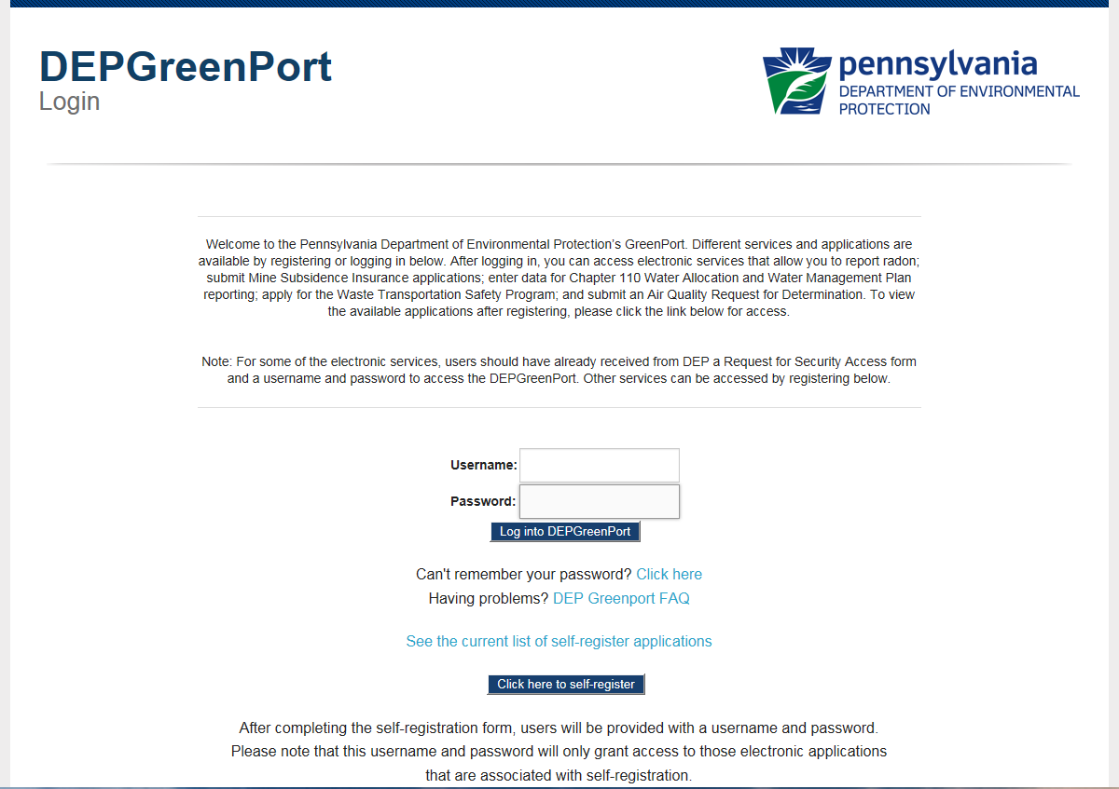

- Click the ‘Click here to self-register’ button.

The ‘Self Registration Name’ page will display.
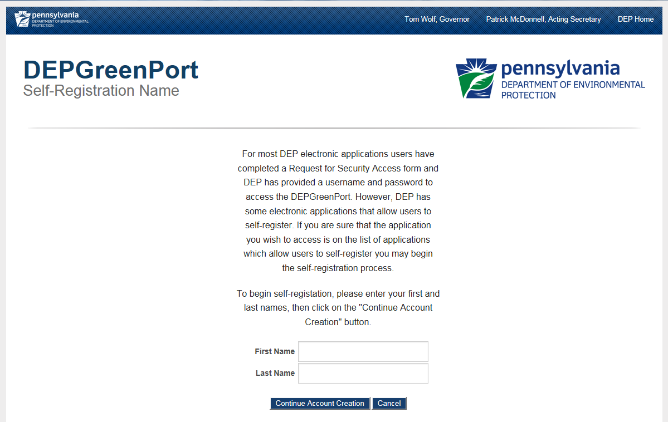

- Enter your First Name in the ‘First Name’ field.
- Enter your Last Name in the ‘Last Name’ field.
Note: Enter YOUR name not the name of the Operator or Company or institution. The name and contact information entered here must be the person who is applying for access and who is signing the EFA or User Agreement Form.
- Click on the ‘Continue Account Creation’ button.

The ‘Create Account” page will display.
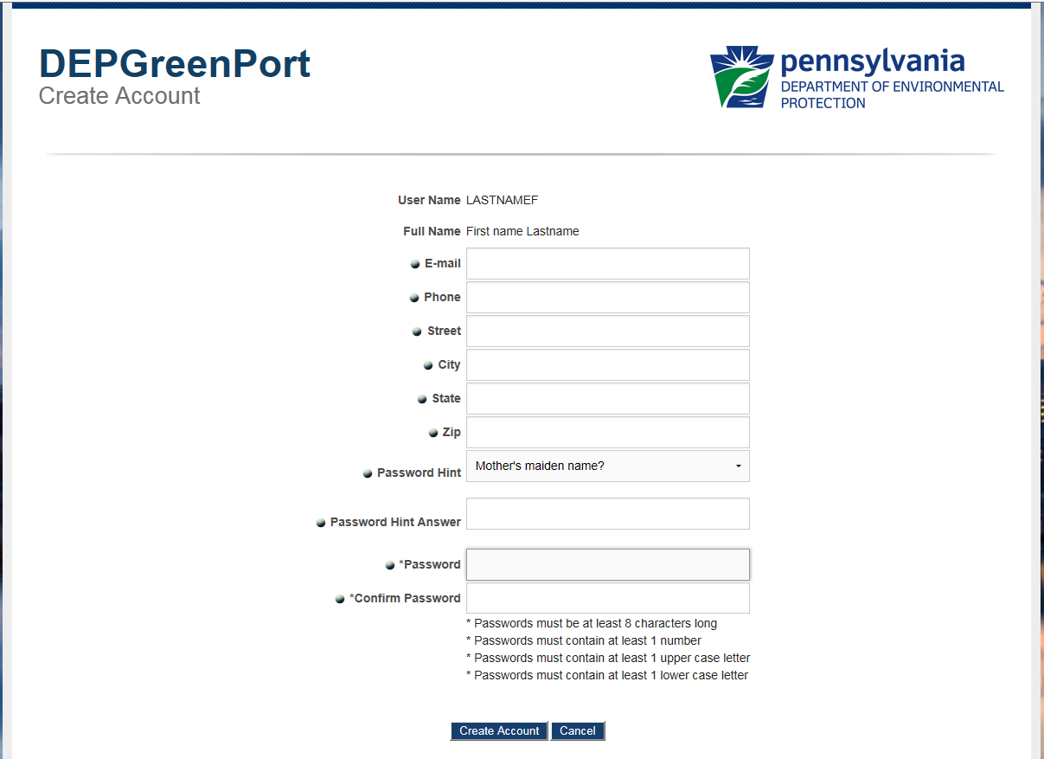
Your User Name

Note: Your User Name and Full Name is displayed at the top of this screen. The Name and Contact Information entered here must be the person who is applying for access and who is signing the EFA or User Agreement Form. The pre-populated username is based on the First and Last Name that was entered on the previous screen.
- Enter your E-mail Address in the ‘e-mail’ field.
- Enter your Telephone Number in the ‘Phone’ field.
- Enter your Street Address in the ‘Street’ field.
- Enter your City in the ‘City’ field.
- Enter your State in the ‘State’ field.
- Enter your Zip Code in the ‘Zip Code’ field.
- Choose a password hint by clicking on the drop-down arrow and selecting a password hint.
- Enter the answer to the Password Hint you had chosen in the ‘Password Hint Answer’ field.
- Enter your Password in the ‘Password’ field.
The Password must be at least:
    - 8 characters long
    - Contain at least 1 number (1, 2, 3…)
    - Contain at least 1 uppercase letter (A, B, C…)
    - Contain at least 1 lower case letter (a, b, c…)

- Confirm your Password by entering it again in the ‘Confirm Password’ field.
- Select the ‘Create Account’ button. If you select the ‘Cancel’ button all information will be erased, and you will be directed back to the previous screen.
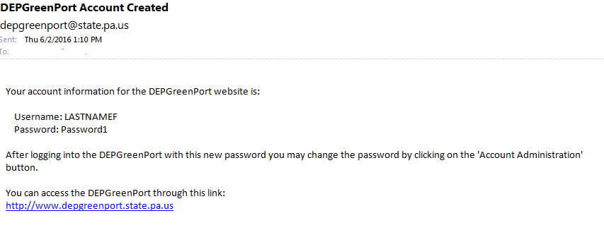
Note: After you click on the ‘Create Account’ button, you will be sent an email message similar to what is shown below.

It is strongly recommended that you record your Password and Username and keep it in an easily accessible and remembered location. If you lose or forget your Password or Username and cannot retrieve it using the “Can’t Remember Password” link, you will need to contact the Applications Support Help Desk to reset it.
Your Username and Password have now been created to access the DEP Greenport application. However, to access the ePermitting page you will need to complete the User Application & Security Agreement form, to be granted access.

Enrolling into the ePermitting Application as User
GreenPort Users are granted authorization by the EFA. Users must first self-register and fill out the User’s Application and Security Agreement Form and give the form to the EFA.
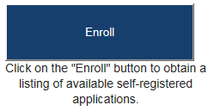
- After a user is registered, the user must sign into the GreenPort using their Username and Password, click on the ‘ENROLL’ button.

- The user will be taken to the ‘DEP GreenPort Self-Registered Available Applications’ page.
- Toward the bottom of the page, the user will click the ‘ePermitting’ button under the section of applications listed as ‘Permitting’.
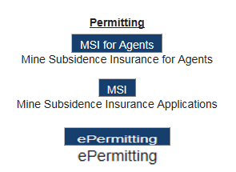
- The user will be taken to the ‘Additional Data Required for access to ePermitting’ page.
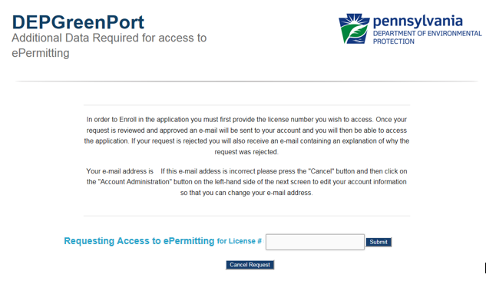

- The user must enter the License # for the Operator that they are requesting to work on behalf of and click the ‘Submit’ button.

An electronic request will be sent to the EFA for the Operator. Once the User Application & Security Agreement Form has been completed and submitted to the EFA, the electronic request can be approved, and the user will be notified that their account has been given access to the ePermitting system.

User Application & Security Agreement Form
Users who wish to work in the ePermitting system on behalf of the Operator must first go to the website below and follow the previous instructions in this guide to create a Greenport account and request enrollment into ePermitting, https://www.depgreenport.state.pa.us.

Users must then submit a User’s Application and Security Agreement form. This form is to be completed and submitted to the Electronic Filing Administrator (EFA) before the user can access the ePermitting system.

The User’s Application & Security Agreement Form is located on the Bureau of Air Quality’s website (http://www.dep.pa.gov/Business/Air/BAQ/Permits/Pages/GeneralPermits.aspx) and must be completed and submitted to the EFA before access can be given.

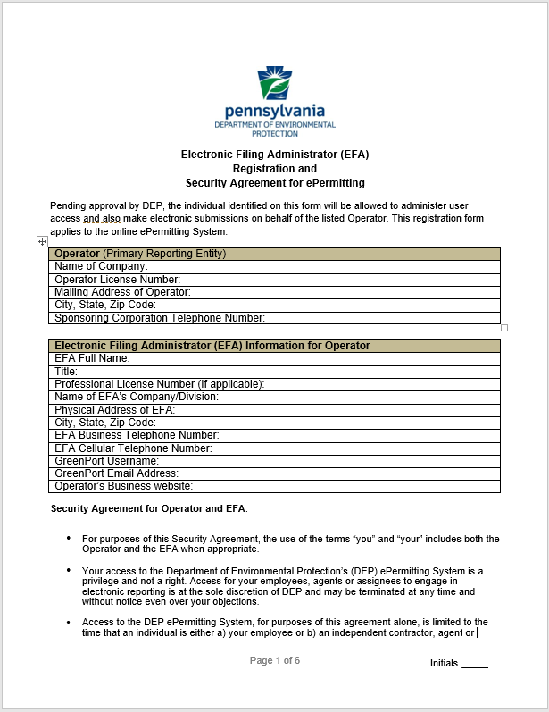

ePermit Dashboard
ePermitting users access the ePermit Dashboard to create, view, modify and/or delete draft authorization applications or previously submitted authorizations based on security roles given by the Electronic Filing Administrator (EFA). Users can view applications that are Draft, Submitted, Correction Required, Approved and/or Withdrawn/Denied.

Accessing the ePermit Dashboard
- Log into Greenport. You will see ePermitting from your list of available applications.
- Click the ‘ePermitting’ button.
The ePermit Dashboard is the ‘Home’ page. It can be accessed at any time by clicking the ‘Home’ button.
Authorized users will see various tabs based on the applications that they have been given access to. In addition, the tabs are only displayed when applications have been submitted that fall into the specific tab category.
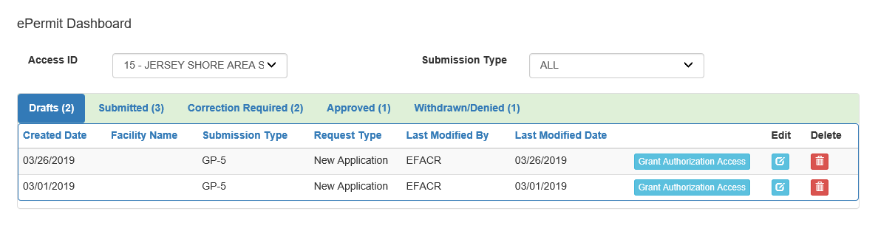

Creating a Draft Permit Application
Authorized ePermitting users can create a new draft permit application from the ePermit Dashboard within the ePermitting application.
From within the ePermitting Application, access the ePermit Dashboard.
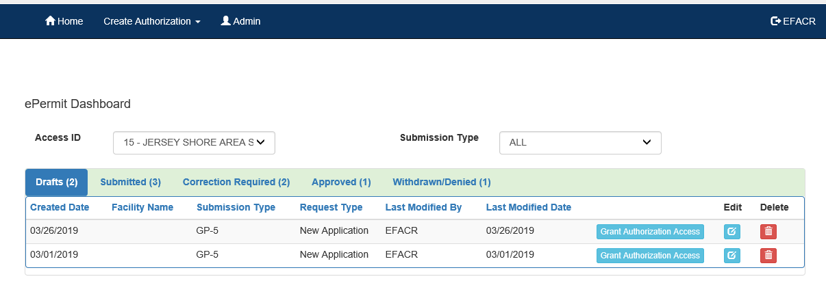
- Click the ‘Create Authorization’ button.

- Mouse over the ‘Authorization Type’ and click the ‘New Application’ button.
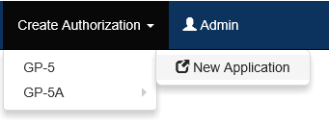
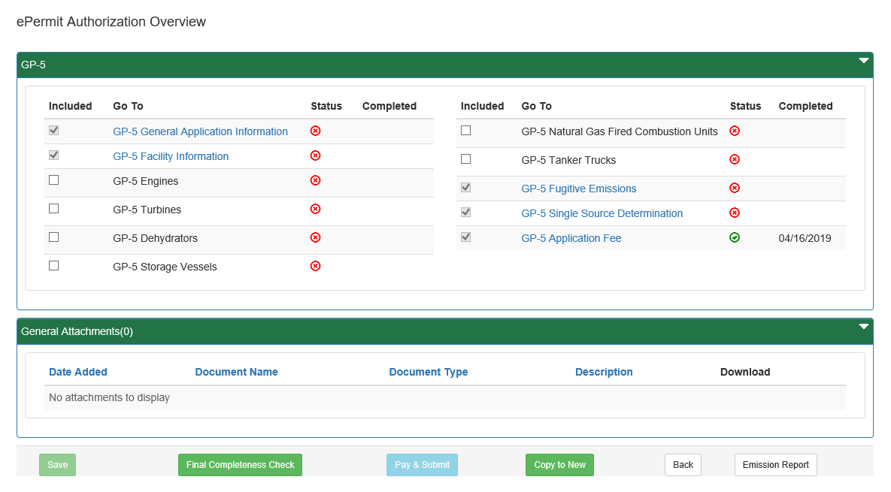
The ‘ePermit Authorization Overview’ page will display.

- Click the ‘Link’ for the Module you wish to open and work on.
- When finished working on the module, click the ‘Save’ button.

Working Through a Draft Permit Application
Authorized ePermitting users have the ability create draft permit applications by completing modules and saving them at any time within the ePermitting Application.

Types of Data Fields
Users will encounter several different types of data field types when working through their applications. Some samples of these types of data fields are below.
- Checkbox – a checkbox is clicked to select the value next to it. You may click it a second time to deselect it.
Example:
- Text Box – a textbox is a box where users can enter text manually or paste text that was copied from another application.
Example:
- Radio Button – a radio button is used to select one item from a series of items. Only one button in the grouping can be selected.
Example:
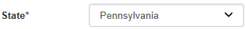
- Dropdown Menu – a dropdown menu is a menu you click on to display a list of items. You will click the item you wish to select from the list for it to display as the selected item from the list.
Example:
- Button – a button is used to operate the command shown on the button. In the example below, the Save button saves the data that had been entered onto the screen.
Example:

Unlocking Non-Required/Optional Modules
The ePermitting Application allows authorized users the ability to add additional, non-required information to the application by unlocking optional modules from the ePermit Authorization Overview page.
- From the Authorization Overview page for a draft permit in the ePermitting application, click the ‘checkbox’ beside the optional module under the Included column to unlock the module.
- Click the ‘Save’ button.
- Click the name of the module under the ‘Go To’ column to view and complete the module.

Entering Data into Your Draft Application
The ePermitting Application is a dynamic application which means it can change based on the information entered it. Users may notice that, depending on the answers given in some areas, the application will add additional questions or perhaps even require additional modules.
- While working in a draft application in the ePermitting application, you will select the the link of an unfinished module.
- Complete all data fields in the module, including all required fields.
Required fields – a required field is indicated by an asterisk * to the right of the Field Title. The module will not be considered complete until all required fields have been entered.
- Upload all required attachments.
Missing Required Attachments – certain modules require attachments to be uploaded to the application. They will be listed in the “Missing General Attachments” grid.
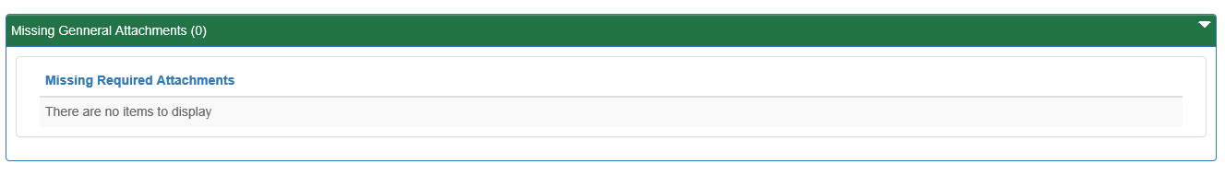

- Click the ‘Save’ button to save your changes at any time while working on the module. You can return to the module to complete it at another time.
You may encounter an error message when saving a module if something was entered incorrectly.
- You will see a message indicating if the module was saved successfully or not.

- Click the ‘Completeness Check’ button to verify all required information has been completed for the module.
Note: When a module is not complete, you will see a list of items needed to be finished before the module can be considered complete.
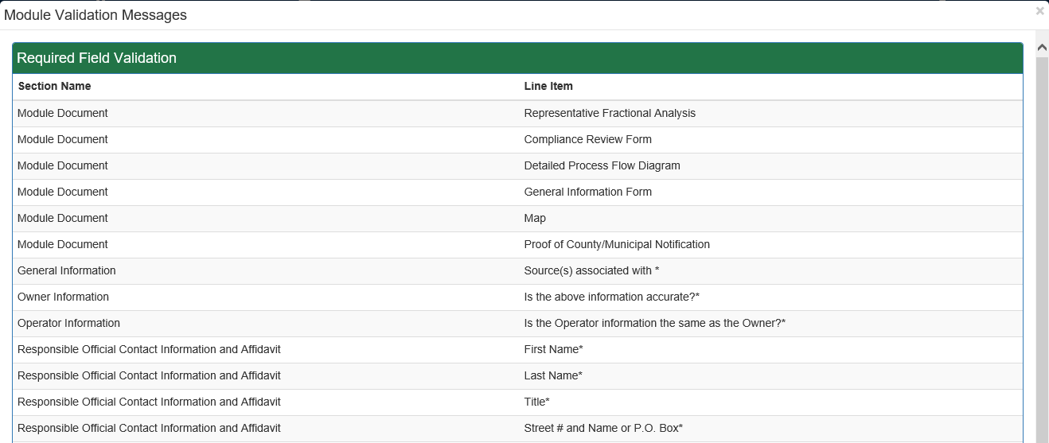
- Click the ‘Close’ button.
- Click the ‘Back’ button to return to the ‘Authorization Overview’ page.
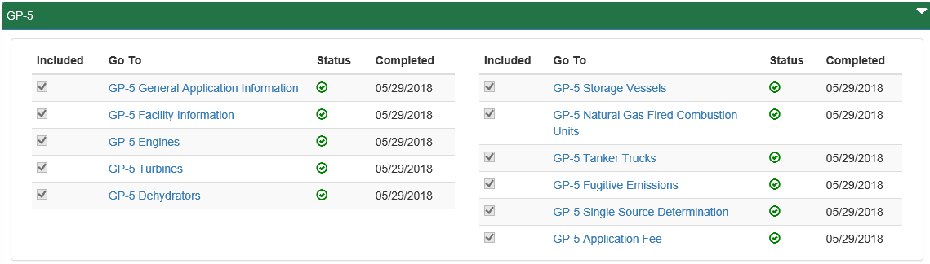
- Click the next module on which you would like to work until all required and selected modules have been completed.

Uploading Attachments
Several modules within the ePermitting application require attachments to be included with the submission. Authorized users will need to include these attachments for the module to be considered complete. Authorized users are also able to add additional, non-required attachments to their submission.
- Click the ‘Upload New Attachment’ button in the ‘General Information Attachments’ section or select to Attach the document(s) in the ‘Missing General Attachments’ section.
- The ‘Upload Attachment' window will open.
Note: When the user selects to ‘Attach’ the document(s) in the ‘Missing General Attachments’ section, the ‘Document Type’ field will be prepopulated with the name of the document.
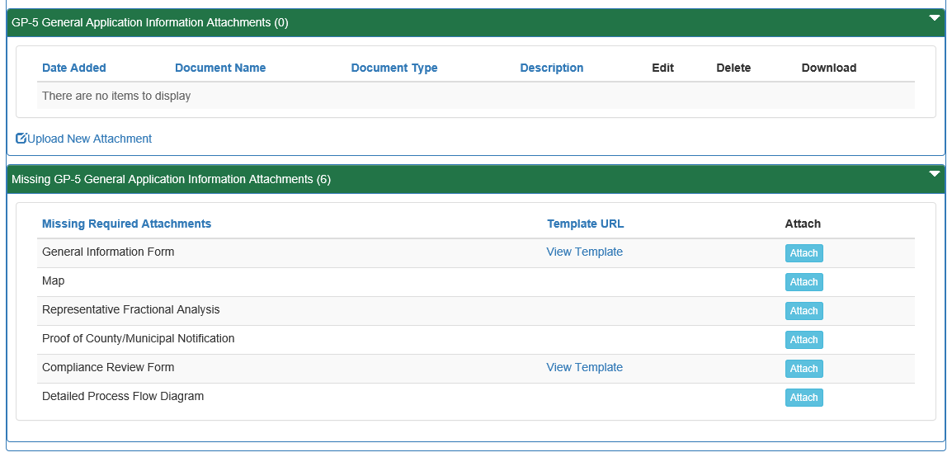

- Select the ‘Attachment Type’ from the ‘Document Type’ dropdown menu.
- Select the ‘Browse’ button to open a ‘Windows Explorer’ window to browse and select the file.
- Enter a ‘Document Name’ and ‘Description’ as needed.
- Click the ‘Upload and Save’ button.
Note: A user may chose the ‘Reset’ button to clear the contents of all fields and start over.

Submitting a Permit Application
Authorized ePermitting users have the ability to submit permit applications after completing all the appropriate required and non-required/optional modules.

Submitting Permit Applications
- From within the ‘ePermitting’ application, complete all required and selected optional modules.
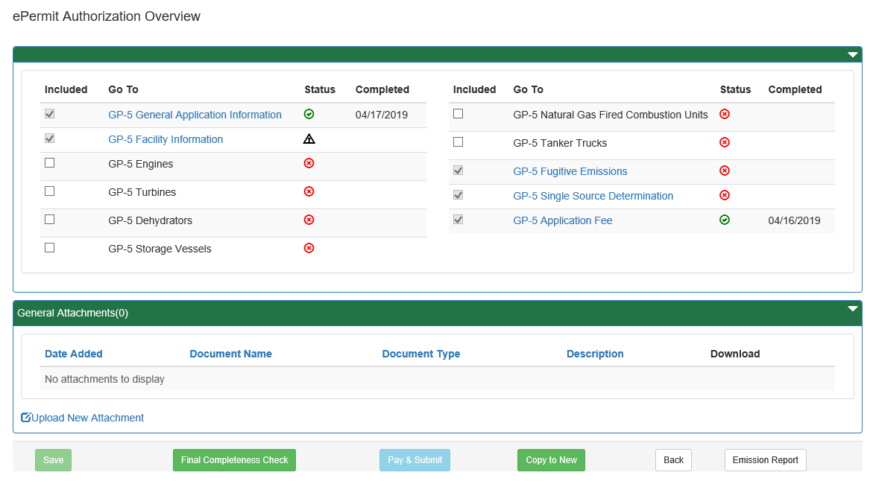

- After all modules have been completed, you will need to complete the ‘Application Fee’ module to submit the application for payment.

Paying and Submitting the Application
- Click the ‘Application Fee’ module.
- Enter the appropriate fees (if any) for the modules listed.
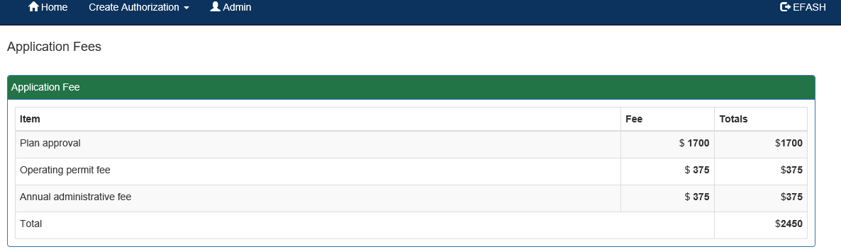

- Click the ‘Back to Overview’ button.
- Click the ‘Pay & Submit’ button.

Pay by Credit Card
You will now be taken to the ‘Payeezy’ page to enter your payment information. When finished, click the ‘Pay with Your Credit Card’ button.
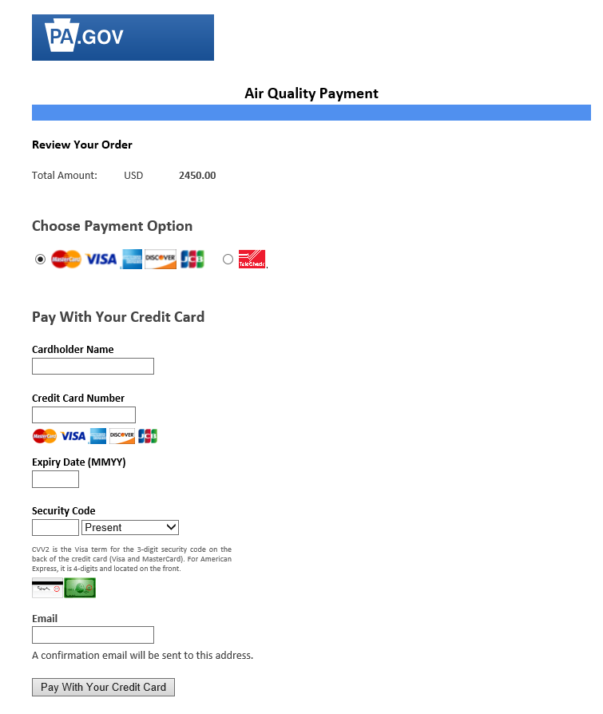

Pay by Telecheck
You will now be taken to the ‘Payeezy’ page to enter your payment information. When finished, click the ‘Pay with Your Credit Card’ button.
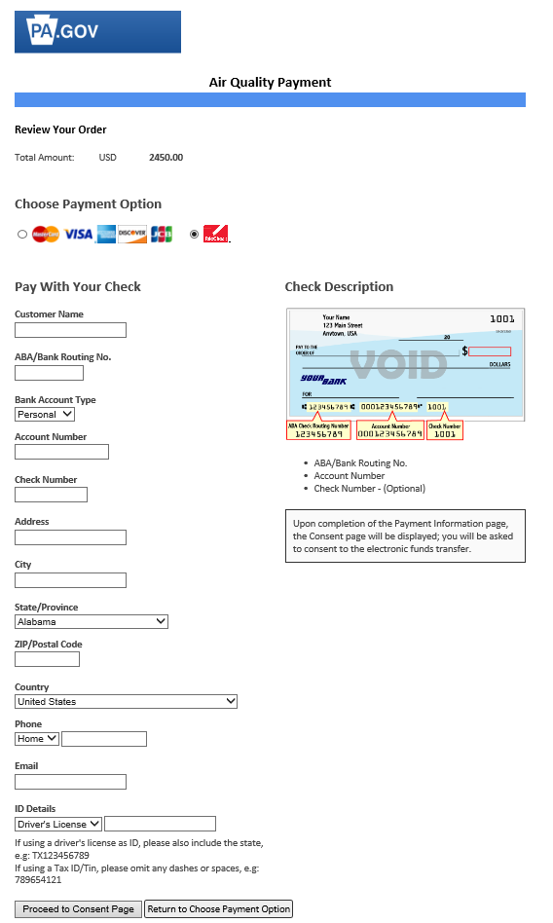

If payment is accepted, you will receive a message indicating the payment is processed successfully and you will be returned to the ePermit Dashboard, where you will now see a new ‘Submitted’ tab, or if you had previously submitted applications, you will see an increase in the number of submissions on the ‘Submitted’ tab.
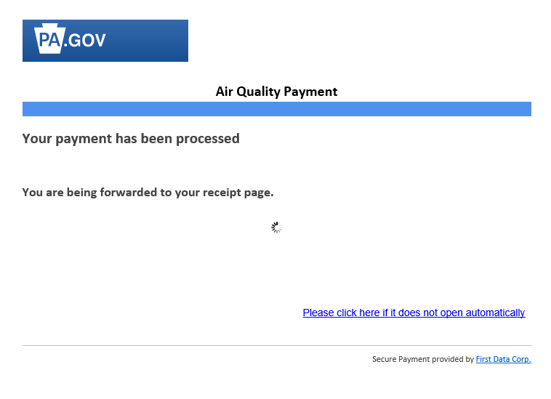

If payment is not successful, you will see a message on the ‘Payeezy’ screen indicating your payment was not processed. You will then be returned to the ‘ePermit Authorization Overview’ screen.

Reviewing and Modifying a Correction Required Permit Application
Authorized ePermitting users will see a Correction Required tab on the ePermit Dashboard if a previously submitted application is in need of a correction(s).

Reviewing and Completing a Correction Required Permit Application
- From within the ‘ePermitting’ application, click the ‘Correction Required’ tab on the ePermit Dashboard to display the list of Correction Notices.
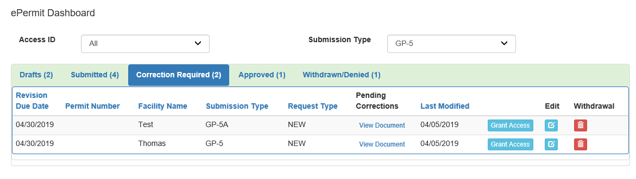
Click the ‘View Document’ Link under the ‘Pending Corrections’ header.
- Click the item under Module/Area you wish to work on.

The appropriate ‘Module/Area’ will display.
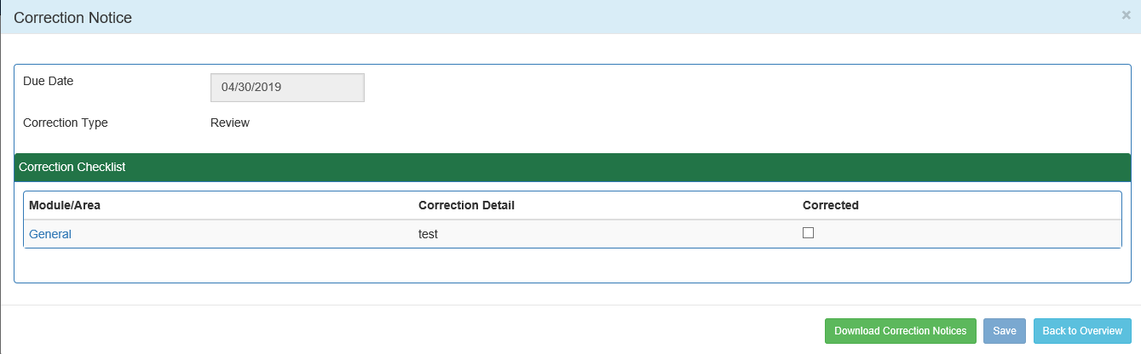

- Correct the indicated items, and click the ‘Save’ button. Click the ‘Back to Overview’ button to return to the ‘ePermit Authorization Overview’ screen.
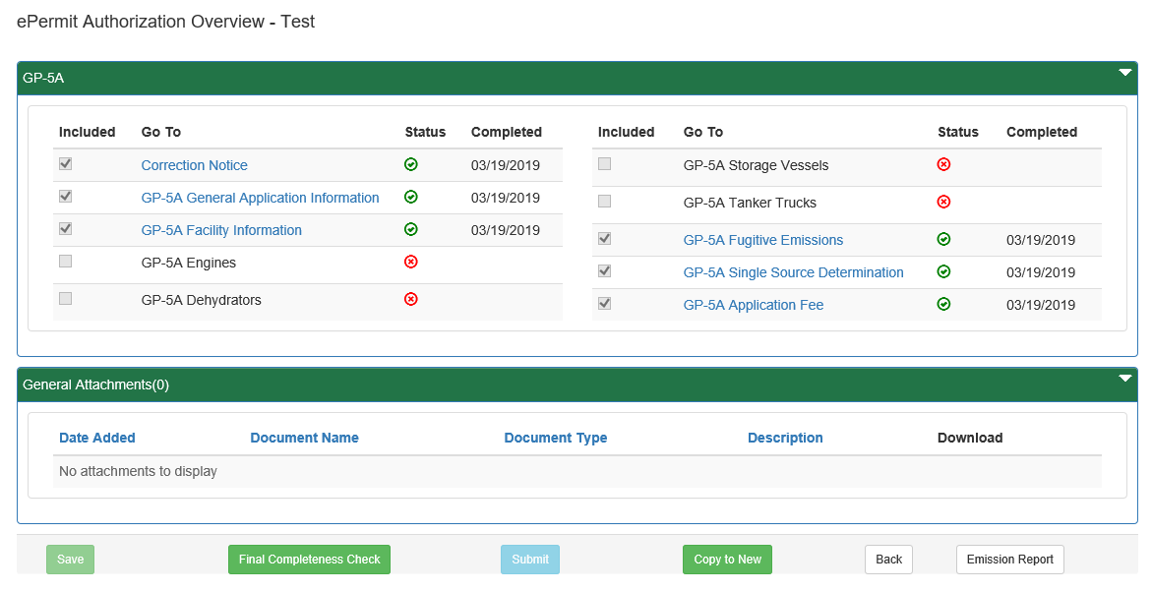
- Click the ‘Corrections Required’ tab from the ePermit Dashboard to mark the item(s) as Corrected.

- Click the ‘Correct’ Checkbox, to indicate the corrections have been made.
- Click the ‘Save’ button.

Viewing a Previously Submitted Permit Application
ePermitting users have the ability to view previously submitted Permit Applications.

Viewing Submitted Applications
- From within the ‘ePermitting’ application, click the ‘Submitted’ tab on the ePermit Dashboard.
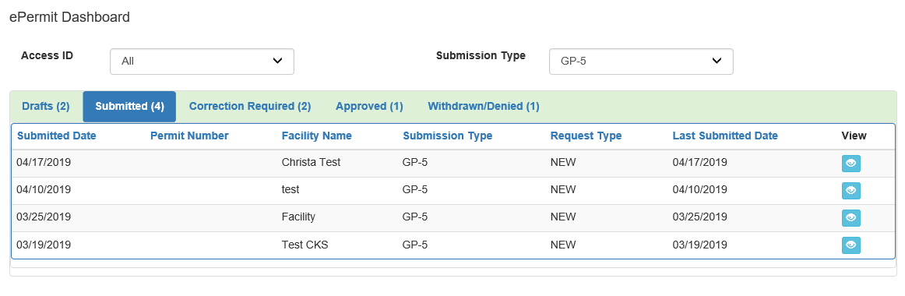

- Click the ‘View’ button to view the submitted Permit application.

