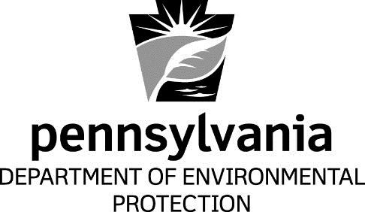

Attachment E

EPA’s Determinations of Attainment of the 2008 NAAQS – Pennsylvania’s Nonattainment Areas
Informational

Bureau of Air Quality
Department of Environmental Protection

[This page intentionally left blank.]

