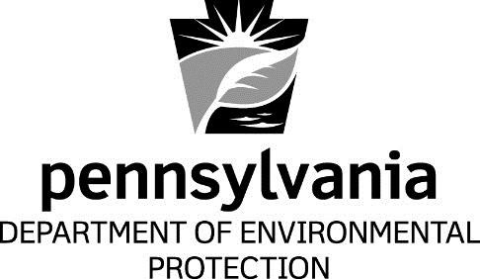

Attachment D

New York’s RACT Submittal Approved by EPA
Informational

Bureau of Air Quality
Department of Environmental Protection

[This page intentionally left blank.]

