**Commonwealth of Pennsylvania**

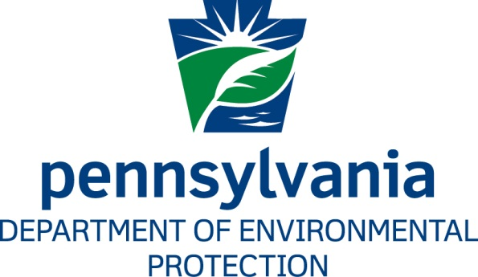

**Final**

**Pennsylvania Lake Erie Phosphorus Reduction**

**Domestic Action Plan**

**September 2017**

Compacts and Commissions Office

Pennsylvania Department of Environmental Protection

P.O. Box 8465

Harrisburg, PA 17105‑8465

717‑772‑4785

www.dep.pa.gov

**TABLE OF CONTENTS**

1. Introduction and Purpose 1

2. Background and Goals 1

2.1. History of Phosphorus Targets in the Lake Erie Basin 1

2.2. 2012 Amendments to the GLWQA, Annex 4 Process, and Applicability to Pennsylvania 2

2.3. Applicable Targets to Pennsylvania Sources 2

3. Objectives 3

3.1. Regional Objectives 3

3.2. Pennsylvania Specific Objectives 3

3.3. Pennsylvania Lake Erie Watershed and Definition of the Central Basin 4

3.4. Point Source Loading Sources and Characteristics 8

3.4.1. Concentrated Animal Feeding Operations (CAFO) 9

3.4.2. Municipal Separate Storm Sewer Systems (MS4) 9

3.4.3. Publicly-Owned Treatment Works (POTW) 9

3.4.4. Non-Publicly Owned Wastewater Treatment 10

3.4.5. Industrial Stormwater Discharges 10

3.5. Estimated Pennsylvania Nonpoint Source Phosphorus Loading Characteristics 11

3.6. Commitment to Local Water Quality Improvements 13

4. Tactics 14

4.1. Provide Greater Assurance of Pennsylvania Phosphorus Loading Estimations 14

4.2. Prioritize Delivery of Nutrient Reduction Programs to Central Basin Tributaries 15

4.2.1. PADEP Program Initiatives 15

4.2.2. PADEP Partnerships with County/Local Governments and Non‑Governmental Organizations 21

5. Measuring Progress and Achieving Consensus 23

5.1. Phosphorus Reduction Tracking Mechanisms 23

5.2. Phosphorus Contribution and Reduction Reporting 24

5.3. Public Participation and Consensus Building 24

5.4. Adaptive Management and Plan Updates 24

Appendix 1: Comment and Response Document 27

**LIST OF FIGURES**

Figure 1: Pennsylvania’s Lake Erie Watershed and Tributary Basins 4

Figure 2: Pennsylvania’s Lake Erie Central Basin 5

Figure 3: Pennsylvania Central Basin Small Watershed Direct Discharges 8

**LIST OF TABLES**

Table 1: Estimated Pennsylvania Annual TP Loading to the Ashtabula-Conneaut Complex (2008‑2013)* 11

Table 2: Estimated Pennsylvania Annual TP Loading to the Central Basin (2008‑2013) 12

Table 3: Estimated Pennsylvania Annual Percent TP Loading to the Central Basin (2008‑2013) 12

# Introduction and Purpose

The Commonwealth of Pennsylvania is one of the eight U.S. state governments with coastline and contributing watersheds to the North American Great Lakes and one of five states that shares jurisdictional responsibilities for Lake Erie. The Great Lakes Water Quality Agreement (GLWQA) is an environmental agreement, originally signed by the United States and Canada in 1972, that provides a framework for the restoration, protection, and management of the water resources shared between the countries. The Agreement was amended in 1978, 1983, 1987, and then most recently in 2012 to include enhanced measures to protect the “chemical, physical, and biological integrity” of the Great Lakes. These enhanced measures were incorporated into thirteen Articles that presented general provisions that outlined general objectives and responsibilities of the countries, and ten Annexes that addressed specific concerns such as Nutrients, Areas of Concern, and Aquatic Invasive Species.

The Pennsylvania Department of Environmental Protection (PADEP) is the state agency designated for water quality initiatives with responsibility for developing this document, the Pennsylvania Lake Erie Phosphorus Reduction Domestic Action Plan (DAP). The DAP addresses the General and Specific Objectives in Article 3 of the GLWQA, with special emphasis on the Lake Erie Ecosystem Objectives and Phosphorus Substance Objectives developed with guidance from Annex 2 - Lakewide Management and Annex 4 - Nutrients requirements. This document provides a focus for phosphorus reduction activities in the Pennsylvania Lake Erie Central Basin and allows resources to be allocated using methods that will maximize returns on future water quality investments. The scope of activities needed will be identified through an examination of the types of sources of phosphorus loading and of the physical characteristics of Pennsylvania’s watersheds contributing to the Central Basin of Lake Erie. Additionally, an analysis of water quality policies and programs will guide recommendations for programmatic and on-the-ground implementation of reduction practices, and methods will be identified for Pennsylvania to measure and track progress toward meeting phosphorus reduction goals.

# Background and Goals

## History of Phosphorus Targets in the Lake Erie Basin

Nutrient targets for Lake Erie were first established in the 1978 Amendments to the GLWQA in response to severe eutrophication of the lake and a need to reduce Total Phosphorus (TP) contributions to the system. An in‑lake TP maximum loading target of 11,000 metric tonnes per annum (MTA) was established to support the desired trophic statuses of the Western and Central Basins as mesotrophic and the Eastern Basin as oligotrophic (U.S. and Canada, 1978 Amendments to the Great Lakes Water Quality Agreement, 1978). Despite the success of government programs in reducing phosphorus inputs and the declines of in-lake concentrations for many years, the frequency of Western Basin algae blooms has again increased and occurrences of widespread Central Basin hypoxia have returned. Between the years 2000‑2010, the U.S. and Canada recognized that additional actions were necessary to study and adopt new phosphorus loading targets. These revised requirements were incorporated into the 2012 Amendments to the GLWQA.

## 2012 Amendments to the GLWQA, Annex 4 Process, and Applicability to Pennsylvania

Annex 4, Section B of the 2012 Agreement sets forth six Lake Ecosystem Objectives (LEOs) related to nutrients, of which three were used specifically by the Annex 4 Subcommittee to develop the Lake Erie Binational Phosphorus Load Reduction Targets. Of the three LEOs used for the targets, only one is directly applicable to Pennsylvania for the specific purposes of this DAP, which is to “*minimize the extent of hypoxic zones in the Waters of the Great Lakes associated with excessive phosphorus loading, with particular emphasis on Lake Erie”*(U.S. and Canada, 2012)**.**

The Annex 4 Subcommittee assembled the Annex 4 Objectives and Targets Task Team in September 2013 to review the existing science and nutrient loading models for Lake Erie to make recommendations for phosphorus reduction targets to meet the LEOs. The Task Team was binational in composition and consisted of members from the federal and state/provincial governments as well as scientists from academia and private industry. The Task Team evaluated and eventually supported a suite of nine nutrient loading and lake processing models (Annex 4 Objectives and Targets Task Team, 2015) that contributed to the final target recommendations for the Western, Central, and Eastern Basins and Specific Nearshore Waters of Lake Erie. Pennsylvania has no contributing watershed area to the Western Basin and no Pennsylvania tributary was named a Priority 1 or Priority 2 tributary contributing to cyanobacteria blooms in Nearshore Waters. Also, the Task Team was unable to recommend an Eastern Basin target to address nuisance algae (Cladophora) due to lack of available data, therefore the only phosphorus reduction targets applicable to Pennsylvania as determined by the Annex 4 Subcommittee are for those tributaries contributing to the Central Basin.

## Applicable Targets to Pennsylvania Sources

The Annex 4 Objectives and Targets Task Team consulted with the Great Lakes Fisheries Commission on Lake Erie’s hypoxia concerns to identify a Eutrophication Response Indicator for the Central Basin. Consideration was given to the nutrient requirements of a healthy and diverse Lake Erie fish community and integrated into the evaluation of nutrient modeling results. Based upon the analysis of multiple data sources and studies, the Task Force recommended an August through September average hypolimnetic dissolved oxygen concentration of 2 mg/L or more for the Central Basin. The Task Team identified that a Central Basin Total Phosphorus loading target of 6,000 metric tonnes per annum(MTA) would be required to attain the Indicator, which became the accepted Central Basin target as finalized by the U.S. and Canada in February 2016 (www.binational.net, 2016). Attaining 6,000 MTA loading to the Central Basin will require an approximate 40% reduction in Total Phosphorus by all Western Basin and Central Basin sources over the baseline 2008 year’s loading of 9,577 MTA of TP (Annex 4 Objectives and Targets Task Team, 2015).

The Agreement requires that the U.S. and Canada develop within five years of the entry into force of the Agreement, February 2018, a common Binational Nutrient Reduction Strategy. Additionally, each Party must create a Domestic Action Plan to meet loading targets and allocations developed pursuant to Annex 4 (U.S. and Canada, 2012). Pennsylvania is participating in this process by examining commitments to achieving the goals of the Agreement and presenting this plan for inclusion into the U.S. DAP being coordinated by U.S. EPA.

# Objectives

## Regional Objectives

Phosphorus contributions to the Lake Erie Basin are a complex interaction of point, nonpoint, and natural sources. A full examination and estimation of the sources and loadings of TP and Soluble Reactive Phosphorus (SRP) to Lake Erie was attempted by Maccoux (Maccoux, et al., 2016) to attribute loading amounts to U.S. and Canadian sources to serve as a baseline for future reductions. The Maccoux study allows a comprehensive understanding of sources for which a great deal of monitoring data is available, such as municipal point source discharges and the largest tributaries to the Western and Central Basins that have high-frequency water quality monitoring and extensive historic datasets. In this way, the Maccoux methodology can inform the actions necessary to reduce loading of those major sources, and provide accountability for state jurisdictions and federal agencies for implementation of management actions that will achieve the objectives of the GLWQA, specifically Annex 4.

## Pennsylvania Specific Objectives

The development of a Lake Erie phosphorus reduction strategy around the Maccoux loading estimations presents specific difficulties for Pennsylvania in quantifying annual loading from Pennsylvania tributaries and sources contributing to the Central Basin. The well-established loading data such as high-frequency sampling and monitoring associated with flow weighted mean concentrations (FWMC) available for the major tributaries in Ohio, Indiana, and Michigan are not available for watersheds in Pennsylvania. This lack of data can be attributed to two significant reasons: the relatively small area of Pennsylvania’s Central Basin-contributing watersheds and their associated flow and the lack of significant nutrient sources and problems within the identified watersheds (PADEP, 2013). The following section will examine the Pennsylvania tributaries that contribute flow to the Central Basin for scoping proportionate actions to achieve the stated goals.

## Pennsylvania Lake Erie Watershed and Definition of the Central Basin

Pennsylvania Sea Grant and PADEP completed a comprehensive review of the Lake Erie basin in 2015 (Rafferty and Boughton, 2015) to provide an integrated approach to managing the resource. That study and planning document, entitled *Pennsylvania Lake Erie Watershed Integrated Water Resource Management Plan,* will contribute to the following sections on tributary characteristics that will determine Pennsylvania’s role and tactics in phosphorus reduction to the Central Basin.

Figure 1: Pennsylvania’s Lake Erie Watershed and Tributary Basins

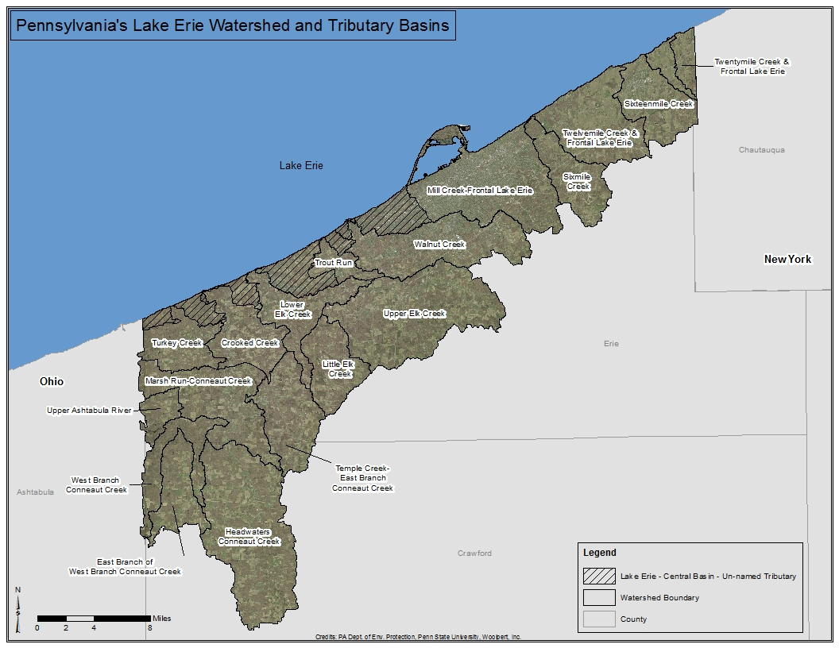

The Pennsylvania Lake Erie Basin covers approximately 507.72 mi2 as calculated from a 2012 geospatial survey of the Basin, consisting of 56 streams totaling a length of 1,121.35 miles (*Figure 1*). Fifteen of these tributaries were identified as significant in the Pennsylvania Lake Erie Watershed Integrated Water Resources Management Plan (Rafferty and Boughton, 2015) and the remaining streams are of smaller order and discharge directly to Lake Erie. Pennsylvania relied upon clarifications from the Maccoux study, U.S. EPA (U.S. EPA, 2017) and additional geomorphological sources (NOAA, 2017) to define the extent of the Central Basin in Pennsylvania. For the purposes of this Plan, all watershed area draining to Lake Erie from the base of Presque Isle (Longitude 42.109938, Latitude ‑80.159606) west to the Pennsylvania-Ohio border is considered to discharge to the Central Basin.

Figure 2: Pennsylvania’s Lake Erie Central Basin

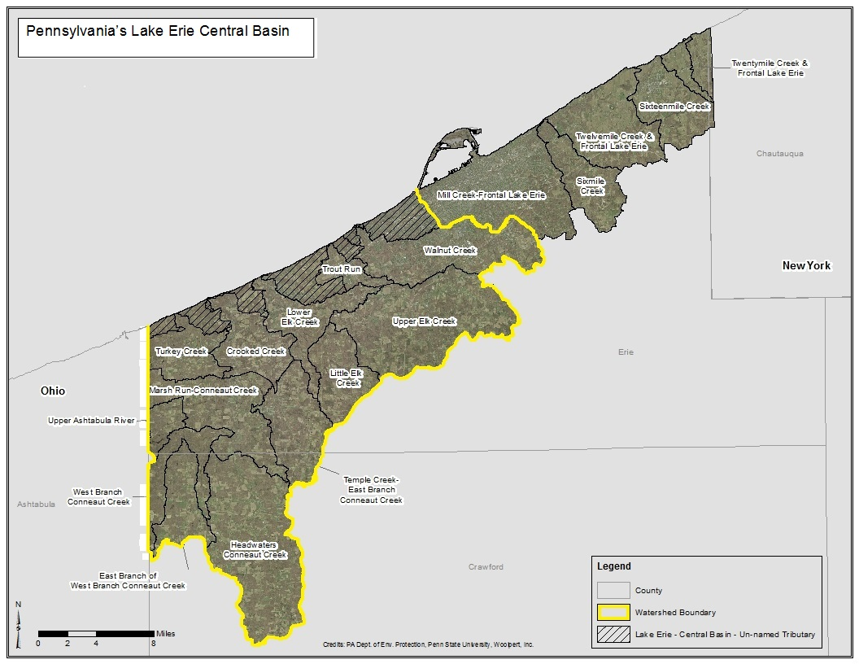

The Pennsylvania Lake Erie Central Basin covers approximately 375 mi2 and contains eight significant tributaries ranging in size from 6.94 mi2 to 153.10 mi2 (*Figure 2*).While these eight tributaries are considered significant within the scale of Pennsylvania’s Lake Erie Central Basin, all the tributaries are substantially smaller in watershed area compared to those identified by the United States and Canada as Lake Erie Nearshore Priority Tributaries for having detrimental effects on nearshore water quality (Annex 4 Objectives and Targets Task Team, 2015). For the purposes of this plan, the significant Pennsylvania Lake Erie Central Basin tributaries and watershed characteristics (Rafferty and Boughton, 2015) are listed below from East to West.Also included is a short description of the unnamed smaller watershed areas that discharge directly to the Central Basin.

1. **Walnut Creek –** Walnut Creek (HUC12 #041201010407) is Pennsylvania’s third largest Central Basin tributary. The Walnut Creek watershed is approximately 38.07 mi2 consisting mostly of Group C and Group D hydrologic soil types with medium to high urbanization mixed with lower density residential, low intensity agriculture, and forested land uses. In 2008, USGS and PADEP established a continuous water quality and flow gauge station (USGS Gauge 04213152) at the mouth of Walnut Creek. This monitoring location has also served as Water Quality Network Site 644 with monitoring conducted every two months sinceNovember 2008 (PADEP, 2012).
2. **Trout Run –** Trout Run (HUC12 #041201010408) is Pennsylvania’s smallest major Central Basin named tributary. The Trout Run watershed is approximately 6.94 mi2 consisting of approximately 40% Group A and Group B hydrologic soil types and 60% Group C and Group D soil types. Segments of this watershed are identified as being impaired by Nutrients on Category 5 of the Pennsylvania Integrated List of All Waters (PADEP, 2016). However, no in-lake conditions have been observed at the mouth of the stream to indicate that the impairment is causing any increased nearshore algae growth. The watershed is approximately 30% agricultural land uses and 30% forested, with the balance low density residential and urban land uses.
3. **Elk Creek –** Elk Creek(HUC12 #041201010503) is Pennsylvania’s second largest Central Basin tributary. The Elk Creek watershed is approximately 98.35 mi2 and consists of approximately 90% of Group C and Group D hydrologic soil types, with almost 50% of the area having forested land cover and 40% in various agricultural production.
4. **Crooked Creek –** Crooked Creek (HUC12 #041201010702) is Pennsylvania’s fourth largest Central Basin tributary. The Crooked Creek watershed is approximately 20.29 mi2 consisting of approximately 40% Group A and Group B hydrologic soil types and 60% Group C and Group D. Land uses consist mostly of forested, low intensity agriculture, and wetlands.
5. **Raccoon Creek –** Raccoon Creek (HUC12 #041201010702) is Pennsylvania’s fifth largest Central Basin tributary. The Raccoon Creek watershed is approximately 8.73 mi2 consisting of approximately 35% Group A and B hydrologic soil types and 65% Group C and D soil types. This watershed is sparsely populated with land cover evenly split between forest and open space/fields. Much of this watershed is publicly owned by the PA State Game Commission in State Game Lands No. 314.
6. **Turkey Creek –** Turkey Creek (HUC12 #041201010702) is Pennsylvania’s seventh largest Central Basin tributary. The Turkey Creek watershed is approximately 7.91 mi2 consisting of approximately 45% Group A and 65% Group C and Group D hydrologic soil types. It is sparsely populated with land cover consisting of over 60% forested, 13% in open space/fields and 11% wetlands. Much of this watershed is publicly owned by the PA State Game Commission in State Game Lands No. 314.
7. **Conneaut Creek –** Conneaut Creek (HUC10 #0412010106) is the largest Pennsylvania Central Basin tributary. The Conneaut Creek watershed is approximately 153.10 mi2 consisting of mostly Group C and Group D hydrologic soil types. It is sparsely populated with approximately 50% forested land cover, 35% agricultural, 6% wetland, and 9% in open space and low intensity developed land uses. PADEP and USGS have maintained a Water Quality Network Site 643 at SR3001 Bridge (Cherry Hill) with sampling conducted every two months sinceJanuary 1988 (PADEP, 2012).
8. **Ashtabula Creek –** Ashtabula Creek (HUC12 #041100030103) is Pennsylvania’s sixth largest Central Basin tributary. The Ashtabula Creek watershed is approximately 8.24 mi2 consisting of approximately 90% Group C and Group D hydrologic soil types. It is sparsely populated with land cover consisting of 50% forest, 30% agriculture, 11% wetlands, and the remainder in open space and low density residential.
9. **Direct Discharge Small Watershed Areas –** Six small unnamed watershed areas discharge directly to the Central Basin covering a combined 34 mi2 and consisting of various hydrologic soil type distributions as the watersheds move from east to west through different formations of glacial deposition. Also, the land use and land cover characteristics transition from Urban/Developed to mixed Developed/Agriculture to predominantly Forested as the watersheds move away from the urbanized core of the City of Erie. Land use characteristics of the small watersheds can be seen in *Figure 3*.

Figure 3: Pennsylvania Central Basin Small Watershed Direct Discharges

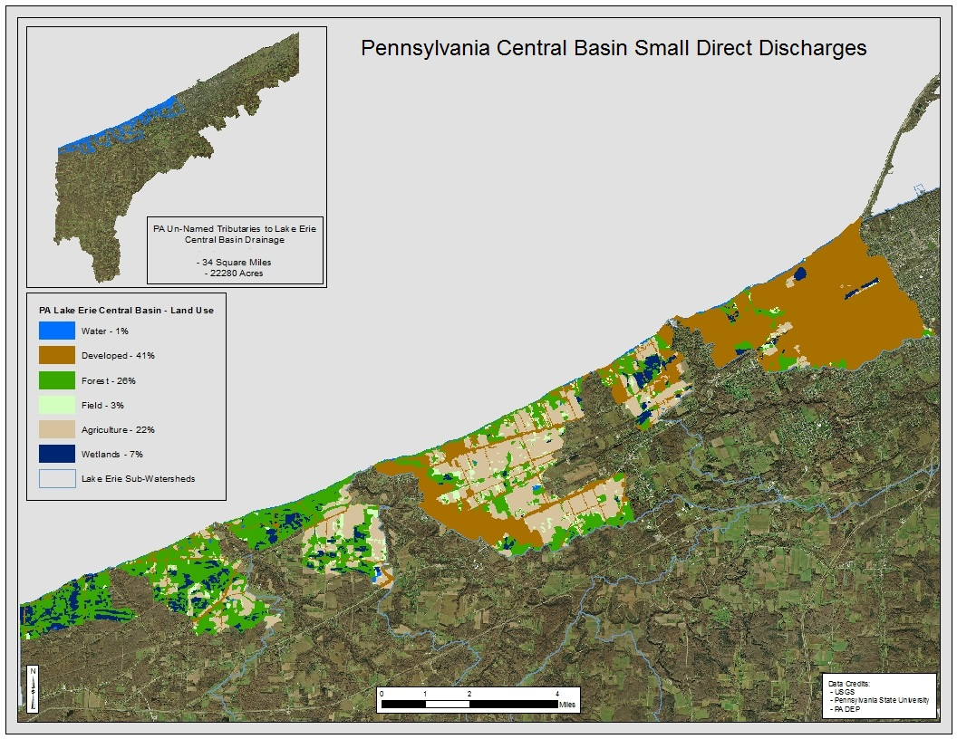

## Point Source Loading Sources and Characteristics

Pennsylvania implements the federal Clean Water Act and the Pennsylvania Clean Streams Law requiring wastewater dischargers to have a permit establishing pollution limits, and specifying monitoring and reporting requirements. National Pollutant Discharge Elimination System (NPDES) permits regulate household and industrial wastes that are collected in sewers and treated at municipal wastewater treatment plants. Permits also regulate industrial point sources, concentrated animal feeding operations, and municipal stormwater sources that discharge into other wastewater collection systems, or that discharge directly into receiving waters. There are currently 237 NPDES permitted discharges in the Pennsylvania Central Basin tributaries, many of which are single-residence, small-flow sewage treatment facilities (PADEP, Clean Water Program, 2017). Other types of NPDES permits are in place other than those included in this section, although phosphorus is not the pollutant of concern in those operations.

### Concentrated Animal Feeding Operations (CAFO)

Pennsylvania defines a CAFO as a concentrated animal operation with greater than 300 animal equivalent units, any agricultural operation with greater than 1,000 animal equivalent units, or any agricultural operation defined as a large CAFO under 40 CFR 122.23(b)(4) relating to concentrated animal feeding operations (Pa. Code Chapter 92a Subchapter A). Those operations that meet this definition are required to obtain an NPDES permit for discharges that occur from the operations. Currently, two permitted CAFOs are located in Central Basin tributary watersheds, one in Walnut Creek and one in Conneaut Creek.

### Municipal Separate Storm Sewer Systems (MS4)

Municipalities and other entities, such as universities, prisons and road systems, that meet certain standards must obtain NPDES permit coverage for discharges of stormwater from their MS4s. An MS4 is defined as any conveyance or system of conveyances (including but not limited to streets, ditches, and pipes) that is:

* Owned by a municipality or other public body created by state law and having jurisdiction over disposal of sewage, industrial wastes, stormwater or other wastes;
* Designed or used for collecting or conveying stormwater;
* Not a combined sewer (i.e. not intended for both sewage and stormwater); and
* Not part of a publicly owned treatment works (POTW).

MS4s are categorized as Large, Medium or Small based on criteria in federal regulations at 40 CFR 122.26. Pennsylvania has five Small MS4 municipalities within the Central Basin of Lake Erie, of which three municipalities maintain MS4 NPDES General Permits (PAG‑13), one municipality maintains an MS4 Individual Permit, and one is waived from PAG‑13 General Permit coverage due to meeting criteria in 40 CFR 122.32(d) and (e).

### Publicly-Owned Treatment Works (POTW)

All POTWs and sewer systems owned by or serving a municipality are covered by PADEP’s Wasteload Management Regulations in 25 Pa. Code Ch. 94. The purpose of these regulations is to provide adequate conveyance and treatment for future needs, prevent sewage facilities from becoming overloaded, limit additional connections to overloaded facilities, correct overload conditions, and prevent introduction of industrial discharges into municipal sewer systems that will interfere with operations or pass through the plant. Ultimately, these regulations protect Pennsylvania’s waters from inadequately treated wastewater discharges.

There are seven permitted POTWs discharging to Pennsylvania Lake Erie Central Basin tributaries, of which five are Minor Sewage Facilities discharging less than 1 million gallons per day (MGD). Two permitted POTWs are Major Sewage Facilities that discharge greater than 1 MGD but fewer than 5 MGD. Major Sewage Facilities in Pennsylvania discharging to Lake Erie have NPDES permit conditions limiting maximum effluent concentration of total phosphorus to 1.0 milligram per liter (PADEP, Clean Water Program, 2017).

### Non-Publicly Owned Wastewater Treatment

Non-publicly owned wastewater treatment discharges serve an individual facility including single-family residences, individual residential/community developments, or businesses that do not have access to publicly-owned wastewater infrastructure. In the absence of public infrastructure, facilities can use traditional in-ground, on‑lot wastewater treatment in areas of favorable soil drainage characteristics. However, many areas in the Pennsylvania Lake Erie Central Basin watershed consist of Groups C and D hydrologic soil types not conducive to effective on-lot treatment. In these instances, small “package plants” are used to treat wastewater and discharge to a surface water body. Pennsylvania uses several different types of NPDES permits for these facilities based upon the daily discharge flow. Currently, Pennsylvania’s Central Lake Erie Basin has nine Minor Sewage Facilities (<0.05 MGD), three Minor Sewage Facilities (> = 0.05 MGD < 1 MGD), and 154 Small Flow Treatment Facilities (<2,000 GPD).

### Industrial Stormwater Discharges

Specific classes of industrial facilities must apply for NPDES permit coverage in Pennsylvania as implemented by federal regulations at 40 CFR 122.26. Additionally, PADEP may require any other facility not identified in the federal regulations to obtain a permit if PADEP finds that the facility or activity is resulting in the discharge of pollutants to waters of the Commonwealth.

Facilities that are required to obtain NPDES permit coverage may, if eligible, apply for this coverage under PADEP’s NPDES General Permit for Discharges of Stormwater Associated with Industrial Activities (PAG‑03). The PAG‑03 General Permit was reissued on September 24, 2016, for a new 5‑year term. Currently, 27 Pennsylvania Central Basin NPDES Industrial Stormwater discharge points are classified as Minor discharges covered by PAG‑03 General Permits, and another five discharges are assigned No Exposure Certification meaning all industrial materials and activities are stored and conducted indoors or under a facility’s roof.

## Estimated Pennsylvania Nonpoint Source Phosphorus Loading Characteristics

The relative lack of phosphorus and nutrient-related data for Pennsylvania’s Central Basin tributaries compared to the other Lake Erie state jurisdictions requires PADEP to examine the available data to determine watersheds of focus for prioritization of activities. As described previously, Maccoux estimated tributary loadings for the Western and Central Basins and assigned specific annual phosphorus loading totals to the Ashtabula-Conneaut Complex in Pennsylvania and Ohio. Maccoux grouped all other Pennsylvania Central Basin tributaries into a batch-calculated group, a technique that allows a modeler to represent a large area of smaller watersheds with a single loading value. Unfortunately, in Pennsylvania the calculations combined Central Basin and Eastern Basin tributaries, therefore Pennsylvania is unable to discern specific loading characteristics for tributaries other than Conneaut Creek and Ashtabula Creek.

For the 2008 baseline year, Maccoux estimated the annual loading of the Ashtabula-Conneaut Complex to be 69 MTA and the total area of the Complex to be approximately 347 mi2. Based upon recent updates in Pennsylvania geospatial hydrographic datasets, it is known that 161 mi2 of that watershed is in Pennsylvania, or approximately 46.4% of the Complex (Rafferty and Boughton, 2015). On a prorated comparison, Pennsylvania appears to have met the 40% reduction in TP between the years 2009‑2013 for every year except 2012 as shown in *Table 1*.

Table 1: Estimated Pennsylvania Annual TP Loading to the  
Ashtabula-Conneaut Complex (2008‑2013)*

Table 1:  Estimated Pennsylvania Annual TP Loading to the Ashtabula-Conneaut Complex (2008-2013)


**\*Statistics and percent reductions derived from data presented by Maccoux.**

The Ashtabula-Conneaut Complex may also be useful as a surrogate in estimating the total Central Basin loading of Pennsylvania tributaries, including those that Maccoux grouped into the batch-calculated category. The Ashtabula-Conneaut Complex topography, soil types, land cover, and land uses generally resemble those that are found in the other Pennsylvania Central Basin tributaries (PADEP, Office of the Great Lakes, 2017). Therefore, the Complex could be used as a reference to determine loading characteristics for those tributaries in Pennsylvania that lack detailed loading estimates. The total Ashtabula-Conneaut Complex watershed area in Pennsylvania and Ohio is 347 mi2 and the entire Pennsylvania Central Basin watershed is approximately 378 mi2. Extrapolating these datasets and applying similar loading characteristics to Pennsylvania tributaries would result in the 2009‑2013 Pennsylvania TP loading totals in *Table 2*.

Table 2: Estimated Pennsylvania Annual TP Loading  
to the Central Basin (2008‑2013)

Table 2:  Estimated Pennsylvania Annual TP Loading to the Central Basin (2008-2013)


This analysis infers that Pennsylvania’s contributions of TP to the Central Basin of Lake Erie are *de minimus* to the overall reduction strategies necessary to reduce the frequency and severity of hypoxia events in the Central Basin. Between the years 2008 and 2013, it is estimated that Pennsylvania represented only 0.51% on average of the total loading to the Central Basin as described in *Table 3*.

Table 3: Estimated Pennsylvania Annual Percent TP Loading  
to the Central Basin (2008‑2013)

Table 3:  Estimated Pennsylvania Annual Percent TP Loading to the Central Basin (2008-2013)


In sum, it is estimated that Pennsylvania’s loading contributions to the Central Basin of Lake Erie may already be attaining the 40% reduction in TP over the 2008 baseline, though the existing water quality data used to make that determination may need enhancement. Additionally, the loading estimations suggest that additional large-scale phosphorus reductions in some Pennsylvania tributaries could affect the biologic productivity of those stream systems and management actions should be examined on a tributary-by-tributary basis.

## Commitment to Local Water Quality Improvements

Pennsylvania maintains strong commitments to local water quality and the benefits provided to citizens that live, work, and recreate in the Lake Erie watershed. PADEP developed, and continues to implement, several water quality programs to reduce phosphorus pollution through the cooperative work with our partners. These programs implement practices that improve local water quality and have the potential to reduce the runoff of phosphorus and other contaminants to our watersheds. Additionally, reductions realized through these programs will incrementally help with overall reductions to the Central Basin of Lake Erie.

Specific named tributaries for future phosphorus pollution reduction actions in support of local water quality include the following:

1. **Trout Run** – 6.94 mi2, Reaches Impaired by Nutrients – Trout Run is the only Pennsylvania Lake Erie tributary that is currently impaired by nutrients. In 2009, the Erie County Conservation District published the *Trout and Godfrey Run Watershed Implementation Plan* meeting the requirements of a U.S. EPA Section 319 Nine‑Element Watershed Implementation Plan. This tributary was reassessed in 2016, and in-stream impairments remain though no nearshore nutrient-related impairments such as algae blooms have been observed in Lake Erie at the mouth of the tributary. PADEP will re‑examine the implementation scenarios in this plan and identify potential funding sources and partners for on-the-ground activities to continue to address watershed impairments.
2. **Walnut Creek** – 38.07 mi2, Reaches Impaired by Urban Stormwater – Walnut Creek was named a PADEP priority watershed in 2006 due to impairments discovered in the stream as a result of impervious cover and urban development. Impairments include flow variability, hydromodifications, and sediment/siltation, all indicative of the urban land uses common within the watershed. In response, PADEP completed the *Walnut Creek Watershed Environmental Quality Report* (PADEP, 2007) and the *Walnut Creek Protection and Restoration Plan* (PADEP, 2008). The Assessment and Plan identified methods to restore the watershed’s beneficial uses, and many Best Management Practices (BMPs) have been implemented since the creation of those documents. PADEP will re‑examine the goals within the Walnut Creek watershed and identify those activities that will provide nutrient reduction benefits. Additionally, PADEP will identify opportunities to assure municipal activities are in support of nutrient reduction goals within MS4 municipalities discharging to Walnut Creek.

# Tactics

PADEP commits to implementing the following actions in support of Central Basin nutrient reduction goals.

## Provide Greater Assurance of Pennsylvania Phosphorus Loading Estimations

As discussed in Section 3.4, the estimated phosphorus loading contributions to the Central Basin from Pennsylvania tributaries, and the statistical confidence in those loading estimations, require additional focus and efforts to assure accuracy. Pennsylvania will conduct the following activities by the year 2021 to attain greater confidence in the loading estimations:

1. *Research and Assemble all Available Water Quality Data for Central Basin Tributaries*

Pennsylvania will gather all available and applicable monitoring records for Central Basin tributaries from state, county, local, and non-profit entities. Additionally, point source discharge permits and associated discharge monitoring records for permittees located in the Central Basin watersheds will be researched.

1. *Evaluate and Assess Applicability of Existing Data and Report*

Pennsylvania will evaluate the quantity and quality of the data sources, catalog by tributary, assess the applicability of the data for phosphorus reduction estimations, identify data gaps, and produce a report defining data needs.

1. *Conduct Tributary Land Use Assessment and GIS‑based Nutrient Modeling*

Pennsylvania will use historical geospatial data to conduct a land use and land cover assessment of Central Basin tributary watersheds to determine trends that could indicate changes in nutrient contributions in those watersheds. The assessment outputs will be used in a GIS-based pollutant transport model appropriate for the size and scale of the tributaries. Achieving the actions described in this subsection will rely on the future availability of federal grant funding.

During the years 2021 and 2022, Pennsylvania will evaluate the existing data, land use and land cover assessments, any available pollutant transport modeling, and then determine with the help of other agencies such as USGS and U.S. EPA additional data needs in specific tributaries necessary to increase the statistical confidence of the pollutant transport models.

## Prioritize Delivery of Nutrient Reduction Programs to Central Basin Tributaries

Pennsylvania currently conducts programs in the Lake Erie Basin focused on phosphorus pollution reduction activities. These programs address individual types and sources of water quality problems including urban stormwater, agricultural runoff, and municipal residential sewage treatment. The following PADEP programs will continue to provide services to the Lake Erie Basin, although PADEP will examine opportunities to focus resources on applicable projects in Central Basin tributaries.

### PADEP Program Initiatives

1. ***Program Name: PADEP Clean Water Program***

***Program Initiative: NPDES Point-Source Permitting Considerations***

Pennsylvania implements the EPA-delegated point source National Pollutant Discharge Elimination System (NPDES) program, which includes permitting for publicly-owned treatment works, stormwater facilities, and other activities that discharge to waters of the Commonwealth. While program development and evaluation occur in PADEP’s central office, PADEP field offices conduct site-specific permitting, monitoring, compliance, and enforcement activities. The central office also provides specialized assistance in the areas of policy, regulatory development, complex permitting, safety training, treatment plant operations, enforcement, and data management.

The NPDES permitting program includes the following permits:

Stormwater Associated with Industrial Activities (PAG‑03)

Federal regulations at 40 CFR 122.26 identify specific classes of industrial facilities that must apply for NPDES permit coverage. In addition, PADEP may require any other facility not identified in the federal regulations to obtain a permit if PADEP finds that the facility or activity results in the discharge of pollutants to waters of the Commonwealth. The current PAG‑03 general permit was reissued on September 24, 2016, for a new 5‑year term.

Small Flow Treatment Facilities (PAG‑04)

PAG‑04 provides NPDES general permit coverage for Small Flow Treatment Facilities (SFTFs) to discharge to waters of the Commonwealth. SFTFs are treatment works designed to treat sewage flows no greater than 2,000 gallons per day. The existing PAG-04 was issued on May 10, 2014. PADEP will be revising the general permit as necessary and reissuing PAG‑04 in the spring of 2019.

Concentrated Animal Feeding Operations (PAG‑12)

Pennsylvania defines a CAFO as a concentrated animal operation with greater than 300 animal equivalent units, any agricultural operation with greater than 1,000 animal equivalent units, or any agricultural operation defined as a large CAFO under 40 CFR 122.23(b)(4) relating to concentrated animal feeding operations (Pa. Code Chapter 92a Subchapter A). Those operations that meet this definition are required to obtain an NPDES permit for discharges that occur from the operations. PADEP issues individual and general permits for CAFOs. The existing CAFO general permit, PAG‑12, was issued on April 1, 2013. PADEP expects to review and revise PAG‑12 as necessary so that it can be reissued before April 1, 2018.

1. ***Program Name: PADEP Clean Water Program***

***Program Initiative: NPDES MS4 Permitting Considerations***

Pennsylvania Lake Erie Central Basin municipalities are currently operating under MS4 permits issued in 2013. PADEP published a final NPDES General Permit for Stormwater Discharges from Small MS4s (PAG‑13) on June 4, 2016. The new PAG‑13, which becomes effective March 16, 2018, will contain requirements for MS4s that discharge to streams designated as impaired in the Pennsylvania Integrated Water Quality Monitoring and Assessment Report. Those MS4s will be required to designate regulated outfalls to impaired streams and calculate existing pollutant loads, then reduce sediment loading by ten percent, phosphorus loading by five percent, and nitrogen loading by three percent. The four MS4 communities in the Pennsylvania Central Basin that are renewing permits will be required to meet the new reductions required under PAG‑13. Coverage under the new PAG‑13 will be for a five‑year term.

1. ***Program Name: PADEP - Clean Water Program***

***Program Initiative: NPDES Erosion and Sediment Control (E&S) Permitting Considerations***

Pennsylvania’s E&S regulations at 25 Pa. Code Ch. 102 describe the requirements for controlling accelerated erosion and preventing sediment pollution from various earth disturbance activities. These regulations contain standards and criteria for minimizing erosion and preventing sediment pollution, as well as post construction stormwater management (PCSM). The erosion and sediment control requirements apply to any earth disturbance activity permitting requirements cumulatively over one acre, including land development and road, highway, or bridge construction. Requirements for control measures and facilities include the use of BMPs, primarily by establishing design and performance standards. The PCSM requirements, which emphasize minimization of impervious cover, low-impact development designs, and innovative stormwater BMPs provide for infiltration, water quality treatment, and management of the rate and volume of stormwater discharges, are mandatory when permit coverage for construction activities under Chapter 102 is necessary, unless specifically exempted.

The provisions of Pennsylvania’s E&S regulations are carried out through the issuance of permits for discharges associated with construction activities. The General Permit for Stormwater Discharges Associated with Construction Activities (PAG‑02) became effective on December 1, 2012. PADEP is working to revise and reissue PAG‑02 prior to December 2017. PADEP is also working toward issuance of a general permit for stormwater discharges associated with small construction activities (PAG‑01).

PADEP has published technical guidance documents, the Erosion and Sediment Pollution Control Program Manual (E&S Manual) and the Stormwater Management Best Management Practices Manual (BMP Manual), that are intended to assist the public and the regulated community in understanding and complying with regulations and permit requirements. The E&S Manual includes specific guidance, performance requirements, and design criteria to support the implementation of the Department’s water quality regulatory requirements for erosion and sediment control as provided in Title 25 Pa. Code §102.11(a)(1), including antidegradation provisions. PADEP finalized revisions to the E&S Manual in March 2012. The BMP Manual provides the design standards and planning concepts to guide local authorities, planners, land developers, contractors, and others involved with planning, designing, reviewing, approving, and constructing land development projects. PADEP is planning to have revisions to the stormwater BMP Manual completed by 2019.

1. ***Program Name: PADEP Clean Water Program***

***Program Initiative: Act 537 Sewage Facilities Planning Program***

Domestic sewage is treated and disposed of by various methods, ranging from large municipally-owned sewage treatment plants to community or individual on-lot disposal systems (OLDS), also called “septic systems.” Malfunctioning sewage disposal systems, regardless of type, pose a serious threat to public health and the environment. They can pollute public and private drinking water sources, often by discharging directly to the groundwater, and they can expose humans and animals to various bacteria, viruses and parasites. Repairs to these systems often can lead to financial hardships for affected municipalities or homeowners. On January 24, 1966, the Pennsylvania Sewage Facilities Act (Act 537) was enacted to address existing sewage disposal problems and prevent future problems. Pennsylvania also has regulations at 25 Pa. Code Ch. 71 (relating to Administration of Sewage Facilities Planning Program), 25 Pa. Code Ch. 72 (relating to Administration of Sewage Facilities Permitting Program), and 25 Pa. Code Ch. 73 (relating to Standards for On-lot Sewage Treatment Facilities) that supplement Act 537. To meet the objectives of the act and regulations, proper planning of all types of sewage facilities, permitting of individual and community OLDS, as well as uniform standards for designing OLDS are required.

The sewage facilities program, often referred to as simply the “Act 537 program,” is largely administered by individual municipalities, groups of municipalities, local agencies including county health departments and groups of local agencies (known as joint local agencies). All municipalities must develop and implement a comprehensive official sewage management plan that addresses their present and future sewage disposal needs. These plans are modified when new land development projects are proposed or whenever a municipality’s sewage disposal needs change. PADEP reviews and approves the official plans and any subsequent revisions. PADEP also expects to begin the process of updating 25 Pa. Code Chs. 72‑73 so that the revisions are completed by 2020.

1. ***Program Name: PADEP - Clean Water Program***

***Program Initiative: Manure and Nutrient Management***

Pennsylvania regulations at 25 Pa. Code Ch. 91 address pollution control and prevention at agricultural operations, specifically reducing nitrogen and phosphorus. All farming operations that land-apply manure or agricultural process wastewater, whether they generate the manure or import it from another operation, are required to develop and implement a written Manure Management Plan. In addition, all farming operations that include an Animal Concentration Area (ACA) or pasture must have and implement a written Manure Management Plan. For farms not defined as Concentrated Animal Feeding Operations (CAFOs) or Concentrated Animal Operations (CAOs), Manure Management Plans can be prepared by the farmer. Manure Management Plans do not have to be submitted for approval but must be kept on the farm and made available upon request.

Farms defined as CAFOs or as CAOs are required to develop written plans, called Nutrient Management Plans, that are more detailed than Manure Management Plans. These plans must be developed by a Certified Nutrient Management Specialist and submitted to the local county conservation district or the State Conservation Commission for review and approval.

1. ***Program Name: PADEP Clean Water Program***

***Program Initiative: Agricultural Erosion and Sediment***

Pennsylvania regulations found at 25 Pa. Code Ch. 102 address pollution control and prevention at agricultural operations, specifically reducing erosion and sedimentation (as well as soil-bound phosphorus). All farms that disturb 5,000 square feet or greater via plowing and tilling (which includes no‑till) and/or Animal Heavy Use Areas (AHUAs) are required to develop and implement a written Agricultural Erosion and Sediment Control plan to reduce erosion. AHUAs are defined as “barnyard, feedlot, loafing areas, exercise lot or other similar areas on agricultural operations where, due to the concentration of animals it is not possible to establish and maintain vegetative cover of a density capable of minimizing accelerated erosion and sedimentation by usual planting methods.” Ag E&S Plans include Best Management Practices that will: limit soil loss due to sheet and rill erosion to at least the acceptable soil loss tolerance per acre (T) over the rotation; minimize soil loss due to concentrated flow; and minimize accelerated erosion and sedimentation from animal heavy use areas. Ag E&S Plans do not have to be submitted for approval but must be kept on the farm and made available upon request. In order to assist the public and agricultural operators in understanding and complying with the regulatory requirements of 25 Pa. Code Ch. 102, PADEP intends to develop an Agricultural E&S Program Technical Guidance Document. PADEP hopes to make the final version of this guidance document available in 2019.

1. ***Program Name: PADEP Coastal Resources Management Program (CRM)***

***Program Initiative: Coastal Zone Management Program***

In September 1980, the U.S. Department of Commerce approved Pennsylvania’s Coastal Zone Management Plan under the authority of the federal Coastal Zone Management Act of 1972. PADEP’s Compacts and Commissions Office coordinates and implements the Coastal Resources Management (CRM) Program to execute sound coastal management program policies in Pennsylvania’s two coastal areas. The CRM program receives funding from the National Oceanic and Atmospheric Administration (NOAA) to administer the PA Coastal Resources Management Program and provide grants to local governments, state agencies and nonprofit organizations to undertake projects in the coastal zones. Since the program’s federal approval in 1980, the CRM program has provided over 50 million dollars in funding for coastal zone projects. Projects that address phosphorus reductions that will continue to be supported by the program include nonpoint source pollution BMPs, such as those to control stormwater and agricultural runoff, as well as support work in addressing harmful algal blooms. The program will also continue to provide education and outreach to all ages about stressors on the lake ecosystem and coastal area.

CRM program work activities include:

* Working with other organizations and agencies with similar policy goals on coastal issues of regional or national importance.
* Providing financial assistance for coastal improvement projects in the coastal zones.
* Supporting public outreach, education and public input strategies.
* Monitoring coastal wetland activities and investigating acreage changes.
* Assisting local administration and enforcement of the Bluff Recession Setback Act, which requires local zoning permits for development within Lake Erie bluff areas.
* Evaluating federal, state and local activities for consistency with coastal program policies.
* Providing technical assistance to Lake Erie property owners affected by shoreline erosion and bluff recession.
* Measuring rates of shoreline erosion and bluff recession.
* Controlling coastal nonpoint source pollution.

### PADEP Partnerships with County/Local Governments and Non‑Governmental Organizations

The following programs are funded exclusively by a Great Lakes Restoration Initiative (GLRI) grant for Pennsylvania state programmatic capacity. The continuation of the following programs and partnerships beyond March 2019 will rely exclusively on the continuation of the GLRI Pennsylvania State Capacity Grant.

1. ***Program Name: Pennsylvania Vested in Environmental Sustainability (PA VinES)***

***Program Partner: Erie County Conservation District (ECCD)***

PA VinES is a cooperative, coordinated agricultural initiative between PADEP, ECCD, Penn State Cooperative Extension, Cornell University, Natural Resources Conservation Service, and Pennsylvania Farm Bureau. The mission is to foster and promote concepts of environmental consciousness and sustainability through education, outreach, and self-assessment to reduce conflicts between viticulture and water quality in the Lake Erie basin. The program focuses on a guided self-assessment workbook that identifies opportunities to enhance environmental sustainability and profitability, then provides an ECCD-sponsored cost-share program for installation of agricultural best management practices. While much of the viticulture and grape growing occurs in Pennsylvania’s Lake Erie Eastern Basin tributaries, vineyard operations in the Central Basin tributaries can be served by the program. Additionally, ECCD provides agricultural outreach and soils services to other forms of agriculture, which can address the Central Basin fruit and row crops.

1. ***Program Name: Erie County Small Flow Treatment Facility (SFTF) Program***

***Program Partner: Erie County Department of Health (ECDH)***

As described in Section 3.4.4., certain soil types in the Pennsylvania Lake Erie Central Basin can be challenging for the proper function of traditional, in‑ground, on‑lot private sewage treatment in the absence of public sewage collection infrastructure. There are currently 166 permitted Non‑Publicly Owned Wastewater Treatment Systems and Small Flow Treatment Facilities (SFTF) in Pennsylvania’s Central Basin tributaries. In previous years, ECDH discovered that a significant percentage of these systems were in noncompliance for violations such as lack of disinfection, inadequate operation and maintenance, and failure to submit reports. These systems contribute to nutrient, bacterial, and other forms of pollution of Lake Erie tributaries. Through GLRI funding provided by PADEP, ECDH is dedicating staff to the SFTF Program to provide a better understanding of the impact on streams by:

* Conducting geospatial mapping of SFTF locations.
* Identifying treatment system owners who are failing to submit required self-monitoring reports.
* Contacting system owners to provide education and outreach.
* Monitoring and sampling of SFTF outfalls.
* Developing and implementing a more robust compliance program to evaluate, quantify, and abate pollution to Lake Erie tributaries.

PADEP will work with ECDH to assure that Central Basin systems will be prioritized for inspection and monitoring activities in the SFTF Program.

1. ***Program Name – Urban Stormwater Management and Green Infrastructure Initiatives***

***Program Partners – Multiple***

The Pennsylvania Lake Erie Central Basin watersheds are located geographically outside of the urban core of the City of Erie metropolitan area, though one of Erie County’s fastest growing commercial corridors is in the Central Basin tributary of Walnut Creek (PADEP, 2007). Additionally, the Erie County Comprehensive Plan and associated Erie County Demographic Study (Erie County Department of Planning, 2014)anticipate continued residential and commercial growth in the Central Basin tributaries extending west from the City of Erie. Urban stormwater management and green infrastructure programs will be integral to assuring that water quality issues caused by past development are rectified and that new problems are avoided through contemporary stormwater management and green infrastructure.

Opportunities exist for the coordination of MS4 permit obligations for communities in the Lake Erie Basin and the streamlining of how municipalities manage stormwater both within their own jurisdictions and across watershed boundaries. Possible partnerships to encourage municipal stormwater management coordination may use the cross-municipal expertise of Councils of Governments as well as Erie County government resources such as the Erie County Department of Planning and ECCD. Likely areas of coordination include cooperation on Minimum Control Measures such as Public Education and Outreach, Public Involvement and Participation, and Illicit Discharge Detection and Elimination.

# Measuring Progress and Achieving Consensus

This plan will cover Pennsylvania nutrient reduction activities for five years from 2018 through 2022. Therefore, PADEP commits to the following tracking and reporting activities as resources allow.

## Phosphorus Reduction Tracking Mechanisms

1. PADEP will be responsible for compiling and evaluating NPDES discharge monitoring reports for facilities in the Pennsylvania Central Basin tributaries for average monthly phosphorus discharge concentrations and total discharge volumes.
2. PADEP will work with all existing nonpoint source pollution reduction PADEP grant recipients within the Pennsylvania Lake Erie Central Basin to assure that nutrient reductions from constructed best management practices are quantified and reported during the remainder of the period of performance of the grant agreements.
3. PADEP will assure that all new nonpoint source pollution reduction PADEP grant recipients within the Pennsylvania Lake Erie Central Basin will be required to report nutrient reductions from all constructed best management practices on an annual basis during the period of performance of the grant agreements.
4. PADEP intends to participate in ErieStat, a web-based information system being developed by the Great Lakes Commission to provide a common reporting platform for states and provinces to consistently track progress toward Lake Erie phosphorus reduction goals. ErieStat will determine standardized measurements to track progress toward the adopted reduction targets, while also considering the effects of strategies and investments intended to reduce phosphorus loading. The website is being developed with an initial focus on the western Lake Erie basin, with the intent to include central and eastern basins as consistent with the Annex 4 process.

## Phosphorus Contribution and Reduction Reporting

1. PADEP will produce a report quantifying known phosphorus contributions and reductions on a frequency to be mutually determined between PADEP and U.S. EPA.
2. PADEP will participate in the submission of phosphorus contribution and reduction data to U.S. EPA or a designated third-party entity on a frequency to be mutually determined for the purposes of tracking and accounting for total lakewide phosphorus reductions.

## Public Participation and Consensus Building

Public participation is essential for Pennsylvania’s future success in the implementation of this plan and the actions necessary to reduce phosphorus impacts to the Central Basin of Lake Erie. Phosphorus reduction and the development of the DAP were driving factors in the creation of the Pennsylvania Lake Erie Environmental Forum. The Forum consists of members of the public and informs them of contemporary environmental issues on the Great Lakes, with special focus on Lake Erie policies and actions. The DAP and phosphorus reduction concepts were presented at four meetings of the Forum during 2016 & 2017 and public input on the process was received at those times. Additionally, notice for a 30‑day public comment period was issued in the *Pennsylvania Bulletin* (47 Pa.B. 3045, Saturday, May 27, 2017) in addition to an informational webinar conducted on June 15, 2017. All comments received by PADEP were considered fully and revisions to the Plan were made accordingly to address those comments. In the future, PADEP intends to use the consensus building nature of the Forum to inform future nutrient reduction activities.

## Adaptive Management and Plan Updates

This plan approaches phosphorus reductions in Pennsylvania within an adaptive management framework that allows for the establishment of goals and objectives, implementation of activities, monitoring and assessment of outcomes, and adaptation of methods and activities to achieve the desired outcomes. Lake Erie’s basins are dynamic, natural systems that require adequate time to assess how the complete system is responding to inputs. It is important to first complete the large-scale phosphorus reductions in the Maumee River, Lake Huron-Lake Erie Corridor, and Priority Nearshore Tributaries, then assess how the complete system is reacting to those reductions. Meanwhile, Pennsylvania will implement the strategies presented in this document on a smaller, more local scale to address water quality concerns.

Pennsylvania intends to revise this plan at 5‑year intervals, the next revision date being in 2022. The revisions will incorporate lessons learned and augment the DAP to include any additional targets adopted for the Eastern Basin of Lake Erie. PADEP participation in GLWQA activities, specifically Annex 2 and Annex 4 Subcommittees and the Lake Erie LAMP Partnership, will allow coordination of implementation activities and greater cooperation in monitoring and assessment. These partnerships will help inform future revisions of the DAP and allow us to better understand how phosphorus reductions are affecting the various physical properties of Lake Erie.

**Works Cited**

Annex 4 Objectives and Targets Task Team. (2015). *Recommended Phosphorus Loading Targets for Lake Erie.*

Erie County Department of Planning. (2014). *Erie County Comprehensive Plan, Future Land Use Map 2014 Update.*

Maccoux, et al. (2016). Total and soluable reactive phosphorus loadings to Lake Erie: A detailed accounting by year, basin, country, and tributary. *Journal of Great Lakes Research*, 1151-1165.

NOAA. (2017). *Lake Erie and Lake Saint Clair Geomorphology*. Retrieved from Long Point Spit, Pennsylvania Channel, Clear Creek Ridge, Long Point_Erie Ridge and Presque Isle Spit: https://www.ngdc.noaa.gov/mgg/greatlakes/lakeerie_cdrom/html/e_gmorph.htm)

PADEP. (2007). *Walnut Creek Watershed Environmental Quality Assessment Report.*

PADEP. (2012). *Pennsylvania's Surface Water Quality Monitoring Network (WQN).*

PADEP. (2013). *Status of Nutrients in Pennsylvania Tributaries.* Pennsylvania Department of Environmental Protection.

PADEP. (2016). *2016 Draft Pennsylvania Integrated Water Quality Monitoring and Assessment Report.*

PADEP, Clean Water Program. (2017). Internal communication with PADEP, Clean Water Program Staff.

PADEP, O. o. (n.d.).

PADEP, Office of the Great Lakes. (2017).

Rafferty and Boughton. (2015). *Pennsylvania Lake Erie Watershed Integrated Water Resources Management Plan.*

U.S. and Canada. (1978). 1978 Amendments to the Great Lakes Water Quality Agreement.

U.S. and Canada. (2012). 2012 Amendments to the Great Lakes Water Quality Agreement.

U.S. EPA. (2017, January Multiple). Discussion on Pennsylvania Lake Erie Central Basin Geomorphology and Extent with USEPA Santina Wortman. (PADEP, Interviewer)

www.binational.net. (2016, February 22). *The United States and Canada Adopt Phosphorus Load Reduction Targets to Combat Lake Erie Algae Blooms*. Retrieved from www.binational.net: https://binational.net/2016/02/22/finalptargets-ciblesfinalesdep/

#### Appendix 1: Comment and Response Document

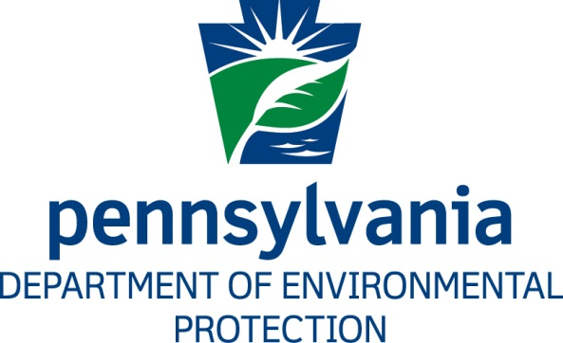

***Compacts and Commissions Office***

**Pennsylvania Lake Erie**

**Phosphorus Reduction Domestic Action Plan**

**Comment and Response Document**

**INTRODUCTION**

The Pennsylvania Department of Environmental Protection (DEP) developed the Pennsylvania Lake Erie Phosphorus Reduction Domestic Action Plan (DAP) to assist in the elimination of nutrient pollution in Lake Erie.

Pennsylvania is one of eight United States (U.S.) state governments with coastline and contributing tributaries to the Great Lakes, and one of five states that shares jurisdictional responsibilities for water quality in the Lake Erie Basin. In 1972, the U.S. and Canada signed the Great Lakes Water Quality Agreement (GLWQA) to provide a framework for the restoration, protection, and management of the Great Lakes water resources shared between the countries. The U.S. states and Canadian provinces fully participate in this process to assure cooperative restoration success.

The GLWQA was amended and reaffirmed in 2012 to include a process to develop new phosphorus reduction targets for Lake Erie, which were adopted formally in February 2016, to address over-nutrification problems identified within the lake and develop U.S. and Canadian Domestic Action Plans (DAP) for phosphorus reductions in each country. The U.S. Environmental Protection Agency (EPA) is developing the U.S. DAP that will coordinate and integrate each U.S. state-written DAP. The U.S. DAP also will include those actions to be completed by each U.S. federal agency with programs that affect Lake Erie water quality. The U.S. and Canada are bound by the GLWQA to complete these plans by February 2018, and the DAPs will be included as components of the Lake Erie Lakewide Action and Management Plan to be completed by the end of 2018.

DEP noticed a 30‑day public comment period in the *Pennsylvania Bulletin* (47 Pa.B. 3045) which allowed for submittal of comments from May 27, 2017 to June 26, 2017 through DEP’s eComment system, by email, and by mail. Also during this period a public webinar was conducted on June 15, 2017 to review the draft DAP. DEP received one (1) formal comment on the DAP pertaining to Section 5, “Measuring Progress and Achieving Consensus,” and Section 5.1.d. was added to address the comment. Additionally, minor edits and clarifications were completed to Sections 3.4, 3.4.1, 3.4.2, 3.5, 3.6, 4.2, 4.2.1, 5.3, and 5.4 to provide updated information and more detailed program descriptions.

**LIST OF COMMENTATORS**

1. Nicole Zacharda

Great Lakes Commission

Ann Arbor, MI

**COMMENTS AND RESPONSES**

1. **COMMENT:** *Commentator No. 1*

**“Staff of the Great Lakes Commission appreciate the Pennsylvania Department of Environmental Protection’s comprehensive approach to meeting phosphorus reduction goals within its draft Domestic Action Plan and this opportunity to provide comments.**

**Staff encourage PADEP to reference the ErieStat project being developed under the GLC’s Blue Accounting program as a tool for “Measuring Progress and Achieving Consensus” within Section 5 of the draft DAP. Starting with pilot watersheds in the western basin of Lake Erie, the ErieStat project will expand eastward in future phases, tracking progress toward a healthier Lake Erie.”**

**RESPONSE:**

DEP acknowledges the Great Lakes Commission for their proactive role in efforts to track Lake Erie phosphorus reduction activities of the United States and Canada, as well as the state and provincial jurisdictions. The ErieStat Project created through the Blue Accounting Program will be an important element in demonstrating the overall status of phosphorus reductions in the Western and Central Basins of Lake Erie. Pennsylvania intends to participate in this progress as the ErieStat Project expands to include both the Western and Central Basin. Section 5.1.d. of the DAP has been created to include a description of ErieStat and how Pennsylvania will participate.