Storage Tank Assessment Spreadsheet Guidance
TankSpreadsheet_2013.xls
The purpose of this spreadsheet is to summarize storage tank characteristics, estimate tank turnover time and mixing, and evaluate possible operational strategies that may improve turnover time and mixing. If operational changes are pursued, they should be made incrementally and supported with increased monitoring to ensure that any adverse effects to hydraulics and water quality are minimized.
This spreadsheet was developed by the USEPA’s Office of Groundwater and Drinking Water’s Area-Wide Optimization Program, which utilizes a facilitated approach to help drinking water systems move beyond regulatory water quality levels to enhance public health protection.
The spreadsheet inputs include tank information (diameter, inlet diameter, shape, height) as well as tank water level data over a period of time. There are guidelines provided on this worksheet about when the Tank Mixing Assessment and Turnover Time Calculations may, and may not, apply. Additionally, cautions about applying these calculations are provided. These include, but are not limited to:
- When the tank inlet configuration, or whether baffles exist, is not known, the estimates will be less accurate
- When the inlet is near the tank wall, the mixing ratio may be overestimated
- If the age of the water entering the tank is excessive, the turnover time will not approximate total water age
- If the temperature difference between the water entering the tank and the bulk water in the tank is significant, the tank mixing ratio may be overestimated (due to buoyancy effects)
- In situations where the tank is not well-mixed or when the mixing calculations cannot be used, the tank turnover time calculations will only indicate the average turnover time of the tank; in these instances there will likely be much older “dead-zones” of water in the tank.
A tank Summary worksheet provides space to enter general information for up to 9 tanks. Also, on this worksheet, the estimated Tank Mixing and Tank Turnover data are automatically populated (once the tank water level data are entered). There are 9 worksheets (labeled Tank#1 through Tank#9) for entering tank level data and assessing the impact of (theoretical) operational changes on (estimated) tank mixing and turnover characteristics, as well as a fully populated Example worksheet for reference. Finally, the spreadsheet provides Glossary and Hints worksheets as references for the user.
The software also looks at distribution tank operations in terms of optimization. The following optimization goals are incorporated into this software:
DISTRIBUTION SYSTEM GOALS
Performance Goals
Tank Turnover
- Maintain turnover time less than or equal to 5 days at all times or establish and maintain an optimal water turnover rate at each storage facility.
Tank turnover is essential to ensure that fresh water is entering the tank and replacing a specific volume of water within the tank. This is needed to maintaining water quality within a tank and to minimize the impacts of the tank on the quality of water leaving the tank.
Turnover time is the amount of time that it takes for the volume of the water in a tank to be completely replaced. For example, if a 1 million-gallon tank draws 20% of its tank volume once per day, the total volume of the tank, or 1 million gallons, will be replaced in 5 days. In this example, the tank turnover time is equal to 5 days, which meets the goal presented.
Mixing Performance Ratio
- Maintain good mixing performance ratio (PR ≥1.0) at all times.
In distribution system storage facilities, once tank turnover has been optimized, mixed conditions should be achieved. It has been shown through studies that the disinfectant residual decays more rapidly under a plug-flow versus a completely mixed scenario. Although, without proper turnover and sufficient exchange of the volume of water present within the tank, mixing may not show any benefits and may even be detrimental when very poor tank turnover is occurring.
Tank mixing can be measured by calculating the volume exchange fraction or the fraction of water that has been added to the tank during a fill period. In most tanks, mixing can be improved by increasing the volume added during the fill period or decreasing the inlet diameter (i.e., increasing inlet velocity). Other mechanical or passive mixers can be utilized to enhance mixing as well. A mixing performance ratio (PR) is used to assess the actual mixing compared the desired mixing.
Although these goals are incorporated into this software, the system may wish to establish their own system specific goals and incorporate them as part of this software.
It is important to keep system pressure in mind when manipulating tank operations to meet tank turnover goals. Lowering a tank to a point where pressure issues arise should be avoided.
It is important to note that these are calculations based on theory. Although they provide a starting point for enhancing tank operations, water quality data should always be used as the basis for determining the extent of impacts of tank operations on water quality. It is also important to keep system pressure in mind when manipulating tank operations to meet tank turnover goals. Lowering a tank to a point where pressure issues arise should be avoided.
INSTRUCTIONS
Summary
- Open the file entitled “TankSpreadsheet_2013.xls”.
- Ensure that macros have been enabled once opened. This spreadsheet will only work if macros are enabled!
- Click on the “Summary” tab at the bottom of the open spreadsheet.
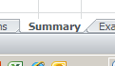
- Enter the Name of Tank and associated tank information as requested in the spaces provided to the right of each of the questions, starting with Tank #1. If multiple tank operations are being monitored, then complete the data for each additional tank.
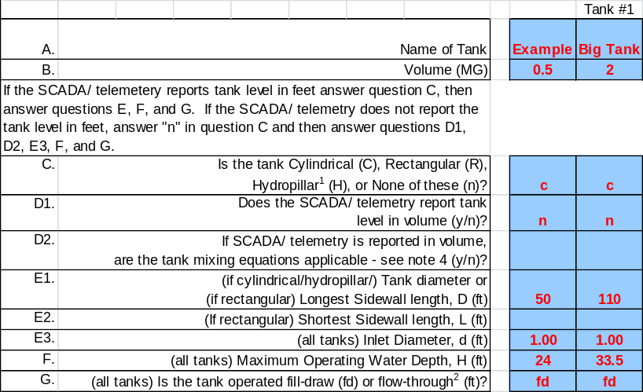
- Based on the specifications provided, the spreadsheet will calculate the height to diameter ratio and determine if the tank turnover and mixing calculations are applicable.
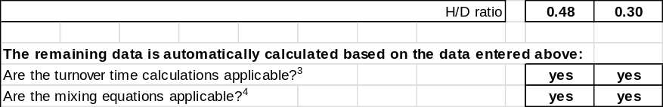
Tank Data Entry
- Click on the “Tank #1” tab at the bottom of the open spreadsheet.
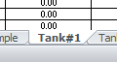
- Using data collected from the system SCADA, or other means (e.g. pressure data logger), for the tank being analyzed, enter the required date, time and level data (in red) for each fill and draw cycle during the timeframe being analyzed. The spreadsheet can accept a total of 15 fill and draw cycles (30 data points). When entering the data, each Min Level must be followed by a Max Level. Errors will occur if; the min level and max level are not alternated or are reversed and the dates and times are not consecutive. For the best tank analysis, all 30 data points should be provided.
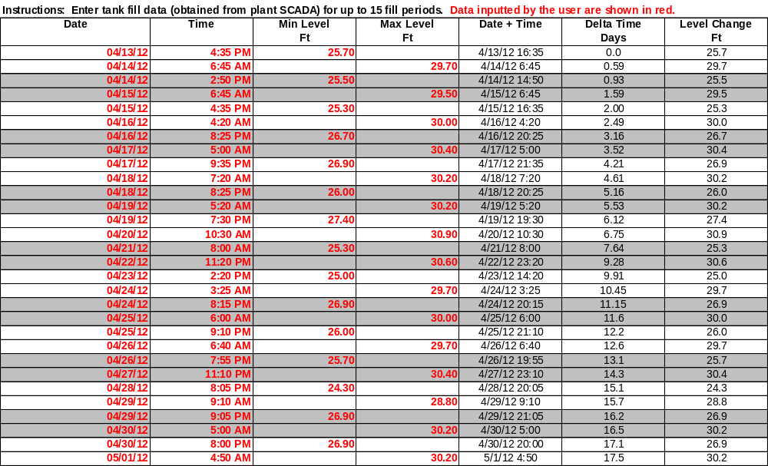
- Once completed, the data is used to calculate the tank turnover and mixing performance ratio for the timeframe analyzed. If the calculated tank turnover and mixing performance ratio meets the goals provided in the Introduction, the cell will be shaded green. If they do not meet the goals, then they will be shaded yellow.
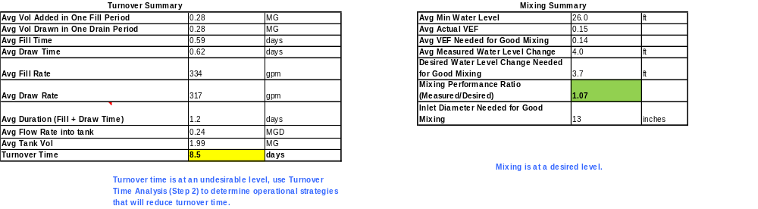
- After a complete set of data is entered and the tank turnover and mixing performance ratio calculated, Step 2 of the worksheet can be utilized to experiment with different tank levels to determine the impact on tank turnover and mixing. This is done by changing the maximum and minimum tank levels in the spreadsheet in Step 2. If mixing is an issue, and physical sizing changes to the inlet is being investigated, then this can be altered as well.
It is important to keep system pressure in mind when manipulating tank operations to meet tank turnover goals. Lowering a tank to a point where pressure issues arise should be avoided.
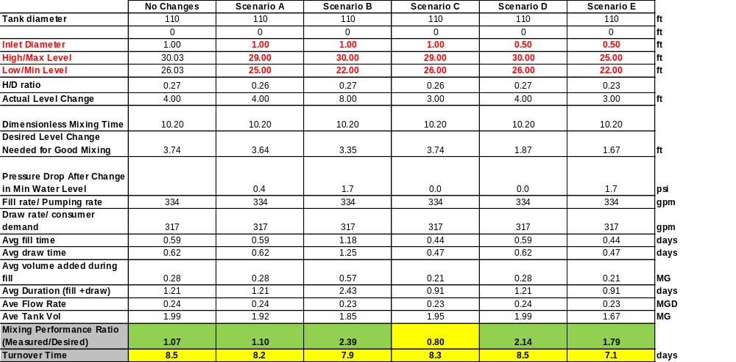
- Step 3, at the bottom of the worksheet, is only utilized in situations where a chlorine degradation hold study was done in conjunction with the tank mixing and turnover assessment. The hold study must be completed in order to determine a chlorine decay rate constant (k). This section of the worksheet is useful in relating current and proposed tank operations with water quality.
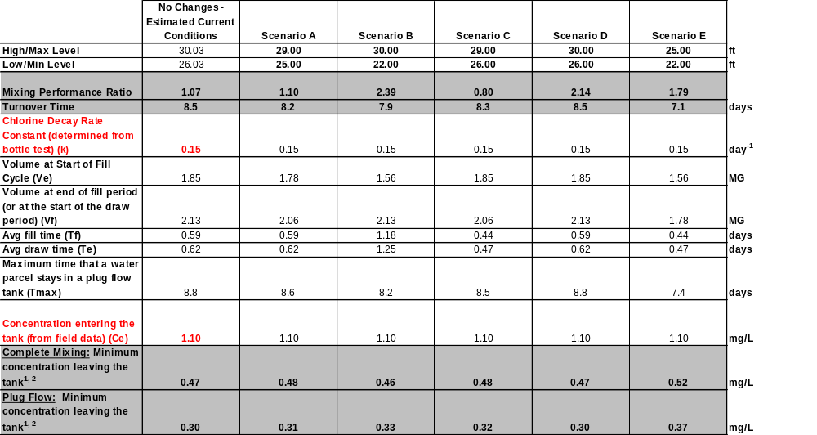
- Repeat steps 1 through 5 for each tank being analyzed.
Refer to the Instructions, Example, Glossary and Hints Tabs for additional guidance or clarification.


