ePermitting Electronic Administrator
User's Guide

Prepared by: | Business Support Services
Version: | 1.2
Date: | October 11, 2019

Table of Contents
Disclosure Information 3
Change History 3
Purpose 3
Applications Support Help Desk Team 3
DEPGreenport Self-Registration 4
Creating a DEPGreenport Self-Registration Account 4
Enrolling into the e-permitting Application 7
DEP New Client Registration 9
Client Identification 9
Security Agreement for Owner and EFA 9
ePermit Dashboard 12
Accessing the ePermit Dashboard 12
Working Through a Draft Permit Application 14
Types of Data Fields………………………………………………………………………………………………………..…..14
Paying a Registration Fee 16
Pay by Telecheck 16
Printing a Certificate …………………………………………………………………………………..……………………….17

Disclosure Information
The information in this document may not be changed without the express written agreement of the Department of Environmental Protection.

Change History
Version | Date | Revision Description
1.0 | February 28, 2018 | Version for user review
1.1 | August 15, 2019 | Updated for formatting, etc.
1.2 | October 11, 2019 | Updated for Instant Access Functionality
1.3 | February 6, 2020 | Modified access for consultants
1.4 | May 19, 2020 | Updated for new Greenport screens

Purpose
Welcome to the guide to user administration for the e-permitting website via the DEPGreenPort website.
This guide provides information on how to successfully administer eDMR users on the DEPGreenPort website and use the functions available through the e-permitting Application.

Applications Support Help Desk Team
Help Desk Support Line
Number: (717) 787-HELP (4357)
Hours: Monday to Friday 8:00 am to 4:30 pm
Business Support Help Desk Team
The Applications Support Help Desk Team includes helpdesk specialists, trainers, web masters, on-line help developers, and testing engineers working together to provide complete end-user support for eFACTS and other applications.
Applications Support Help Desk Team's Services
- Applications Training
- Formalized Classroom Training
- Small Group Training
- One-on-One Training
- Participate in meetings to provide application guidance
- Telephone Support Help Desk
- Application Web Page Development and Maintenance
- Publish articles identifying solutions to common problems
- Application Testing
- Documentation Development
- Application On-Line Help Development and Maintenance

DEPGreenport Self-Registration
For most DEP electronic applications users have completed a Request for Security Access form and DEP has provided a username and password to access the DEPGreenPort. However, DEP has some electronic applications that allow users to self-register. If you are sure that the application, you wish to access is on the list of applications which allow users to self-register you may begin the self-registration process.

Creating a DEPGreenport Self-Registration Account
- Go to the https://www.depgreenport.state.pa.us website.
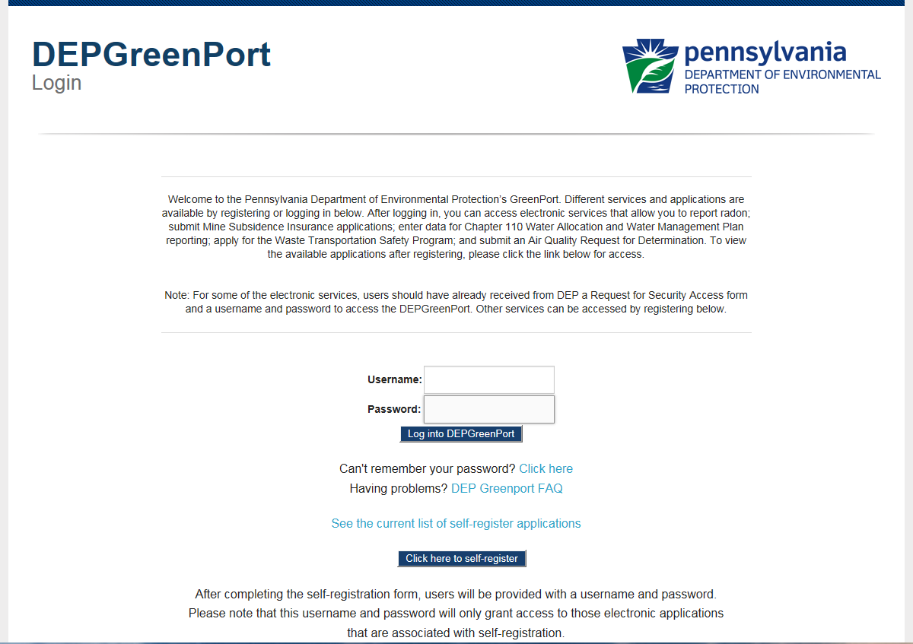
The DEPGreenPort Login screen will display.

- Select the Click here to Self-Register button.
- Click the ‘Click here to self-register’ button.
- The DEPGreenPort New Account – User Profile screen will display.
- Click the User Guide link and follow the steps to complete the set-up of your GreenPort user account.
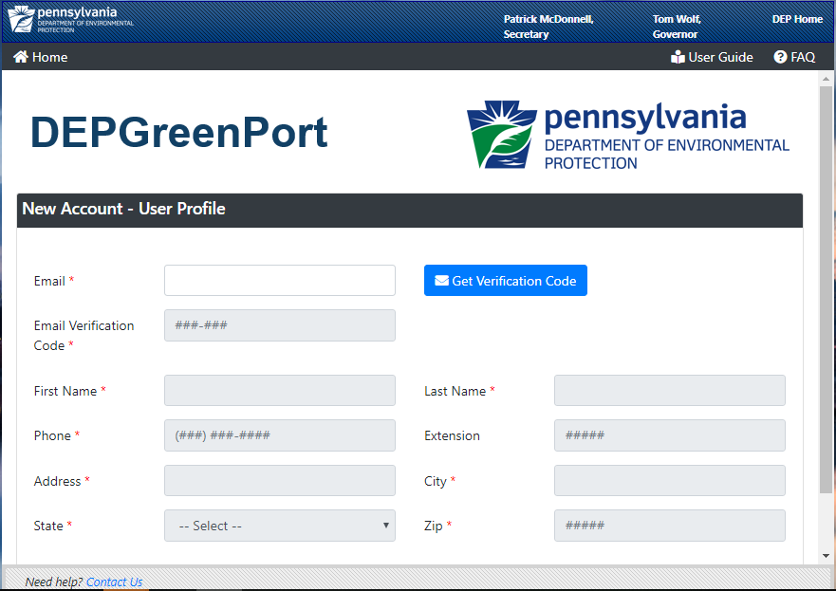

Enrolling into the e-permitting Application
After a user is registered, the user must log into DEP GreenPort to Enroll into the e-permitting Application.
- Select the Application Enrollment header.
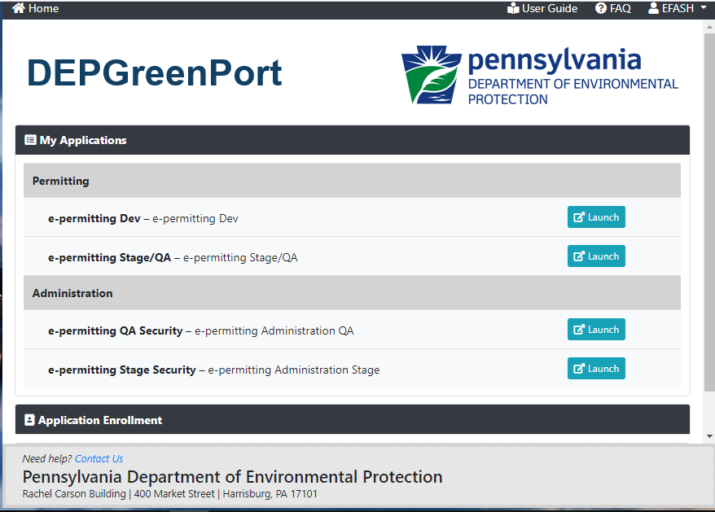
- The DEP GreenPort List Applications screen will display.
- Under the Permitting header, select the Enroll button for e-permitting.
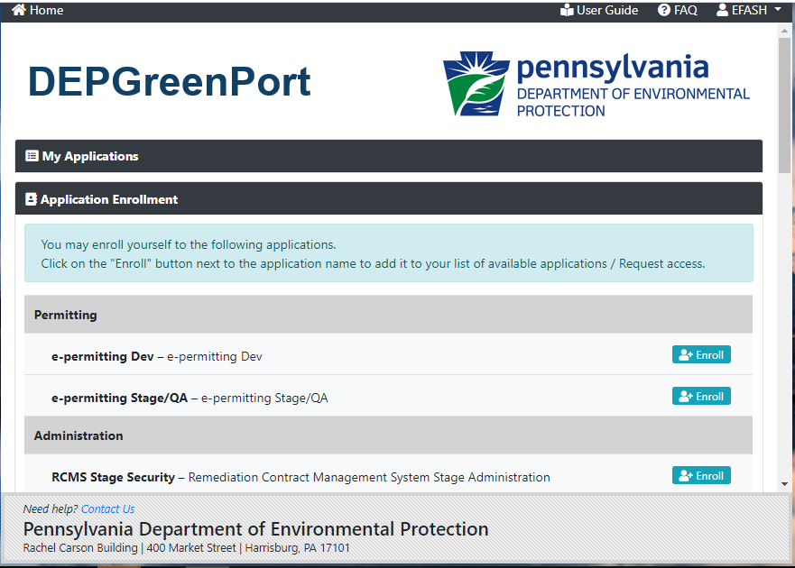
- The user will be taken to the DEP GreenPort Additional Data Required for access to ePermitting screen.
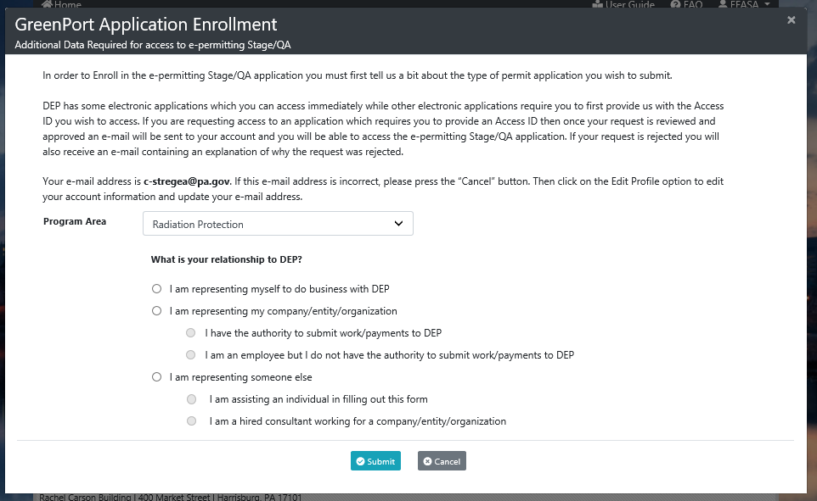
- Select Radiation Program from the Program Area drop down list.
- Select one of the following options to act as an EFA:
  - I am representing myself to do business with DEP
  - I am representing my company/entity/organization, and the follow up option of I have the authority to submit work/payments to DEP
  - I am representing someone else, and the follow up option of I am assisting an individual in filling out this form.
- Select the Submit button.

DEP New Client Registration
Currently, Radiation Protection functionality will be limited to users making payment on an existing invoice. If there are no existing invoices to be paid at this time, please contact the Bureau of Radiation Protection at 717-787-3720.
Applicants are given the ability to upload documentation as needed.

Client Identification
The user will have the ability to Search for an existing registration number by entering a valid registration number. The user may add additional facility registration numbers, if necessary.
When a registration number is entered incorrectly, a notification message will display indicating verification of the registration number and ask the user to re-enter the number.
Upon entry of a valid registration number, the Client Search Name and Facility address will display. Once the user validates the information that was returned from the system is accurate, the user will select to proceed by selecting the Continue button.
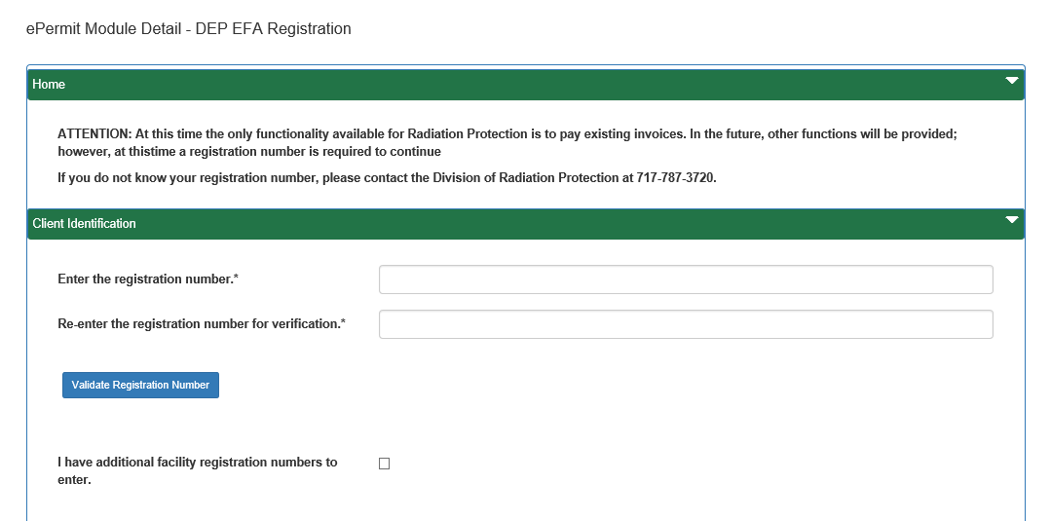

Security Agreement for Owner and EFA
The applicant is required to select the Terms outlined within this Agreement, additional required information will be entered by the applicant as applicable, and the date the agreement was signed prior to the save and submission of this form. The Signature page will only display when an invoice # is provided.

Once the user selects to save and submit the form, the Security Agreement for Owner and EFA will display.
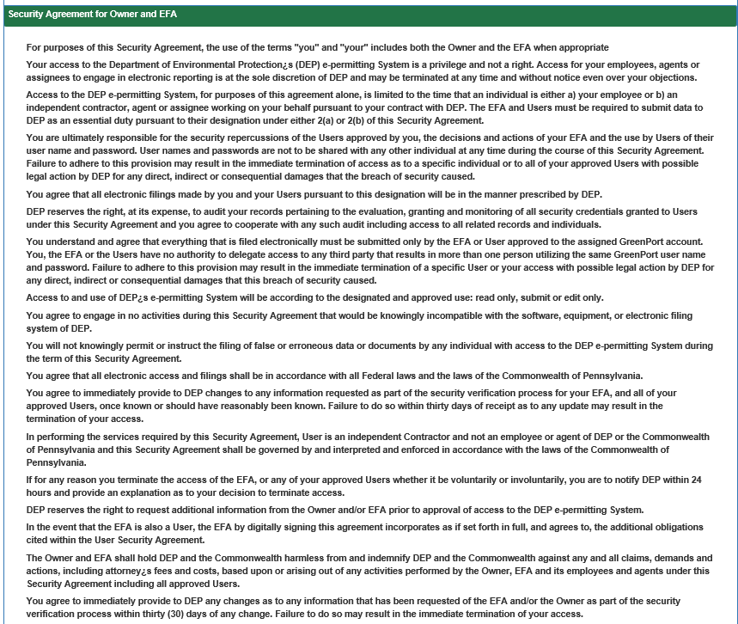
Once the form has been submitted, an E-mail notification will be sent to the E-mail Address entered when setting up the DEPGreenPort Self-Registration account.
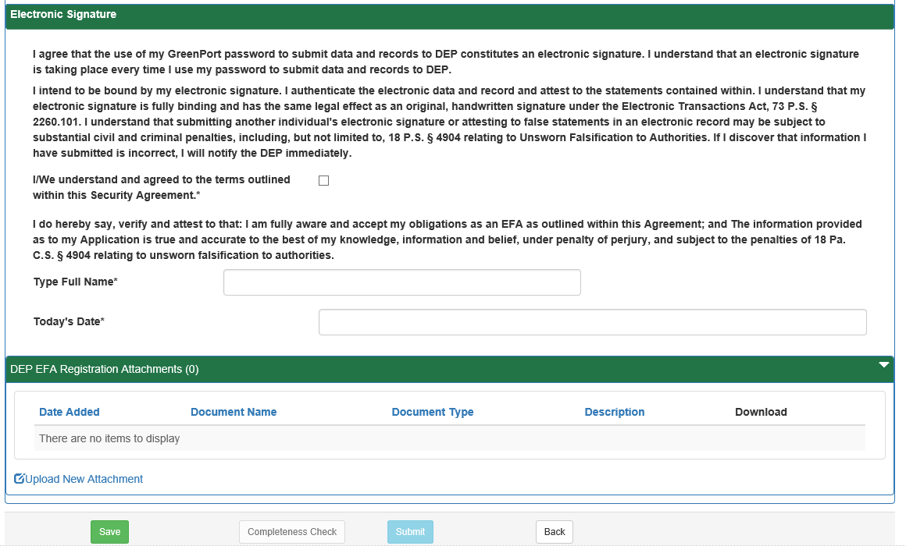
Upon success of the submission, the user will be navigated to their e-permitting dashboard where they can pay pending registrations

Accessing the ePermit Dashboard
- Open Internet Explorer.
- In the URL Address Bar type in https://www.depgreenport.state.pa.us
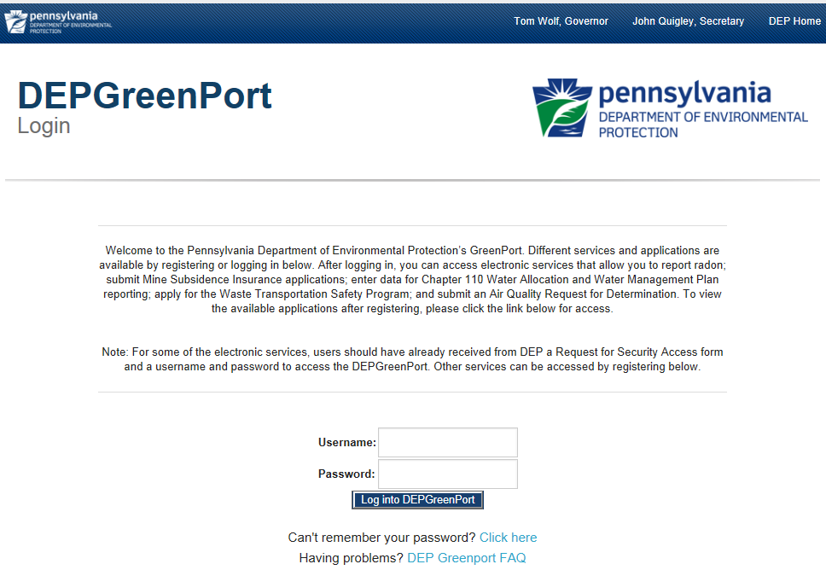
- The DEPGreenPort website will display.

- Enter your username in the Username field.
- Enter your password into the Password field.
- Click the Log into DEPGreenPort button.
- The List Applications Screen will display.

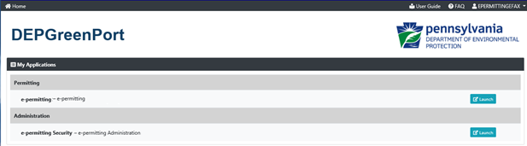

- Click the launch button.
- From within the ePermitting application, the ePermit Dashboard is the Home page. It can be accessed at any time by clicking the Home button.
- Authorized users will see various links based on the programs they have been given access to.
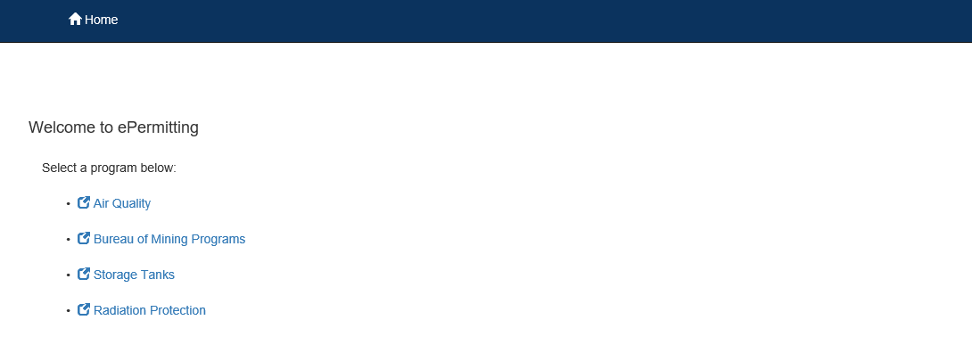

If users only have access to one program, this page is skipped, and the user is taken directly to their dashboard for that program.
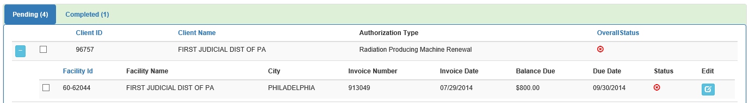

Working Through a Draft Permit Application
Authorized ePermitting users have the ability to create draft permit applications by completing modules and saving them at any time within the ePermitting Application.

Types of Data Fields
Users will encounter several different types of data field types when working through their applications. Some samples of these types of data fields are below.
- Checkbox – a checkbox is clicked to select the value next to it. You may click it a second time to deselect it.
Example: 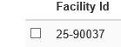
- Text Box – a textbox is a box where users can enter text manually or paste text that was copied from another application.
Example:
- Radio Button – a radio button is used to select one item from a series of items. Only one button in the grouping can be selected.
Example:
- Dropdown menu – a dropdown menu is a menu you click on to display a list of items. You will click the item you wish to select from the list for it to display as the selected item from the list.
Example: 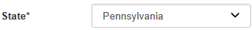
- Button – a button is used to operate the command shown on the button. In the example below, the Save button saves the data that had been entered onto the screen.
Example:

Entering Data into Your Draft Application
The ePermitting Application is a dynamic application which means it can change based on the information entered into it. Users may notice that, depending on the answers given in some areas, the application will add additional questions or perhaps even require additional modules.
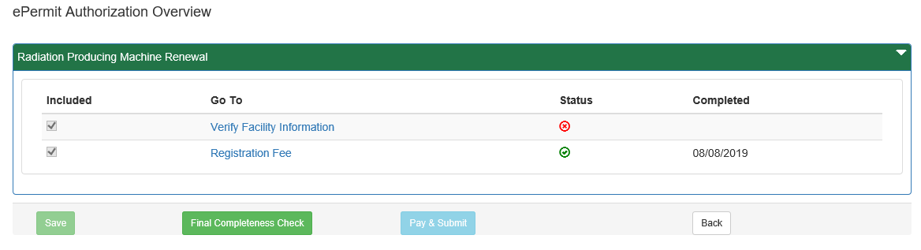

- While working in a draft application in the ePermitting application, click the link for an unfinished module.
- Complete all data fields in the module, including all required fields.
Required fields: A required field is indicated by an asterisk * to the right of the field title. The module will not be consisdered complete until all required fields have been completed.
- Click the Save button to save your changes at any time while working on the module. You can return to the module to complete it at another time.
You may encounter an error message when saving a module if something was entered incorrectly.
You will see a message indicating if the module was saved successfully or not.
- Click the Completeness Check button to verify all required information has been completed for the module.
If a module is not complete, you will see a list of items that need to be finished before the module can be considered complete.
- Click the Close button.

Paying a Registration Fee
Payment can only be made once client/facility information is verified and a green icon appears in the status column on the dashboard.

Pay by Telecheck
You will now be taken to the ‘Payeezy’ page to enter your payment information. When finished, click the ‘Pay with Your Credit Card’ button. Master Card is not accepted at this time.
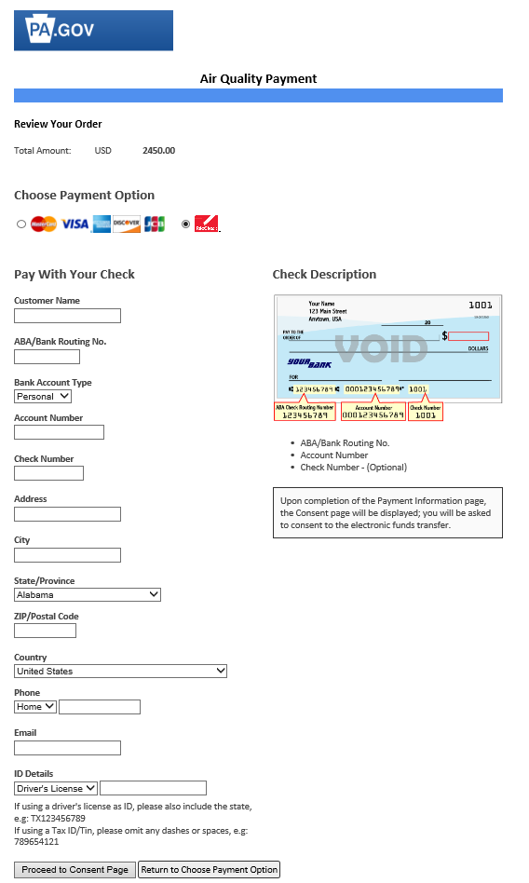

If payment is accepted, the user will receive a message indicating the payment is processed successfully and the user will be returned to the ePermit Dashboard.
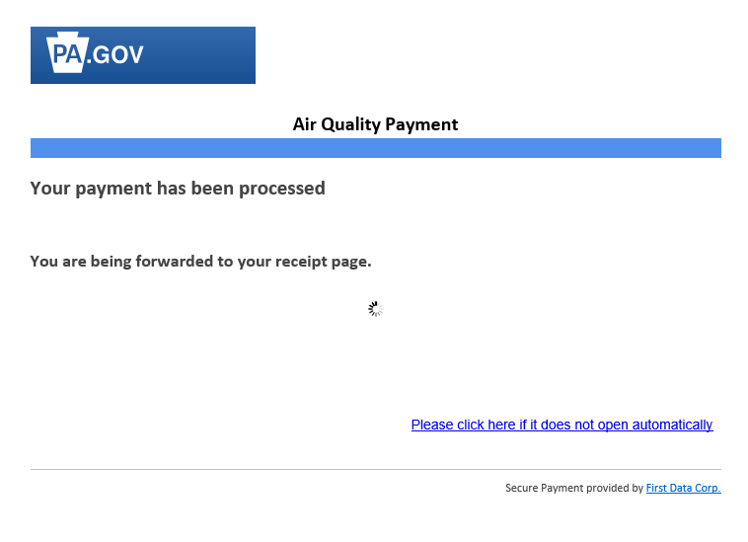

If payment is not successful, a message will display on the ‘Payeezy’ screen indicating the payment was not processed.

Printing a Certificate
- To view paid registrations, select the Completed tab from the ePermitting dashboard.
- The user may view and print a Registration Certificate by selecting the View Temporary Certificate link

