Instructions for the On-line Application

The Air Quality Small Business Technical Provider Assistance Grant application must be submitted online through the Electronic Single Application (ESA) website. Paper and faxed copies will not be accepted. This change allows DEP to expedite the review process. The link to the ESA website is: https://www.esa.dced.state.pa.us/Login.aspx

No documentation should be mailed to DEP.

User Tips
- Electronic Single Application works best when accessed through Microsoft Edge or Google Chrome
- If you allow your screen to sit idle for 30 minutes or more, you will lose the data entered since your last save and will have to re-enter it.
- Save frequently.
- When completing the application, fields with a “” are required fields. If a required field is skipped, you will be notified later in the application to return to the affected section to complete the field.
- Do not use special characters such as \,/,*,&,%,#, etc.
- If you have questions completing the application, please contact Enterprise eGrants Customer Service Center at 1-833-448-0647 or email at egrantshelp@pa.gov. Operating hours are Monday through Friday from 8:30 am to 6:00 pm EST.

Table of Contents

1. Registration and Login Page 3

2. Begin a New Application Page 4

3. Select a Program Page 5

4. Apply Page 6

5. Applicant Information Tab Pages 6-7

6. Project Overview Tab Page 8

7. Project Site Tab Page 9

8. Narrative Tab Page 10

9. Budget Pages 11-12

10. Program Addenda Tab Pages 13-15

11. Certification and Submission Page 16

12. Application Receipt Verification Page 17

Reminder: If you have questions completing the application, please contact Enterprise eGrants Customer Service Center at 1-833-448-0647 or email at egrantshelp@pa.gov. Operating hours are Monday through Friday from 8:30 am to 6:00 pm EST.

- Registration and Login
- Write down and save the Username and Password you have chosen. You will need this for later your grant documents.

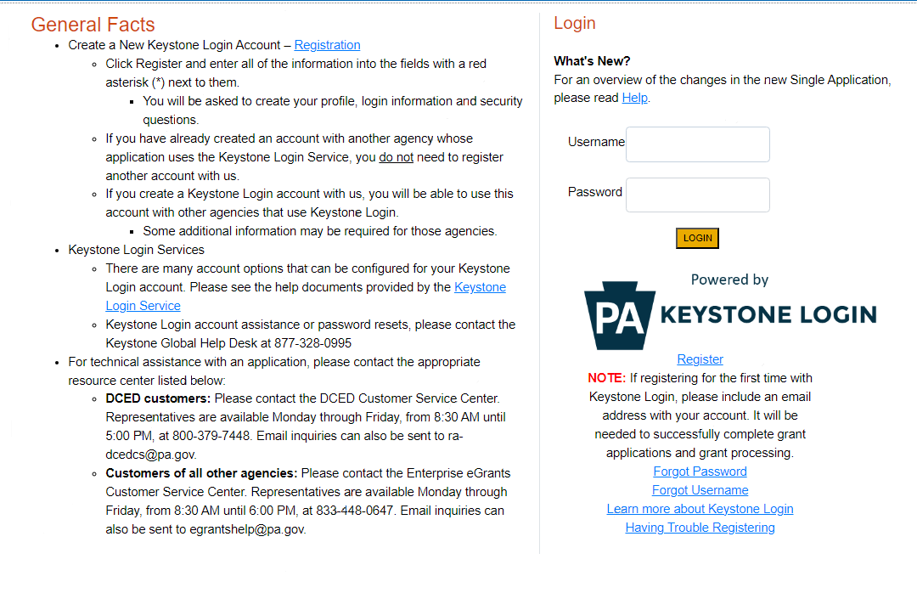

- Begin a New Application
- Project Name – Choose and enter a name for your project.
- Do you need help selecting your program – Select “Yes”
- Click on “Create a New Application”

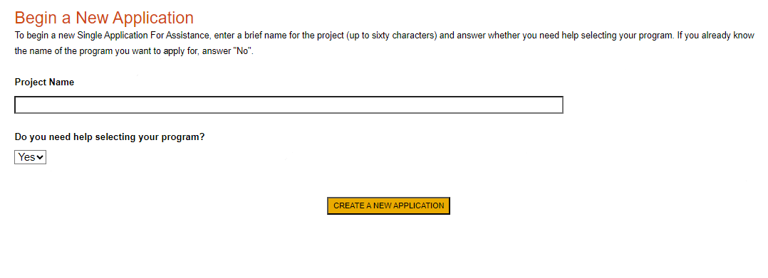

- Select Program
- Under “Agencies,” click DEP
- Scroll down and click “Search”

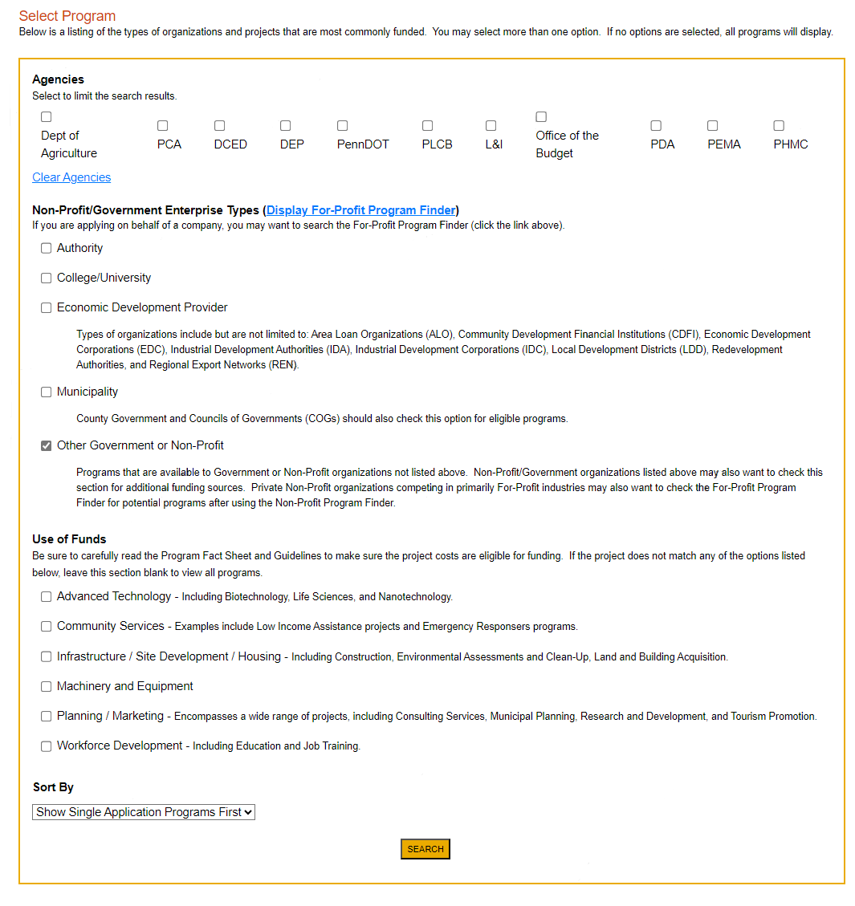

- Apply
- Scroll down through the various grant offerings, locate the “ Air Quality Small Business Technical Assistance grant and click on “Apply.”

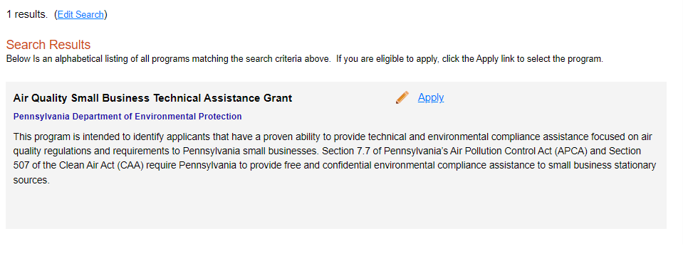
- Applicant Information

- The Applicant Information section requires data related to the entity for which the application is being submitted.
- Applicant Entity Type –
- Applicant Name – Enter the legal County name, the name under which the county legally conducts business.
- NAICS Code - From the dropdown box, enter your 4-digit industry code.
- FEIN/SSN Number - Enter the Federal Tax ID number for the legal County name (no dashes).
- UEI Number – Unique Entity Identifier. Enter the applying organization’s unique, 12-character alphanumeric identifier which is assigned to all entities that conduct business with the federal government.
- Top Official/Signing Authority – In this block, enter either the County Commissioner, County Secretary or County Treasurer name.
- Title – Enter either County Commissioner, County Secretary or County Treasurer.
- SAP Vendor# - Enter, if known.
- Contact Name – Enter the primary contact name for this project.
- Contact Title – Enter the primary contact title for this project.
- Phone and Fax – Enter the phone and fax numbers for the primary contact title for this project. This should be a phone at the County for which the application is being submitted.
- E-mail – Enter the e-mail for the primary contact title for this project.
- Mailing address, City, State and Zip Code – Enter this information for the County and primary contact title for this project.
- Enterprise Type – Select Government.
- Click “Continue”

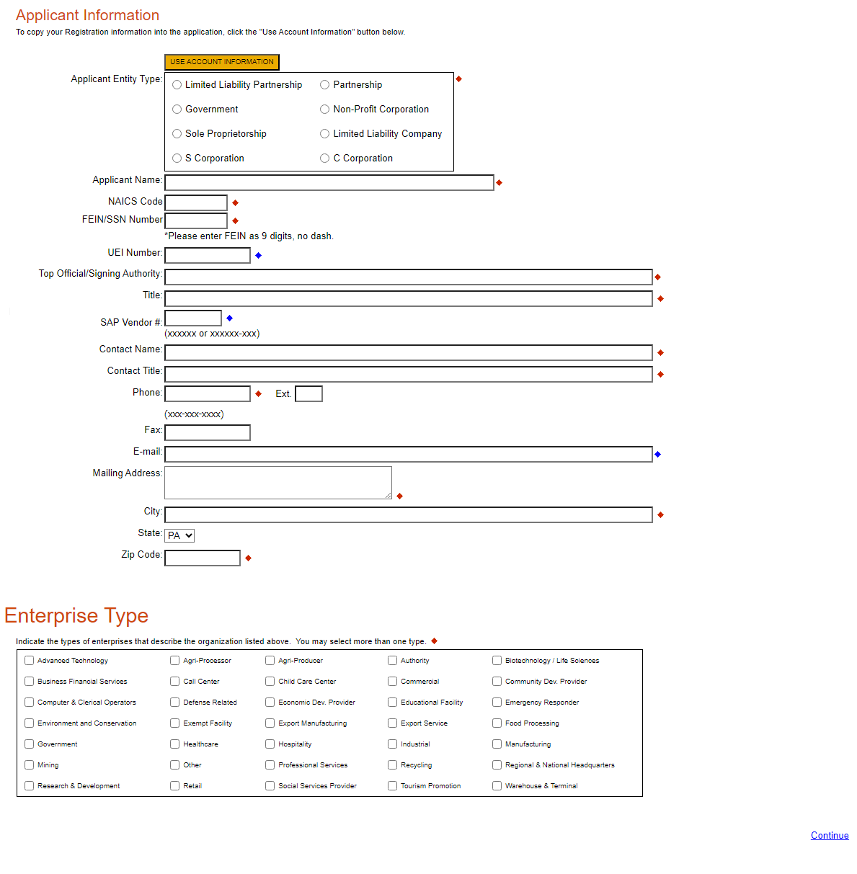

- Project Overview

- Project Name – The project name will auto-populate.
- Site Locations – Default setting at 1. Only needs filled in if more than one site location exists for this project.

The rest of the information in the Project Overview section is not required and does not need to be filled out.
Replace Image based on program
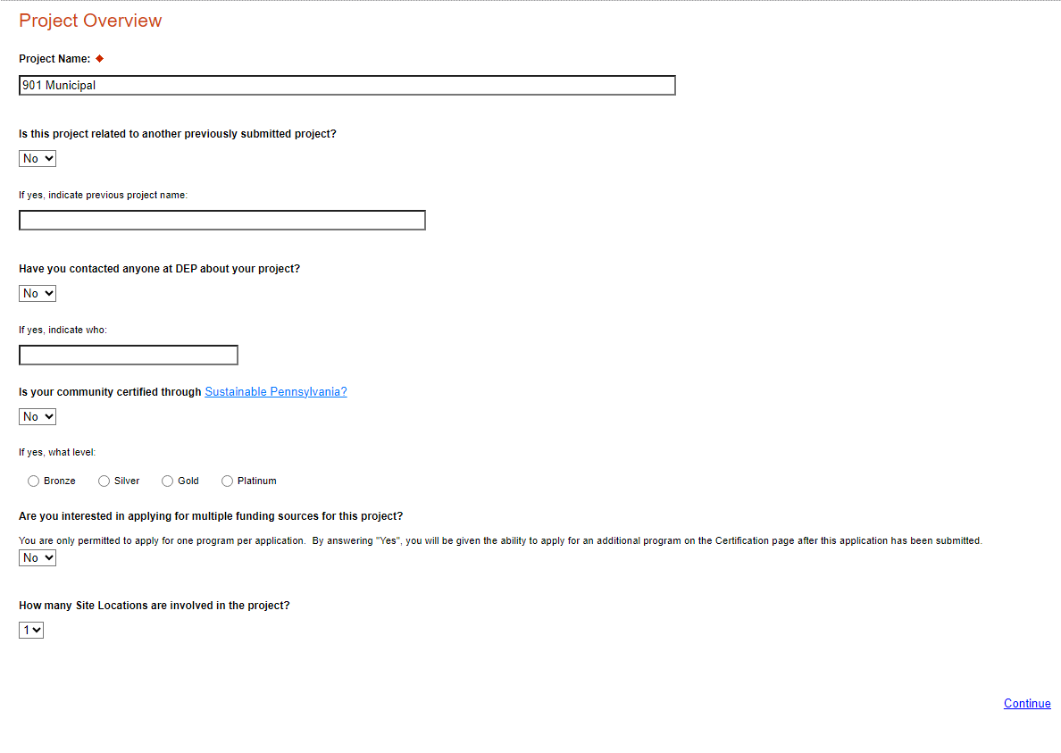

Click on “Continue”

- Project Site

- Address – Enter the applicant’s mailing address (street address). P.O. Boxes are not acceptable.
- City, State and Zip Code – Enter this information.
- County – Select county from the dropdown box.
- Municipality – Select municipality from the dropdown box.
- PA House & Senate – These fields will be auto-populate based on the information entered above.
- Designated Areas – Leave blank.

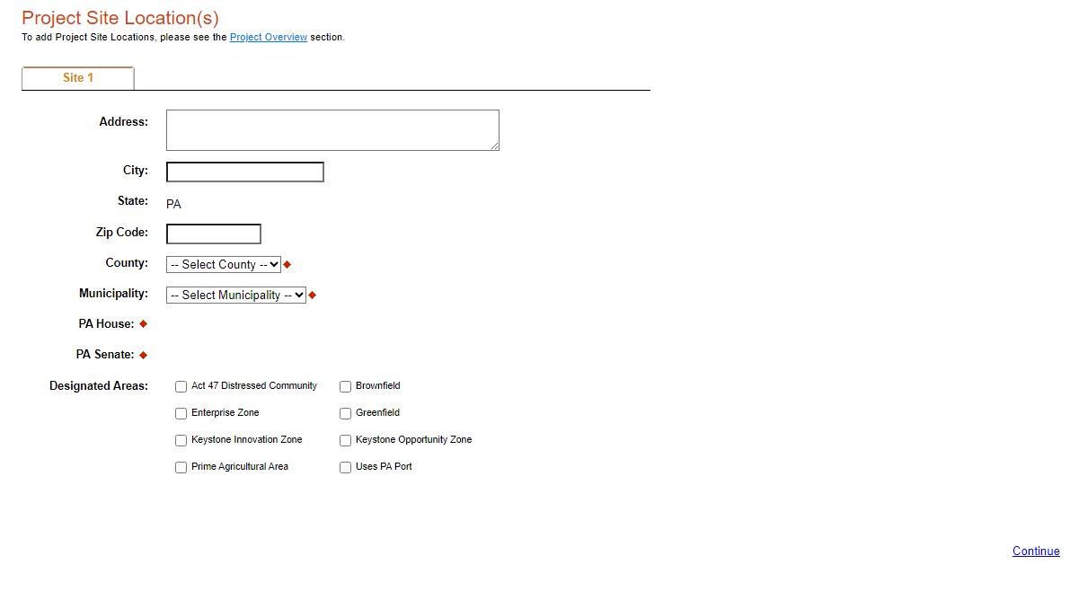

Click on “Continue”

- Project Narrative
- Complete all fields in this section

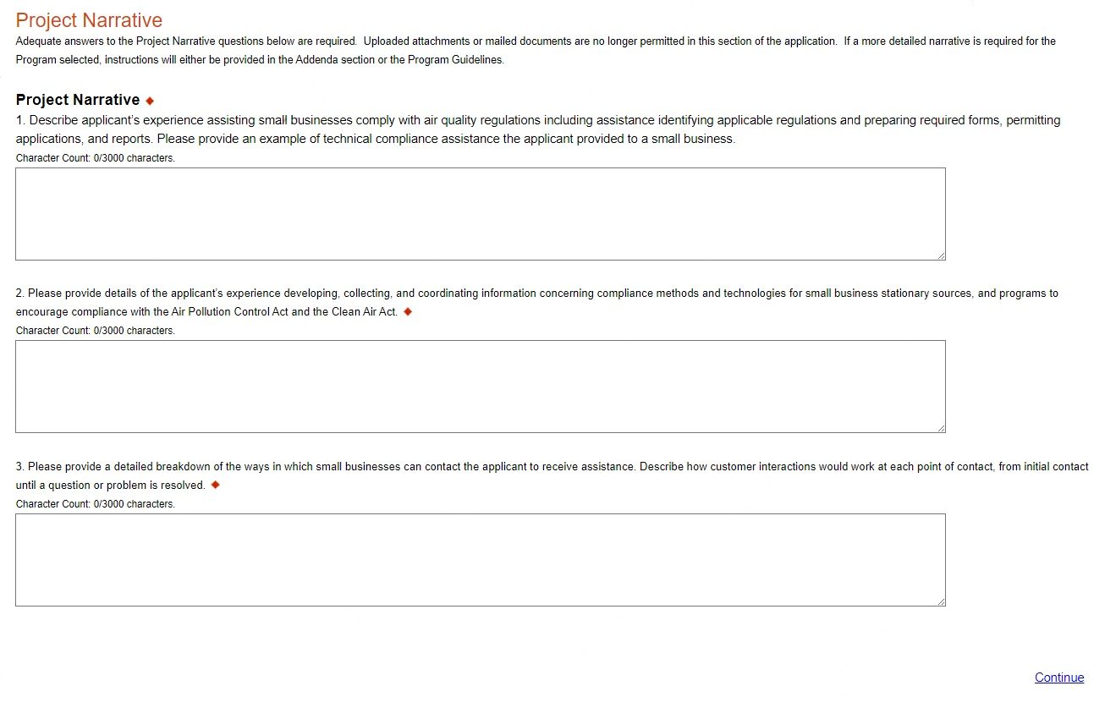

Click on “Continue”

- Program Budget

There are two tabs on this page which need to be completed, the Spreadsheet and Basis of Cost.

- Spreadsheet
- Click on the Spreadsheet tab
- Enter any budget instructions or minimum/maximum amounts as needed

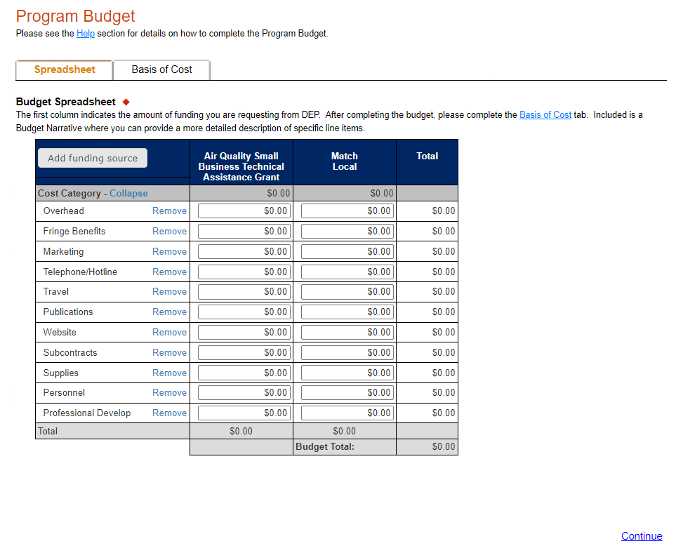

Click on “Continue”

- Basis of Cost Tab
- Click the Basis of Cost Tab
- Provide a brief narrative of the cost of each requested item.

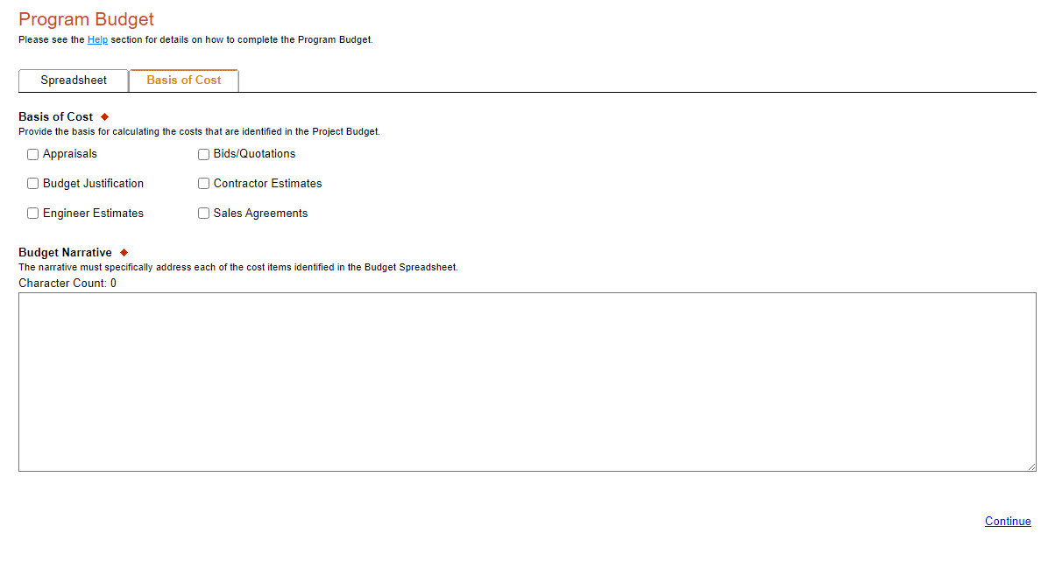

Click on “Continue”

- Program Addenda
- Complete all fields in this section.

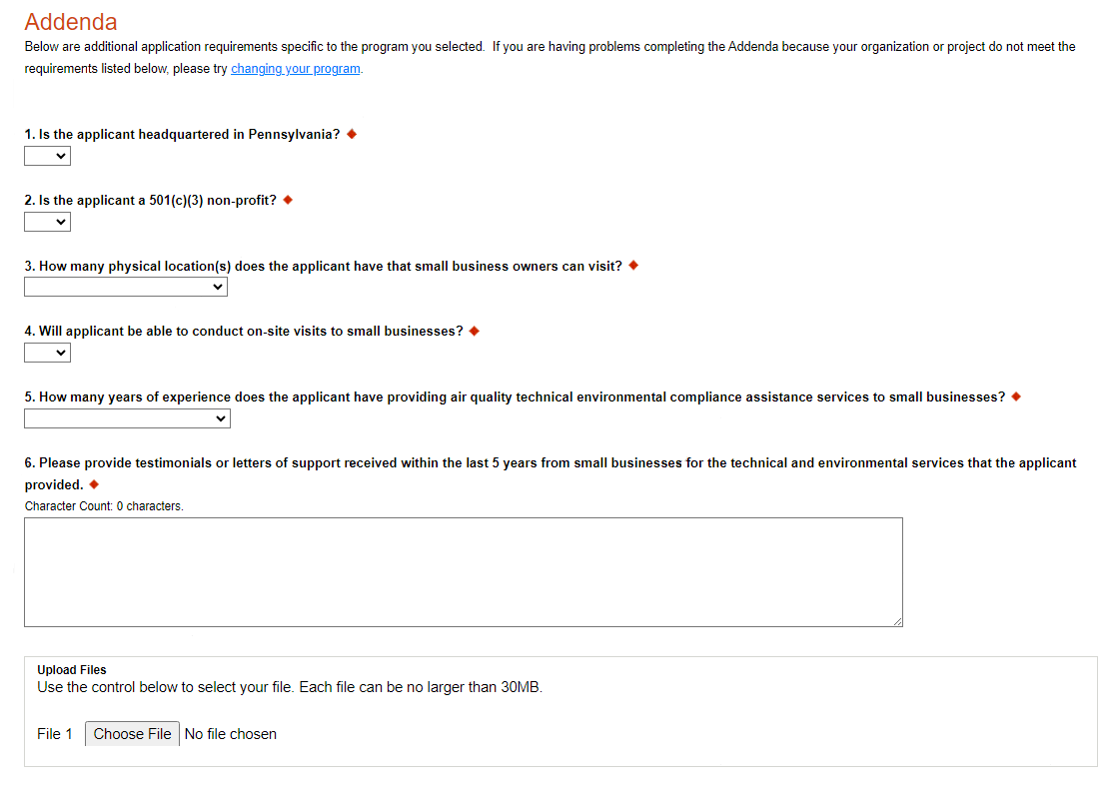
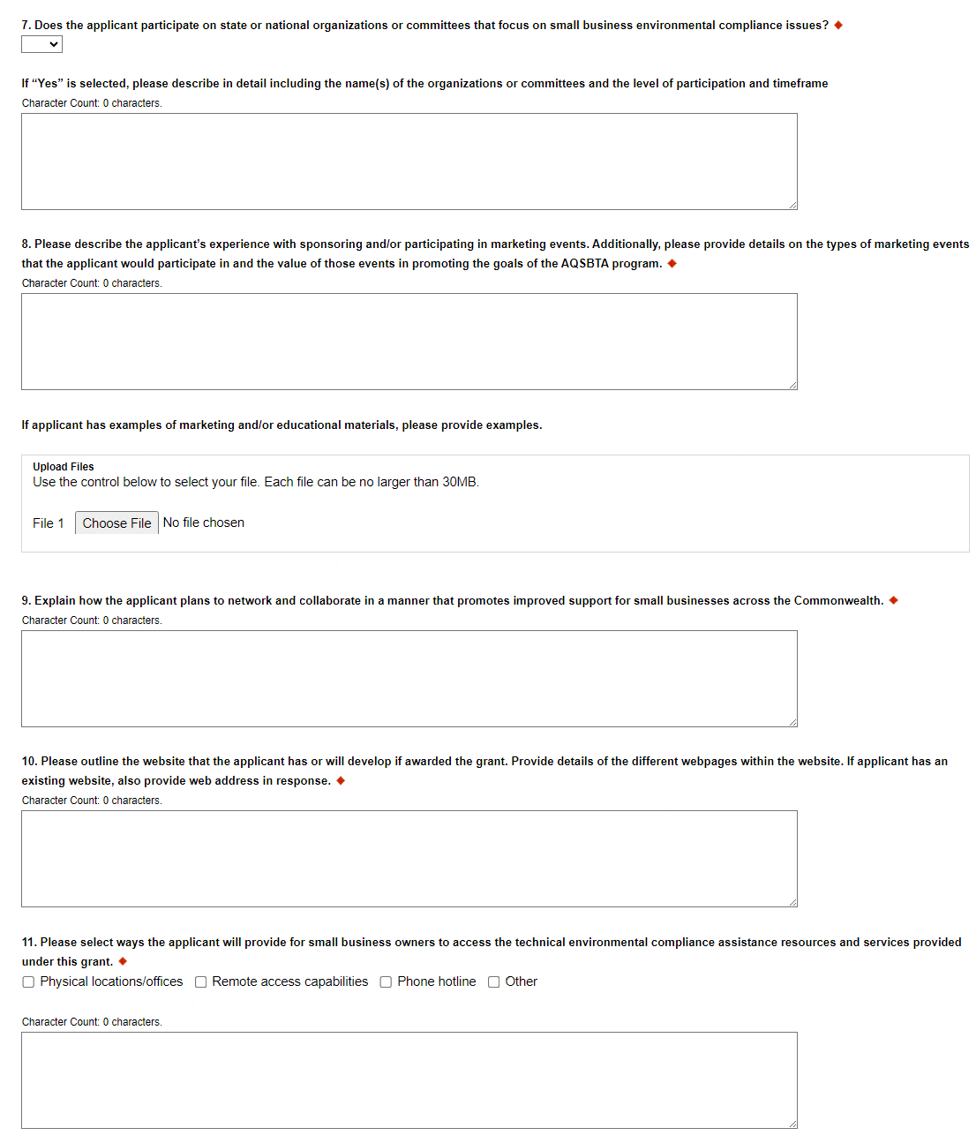
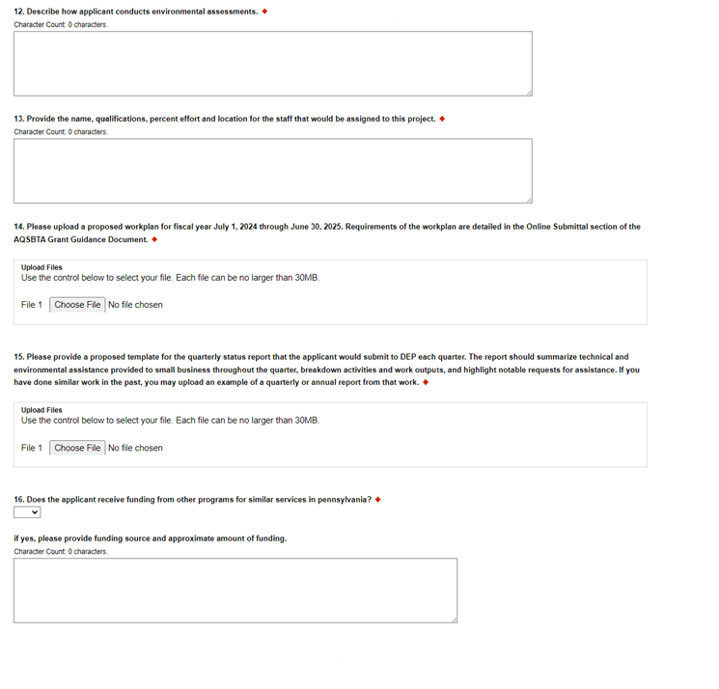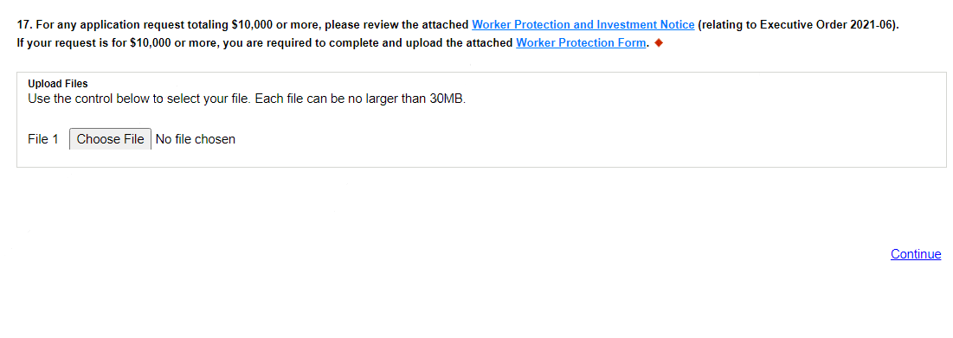
Click “Continue”

- Certification and Submission
- If there is any missing information in your application, your screen will look similar to the following example.
- Under the orange “Application Certification” heading, it will state, “The following sections are incomplete. All required fields marked with a red diamond must be completed before you are able to submit this application”.
- To add/correct the information on your application, click on the section heading to return to the page.

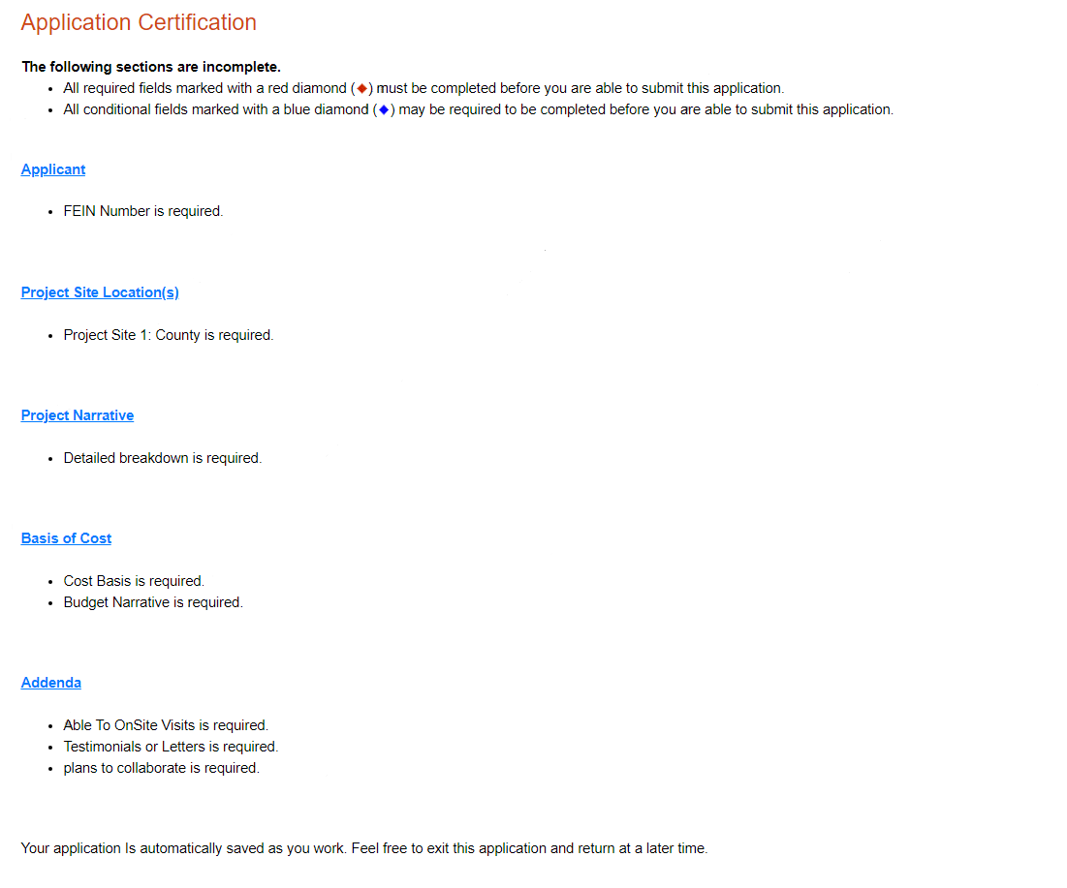

- Application Receipt Verification
- If you want a copy of your application, click the “Print Entire Applications with Signature Page” link. You will always be able to access your application with the username and password you created at the beginning of the application.
- Make sure to note the Single Application ID#. All future correspondence from the Department will reference this number.
- You do not need to send the signature page and/or any further documentation to the Grants Center. All the information needed is contained in your online submission.

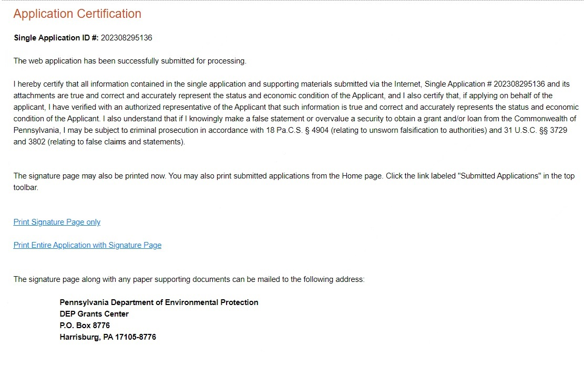
You do not need to mail any documentation to DEP. All information needed is contained in your on-line submission.

- Congratulations! You have completed the online application.

