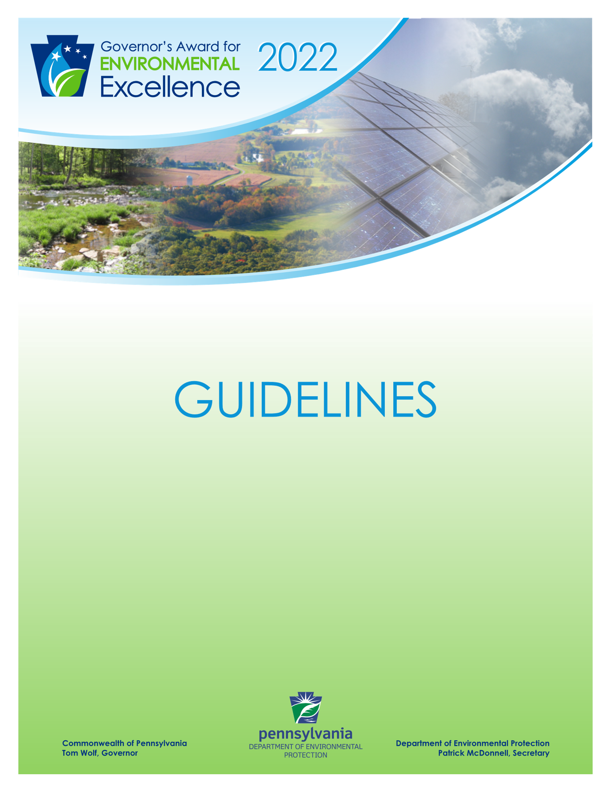

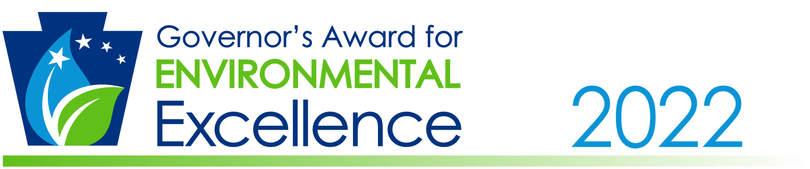

Dear Friend,

On behalf of Governor Tom Wolf, it is with great pleasure that I invite you and your organization to apply for the 2022 Governor’s Award for Environmental Excellence. Under the Governor’s direction, the Department of Environmental Protection (DEP) dedicates its efforts to developing environmental education opportunities, assisting organizations to achieve greater pollution prevention, mitigating greenhouse gases and adapting to climate change, protecting watersheds in need, supporting environmental cleanup programs statewide, and promoting environmental justice.

The past year presented significant challenges to Pennsylvanians, particularly the devastating impact of COVID-19 on our communities, businesses, and families. For many, having access to a clean, healthy environment became more meaningful than ever as they practiced social distancing to keep themselves and their neighbors safe. This year’s Governor’s Award for Environmental Excellence will demonstrate the spirit of resilience and stewardship shared among individuals and organizations that persevered in pursuing projects aimed at environmental protection, education, and justice. Together, teamwork and partnership foster the most significant accomplishments and I encourage all those who share this belief to submit an application to be considered for an award in 2022. This award is open to all Pennsylvania businesses, farms, government agencies, educational institutions, non-profit organizations and individuals who have created, or participated in, the development of a project that promotes environmental protection in the state. We would like to recognize those leaders who have transformed environmental obstacles into opportunities and have laid the groundwork for a new era of environmental stewardship within the Commonwealth of Pennsylvania.

By nominating yourself, your organization, or an individual or organization you know, you can help to highlight the many ways citizens and businesses are making Pennsylvania a leader in environmental protection. I am confident that the 2022 awards will showcase the individuals and organizations that have laid the groundwork for a new path for environmental stewards to follow in Pennsylvania. For more information about the Governor’s Awards for Environmental Excellence, please visit DEP’s award website at www.dep.pa.gov/About/Awards/EnvironmentalExcellence.

We look forward to reviewing your application.

Sincerely,

Patrick McDonnell
Secretary

Project Eligibility

The Governor’s Award for Environmental Excellence is open to any Pennsylvania business, farm, government agency, educational institution, non-profit organization and individual that has created, or participated in, the development of a project that promotes environmental stewardship and economic development in the Pennsylvania. To be eligible for consideration, projects must have been completed between October 14, 2020 and October 4, 2021.

Examples of eligible projects include, but are not limited to:

- Innovative Advances
Companies, individuals, or projects that contribute to environmental protection through technological advances in pollution prevention, water treatment, renewable energy development and energy efficiency.

- Sustainable Practices
Companies, individuals, or projects that employ sustainable practices for the purpose of conserving resources, reducing waste, and promoting environmental resiliency.

- Climate Change Mitigation and Adaptation
Companies, individuals, or projects that actively seek to limit, reduce, or adjust to long-term climate change through the reduction of greenhouse gas emissions and adaptation of impacts.

- Energy Solutions
Companies, individuals, or projects that offer best service/best price options for renewable energy strategies, meet demands in the restructured electricity market and promote economic development and investment in renewable and alternative energy.

- Environmental Education
Companies, individuals, or projects that create communication pathways, break down barriers, foster environmental education, address environmental concerns and challenges, and create awareness for responsible environmental practices.

- Watershed Restoration
Companies, individuals, or projects that display practicable engineering based on science, ensure future growth, and yield maximum environmental benefits for Pennsylvania’s waterways.

- Natural Areas
Companies, individuals, or projects that protect our natural areas such as parks, forests, and open spaces by cleaning up pollution, planting trees, restoring habitat, or increasing our understanding of the treasures we already possess.

- Environmental Justice
Companies, individuals, or projects that increase the environmental education of people in designated Environmental Justice communities, protect or improve their natural environment, or increase their access to resources for environmental protection.

Evaluation and Selection

Projects will be selected for awards based on the eight criteria listed below:

- Protection – Projects must demonstrate, above all, a commitment to protecting the environment. DEP evaluates projects the most points under these criteria have implemented an environmental project in the most effective manner possible with measurable and demonstrable results.

- Partnership – Projects should demonstrate the involvement of employees, government officials and/or community members.

- Environmental Education and Outreach – Projects should teach others about environmentally responsible practices.

- Economic Impact – Projects should be cost-effective, either minimizing costs or demonstrating a payback on investments or create or retain jobs.

- Innovation – Projects effectively using innovative technology or approaches will receive additional consideration.

- Climate Change – Projects should consider the potential impact on reducing greenhouse gas emissions or implementing strategies to adapt to climate change.

- Sustainability – Project should be implemented using sustainable practices, or should enhance sustainability regarding consumption of food or energy, waste management, or other environmental influences.

- Environmental Justice – Projects should directly or indirectly benefit those who are or historically have been exposed to greater environmental health risks, particularly those living in Environmental Justice Areas (EJ Areas).*

* – defined by the Department of Environmental Protection as a community where 20 percent or more individuals live in poverty and/or 30 percent or more of the population are residents of color according to the U.S. Census. For More information, visit: https://www.dep.pa.gov/PublicParticipation/OfficeofEnvironmentalJustice

Application and Project Summary Guidelines
Application Guidelines

Applicants may submit one application per project. If an organization completed multiple projects, they may submit one application for each project. Projects that have previously received a Governor's Award for Environmental Excellence are not eligible for this award. Past winners may submit new projects for consideration. Projects that are required by a regulation, order, or permit condition are not eligible unless they demonstrate an additional benefit beyond what is mandated by the required activity.

All applications must be typed in the forms provided. To be considered, all applications must be submitted using DEP’s online application form by Wednesday, December 1, 2021, at 5:00 p.m. The online application can be found by visiting www.dep.pa.gov/About/Awards/EnvironmentalExcellence.

Project Application Guidelines

Please complete the provided application and blank project application form to describe your project. The project application form should be no more than 4 pages. Applicants may submit additional supporting documents (i.e., photos, graphs, charts) but limit them to no more than 3 additional pages. The summary must be clear and concise. The description should include the following:

- Name of organization
- A brief paragraph about your organization
- Title of project
- A description of the project including the characteristics, objectives, goals, benefits and outstanding attributes
- The environmental results achieved (waste eliminated, recycled, etc.)
- An overview of the project’s commitment to the public’s best interest
- An explanation of employee, government official and community member involvement
- An overview of any innovative technologies and approaches used to achieve results
- An explanation of how the project provides community education on environmentally responsible practices
- The economic impact (total project costs, potential job creation, etc.)
- An explanation of how the project addresses sustainability, climate change, pollution prevention, and/or environmental justice.

If you have any questions regarding your application please contact the Policy Office at the Department of Environmental Protection.

The Policy Office
Department of Environmental Protection
P.O. Box 2063
Harrisburg, PA 17105-2063
(717) 783-8727
ra-epgovenviroawards@pa.gov

As part of our continuing efforts to go green, we are requesting all application materials be submitted via DEP’s online application system. Please send all completed Applications and Project Supplements to http://www.ahs.dep.pa.gov/GovernorsAwardsApplication.

All Applications and Project Summaries must be submitted by
Wednesday, December 1, 2021, at 5:00 p.m.

