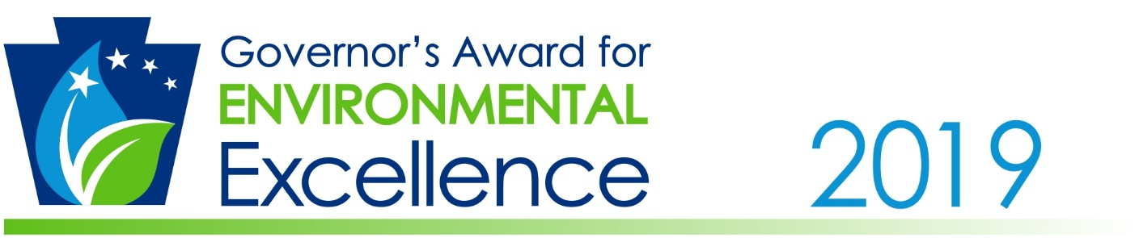
Apply now for the 2019 Governor’s Award for Environmental Excellence!
The Governor’s Award for Environmental Excellence is open to any Pennsylvania business, farm, government agency, educational institution, non-profit organization and individual that has created, or participated in, the development of a project that promotes environmental stewardship in Pennsylvania.
Applications can be submitted to DEP from October 17, 2018 through December 17, 2018.
How to apply:
DEP will accept project applications through the Award Nomination Website.
- Refer to the Project Guidelines for information regarding project eligibility and evaluation.
- Fill out the required information on the Award Nomination Website.
- Provide the details about the project using this Application Form.
- Upload the Application Form.
- Upload supplemental photos, videos, or other documentation about the project (optional).

Helpful Tips:

Consider these helpful tips when filling out your application:
- Complete each section of the Application Form.
- Provide clear, thorough details about the project.
- Graphs, charts, and graphics are helpful when explaining data and statistics.
- Photos, videos, press releases, letters of support, etc., are excellent supplements for project applications!

FAQ:
When can applicants expect to be notified if they were selected for an award?
- Applicants selected for an award will be notified in February 2019.

Can an applicant submit applications for multiple projects?
- Yes. If an individual, organization, or business would like to apply for multiple projects, they may submit ONE application PER project.
If selected, what do applicants receive as an award?
- If selected, applicants chosen for the Governor’s Award for Environmental Excellence will receive a physical award plaque and will be invited to the Award Reception Dinner in April 2019.

