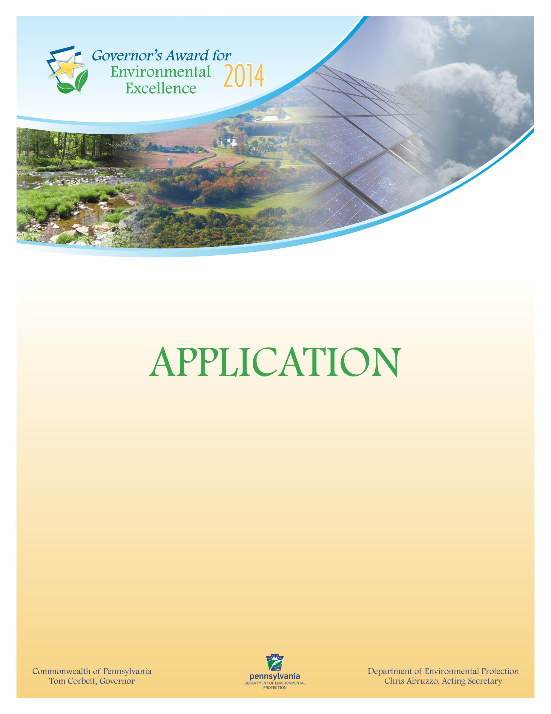

**0120-FM-PO0015 10/2013 COMMONWEALTH OF PENNSYLVANIA**

DEP Logo **DEPARTMENT OF ENVIRONMENTAL PROTECTION**

**POLICY OFFICE**

**GOVERNOR’S AWARD FOR ENVIRONMENTAL EXCELLENCE**

**2014**

|  |  |
| --- | --- |
| **Award Application** | |
| *All applications must be typed in the format outlined below. Incomplete applications will not be considered. The applicant is the individual, business, governmental agency, non-profit organization, educational institution, farm or agribusiness that owns the project or was instrumental in implementing the project. Identify the applicant using the format below:* | |
| Name of the Project: | |
| Implementation Date: | |
| Completion Date: | |
| **APPLICANT INFORMATION:** | |
| Company Name: | |
| Name (CEO President, Owner): | |
| Contact: | Contact Title: |
| Address: | |
| Phone Number: | Fax Number: |
| Email: | Website: |
| County/Municipality: | |
| List any related trade associations or similar professional or industry-related groups to which you or your business or organization belong: | |
| Does your organization have any unresolved compliance issues with U.S. EPA, DEP, other state, federal or local authority?  Yes (*Please include brief explanation on an attached sheet*)  No | |
| **APPLICANT TYPE** | |
| Large Business *(more than 100 employees)* | Educational Institution |
| Small Business *(less than 100 employees)* | Governmental Agency |
| Individual | Trade/Professional Organization |
| Media | Farm or Agribusiness |
| Technical Assistance Provider | Nonprofit/Civic Organization |
| Other |  |

*Please submit all documents electronically to [RA-EPgovenviroawards@pa.gov](mailto:RA-EPgovenviroawards@pa.gov?subject=2012%20Governor's%20Award%20for%20Environmental%20Excellence) no later than

5 p.m. on Friday, January 17, 2014.



**Project Summary**

|  |
| --- |
| 1. Project Name: |
| 1. Brief paragraph about the organization: |
| 1. Project Description: |
| 1. Characteristics, objectives, goals, benefits and outstanding attributes of the project: |
| 1. Environmental results achieved by the project: |
| 1. Overview of the project’s commitment to improving Pennsylvania’s environment: |
| 1. Explanation project partnerships: |
| 1. Overview of any innovative technologies and approaches used to achieve results: |
| 1. Explanation any environmental education components of the project (if applicable): |
| 1. Economic Impact: |